# Technology Analyst

9661140417 ,” [pinsusinghO12@gmaiI.com](mailto:pinsusinghO12@gmaiI.com) Linkedln/Portfolio G Hyderabad

# CAREER SUNNARY

Dedicated and proficient Java Developer with 4.6 years of hands-on experience in designing, developing, and maintaining robust and scalable software applications. Adept at leveraging Java technologies to deliver high-quality solutions that meet client requirements and drive business success.

## EXPERIENCE

Senior System Engineer

### Infosys

Company Description

* Created api to communicate with two microservices using fieng client.
* Implemented Junit with mackita to test the code.

12/ 2O22 - Present

Pune, India

* Building web applications using Java frameworks like Spring and Spring Boot, with a solid

gra sp of RESTfuI API design and integration

* Implement CI/CD using Azure devops.
* Implementing traditional DB connection, CRUD operations using JDBC connectors
* Created Login form to authenticate users.
* Created separate components for each CRUD operation. Created a Form in each

component to get inputs and communicate with back-end REST apis

* Setting the AWS infrastructure comprising of ASGfor dynamically scaling EC2 i nstances based on loa d, with ALB and NLB load balancers and integration with S3 and EFS and applying proper security to all the resources using Security Groups
* Setup the Kubernaties cluster and deployed the application on containirizatian platform.

### Java Developer ApMoSys Technologies

Company Description

06/2021 12/2022

Navi Mumbai

* 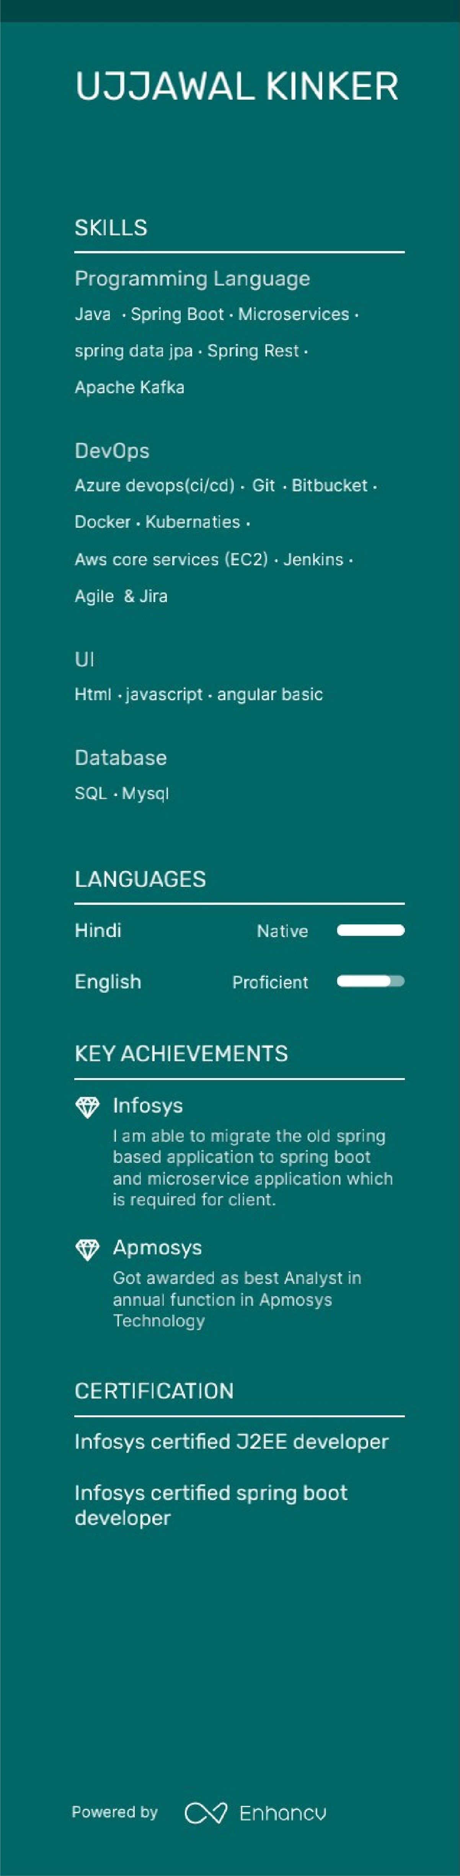Developing Spring boot Rest APIs to communicate with core Repository Rest APLs,

using Spri ng Web and WS iibraries.

* Implementing Retrylogic, Log4j logging, AOP based exception handling (ResponseErrorHandler, ResponseEntityErrorHandler). Used Lombok library to reduce boiler plate code.
* Building Data access layef using Spring Data JPA to query, inseft, update data in MySQL

DB.

* •Using Java Stream APIto increase the performance of File, Collection operations, and

lambda functions to make code more readable.

* Which of your achievements match the jab you’re applying to?

EDUCATION

## B.Tech (Computer Science & Engineering)

### Guru Nanak Dev Engineer1ng Col lege. Ludhiana