Techno-economic and environmental impact of transportation in business sector:
building an AI-assisted multi-criteria decision tool

Transportation Systems Doctoral Program

Thesis Project

João Garcia Pinto Oliveira

Supervisor: Marta Campos Ferreira

Co-supervisor: Adélio Magalhães Mendes

Co-supervisor: Francisco Paiva

Abril 2026

Content
- Contents
Content 2
0 Contents 2
1. Background and Context 3
1.1 The "Wicked Problem" of Sustainable Transport 3
1.2 The Methodological Crisis: Data Deluge vs. Holistic Vision 7
1.3 The AI Opportunity: From Probabilistic Risk to Reliable Knowledge Paths 8
1.4 Research Objectives and the Decision-Making Framework 8
2. LITERATURE REVIEW 9
2.1 The Evolving Energy Landscape for Transportation 9
2.1.1 Alternative Fuels and Energy Carriers 9
2.1.2 Fundamental Sciences: The Hard Constraints 10
2.2 FRAMEWORKS FOR EVALUATION AND DECISION MAKING 11
2.2.1 The Limitations of Static Frameworks 11
2.2.2 Operations Research in Fleet Management 12
2.3 SCIENTIFIC MULTIDISCIPLINARY CONTEXT AND AI: THE CORE SYNERGY 12
2.3.1 The Imperative of Multidisciplinarity in Transport Systems 12
2.3.2 The Data Deluge: Rate of Growth of Scientific Publications 12
2.3.3 Enhancing Knowledge Synthesis via AI 13
2.4 Towards Holistic and Actionable Knowledge: The Data-to-Operations Gap 13
3. RESEARCH METHODOLOGY AND PLAN 14
3.1 THE EPISTEMIC TRAJECTORY: PRELIMINARY WORK AND PUBLICATIONS 15
3.2 DSAiVE Framework Architecture 15
3.2.1 The Dynamic Bundle: From Search to Synthesis 16
3.2.2 Structured Extraction Pipeline 16
3.3 Applied Methodology: Validating the Epistemic Compiler 17
3.3.1 Exploratory Validation: The Methanol Case Study 17
3.3.2 Robustness Validation: The SDG Expert Survey 18
3.3.3 Evaluating Epistemic Risk: Beyond Surface Metrics 18
3.3.4 Reasoning vs. Retrieval: DeepSearch, RAG, and the "Stochastic Parrot". 18
3.3.5 Measuring Semantic Drift: The LLM Thread Categorised History Report 19
3.3.6 Validating the "Compass": How LLM-based Exploration vs Deterministic Validation Creates Trust 19
3.3.7 Managing the "Long Tail": The Necessity of Hybrid Semantic-Lexical Retrieval 20
4. APPLIED FLEET OPTIMIZATION (THE UPK TESTBED) 20
4.1 Fleet Reconciliation & Physics Sandbox: The "26 L/100km Illusion" 21
4.2 Tri-State Strategic Routing and TCO Integration 21
4.3 Spatial Analysis: The Range Replenishment Capacity (RRC) Map 22
5. EXPECTED RESULTS AND CONCLUSIONS 22
5.1 Research Plan and Deliverables 23
5.2 23
5.3 Funding and Acknowledgements 24
6. References 24

Background and Context

The "Wicked Problem" of Sustainable Transport
Sustainable transportation isn't just a technology swap. It's a Wicked Problem: economic pressures, environmental limits, technical constraints, social effects, and policy, all tangled together, and none of them can be solved in isolation. That tangle is why this research exists: transportation still drives a huge share of global CO2 emissions, and fossil-fuel alternatives need a real decision-making framework, not guesswork.
Running out of fossil carbon isn't the danger. Reserves are vast, and depletion is centuries away. The real emergency is atmospheric CO2, climbing every year, threatening life on this planet on a far shorter timeline.
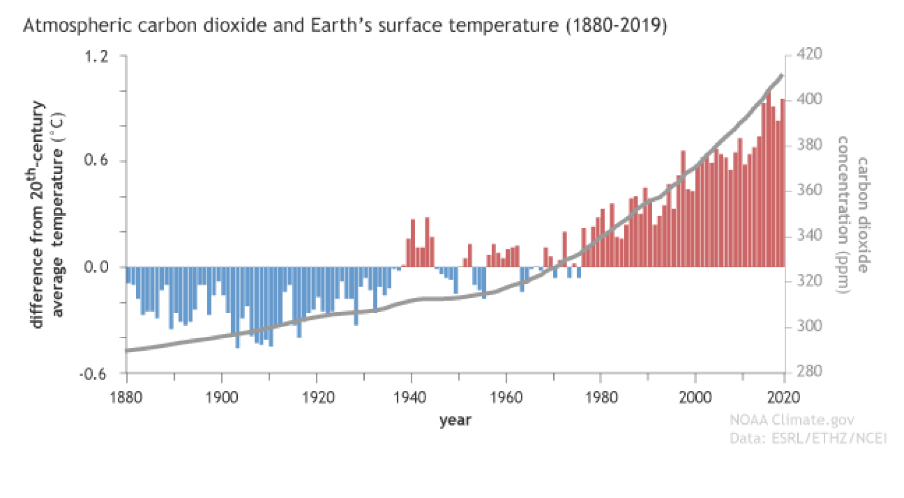
Figure 1 - Atmospheric CO2 and Earth's surface temperature (1880-2019) [141]
Four thousand five hundred million years of natural optimisation, and nature never chose to store hydrogen. It splits water through photosynthesis, produces H2, and immediately locks it into biomolecules instead [1][8]. No stockpile. Global warming, meanwhile, is not a theory anymore. It's an empirical fact, backed by mountains of observational data [12]. The first climate prediction model appeared a century ago [13]. Sixteen years later, GS Callendar (1938) published the paper that tied climate change directly to human carbon dioxide output [14]. It took decades for that idea to reach public consciousness. And even now, despite behavioral shifts everyone agrees are desirable, over half of all anthropogenic greenhouse gas emissions have happened in just the last 30 years. No reversal in sight.
The Treaties of Paris (1951) and Rome (1957) locked in institutional rules for coal and nuclear only. Oil, gas, renewables: each EU Member State was left to write its own national policy [20]. That changed. Europe became a driver of sustainability policy in its own right, and in March 2007 the European Council did something it had never done before: it agreed on an integrated climate and energy policy, complete with an Energy Action Plan for 2007-2009. The target that came out of it: 20% renewables in energy use by 2020 [21], [22].
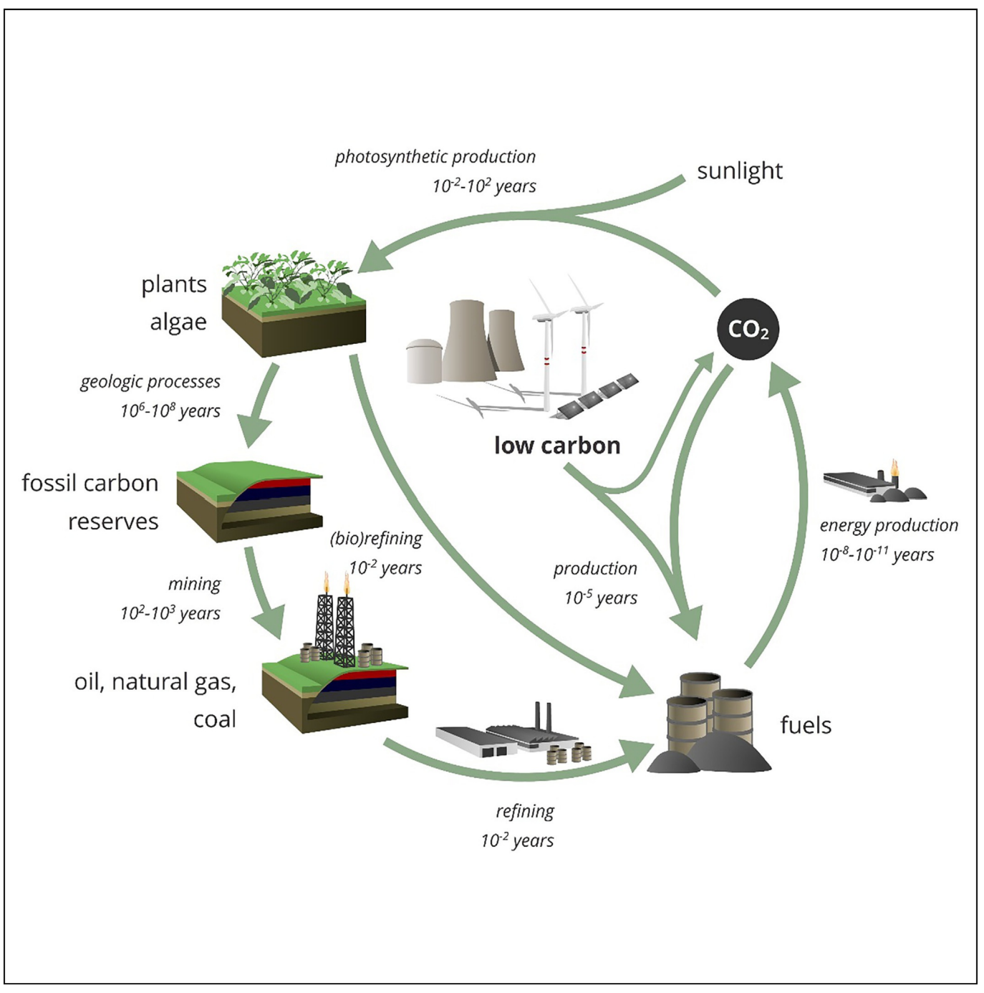
The diagram illustrates a carbon cycle involving photosynthesis, CO2 absorption, geological processes, energy production, and fossil fuel consumption, with various time scales for each process.
Figure 1 shows a dimension people tend to skip over: time. Fossil fuels take 106-108 years to form geologically. We burn them in a fraction of that. That mismatch is the whole problem. Hitting climate targets means switching to low-carbon cycles (photosynthetic production, synthetic refining) that run on human timescales instead, somewhere around 10-2 to 10-5 years. And time matters just as much on the ground: refuelling, charging, logistics. A business runs on minutes, not geologic ages.

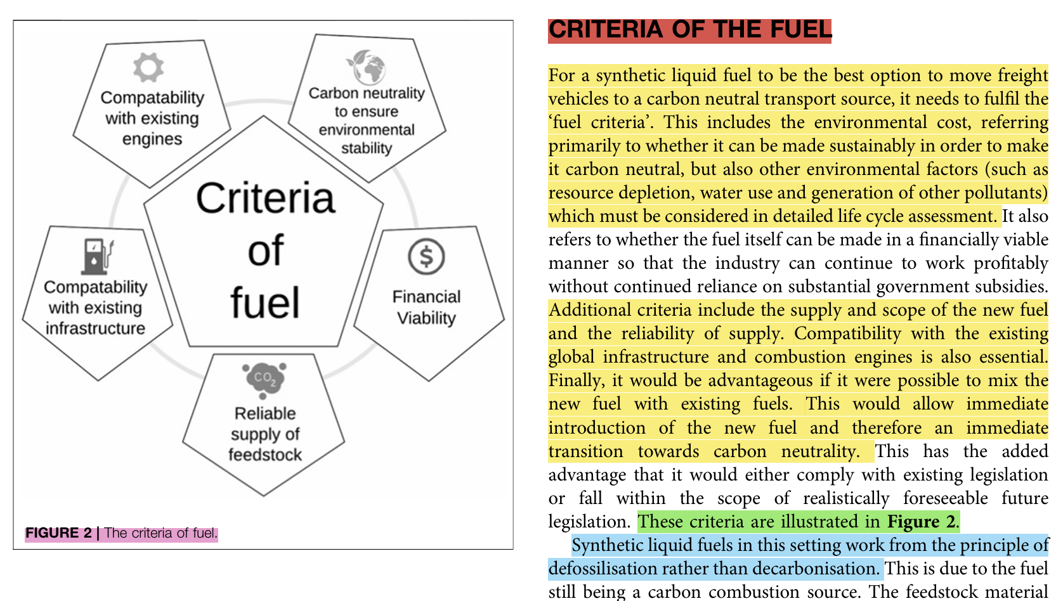
Figure 13 - Important criteria to be included in prompt [113]
Figure 2 lays out the five criteria a viable alternative fuel has to clear: carbon neutrality for environmental stability, compatibility with existing engines, compatibility with existing infrastructure, a reliable feedstock supply, and financial viability. Miss one, and the fuel doesn't scale.
The European Parliament answered with the European Climate Law: climate neutrality by 2050, a minimum 55% cut in net greenhouse gas emissions by 2030 [4], [5]. But policy like this carries real social and economic weight. Take the EU's original plan to phase out internal combustion engines by 2035. It triggered serious pushback [6]. Former Stellantis CEO Carlos Tavares put it bluntly: mandating one specific technology, like EVs, without defining the broader goal, risks real social disruption and ignores the automotive industry's social dimension entirely [7].
The literature backs him up. Ignore affordability, employment, equity, and policy fails; inequality deepens [Pye et al. 2008; Mearns and Norton 2010].
This PhD program tries to close that gap. It pairs academic knowledge with a formal non-academic partnership, aimed squarely at the political and corporate decisions that shape people's lives. The candidate brings entrepreneurial and business management experience to the table, and the research leans on it: practical business problems first, so sustainability models stay tethered to operational reality instead of floating off into theory.

The Methodological Crisis: Data Deluge vs. Holistic Vision
You have to understand demand before you can substitute fossil fuels. Transportation depends on them more than any other end-use sector [53]. And energy availability shifts by geography. Vehicles need fuel delivered directly, wherever they are. That single fact explains most of why fossil fuels are so stubborn to replace here.
EV adoption has picked up speed [57]. The barriers haven't gone anywhere, though: energy density, geographical variability, the infrastructure buildout, lifecycle emissions [58], battery supply chains [62]. Real, technical, and stacked against a fast transition.
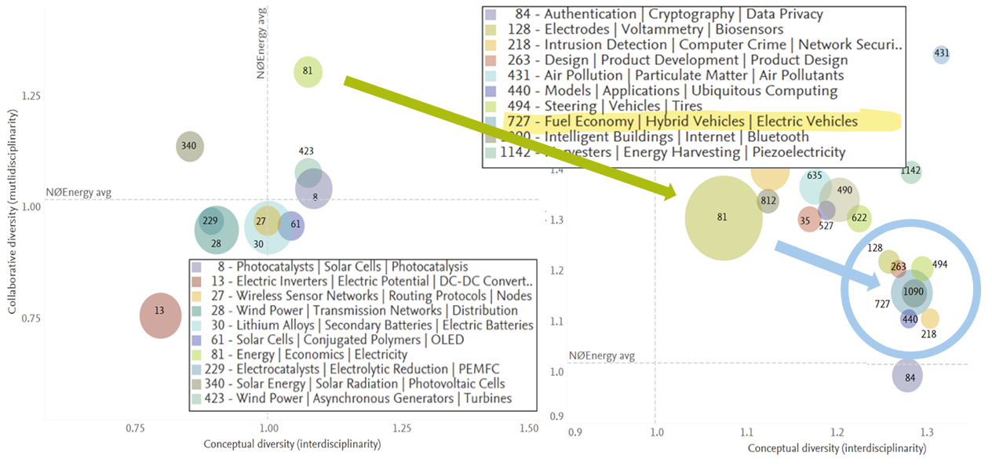
The diagram illustrates a variety of interconnected research areas including energy, environmental technologies, and advanced materials, highlighting collaborations and common themes such as energy efficiency and renewable energy sources.
Elsevier's 2021 report, "Pathways to Net Zero: The Impact of Clean Energy Research" [9], maps this complexity with data mining, and the visuals make the point well. Finding fossil fuel alternatives isn't a job for one discipline. It needs multidisciplinarity (co-authors crossing fields) and interdisciplinarity, real diversity of disciplines, not just adjacent specialists nodding at each other.
That complexity breeds a crisis of method. Publications keep multiplying, a Data Deluge, and a traditional Systematic Literature Review is obsolete before you finish writing it. Researchers get stuck with a false choice: narrow the scope and lose the systemic view fleet management actually needs, or drown. Decision-making needs both broad understanding and deep domain knowledge at once. Right now, it rarely gets either.
The crisis isn't just about volume. It's about vocabulary. The energy transition has outgrown the words we use to manage it. A fleet manager doesn't ask "which fuel?" anymore. The real question is "which way of putting range into a vehicle?" And there's no single word for the answer. "Fuel" excludes battery charging. "Energy carrier" names the vector, not the act of supplying a vehicle. This isn't a linguistics problem, either. It's operational. "Refuelling time" assumes a fuel exists. Infrastructure statistics count installed kilowatts when what a fleet operator actually needs is deliverable kilometres per stop. Even word embeddings, which cluster similar terms together, likely inherit the same blind spot, since they're trained on the very language that's missing the category in the first place. Section 2.1.1 develops this as a literature finding. Section 4.3 redefines replenishment metrics around it. And it sets up the first validation pilot for the Semantic Drift programme, Section 3.3.5.

The AI Opportunity: From Probabilistic Risk to Reliable Knowledge Paths
This research treats AI as a systematic navigation tool for exactly that complexity. The topic was chosen before modern Generative AI even existed, back when sorting valuable information out of the daily flood of publications was already brutally hard.
Then Generative AI arrived, and it brought its own problems. Telling helpful information from "garbage" isn't easy when the tools generating it are opaque. Here's the paradox: endless data, powerful AI, and well-informed decisions are still just as hard to reach.
So this research looked at Retrieval-Augmented Generation and semantic similarity to get past what traditional SLRs can't do. The probabilistic approach did restructure knowledge systematically. It also brought risk with it: hallucinations, the "Stochastic Parrot" problem, where the AI says something plausible and wrong.
Here's the core argument: Generative AI's probabilistic nature isn't a flaw to work around. It's an opportunity, if you constrain it properly. Add deterministic validation layers, and AI can restructure enormous amounts of knowledge into something a human can actually handle. Probabilistic generation, paired with deterministic verification. That pairing is what builds reliable decision pathways.

Research Objectives and the Decision-Making Framework
Building a dynamic multi-criteria decision tool for transport systems means merging two very different data types: hard science grounded in chemistry and thermodynamics, and quantitative and qualitative input from stakeholders. This work takes a business-oriented route to that merge: knowledge transfer that bridges academic theory and high-TRL operational reality, with AI tools doing the heavy lifting.
One intuition kept surfacing throughout this research: AI's probabilistic nature doesn't automatically respect scientific epistemology. Leave a model to predict the next token statistically, with no structural constraints, and it drifts, away from what the user meant, sometimes away from the laws of physics entirely. This work has a name for that: Semantic Drift.
So within a Transport Systems doctoral program, bringing AI in isn't a detour from the real subject. It's a methodological answer to the field's own complexity, one built specifically to keep that drift in check.
Three constraints tie every artifact in this thesis together: time, location, and information, all under scarcity. Call it the scarcity triad. It governs fleet operations directly: vehicles, fuel, chargers, driver hours, all finite, all scattered unevenly across geography. It governs the research process too. The data deluge is really just cognitive capacity running scarce against publication volume, and AI-assisted synthesis runs under its own computational quota. Time binds twice over. Energy replenishment takes time. Decisions have deadlines. A perfect fuel choice delivered after the procurement window closes is worth nothing operationally. Every chapter that follows touches at least two of these three dimensions. Strip the framework down to its essence, and it's a method for making transport decisions reliably when all three constraints bind at once.
Main Objective: Develop and validate a dynamic, AI-enhanced knowledge structuring framework, one that safely turns multidisciplinary inputs into hard constraints, supporting operational Transport Systems decisions on fuel and energy-supply selection.
Specific Objectives:
- Map the complex transport ecosystem and its alternative fuels (methanol, hydrogen, electricity) through a systematic read of the extensive academic literature.
- Identify operational and technology-specific constraints from that literature, using a structured data-extraction pipeline.
- Formally define the neurosymbolic architecture behind the knowledge-structuring compiler, DSAiVE: a design that pairs a probabilistic language model with a rule-based mathematical validator, along with its deterministic validation layers.
Validate the framework through a high-TRL proof-of-concept: a 500-vehicle corporate fleet in Portugal, with literature-derived constraints folded directly into operational Vehicle Routing Problems and predictive maintenance.

LITERATURE REVIEW
This chapter works through the scientific literature on transportation energy systems and sustainability. Not just a survey of technological alternatives, though. The real goal is to diagnose what's structurally broken in how we synthesize knowledge and support decisions today. Two jobs, really. Consolidate what's already understood about alternative fuels and transport systems. And justify why the methodology needs to shift toward AI-assisted, epistemically constrained synthesis, a necessary condition, not an optional upgrade, for high-TRL operational decision-making.
Before an AI-driven "epistemic compiler" makes sense, the fundamental constraints of the transportation energy landscape need mapping first. What follows gets dense: chemical, thermodynamic, and logistical detail on alternative fuels, section by section. That density is deliberate. It's the "Technical Substrate": precise, multidimensional data, exactly the kind that overwhelms a traditional human-led literature review. Which is the point. It's the justification for the methodological shift this work makes later.

The Evolving Energy Landscape for Transportation
Technological maturity doesn't scale linearly into operational feasibility, not anywhere in the literature. Decision frameworks need to handle context-dependent, constraint-driven trade-offs. Universal rankings don't cut it.

Alternative Fuels and Energy Carriers
Evaluating the shift away from fossil fuels starts with one distinction: primary energy sources versus energy carriers [28]. Electricity is a carrier. Zero mass, travels near light speed, brutal to store at scale, yet generated from all kinds of primary sources [29]. Get this distinction wrong, and any sustainability comparison collapses.
These options aren't a homogeneous class, and pretending otherwise causes problems. Diesel is the fossil incumbent. LPG plays transitional fuel. Methanol and dimethyl ether are candidate synthetics; their climate merit hinges entirely on renewable synthesis and where the carbon comes from. Ammonia and hydrogen get grouped together under the EU's Alternative Fuels Infrastructure Regulation, AFIR (Regulation (EU) 2023/1804), as alternative fuels for zero-emission transport, though their real climate performance still depends on production route. And battery-electric charging isn't a fuel at all, not in the conventional sense. That heterogeneity exposes a gap in the language itself, one with real operational consequences: there's no single category word left for what a vehicle takes on board. "Fuel" excludes charging. "Energy carrier" names the vector, one level removed from the actual act of supplying a vehicle. So this thesis adopts a working term instead, vehicle energy supply options, consistent with AFIR's deliberately broad statutory definition of "alternative fuels" in Article 2, point (4), which already includes electricity. This isn't pedantry. The absence of a common comparison unit at the "fuel" level is exactly what gave rise to the technology-agnostic Range Replenishment Capacity index in Section 4.3, the one place these options can actually be compared: delivered range per vehicle stop.
- Electricity: EVs are the benchmark for decarbonization, sure. They're also stuck with real hurdles [68]. Battery technology still struggles with energy density, weight, cost; storage at scale is a genuine bottleneck [69]. Electrifying at any real scale demands massive infrastructure investment [70]. Renewables are intermittent, which complicates supply reliability and forces the need for robust storage just to keep the flow stable [73]. And then there's the battery supply chain itself: lifecycle emissions, extraction dependencies, the ethical weight of "extractivist" practices that comes with it [62].
- Hydrogen: promising, but green hydrogen runs into economic limits fast; production is expensive [75]. Low volumetric energy density complicates storage and transport [76], meaning high-pressure or cryogenic tanks, both energy-hungry. It's highly flammable, so safety measures have to be strict [77]. And distribution infrastructure barely exists yet; building it out demands serious investment [78].
- Methanol and Emerging Carriers: Methanol has real advantages: it fits existing liquid fuel infrastructure, and it can be produced from captured CO2 [79]. Production is energy-intensive, though [80], and toxicity plus a low boiling point make handling tricky [81]. Still, its emissions-reduction potential earns it a spot as a serious transition candidate [82], [83]. Other carriers follow the same pattern. Dimethyl Ether [84], [85], [87] and Ammonia [88], [89], [90] both burn clean and can ride established distribution networks, but energy density, engine modification needs, and toxicity limit them too.

Fundamental Sciences: The Hard Constraints
Technological promises are easy to find. The fundamental sciences set the real bounds on what's feasible. Evaluating energy carriers properly means looking at three interconnected physical layers:
- Classical Thermodynamics and Chemistry, the theoretical limits: energy can't be created or destroyed, only transformed. That's the first law [94]. The second law is less forgiving: irreversibility. No energy transformation hits 100% efficiency, ever; some is always lost as waste heat, and entropy climbs [95]. Physical chemistry adds the molecular detail: Gibbs Free Energy, for instance, predicts whether a reaction in a fuel cell or electrolysis process happens spontaneously at all [82], [96].
- Exergy, the quality of energy: exergy analysis measures not how much energy exists, but how much useful work it can still do. Energy is conserved. Exergy isn't; it gets consumed. That makes it the right tool for finding exactly where transport systems waste potential [91], [97].
- Finite-Time Thermodynamics, the temporal constraint: classical thermodynamics assumes infinite time to reach ultimate efficiency. Real transport systems don't get infinite time. They run on Finite-Time Thermodynamics instead. Tsirlin et al. (2025) make the case directly: optimising irreversible processes means accounting for how long the energy exchange actually takes. The goal stops being theoretical maximum efficiency. It becomes maximum power output, delivered within the time you actually have.
Time shows up explicitly in finite-time thermodynamics, in dynamic exergy formulations, and again in every study on charging, refuelling, queueing, infrastructure reliability. What's missing is the layer that ties it all together, the question nobody's fully answered: how much useful work can a transport system actually deliver, at what rate, with what waiting risk, at what reliability? This isn't "time versus exergy." It's the absence of operational exergy metrics that fold exergy, power, response time, queueing, and uptime into one transport-service framework.
That loss of fidelity, the temporal dimension especially, is exactly why synthesis mechanisms need to preserve physical limits as first-order inputs, not afterthoughts, in operational decision models.

FRAMEWORKS FOR EVALUATION AND DECISION MAKING
Look at where energy supply meets demand, and transportation and location optimisation turn out to matter enormously. The frameworks historically used to evaluate this, though, usually miss the temporal and physical constraints laid out above.

The Limitations of Static Frameworks
Evaluating energy alternatives and their systemic impacts traditionally leans on a handful of established frameworks: Life Cycle Assessment [93], Techno-Economic Analysis [92]. For comparing fuels specifically, Multi-Criteria Decision Analysis earns its keep: economic, environmental, social, technical criteria, weighted and ranked [102]. Bibliometric analysis rounds it out, giving a wide-angle view of the academic knowledge base [9].
Useful, yes. But the literature keeps flagging the same structural cracks in these traditional frameworks:
- Static Assumptions: predefined weights, fixed assumptions; most frameworks freeze the world in place and miss how operational reality actually evolves (Cinelli et al., 2014).
- Boundary Sensitivity: move the system boundary an inch, and the results shift. They're notoriously sensitive to how the researcher frames the initial scenario (Finnveden et al., 2009).
- Exclusion of Dynamics: time-of-day grid carbon intensity, real-time charging availability; dynamics like these get simplified away or dropped entirely (Beloin-Saint-Pierre et al., 2020).
- Narrative Bias and Author Subjectivity: cross disciplines, and subjective narrative bias creeps into the synthesis. Authors' own disciplinary focus, funding sources both bias the claims that end up in the literature, usually toward overestimating a technology's viability and downplaying its operational drawbacks (Gough et al., 2012; Boutron & Ravaud, 2018).
Put those limitations together, and the conclusion is clear: traditional decision frameworks need an upstream data filter: something structured, that keeps relevant knowledge preserved, traceable, correctly mapped, before any numbers get aggregated.

Operations Research in Fleet Management
Macro-level fuel evaluations shape global energy strategy. Fine. But the actual transition to sustainable transport happens at the micro-operational level, and that's where the literature needs to shift focus: toward Operations Research. The Vehicle Routing Problem sits at the center of this, along with its advanced variants. Heuristics and metaheuristics do the heavy lifting: Variable Neighbourhood Search, for instance, systematically varies a candidate solution's neighbourhood structure to escape local optima, which fits fleet routing problems with time windows, mixed vehicle types, and charging constraints particularly well. The goal throughout: minimize travel time and energy consumption (Hansen et al., 2019, demonstrate this on complex logistics networks).
IoT and vehicle telemetry brought something else with them: Predictive Maintenance, now a genuine strategic lever. Machine Learning predicting component failure doesn't just extend vehicle lifecycles; it cuts operational downtime dramatically (Carvalho et al., 2019). But nobody's tied these domains together. Dynamic routing, predictive maintenance, strategic vehicle substitution: the literature treats them as separate silos, not one interconnected operational ecosystem. That's a recognised, and still open, gap.
[PLACEHOLDER: Figure 5 - The Siloed Nature of Fleet Management (Visual showing VRP, Maintenance, and Fuel Substitution as disconnected gears that need to be meshed together)]

SCIENTIFIC MULTIDISCIPLINARY CONTEXT AND AI: THE CORE SYNERGY

The Imperative of Multidisciplinarity in Transport Systems
Transportation Systems research reaches well past infrastructure design. Social Sciences studies user behaviour. Mechanical Engineering handles vehicle power. Electrical Engineering covers charging grids. Computer Science builds the routing algorithms [111], [112], [113]. Environmental science weighs in too, on air quality and the sustainable mobility paradigm [114]. None of that fits inside one discipline. The field demands a genuinely interdisciplinary framework, full stop.

The Data Deluge: Rate of Growth of Scientific Publications
Knowledge production keeps accelerating, and that makes multidisciplinarity even more necessary. Scientific articles pile up exponentially. Digesting the knowledge base gets harder. Finding the publications actually relevant to a specific operational question gets harder too.
Table 1 puts numbers to that trend: recent publication growth across the key energy and transport domains, sourced from Scopus, 2023.
Table 1. Rate of growth of scientific publications.
Topic | Total  Articles | Articles  2022-23 | % last  2 Years | Review  Articles | % Rev.  Articles
Increasing Publications | 32,232 | 6,385 | 19.8% | 4,335 | 13.4%
Energy & Transport  Systems | 35,869 | 6,526 | 18.2% | 3,547 | 9.9%
Carbon Capture | 14,665 | 3,617 | 23.8% | 1,231 | 8.4%
Green Methanol | 132 | 69 | 52.3% | 13 | 9.8%
Look at "Green Methanol": over half of everything ever published on it came out in a single two-year window. Growth like that flips the bottleneck entirely. It's no longer information scarcity limiting research. It's selection and synthesis capacity. Screening that volume of publications for credibility, during an SLR, becomes brutally difficult. And that's when epistemic governance stops being a footnote and becomes the central research challenge.

Enhancing Knowledge Synthesis via AI
Subject complexity plus a rising publication rate. That combination demands better tools. Traditionally, researchers reach for Rayyan [117] to organise articles, or bibliometric packages like Bibliometrix [118], [125]. Useful for macro-level insight. Fall apart, though, the moment you need something detailed, synthetic, or operational.
AI, specifically LLMs and Retrieval-Augmented Generation, promises real transformation here [122]. Early tests exposed the cracks fast, though. Models hit the "Lost in the Middle" problem: relevant information buried deep in a long text just gets skipped over, systematically [121]. Worse: LLMs drift semantically, hallucinate, generate statements that sound completely plausible and happen to be wrong [123]. Let probabilistic AI select and synthesize source data on its own, with no structural constraints, and you've introduced risk no engineering or policy decision at this scale can absorb.

Towards Holistic and Actionable Knowledge: The Data-to-Operations Gap
The literature has gaps, and they're not small ones. The biggest: nothing connects primary energy sources to the operational reality of where they're actually consumed. Fueling a vehicle with liquid fuel takes five minutes. Charging a battery takes hours. That difference is enormous operationally, and traditional literature barely touches it.
That leaves a gap: vast, unstructured academic literature on one side, hard mathematical constraints for running a real transport fleet on the other. Closing it needs a new paradigm. The candidate's earlier work, "An AI Framework for Literature Review in Search of Sustainable Fuels" (Publication 2), makes the case directly: stop treating AI as a probabilistic oracle guessing at the State-of-the-Art. Use it instead as a knowledge-structuring compiler, something that pulls out verifiable atomic facts and puts them through strict, human-defined structural validation. Run this through the scarcity triad from Section 1.4 (time, location, information, all scarce) and the data-to-operations gap turns out to be a scarcity problem itself. Access to information isn't the binding constraint anymore. Time and cognitive capacity are, the resources needed to convert information into constraints tied to a specific place and moment. Data used to be scarce. Now decision time is.
Methodological Rigour and Confirmation Bias in the Age of AI
This literature review stayed open and systemic in its early stages. Fair enough. But there's a reality of modern research that needs naming here. Researchers, at some point in their intellectual development, go looking for established authors who validate what they already believe. It's comforting. It's also confirmation bias: gathering evidence that fits the hypothesis, ignoring what contradicts it. Well documented, and not exactly a secret (Lipton & Steinhardt, 2019; Macoun & Miller, 2014).
Generative AI and "Deep Search" tools change that dynamic completely, though. Now a researcher can find validating claims and weave them into a plausible narrative at speeds nobody had before. Messeri and Crockett (2024), writing in Nature, call the result an "illusion of understanding": retrieval outpaces critical evaluation, and the gap between the two is where the illusion lives. LLMs add their own twist: sycophancy. They tailor retrieved evidence to whatever hypothesis the user seems to be implying (Perez et al., 2022). And it compounds. AI-assisted workflows can amplify Semantic Drift recursively, when one AI-generated framing feeds straight into the next AI's context with no human checkpoint in between; this project hit that exact failure mode itself (see Section 4.1, the 26 L/100km episode). So this thesis treats external validation (expert surveys, supervisor review, deterministic physical constraints) as mandatory. Not a nice-to-have. The grounding layer of the entire workflow, extending the bias argument from just the output to the whole process.
That means putting AI into the research workflow comes with a heavier responsibility attached. If it can validate any claim instantly, the researcher's job has to get harder, not easier: understanding exactly how a counter-argument could tear that claim down. The shift required: stop using AI to confirm. Start using it to falsify.
AI's speed needs a counterweight, rigorous and deterministic validation, and that realisation is what drives the methodology in the next chapter. Not a framework that just retrieves information. One that stress-tests it against competing operational constraints, actively. The question driving it: how do you build something that pulls verifiable constraints out of this literature and feeds them straight into fleet-level decision models?

RESEARCH METHODOLOGY AND PLAN
Bridging fundamental energy sciences with practical, high-TRL operational execution took a rapid, iterative development cycle. Operations Research and Artificial Intelligence did the heavy lifting there. Over the past year the candidate built the theoretical framework, engineered the software architecture, and secured operational validation, all at once, not in sequence.
This thesis asks one question: how do you make fleet fuel and routing decisions reliable when the supporting knowledge is vast, heterogeneous, and increasingly machine-synthesised? The question predates its own instruments. It was chosen before modern generative AI existed, back when the data deluge was already choking transport decision-making (Section 1.3). Generative capability kept advancing, so the instruments got versioned in response. The underlying question never changed, though. Research built on a moving technological substrate needs an explicit versioning methodology, and that's exactly what the Thread Categorised History Report (Section 3.3.5) provides: a record of which instrument produced which output, under which constraints, at which point in the trajectory.

Here's something worth flagging: the architectural logic and epistemic constraints built independently for DSAiVE (Dynamic Systematic Artificial Intelligence Vector Engine) parallel recent commercial developments in managed agentic infrastructure. That's not a coincidence to worry about. It confirms market demand, and it increases the need for the layer DSAiVE occupies, not the reverse. Commercial platforms solve an engineering problem: tool execution, session persistence, sandboxed computation. They leave the epistemic problem alone, deliberately: whether a generated output is scientifically valid for a transport decision, whether it respects thermodynamic bounds, infrastructure realities, cost constraints. DSAiVE isn't converging with these platforms. It occupies a methodological layer commercial infrastructure never claimed in the first place. Infrastructure versus epistemic validity. That's the distinction.
The "Vector" in DSAiVE's name comes from an early bet: that semantic-vector representations would help bridge this categorical gap. That bet hasn't paid off yet. The planned embedding audit (Section 3.3.5) tests it directly instead of just assuming it.
Hosted agentic platforms now handle much of the execution machinery this research used to engineer by hand. That frees up the methodology entirely for what those platforms don't provide: validating transport-decision outputs against physical and economic constraints.
These platforms abstract away tool execution, session persistence, sandboxed computation, the complex engineering layers. What they don't do natively is address epistemic validity. The computational layer doesn't care whether the output violates classical thermodynamics or drifts semantically. It's indifferent. There's a deeper parallel worth noting, though: commercial agent architectures build in iterative validation loops too, checking, constraining, and recalling each output before proceeding, and that mirrors the exact epistemic discipline rigorous science demands. Structuring science and structuring agent orchestration turn out to be the same need, underneath.
Modern AI systems don't just rely on bigger models anymore. They rely on structured external scaffolds, ones that guide model behaviour, constrain interpretation, connect outputs to validated sources or workflows. DSAiVE sits directly above that infrastructure. It takes raw agent execution capacity and turns it into a controlled extraction pipeline, anchored to predefined domain categories, enforcing domain-specific constraints (fuel energy densities, exergy rates) before the probabilistic data ever reaches an operational decision model.

THE EPISTEMIC TRAJECTORY: PRELIMINARY WORK AND PUBLICATIONS
Peer-reviewed submissions, congress presentations, corporate partnerships: this whole trajectory is documented across all three. It traces a shift from macro-theoretical AI exploration down to micro-operational Transport Systems execution. Table 2 summarises the foundational phases and their academic outputs, for a clear overview.

Table 2: Chronological Evolution of the Research Methodology
**Phase** Focus Area | Academic Output /  Core Contribution
**1. Architecture** Identifying the Data Deluge**** | *Publication 1 (July 2025): DSAiVE, Literature Review in Multidisciplinary Context (CISTI)* Introduced the "Data Deluge" problem formally. Proposed the foundational architecture for DSAiVE to process complex energy datasets.
**2. Validation** Quantitative Testing**** | *Publication 2 (Dec 2025): An AI Framework for Literature Review in Search of Sustainable Fuels* Tested the framework against 478 abstracts, cross-validated by 118 original authors. Made the top ten at the European Universities Competition on AI.
**3. Epistemology** Human-AI Interaction**** | *Publication 3 (Feb 2026): Qualitative Contributions of DSAiVE* Highlighted exactly where LLMs struggle without deterministic constraints, and developed the "Traffic Sign" metaphor to guide AI logic.
**4. Application** Real-World Transport Realignment**** | *Presentation (Feb 2026): DSAiVE, Harnessing AI to Support Transport Systems Decision Making (GET2026)* Marked a deliberate pivot back to applied transport policy. It culminated in the partnership with upK's 500-vehicle corporate fleet.
**5. Business Value** Business value Transport Fleet application | *Ongoing business value-oriented work: Applying concepts and frameworks to creating business value* A new academic partnership, upK. The framework now gets applied to routing and predictive maintenance optimisation in a real-world context: a 500-vehicle corporate fleet. That's the move from theoretical AI exercise to validated, high-TRL Transport Systems operational model.
**6. Competences / Multidisciplinarity** | *Short paper (ongoing): Taming the Stochastic Parrot: DSAiVE Framework Contributions for Ethical AI* Not accepted for publication, no. But it produced a critical metaphor for the thesis anyway: LLMs need "traffic signs" to guide them through allowed, verified, recommended epistemic paths. That metaphor fed directly into the "Neuro-Symbolic Handoff" mechanism.

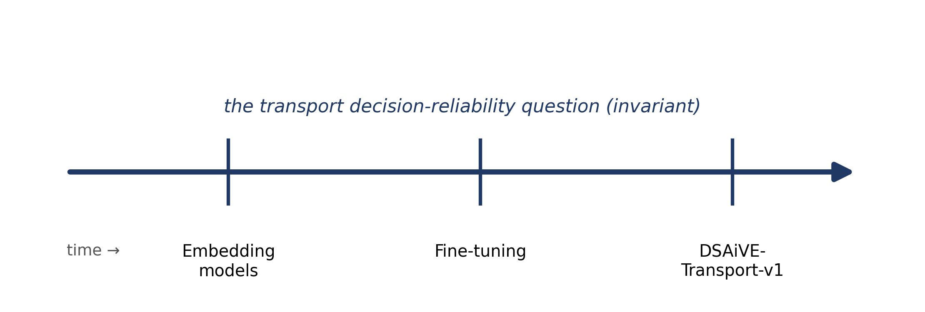
Figure 8 - Research trajectory: the research question is invariant; the instruments are versioned.

DSAiVE Framework Architecture
DSAiVE was built to get past the limitations of traditional systematic literature reviews and early Generative AI tools alike. It combines Retrieval-Augmented Generation with a structured, user-defined clustering approach, so you get systemic coverage and domain-specific depth at the same time.
In design-science terms, DSAiVE is a framework-governed toolkit. A fixed governing core (epistemic hierarchy, Semantic Drift control, graded constraint-validation handoffs) directs a configurable set of operational modules (screening, extraction, validation, visualisation), and that set adapts to the task, the corpus, the resource constraints at hand. Core fixed, toolkit situational. The naming is deliberate, too. "Framework" alone would overstate how methodologically closed this project is right now. "Toolkit" alone would understate how binding the governing core actually is. So "framework" stays, throughout this document, as shorthand for the whole construct.
What's left of this chapter specifies the governing core. Chapter 4 demonstrates the module contracts through handoffs of ascending complexity. And the evaluation programme comes from two places: the epistemic classification of contributions in Chapter 5, and the graded validation sequence introduced just below.
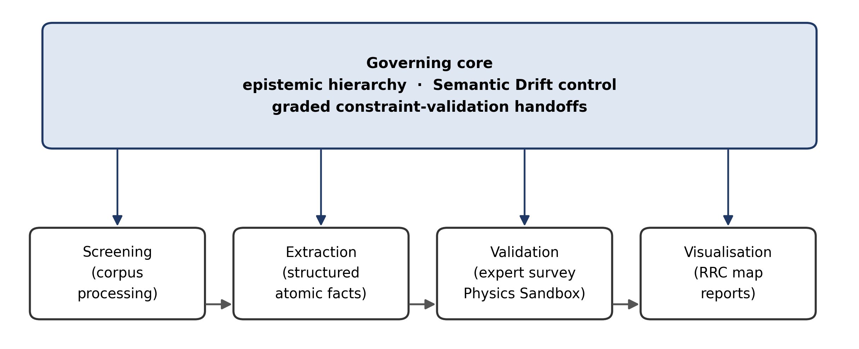
Figure 9 - DSAiVE as a framework-governed toolkit: a fixed governing core directing configurable operational modules (Publication 2).

The Dynamic Bundle: From Search to Synthesis
The previous sections laid out just how complex transportation's impact on greenhouse emissions really is. Managing all those multidisciplinary facets is hard, because detailed technical information has to be evaluated without ever losing the systemic view. And existing AI tools, it turns out, don't provide the transparency or control this needs.
The RAPTOR (Recursive Abstractive Processing for Tree-Organised Retrieval) Python package got investigated first. Liu et al. (2023) and Sun et al. (2021) both note the same thing: Large Language Models underutilise long-range context, and performance diminishes as that context grows. Retrieval-augmented language models have come a long way from TF-IDF and BM25, term-based techniques, to today's RAG architectures, which integrate pre-trained sequence-to-sequence models with a neural retriever.
Apply RAPTOR to our actual article corpus, though, and structural limitations show up fast. Automated clustering via Gaussian Mixture Models sounds conceptually interesting. It didn't address our specific problem statements. Evaluating RAPTOR on a large corpus turns out to be genuinely difficult, because its clustering is statistically indeterministic by design. Trying to add freedom through purely statistical theme grouping just makes the analysis more complex as the article count grows, not less. Purely statistical clustering, in the end, doesn't deliver the transparency or synthesising capacity rigorous research needs. It's built for querying, not for that.

Structured Extraction Pipeline
So here's the first real proposal of this work: adapt RAG architecture away from answering specific questions and toward context summarisation, driven by user-defined clustering instead.
No guessing the themes and letting the AI figure it out. The researcher predefines the clusters upfront, based on their own view of the research question, and that structure dictates what gets built. Predefined means easier to analyse, easier to evaluate, and transparent, finally. There's still room to breathe, though: a "free text" cluster catches anything that doesn't fit the predefined themes.
The DSAiVE bundle throws out the static "separate the wheat from the chaff" approach entirely. In its place: a dynamic system that fuses every SLR phase together. Its main features:
- Flexible Data Source Integration: handles APIs, PDFs, URLs, whatever comes in, seamlessly, and keeps LLM and Embedding Model choice flexible enough to plan robustness tests.
- Segmented Data Ingestion and PDF Text Highlight Extraction: granular analysis, and every piece of synthesised information traces directly back to its source excerpt.
- Multi-Level Parameterisation and Prompt Engineering: the system calls the language model iteratively, generating structured outputs aligned with predefined research categories like thermodynamics, LCA, infrastructure costs. That gives granular control over summarisation, and custom tuning to balance processing cost against detail.

Applied Methodology: Validating the Epistemic Compiler

Before this framework touched anything high-stakes at the corporate level, its outputs needed rigorous validation: quality, transparency, reliability, all of it. Two empirical phases did that work. An exploratory analysis of sustainable fuels literature. And a large-scale expert validation study.

Exploratory Validation: The Methanol Case Study
First application: a corpus of over 1,150 documents on methanol as an alternative fuel. Narrowed down to 121 core articles for deep synthesis.
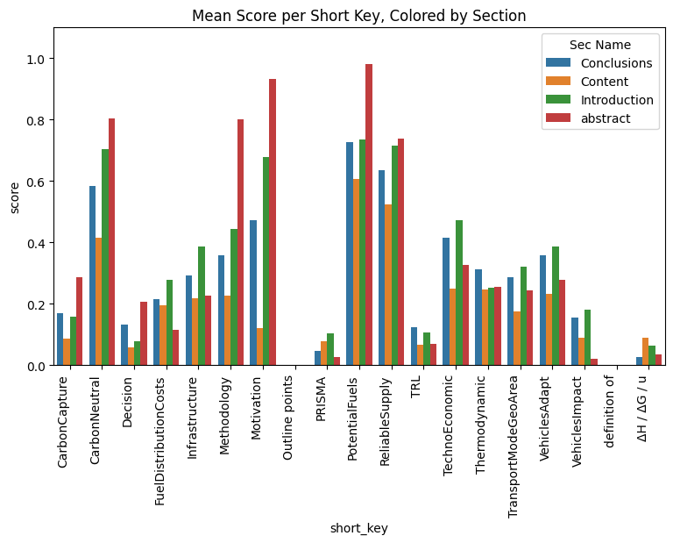
Figure 6 - Article sections ratings per category
Measuring how well these articles aligned with the research objectives needed a number, so the framework introduced Article Rating by Category. Every article got a discrete rating within predefined categories: thermodynamics, infrastructure costs, carbon utilisation, and so on.
- 1.0: Directly related.
- 0.5: Indirectly related.
- 0: No alignment.
Figure 6 visualises this phase, and the structured output made a granular comparison possible: the complete article set against the subset picked by traditional human screening. Human screening turned out to be subjective, hard to replicate. Yet the human-selected subset scored higher on average ratings, and the AI still surfaced several high-relevance articles the human reviewer had rejected outright, for narrative bias. Both things are true at once. What this exploratory phase demonstrated: structured AI prompting is more transparent and more reproducible than manual screening alone, full stop.

Robustness Validation: The SDG Expert Survey
A larger, human-in-the-loop study followed, to push the validation further. DSAiVE classified 478 abstracts from an engineering symposium (DCE25) against the 17 UN Sustainable Development Goals.
Building a community-verified "ground truth" meant generating personalised surveys, programmatically, for each of the 478 authors. Each rated the accuracy of the AI-generated summary of their own work, on a 5-point Likert scale. 118 valid responses came back, a 24.7% response rate, and they revealed something fundamental: the AI is "precise but timid."
Precision hit 0.85 for "High Relevance." Recall for the nuanced, "Medium Relevance" cases was poor. That gap is the "Trust Paradox": experts trust the AI completely to extract atomic facts, specific data points, but stay sceptical the moment it tries to synthesise the State-of-the-Art on its own. The lesson is clear. For scientific research, AI has to be a compiler of facts. Not an oracle of truth.

Evaluating Epistemic Risk: Beyond Surface Metrics
One conclusion from this validation phase mattered more than the rest: standard NLP metrics had to go. ROUGE, BERTScore, tests like these rely on surface-level text similarity, n-gram overlap. Nothing deeper.
Maynez et al. (2020) established this years ago: these metrics can't capture the structural difference between open-ended generation and abstractive summarisation. Goodhart's Law kicks in. The metric becomes the target, rewarding lexical repetition, blind to factual consistency, blind to whether physical constraints survived the process at all.
Text similarity can't measure the real robustness of a transport-oriented AI framework. This research takes that as settled. Validation has to come from operational efficacy instead: does the framework preserve technical constraints, thermodynamic limits included, and pass them into deterministic decision models without Semantic Drift creeping in.
The "AI-Native" Research Trajectory: Orchestration and Validation
This section lays out the specific approach: managing transport systems' multidisciplinary complexity through judicious use of AI. It's a departure from traditional "manual-only" research workflows, a move toward something closer to Epistemic Orchestration.

Reasoning vs. Retrieval: DeepSearch, RAG, and the "Stochastic Parrot".
This thesis sits at an intersection: transport engineering, thermodynamics, operations research, financial modelling. Traditionally, a researcher would need deep, granular expertise in every single one of those sub-domains. Given the current Data Deluge, though, that expectation becomes a bottleneck. It pushes people into narrow, siloed investigations instead.
So here I take the role of Orchestrator instead. State-of-the-art "Deep Search" and RAG tools let me identify relevant data points across multiple domains, efficiently. Early exploration exposed the catch, though: standard LLMs are "Stochastic Parrots," probabilistic engines optimised for statistically likely text, which means plausible but factually wrong statements slip through constantly.
So the job changed. Not "data gathering" anymore. "Data auditing." The AI isn't there to reason; it's there for rapid retrieval, and every probabilistic suggestion it makes gets filtered, strictly, through deterministic physical and economic constraints before it goes anywhere.

Characterising Semantic Drift: The LLM Thread Categorised History Report
Hallucination, the outright fabrication of facts, gets all the attention, and it's a real risk. Semantic Drift is worse, quieter. It happens when an LLM processes dense technical literature and naturally drifts toward generic, homogenised summaries. Nothing gets fabricated. The technical substrate just disappears, because the model converges toward a generic narrative and misses the user's highly specific, multidisciplinary intent entirely.
Quantifying that, and mitigating it, required a new instrument: the LLM Thread Categorised History Report. The human-AI interaction stopped being treated as an ephemeral chat. All 770,000-plus tokens of conversational history became a structured dataset instead.
A deterministic Python classifier audits every AI response, sorting each interaction node into a specific epistemic state:
- Alignment vs Divergence: flags every instance of Semantic Drift, or Structural Divergence, where the AI failed to follow formatting rules.
- Epistemic Novelty: Identifying moments of true Cross-Domain Synthesis versus standard iteration.
- Structural Anchors: tracks the explicit rules, JSON constraints, word limits, whatever it took to force the AI back into alignment.
Run that deterministic classification against the full chat history, and the "AI Learning Trajectory" stops being a subjective narrative. It becomes a quantifiable methodological contribution, longitudinal, single-case evidence that without continuous structured human-in-the-loop intervention and hard constraints, the probabilistic models here drifted semantically, again and again.
Let's be plain about the limits here. The Thread Categorised History Report is a single-researcher longitudinal case. Semantic Drift has been observed and characterised, not measured at statistically significant scale. Not yet. So a graded sequence of validation case studies is planned, ascending in externality. First: a scoped pilot audit checking whether the vehicle energy supply options evaluated in this thesis (Section 2.1.1) stay geometrically faithful in the embedding space DSAiVE relies on, testing concept-neighbourhood integrity and the correlation between embedding geometry and physical dissimilarity, energy density, replenishment time, exergy, since a distorted representation would silently corrupt fuel-selection recommendations. Second: expert-validation extensions. Third: operational testbed outcomes. The pilot's audit instruments get identified here, as methodology. The protocol itself sits outside this document's scope.

Validating the "Compass": How LLM-based Exploration vs Deterministic Validation Creates Trust
Every metaphor in this methodology maps to a specific technical mechanism. The "Dice" is probabilistic exploration by the language model. The "Compass" is deterministic constraint validation. The "Traffic Sign" is the explicit rule set guiding the model between the two.
One finding stands out across this whole trajectory: traditional machine-learning metrics are too "naive" for complex scientific contexts, most of the time. A high surface-level text match guarantees nothing about whether that information actually helps a fleet manager make a decision.
So the methodology focuses on Contextual Validity instead. Resolving the Trust Paradox, where experts trust AI to extract data but reject its attempts to synthesise the State-of-the-Art, means enforcing a strict separation of duties. The LLM plays probabilistic "Dice," exploring the literature and proposing connections. Every proposal then gets handed straight to the "Compass," the deterministic Sandbox detailed in Chapter 4.
The Neurosymbolic Loop works like this: AI proposes a solution, and the human-governed Sandbox delivers the deterministic "Yes/No" check, grounded in fundamental scientific laws. What comes out the other end is a transparent, auditable trail of truth, one that bridges academic research and practical business value.
Named precisely: Operations Research is the deterministic symbolic layer here, the rule-based mathematical validator half of a design that pairs it with a probabilistic language model. The validation layer receiving LLM handoffs is built from OR formulations, Vehicle Routing Problem variants solved by Variable Neighbourhood Search, Total Cost of Ownership constraints, plus physical bounds. As far as the author knows, that makes this thesis an early documented case of OR-grounded neurosymbolic decision support in transport. The claim is interpretive, worth being clear about that. It names an existing design rather than proposing a new workstream. And the dependent variable never changes throughout: fleet cost, emissions, routing, fuel selection.

Managing the "Long Tail": The Necessity of Hybrid Semantic-Lexical Retrieval
Innovation in Transport Systems tends to show up at the intersection of disciplines, not inside any one of them. And that creates a real problem for systematic literature reviews: finding what's genuinely novel, or genuinely limiting, inside a massive textual corpus.
Traditional lexical retrieval, TF-IDF, BM25, is good at emphasising rarity. Its reliance on exact-match fragments, though, means semantically equivalent ideas across different disciplinary vocabularies just don't connect. Pure embedding-based similarity does the opposite: excellent at semantic generalisation, but it smooths frequency information and underweights rare, domain-specific concepts (Luan et al., 2021). Embeddings favour the central, "head" concepts. The marginal but critical "long-tail" ideas lose out.
So DSAiVE relies on hybrid semantic-lexical retrieval instead, a 'Semantic TF-IDF' approach, close in spirit to SPLADE (Formal et al., 2021). The premise: semantic relevance and lexical discrimination are orthogonal dimensions, and detecting innovation needs both, not one or the other. Preserve the rarity of inverse document frequency while still allowing semantic generalisation, and the framework surfaces the "Long Tail" of scientific evidence: low-frequency concepts, specialised terminology, subtle boundary conditions. Exactly the things standard RAG pipelines lose, and exactly the things operational modelling needs.

APPLIED FLEET OPTIMIZATION (THE UPK TESTBED)
Validating DSAiVE and the Neurosymbolic Handoff meant leaving theoretical literature synthesis behind and moving into high-TRL operational execution. The partnership with upK made that possible: their 500-vehicle air-conditioning maintenance fleet became the "Operational Testbed for Deterministic AI Validation."
The goal here wasn't a generic fleet electrification plan. It was a physically bounded, risk-adjusted transition strategy, built by applying deterministic physical constraints to telemetry that is, in the corporate world, highly volatile.
Three cases follow, ascending in handoff complexity, forming a validation pyramid: simplest at the base, most demanding at the apex. Section 4.1 is a single arithmetic plausibility check, a thermodynamic consumption bound that catches physically impossible fleet averages. Deliberately elementary. Its value is pedagogical and structural, not empirical: it shows that even a trivial deterministic check, constraint validation in Operations Research terms, stops data errors from compounding into cost models. Section 4.2 climbs to multi-constraint financial-operational classification, the Tri-State/TCO analysis. Section 4.3 climbs further, to spatial-infrastructural constraint mapping, the RRC index, which also demonstrates something else: the framework can produce simple, self-explanatory interactive applications that shift how fleet managers actually think and decide. There's a complementary axis to this pyramid too: validation externality, ascending from self-audit (Section 3.3.5) through expert survey (Section 3.3.2) to operational testbed outcomes, and finally, supervisor and examiner review.

Fleet Reconciliation & Physics Sandbox: The "26 L/100km Illusion"
Modern fleet optimisation runs into one fundamental problem: asynchronous, fragmented data sources. Here, the raw data was fuel invoices from Repsol and GPS telemetry logs from Cartrack and Diário.
Naive data merging, standard practice in basic fleet analysis, produced an empirical fleet median north of 26 L/100km for Light Commercial Vehicles. A standard probabilistic AI or a static spreadsheet model would have simply accepted that number. The result: disastrously inflated Total Cost of Ownership projections, and EV battery requirements that were physically impossible.
Instead, the data went through the Physics Sandbox, the deterministic validation layer populated by thermodynamic limits (6.0-13.0 L/100km for Diesel) extracted via the DSAiVE Epistemic Compiler. It flagged 83% of the records immediately as THERMODYNAMIC_ANOMALY. No hallucinated fix from the AI here. The hard constraints simply proved the data pipeline itself violated the laws of physics.
That triggered a critical refactor: a shift to a "Rolling Distance" model. Consumption now gets calculated from the exact sequential distance driven between refuelling events, not isolated daily snapshots. One surgical correction, and the empirical data normalised instantly, bringing the Diesel fleet median to a physically verified 6.36 L/100km, and reconciling €854,608 of true fuel expense against 2,967,984 km of telemetry.
Genuine anomalies got identified and quarantined: potential fuel theft, sensor drift, off-book refuelling. That's what guaranteed the optimisation models built afterward stood on mathematically sound ground.

Tri-State Strategic Routing and TCO Integration
Dataset clean, deterministically, the framework moved into Operations Research modelling. No binary "EV Yes/No" assumption based on flat averages. Instead, the system evaluated the 95th-percentile of True Daily Kilometres for each vehicle, a metric that filters out rare statistical outliers, a single 400km trip once a year, say, to capture what really matters: the vehicle's "Routine Maximum Operational Demand."
Financial rigour meant a strict Total Cost of Ownership constraint, an estimated €150/month lease penalty applied to EVs relative to their ICE equivalents. The fleet then split into three distinct business strategies:
- EV_CANDIDATE_CLEAR (up to 200 km/day): vehicles mathematically guaranteed to survive a standard EV battery on 95% of their active days. Strong operational viability, and net-positive financial returns, even after the lease penalty.
- BIFUEL_LPG_PIVOT (over 300 km/day): heavy-duty runners where current EV battery technology just fails, not without disrupting operations. For these high-mileage assets, Autogas conversion is the fastest, most pragmatic route to decarbonization and OPEX reduction.
- EV_INTERMEDIATE_CHARGE (200 to 300 km/day): edge cases. They exceed standard battery limits, but electrification might still work if mid-day charging turns out to be operationally feasible.
The resulting routing models are running on live operations now, ongoing, under Deliverable D5.

Spatial Analysis: The Range Replenishment Capacity (RRC) Map
The 45 vehicles flagged EV_INTERMEDIATE_CHARGE needed one more dimension of validation to resolve: Geospatial Infrastructure.
Standard infrastructure metrics measure "installed kW." That favours EVs on paper, and ignores the physical reality of battery acceptance curves, charge taper, and user wait times. The Range Replenishment Capacity index exists to fix that: a normalised, technology-agnostic metric computing deliverable range, in km, per single vehicle stop within a constrained time window, 30 minutes, say.
The RRC map evaluates the Portuguese charging network with a 30km catchment radius, aligned with EU AFIR compliance targets. A 70% vehicle-acceptance chemical engineering constraint gets applied on top, and the map translates installed power visually into range the user actually experiences.
This spatial sandbox reveals genuine "charging deserts," places where lower-cost AC infrastructure delivers just 13 to 25 km of range per 30-minute stop, against 750 km from an LPG pump in five minutes. Intersect the specific GPS routes of the intermediate vehicles with the RRC map, and fleet managers can decide deterministically: electrify the route if it falls in a "Green Zone" with high RRC, or pivot the asset to LPG if it sits in a "Red Zone." That route-by-route intersection for the 45 intermediate vehicles is in progress now, completion planned under Deliverable D5.
What this case study ultimately demonstrates: an integrated approach to fleet substitution, routing, and predictive maintenance only becomes feasible when AI functions as a foundational structuring mechanism, the thing that actually bridges academic theory and measurable business strategy.
Chronologically, the RRC map is the first concrete realisation of this thesis's core bridging objective. Literature-derived physical constraints, charge-taper behaviour, vehicle acceptance limits, refuelling rates, get translated into something visually communicable: a simple interactive map application a fleet manager can act on directly, no academic intermediation needed. If it can't be explained simply, the thinking goes, it isn't understood well enough yet. Its technology-agnostic definition answers the naming gap from Section 2.1.1 directly: no common category word covers both refuelling and charging, so comparison only works at the level of delivered range per stop. Its rigour comes from a three-layer metric structure: nameplate power, event-based delivered energy, daily throughput.

EXPECTED RESULTS AND CONCLUSIONS
This thesis sets out to redefine how multidisciplinary scientific literature gets synthesised and applied to operational transportation challenges, moving from a macro-theoretical perspective to a high-TRL, micro-operational reality. The expected results fall into three major contributions:
- A Novel AI-Enhanced Epistemic Methodology, DSAiVE: a validated, deterministic compiler framework, one that improves the transparency and comprehensiveness of systematic literature reviews. DSAiVE shows researchers how to defeat "Semantic Drift" and "Lost in the Middle." Force AI into structured, category-constrained outputs, and the framework securely extracts the "Long Tail" of scientific data, thermodynamics, infrastructure limits, exactly what human reviewers tend to miss. In design-science terms: a framework-governed toolkit for epistemically validated decision support in fleet energy transition.
- The Neuro-Symbolic Handoff, a constraint-validation step in Operations Research terms, resolves the Trust Paradox: it formalises a safety bridge between stochastic text generation and hard mathematics. AI can't be trusted as an open-ended oracle for state-of-the-art decision-making. This research is clear on that. It can, though, be trusted as an epistemic compiler, and the "atomic facts" it extracts translate directly into the rigid mathematical constraints Operations Research needs.
- High-TRL Operational Validation, the 500-vehicle fleet testbed: the ultimate conclusion here is empirical proof. Academic literature, compiled through DSAiVE and passed through the Neuro-Symbolic Handoff, can safely route real-world operations. Fold literature-derived constraints on methanol, hydrogen, EVs into Variable Neighbourhood Search algorithms and predictive maintenance models for a 500-vehicle corporate fleet, and you get a tangible bridge between academic sustainability goals (SDGs 7, 9, 11, 13) and efficient, real-world corporate logistics.
So the evidentiary weight stays explicit. Each contribution below gets classified by the type of evidence actually supporting it.
- SDG expert survey, statistical-empirical: 478 abstracts classified, 118 independent author validations, precision 0.85 in the high-relevance category.
- Semantic Drift, definitional-conceptual: the 770,000-token Thread Categorised History Report is a single-researcher longitudinal symptom indicator, not a statistically significant measure. A scoped grounding pilot is planned (Section 3.3.5).
- Handoff taxonomy, methodological-design target: a graded progression from simple to complex constraint validation (Chapter 4).
- RRC index and fleet applications, design-science demonstrations: evaluated on utility and communicability to the fleet operator, not statistical inference (design-science evaluation criteria following Peffers et al., 2007; Gregor and Jones, 2007).
That classification is deliberate. Design-science research legitimately claims utility, not statistical generality, and this thesis never asks its demonstrations to carry more evidentiary weight than their type allows.

Research Plan and Deliverables
September 2024 to August 2027. That's the project timeline, structured around four primary tasks carrying the research from academic theory to corporate application.
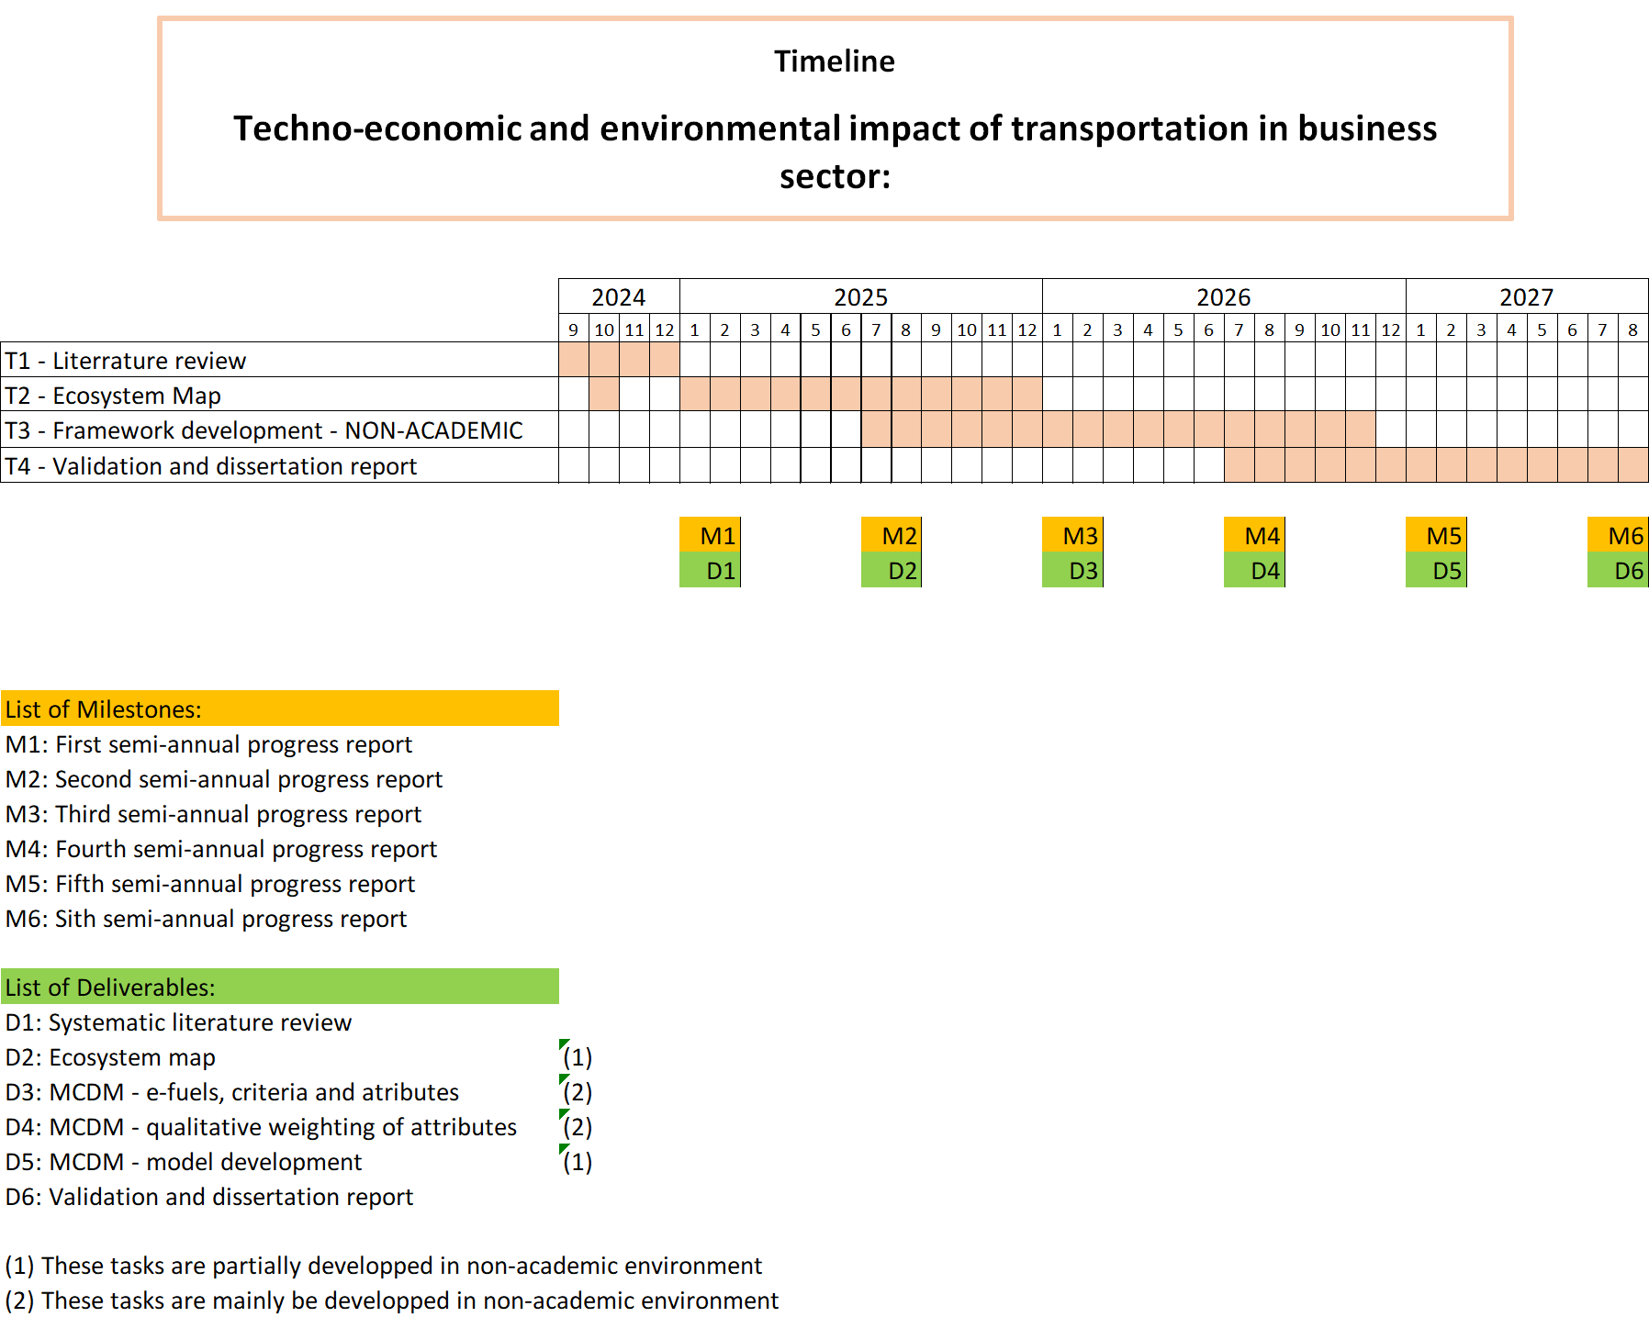
Figure 7 - Project tasks and deliverables timeline

The project deliverables, D1 through D6, align strictly with the four tasks from Chapter 3. Tasks 1 and 2 develop primarily inside the academic environment, laying the epistemic and mathematical foundation. Tasks 3 and 4 integrate heavily into the non-academic corporate environment instead, stress-testing the theoretical models against the partner institution's real operational constraints. Managed agent infrastructures, now commercially productised, provide a scalable execution layer for all of this, which frees the research to focus on epistemic validation rather than low-level software orchestration. So the quota-optimisation and multi-agent orchestration work isn't a side project. It's the third layer of the same reliability question: after output reliability (Semantic Drift, the epistemic compiler) and handoff reliability (the Sandbox constraint-validation loop) comes process reliability under resource constraints, whether validated decision pipelines survive within finite computational quota at the scale of routine fleet operations. Future work might also test whether the Operations Research tradition of per-instance method selection offers a useful lens for retrieval-governance research.
- D1: Systematic Literature Review (M1): Completion of the DSAiVE-assisted literature extraction.
- D2: Ecosystem Map (M2): turning extracted data into operational constraints, parameterised. Partially developed in a non-academic environment.
- D3: MCDM, e-fuels, criteria, and attributes (M3): defining the evaluation criteria for alternative fuels. Mainly developed in a non-academic environment.
- D4: MCDM, qualitative weighting of attributes (M4): applying the Neuro-Symbolic Handoff to establish operational rules. Mainly developed in a non-academic environment.
- D5: MCDM, model development (M5): running the Tri-State Routing and predictive maintenance models on the 500-vehicle fleet. Partially developed in a non-academic environment.
- D6: Validation and dissertation report (M6): the final synthesis, operational results and academic contributions brought together.

Funding and Acknowledgements
This research is supported by the Fundação para a Ciência e a Tecnologia (FCT), under grant agreement [Insert Grant Number Here]. The high-TRL operational testbed exists because of a non-academic partnership with upK, whose real-world fleet telemetry and logistical data proved fundamental to validating this decision-support framework.

References
[1] “Adélio Mendes – The 9th International Hydrogen Technologies Congress – IHTEC 2025.” Accessed: Mar. 18, 2025. [Online]. Available: https://ihtec2025.org/adelio-mendes/
[2] Y. Houndonougbo, “Molecular simulation of carbon capture in a series of isoreticular zeolitic imidazolate materials,” ACS Symposium Series, vol. 1132, pp. 83–98, 2013, doi: 10.1021/BK-2013-1132.CH003.
[3] “Energy decarbonization: a story inspired by nature.” Accessed: Mar. 18, 2025. [Online]. Available: https://pse.kaust.edu.sa/current-faculty-staff/2023/11/07/default-calendar/energy-decarbonization-a-story-inspired-by-nature
[4] “Regulation - 2019/631 - EN - EUR-Lex.” Accessed: Mar. 18, 2025. [Online]. Available: https://eur-lex.europa.eu/eli/reg/2019/631/oj/eng
[5] E. Maklári, “Economic comparison between conventionally powered and electric cars,” Acta Academiae Beregsasiensis. Economics, vol. No. 3, no. 3, pp. 75–85, Sep. 2023, doi: 10.58423/2786-6742/2023-3-75-85.
[6] “2035 EU combustion ban moves forward with e-fuels agreement.” Accessed: Mar. 18, 2025. [Online]. Available: https://electrek.co/2023/03/25/2035-combustion-ban-moves-forward-germany-eu-reach-agreement-e-fuels/
[7] “Carlos Tavares diz que a UE chegou a um ‘beco sem saída’ nos veículos elétricos porque se esqueceu da ‘dimensão social’ — CNN Portugal.” Accessed: Mar. 18, 2025. [Online]. Available: https://cnnportugal.iol.pt/setor-automovel/automovel/carlos-tavares-diz-que-ue-chegou-a-um-beco-sem-saida-nos-veiculos-eletricos-porque-se-esqueceu-da-dimensao-social/20250127/67980ea2d34e3f0bae99b924
[8] “Energy decarbonization: a story inspired by nature.” Accessed: Mar. 20, 2025. [Online]. Available: https://pse.kaust.edu.sa/current-faculty-staff/2023/11/07/default-calendar/energy-decarbonization-a-story-inspired-by-nature
[9] B. Candemir, J. Hellwig, E. Vignola-Gagné, J.-M. van Schalkwijk, and C. Sealy, “Pathways to Net Zero: The Impact of Clean Energy Research,” Public Reports, Jan. 2021, Accessed: Mar. 18, 2025. [Online]. Available: https://analyticalservices.researchcommons.org/reports/8
[10] M. J. Buehler, “MechGPT, a Language-Based Strategy for Mechanics and Materials Modelling That Connects Knowledge Across Scales, Disciplines, and Modalities,” Appl Mech Rev, vol. 76, no. 2, Mar. 2024, doi: 10.1115/1.4063843/1169582.
[11] “How large language models will shape search | THE Campus Learn, Share, Connect.” Accessed: Mar. 20, 2025. [Online]. Available: https://www.timeshighereducation.com/campus/breaking-academic-barriers-large-language-models-and-future-search
[12] “Erbil hosts climate change dialogue, focus on Iraqi journalism’s role - Shafaq News.” Accessed: Mar. 19, 2025. [Online]. Available: https://www.shafaq.com/en/Kurdistan/Erbil-hosts-climate-change-dialogue-focus-on-Iraqi-journalism-s-role
[13] “Weather prediction by numerical process : Richardson, Lewis Fry, 1881-1953 : Free Download, Borrow, and Streaming : Internet Archive.” Accessed: Mar. 18, 2025. [Online]. Available: https://archive.org/details/weatherpredictio00richrich/weatherpredictio00richrich/

[14] G. S. Callendar, “The Artificial Production of Carbon Dioxide and Its Influence on Temperature,” Quarterly Journal of the Royal Meteorological Society, vol. 64, no. 275, pp. 223–240, Apr. 1938, doi: 10.1002/qj.49706427503.
[15] “Fossil Fuels | EESI.” Accessed: Mar. 18, 2025. [Online]. Available: https://www.eesi.org/topics/fossil-fuels/description
[16] H. Nordlund, “Energy justice in the development of offshore wind farms on the Åland Islands,” 2023, Accessed: Mar. 18, 2025. [Online]. Available: https://nmbu.brage.unit.no/nmbu-xmlui/handle/11250/3078356
[17] “Frequently Asked Questions | UNEP - UN Environment Program.” Accessed: Mar. 18, 2025. [Online]. Available: https://www.unep.org/topics/sustainable-development-goals/why-do-sustainable-development-goals-matter/frequently-asked
[18] “The Limits to Growth+50 - Club of Rome.” Accessed: Mar. 18, 2025. [Online]. Available: https://www.clubofrome.org/ltg50/
[19] “How to Feed the World in 2050”.
[20] F. Umbach, “www.ssoar.info China and Russia: implications for European and transatlantic security Zur Verfügung gestellt in Kooperation mit / provided in cooperation with: SSG Sozialwissenschaften, USB Köln”, Accessed: Mar. 18, 2025. [Online]. Available: www.ssoar.info
[21] “2020 Climate and Energy Package (contains Directive 2009/29/EC, Directive 2009/28/EC, Directive 2009/31/EC, and Decision No. 406/2009/EC of the Parliament and the Council ; see below) - Climate Change Laws of the World.” Accessed: Mar. 19, 2025. [Online]. Available: https://climate-laws.org/document/2020-climate-and-energy-package-contains-directive-2009-29-ec-directive-2009-28-ec-directive-2009-31-ec-and-decision-no-406-2009-ec-of-the-parliament-and-the-council-see-below_c91b
[22] “Power Quality and EMC in Smart Grid.” Accessed: Mar. 20, 2025. [Online]. Available: https://interferencetechnology.com/power-quality-and-emc-in-smart-grid/
[23] F. Müller-Langer et al., “A Report from the Advanced Motor Fuels TCP and IEA Bioenergy TCP Key Strategies in Selected Countries The Role of Renewable Transport Fuels in Decarbonising Road Transport,” 2020.
[24] Z. Shi, Y. Qian, J. Zeng, X. Wei, and M. Yang, “Coordinated Development of Urban Transportation Structure Optimization and Energy Conservation, and Emission Reduction Under the Low-Carbon Background in Lanzhou, China,” Systems 2025, Vol. 13, Page 34, vol. 13, no. 1, p. 34, Jan. 2025, doi: 10.3390/SYSTEMS13010034.
[25] “Transport infrastructure: A tough road ahead – Gfiles India.” Accessed: Mar. 20, 2025. [Online]. Available: https://gfilesindia.com/transport-infrastructure-a-tough-road-ahead/
[26] C. G. Corlu, R. De La Torre, A. Serrano-Hernandez, A. A. Juan, and J. Faulin, “Optimizing Energy Consumption in Transportation: Literature Review, Insights, and Research Opportunities,” Energies 2020, Vol. 13, Page 1115, vol. 13, no. 5, p. 1115, Mar. 2020, doi: 10.3390/EN13051115.
[27] J. S. G. Collazos, L. M. C. Ardila, and C. J. F. Cardona, “Energy transition in sustainable transport: concepts, policies, and methodologies,” Environmental Science and Pollution Research 2024 31:49, vol. 31, no. 49, pp. 58669–58686, Sep. 2024, doi: 10.1007/S11356-024-34862-X.
[28] “Energy use basics - Energy Kids: U.S. Energy Information Administration (EIA).” Accessed: Mar. 17, 2025. [Online]. Available: https://www.eia.gov/kids/using-and-saving-energy/energy-use-basics.php
[29] R. C. Duncan, “World Energy Production, Population Growth, and the Road to the Olduvai Gorge,” Population and Environment: A Journal of Interdisciplinary Studies, vol. 22, no. 5, 2001.
[30] A. O. M. Maka and M. Mehmood, “Green hydrogen energy production: current status and potential,” Clean Energy, vol. 8, no. 2, pp. 1–7, Apr. 2024, doi: 10.1093/CE/ZKAE012.
[31] V. Kalchschmid, V. Erhart, K. Angerer, S. Roth, and A. Hohmann, “Decentral Production of Green Hydrogen for Energy Systems: An Economically and Environmentally Viable Solution for Surplus Self-Generated Energy in Manufacturing Companies?” Feb. 2023, Accessed: Mar. 20, 2025. [Online]. Available: https://www.h2knowledgecentre.com/content/journal4404
[32] “Potential of Solar Thermal in Europe”.
[33] I. Dincer, “Energy and Environmental Impacts: Present and Future Perspectives,” ENERGY SOURCES, vol. 20, pp. 427–453, 1998, doi: 10.1080/00908319808970070.
[34] A. Sofia e G. Madeira, “UNIVERSIDADE NOVA DE LISBOA INTEGRAÇÃO DE PAINÉIS SOLARES TÉRMICOS: SOLUÇÕES DE PÓS-CONSTRUÇÃO”.
[35] “Portugal: Sun & Innovation Drive Change,” Portugal: Sun & Innovation Drive Change. Accessed: Mar. 17, 2025. [Online]. Available: https://www.iea-shc.org/Data/Sites/1/publications/2018-12-Country-Highlight-Portugal.pdf
[36]Portal das Energias Renováveis ::.” Accessed Mar. 17, 2025. [Online]. Available: https://energiasrenovaveis.com/DetalheNoticias.asp?ID_conteudo=279&ID_area=53
[37] L. Silva and S. Sareen, “Solar Photovoltaic Energy Infrastructures, Land Use and Sociocultural Context in Portugal”, doi: 10.1080/13549839.2020.1837091.
[38] “IEA SHC || Advanced Publication Search.” Accessed: Mar. 18, 2025. [Online]. Available: https://www.iea-shc.org/publications-search
[39] “Portugal: Market Players facing Serious Problems | Solarthermalworld.” Accessed: Mar. 18, 2025. [Online]. Available: https://solarthermalworld.org/news/portugal-market-players-facing-serious-problems/
[40] “Portugal: Market Transformation in Time of Crisis | Solarthermalworld.” Accessed: Mar. 18, 2025. [Online]. Available: https://solarthermalworld.org/news/portugal-market-transformation-time-crisis/
[41] “Austria: Solar Thermal Market on the Verge of Collapse in one Province | Solarthermalworld.” Accessed: Mar. 17, 2025. [Online]. Available: https://solarthermalworld.org/news/austria-solar-thermal-market-verge-collapse-one-province/
[42] “Austria: Tough Competition in a Shrinking Market | Solarthermalworld.” Accessed: Mar. 17, 2025. [Online]. Available: https://solarthermalworld.org/news/austria-tough-competition-shrinking-market/
[43] P. Lourenço and C. Almeida, “Production under feed-in tariffs in Portugal,” p. 4, 2017, doi: 10.24084/repqj15.381.
[44] “Feed-In Tariff (FIT): Explanation, History, and Uses.” Accessed: Mar. 19, 2025. [Online]. Available: https://www.investopedia.com/terms/f/feed-in-tariff.asp
[45] “Photovoltaics Report - Fraunhofer ISE.” Accessed: Mar. 19, 2025. [Online]. Available: https://www.ise.fraunhofer.de/en/publications/studies/photovoltaics-report.html
[46] S. Piotrowski, “Critical Raw Materials in the Semiconductor Industry: Current Challenges and Perspectives”, Accessed: Mar. 19, 2025. [Online]. Available: https://www.researchgate.net/publication/371936514
[47] “The Paris Agreement | UNFCCC.” Accessed: Mar. 19, 2025. [Online]. Available: https://unfccc.int/process-and-meetings/the-paris-agreement
[48] “Ecology or Economy – Most preferred one, Bharat cares for both!” Accessed: Mar. 20, 2025. [Online]. Available: https://organiser.org/2023/12/21/212059/bharat/ecology-or-economy-most-preferred-one-bharat-cares-for-both/
[49] M. A. Rosen, “Exergy as a tool for sustainability,” 3rd IASME/WSEAS Int. Conf. on Energy & Environment, no. November, pp. 18–19, 2010, doi: 10.2136/sssaj1991.03615995005500060004x.
[50] M. A. Rosen, “Energy Sustainability: A Pragmatic Approach and Illustrations,” Sustainability 2009, Vol. 1, Pages 55-80, vol. 1, no. 1, pp. 55–80, Mar. 2009, doi: 10.3390/SU1010055.
[51] “The EU has cut greenhouse gas emissions everywhere but transport | World Economic Forum.” Accessed: Mar. 19, 2025. [Online]. Available: https://www.weforum.org/stories/2022/09/eu-greenhouse-gas-emissions-transport/
[52] “Northwest Energy Flows Analysis | NW Clean Energy Atlas.” Accessed: Mar. 17, 2025. [Online]. Available: https://www.nwceatlas.org/nw-state-energy-flows-additional-analysis-2018
[53] M. Heyns, M. Sinclair, and R. Combrinck, “Greening our road construction: views from the transportation industry in South Africa,” 2023, Accessed: Mar. 17, 2025. [Online]. Available: https://repository.up.ac.za/handle/2263/92506
[54] K. R. Grebstad, “The transition to sustainable aviation in Northern Norway.” Accessed: Mar. 20, 2025. [Online]. Available: https://munin.uit.no/bitstream/handle/10037/28221/thesis.pdf?sequence=2
[55] S. S. V. Subbarao and R. Kadali, “Impact of COVID-19 pandemic lockdown on the public transportation system and strategic plans to improve PT ridership: a review,” Innovative Infrastructure Solutions, vol. 7, no. 1, Feb. 2022, doi: 10.1007/S41062-021-00693-9.
[56] “The transition to sustainable aviation in Northern Norway,” 2022.
[57] “The Future of Electric Vehicles: Advancements in Batteries, Charging Stations, and Beyond - CEO Weekly.” Accessed: Mar. 19, 2025. [Online]. Available: https://ceoweekly.com/the-future-of-electric-vehicles-advancements/
[58] “The Rich Are Using Private Jets for Short Commutes, Demonstrating the Importance of Sufficiency.” Accessed: Mar. 20, 2025. [Online]. Available: https://www.treehugger.com/private-jet-short-trip-sufficiency-5705843
[59] “Global EV Outlook 2019 – Analysis - IEA.” Accessed: Mar. 19, 2025. [Online]. Available: https://www.iea.org/reports/global-ev-outlook-2019
[60] C. L. Spash, “A tale of three paradigms: Realising the revolutionary potential of ecological economics,” 2019, doi: 10.1016/j.ecolecon.2019.106518.
[61] K. Mayumi, “The Origins of Ecological Economics : The Bioeconomics of Georgescu-Roegen,” The Origins of Ecological Economics, Jul. 2001, doi: 10.4324/9780203468708.
[62] A. Dunlap, J. Verweijen, and C. Tornel, “The political ecologies of ‘green’ extractivism(s): An introduction,” J Polit Ecol, vol. 31, no. 1, pp. 436–463, Jul. 2024, doi: 10.2458/JPE.6131.
[63] “Sustainable urban mobility planning and monitoring - European Commission.” Accessed: Mar. 19, 2025. [Online]. Available: https://transport.ec.europa.eu/transport-themes/urban-transport/sustainable-urban-mobility-planning-and-monitoring_en
[64] P. Jiménez, D. María-Dolores, and S. Beltrán, “An Integrative and Sustainable Workplace Mobility Plan: The Case Study of Navantia-Cartagena (Spain),” Sustainability 2020, Vol. 12, Page 10301, vol. 12, no. 24, p. 10301, Dec. 2020, doi: 10.3390/SU122410301.
[65] S. Baltazar, L. Barreto, and A. Amaral, “Future Mobility in Alto Minho Region,” 2018 IEEE International Conference on Engineering, Technology and Innovation, ICE/ITMC 2018 - Proceedings, Aug. 2018, doi: 10.1109/ICE.2018.8436371.
[66] J. Black and H. Nakanishi, “Towards Net-Zero Emissions from Urban Transport: Ex Post Policy Evaluation in Canberra, the Australian Capital Territory,” Sustainability 2024, Vol. 16, Page 8656, vol. 16, no. 19, p. 8656, Oct. 2024, doi: 10.3390/SU16198656.
[67] “Droughts - ClimateChangePost.” Accessed: Mar. 17, 2025. [Online]. Available: https://www.climatechangepost.com/countries/poland/droughts/
[68] “Hydrogen: Frequent Questions and Answers - H2 IQ - what you need to know.” Accessed: Mar. 17, 2025. [Online]. Available: https://h2iq.org/hydrogen-facts/
[69] “Volkswagen starts operation of $22M North American Battery Engineering Lab in Chattanooga - Green Car Congress.” Accessed: Mar. 17, 2025. [Online]. Available: https://www.greencarcongress.com/2022/06/20220609-bel.html
[70] D. McCollum, V. Krey, P. Kolp, Y. Nagai, and K. Riahi, “Transport electrification: A key element for energy system transformation and climate stabilisation,” Clim Change, vol. 123, no. 3–4, pp. 651–664, Oct. 2014, doi: 10.1007/S10584-013-0969-Z/FIGURES/3.
[71] S. Asiaban et al., “Wind and Solar Intermittency and the Associated Integration Challenges: A Comprehensive Review Including the Status in the Belgian Power System,” Energies 2021, Vol. 14, Page 2630, vol. 14, no. 9, p. 2630, May 2021, doi: 10.3390/EN14092630.
[72] “The Hard Truth About Switching to Renewables - It’s Going to Take Decades.” Accessed: Mar. 19, 2025. [Online]. Available: https://constrofacilitator.com/the-hard-truth-about-switching-to-renewables-its-going-to-take-decades/
[73] G. E. Halkos and E. C. Gkampoura, “Reviewing Usage, Potentials, and Limitations of Renewable Energy Sources,” Energies 2020, Vol. 13, Page 2906, vol. 13, no. 11, p. 2906, Jun. 2020, doi: 10.3390/EN13112906.
[74] J. B. Jarin, S. Beddok, and C. Haritchabalet, “Techno-Economic Comparison of Low-Carbon Energy Carriers Based on Electricity for Air Mobility,” Energies 2024, Vol. 17, Page 1151, vol. 17, no. 5, p. 1151, Feb. 2024, doi: 10.3390/EN17051151.
[75] Q. Hassan, S. Algburi, A. Z. Sameen, M. Jaszczur, and H. M. Salman, “Hydrogen as an energy carrier: properties, storage methods, challenges, and future implications,” Environ Syst Decis, vol. 44, no. 2, pp. 327–350, Jun. 2024, doi: 10.1007/S10669-023-09932-Z/FIGURES/7.
[76] L. S. Langston, “Hot Pursuit,” Mechanical Engineering, vol. 144, no. 6, pp. 38–43, Nov. 2022, doi: 10.1115/1.2022-NOV3.
[77] M. Calabrese et al., “Hydrogen Safety Challenges: A Comprehensive Review on Production, Storage, Transport, Utilization, and CFD-Based Consequence and Risk Assessment,” Energies 2024, Vol. 17, Page 1350, vol. 17, no. 6, p. 1350, Mar. 2024, doi: 10.3390/EN17061350.
[78] M. R. , B. G. , S. A. , S. A. , C.-R. Y. , M. T. , & S. K. Allazadeh, “The UK Hydrogen Innovation Opportunity : Hydrogen Technology Roadmaps - CORE Reader.” Accessed: Mar. 17, 2025. [Online]. Available: https://core.ac.uk/reader/613714040
[79] “Guidelines for using Methanol in Fertilizer Manufacturing Process.” Accessed: Mar. 17, 2025. [Online]. Available: https://www.metacorp.in/blog/guidelines-for-using-methanol-in-indian-fertilizer-manufacturing-process
[80] H. Ameli, G. Strbac, D. Pudjianto, and M. T. Ameli, “A Review of the Role of Hydrogen in the Heat Decarbonization of Future Energy Systems: Insights and Perspectives,” Energies 2024, Vol. 17, Page 1688, vol. 17, no. 7, p. 1688, Apr. 2024, doi: 10.3390/EN17071688.
[81] K. Müller, F. Fabisch, and W. Arlt, “Energy transport and storage using methanol as a carrier,” Green, vol. 4, no. 1–6, pp. 19–25, Dec. 2014, doi: 10.1515/GREEN-2013-0028/MACHINEREADABLECITATION/RIS.
[82] “18.8: Gibbs Energy Changes in Chemical Reactions - Chemistry LibreTexts.” Accessed: Mar. 19, 2025. [Online]. Available: https://chem.libretexts.org/Bookshelves/General_Chemistry/Map%3A_A_Molecular_Approach_%28Tro%29/18%3A_Gibbs_Energy_and_Thermodynamics/18.08%3A_Gibbs_Energy_Changes_in_Chemical_Reactions
[83] “GCh18-2”.
[84] “Dimethyl Ether Market Analysis | Industry Forecast, Size & Report.” Accessed: Mar. 17, 2025. [Online]. Available: https://www.mordorintelligence.com/industry-reports/dimethyl-ether-market
[85] “Alternative Fuels Data Center: Dimethyl Ether.” Accessed: Mar. 20, 2025. [Online]. Available: https://afdc.energy.gov/fuels/emerging-dme
[86] “Vancity Group powers BC’s first hydrogen fuel network. - Vancity.” Accessed: Mar. 17, 2025. [Online]. Available: https://rethink.vancity.com/actions/first-hydrogen-fuel-network-in-bc
[87] M. Al-Breiki and Y. Bicer, “Comparative life cycle assessment of sustainable energy carriers including production, storage, overseas transport and utilization,” J Clean Prod, vol. 279, 2021, doi: 10.1016/j.jclepro.2020.123481.
[88] L. Meng and J. Asuka, “Impacts of Energy Transition on Life Cycle Carbon Emission and Water Consumption in Japan’s Electric Sector,” Sustainability (Switzerland), vol. 14, no. 9, p. 5413, May 2022, doi: 10.3390/SU14095413/S1.
[89] M. H. Hasan et al., “A comprehensive review on the recent development of ammonia as a renewable energy carrier,” 2021. doi: 10.3390/en14133732.
[90] S. Chatterjee, R. K. Parsapur, and K. W. Huang, “Limitations of Ammonia as a Hydrogen Energy Carrier for the Transportation Sector,” ACS Energy Lett, vol. 6, no. 12, pp. 4390–4394, Jan. 2021, doi: 10.1021/ACSENERGYLETT.1C02189.
[91] P. Zhang and Q. Jin, “Evolution, status, and trends of exergy research: a systematic analysis during 1997–2020,” Environmental Science and Pollution Research 2022 29:49, vol. 29, no. 49, pp. 73769–73794, Sep. 2022, doi: 10.1007/S11356-022-22915-Y.
[92] Z. Barahmand and M. S. Eikeland, “Techno-Economic and Life Cycle Cost Analysis through the Lens of Uncertainty: A Scoping Review,” Sustainability 2022, Vol. 14, Page 12191, vol. 14, no. 19, p. 12191, Sep. 2022, doi: 10.3390/SU141912191.
[93] M. Z. Hauschild, R. K. Rosenbaum, and S. I. Olsen, “Life Cycle Assessment: Theory and Practice,” Life Cycle Assessment: Theory and Practice, pp. 1–1216, Sep. 2017, doi: 10.1007/978-3-319-56475-3/COVER.
[94] M. C. Potter and E. P. Scott, “The First Law of Thermodynamics,” Thermal Sciences, pp. 74–143, 2025, doi: 10.1007/978-3-031-63669-1_4.
[95] M. C. Potter and E. P. Scott, “The Second Law of Thermodynamics,” Thermal Sciences, pp. 144–189, 2025, doi: 10.1007/978-3-031-63669-1_5.
[96] P. C. Augustine, A. Moniri-Morad, M. Shahsavar, and J. Sattarvand, “Investigating the Effect of Human Factors on the Underground Mine Evacuation Process Using Agent-Based Simulation,” Applied Sciences 2024, Vol. 14, Page 11773, vol. 14, no. 24, p. 11773, Dec. 2024, doi: 10.3390/APP142411773.
[97] J. Qingyang, Y. Jichun, Z. Yanying, and F. Huide, “Energy and exergy analyses of PV, solar thermal and photovoltaic/thermal systems: a comparison study,” International Journal of Low-Carbon Technologies, vol. 16, no. 2, pp. 604–611, May 2021, doi: 10.1093/IJLCT/CTAA092.
[98] E. Toklu, M. S. Güney, M. Işik, O. Comakli, and K. Kaygusuz, “Energy production, consumption, policies and recent developments in Turkey,” Renewable & Sustainable Energy Reviews, vol. 14, no. 4, pp. 1172–1186, May 2010, doi: 10.1016/J.RSER.2009.12.006.
[99] A. Ostrovsky, “Total factor productivity: Lessons from the past and directions for the future,” 2014, Accessed: Mar. 20, 2025. [Online]. Available: https://www.econstor.eu/handle/10419/144483
[100] J. Santos, A. S. Borges, and T. Domingos, “Exploring the links between total factor productivity and energy efficiency: Portugal, 1960–2014,” Energy Econ, vol. 101, p. 105407, Sep. 2021, doi: 10.1016/J.ENECO.2021.105407.
[101] E. E. Michaelides, “Primary energy use and environmental effects of electric vehicles,” World Electric Vehicle Journal, vol. 12, no. 3, 2021, doi: 10.3390/WEVJ12030138.
[102] C. : Broniewicz, E. ; Ogrodnik, R. Di Pace, and H. Kiryluk, “A Comparative Evaluation of Multi-Criteria Analysis Methods for Sustainable Transport,” Energies 2021, Vol. 14, Page 5100, vol. 14, no. 16, p. 5100, Aug. 2021, doi: 10.3390/EN14165100.
[103] B. Moutik, J. Summerscales, J. Graham-Jones, and R. Pemberton, “Life Cycle Assessment Research Trends and Implications: A Bibliometric Analysis,” Sustainability 2023, Vol. 15, Page 13408, vol. 15, no. 18, p. 13408, Sep. 2023, doi: 10.3390/SU151813408.
[104] “What is Cost-Benefit Analysis? | DealHub.” Accessed: Mar. 20, 2025. [Online]. Available: https://dealhub.io/glossary/cost-benefit-analysis/
[105] T. Roe, “Optimal Cost-Benefit Analysis of Urban Transportation Systems: Its Use in Policy Implementation,” Staff Papers, Jan. 1971, Accessed: Mar. 20, 2025. [Online]. Available: https://www.academia.edu/48761239/Optimal_Cost_Benefit_Analysis_of_Urban_Transportation_Systems_Its_Use_in_Policy_Implementation
[106] T. Vagdatli and K. Petroutsatou, “Modelling Approaches of Life Cycle Cost-Benefit Analysis of Road Infrastructure: A Critical Review and Future Directions,” 2022, doi: 10.3390/buildings13010094.
[107] K. Gharehbaghi, “The predicaments of environmental impact assessment (EIA) for transport infrastructure: an examination of policy stagnation and progress,” Transforming Government: People, Process and Policy, Sep. 2022, Accessed: Mar. 19, 2025. [Online]. Available: https://www.academia.edu/119718710/The_predicaments_of_environmental_impact_assessment_EIA_for_transport_infrastructure_an_examination_of_policy_stagnation_and_progress
[108] R. Mahmud, S. M. Moni, K. High, and M. Carbajales-Dale, “Integration of techno-economic analysis and life cycle assessment for sustainable process design – A review,” J Clean Prod, vol. 317, p. 128247, Oct. 2021, doi: 10.1016/J.JCLEPRO.2021.128247.
[109] P. Sarthi, S. Abdullah, A. Tuli, S. Khanna, A. Goldie, and C. D. Manning, “RAPTOR: Recursive Abstractive Processing for Tree-Organized Retrieval,” 12th International Conference on Learning Representations, ICLR 2024, Jan. 2024, Accessed: Mar. 19, 2025. [Online]. Available: https://arxiv.org/abs/2401.18059v1
[110] J. Hansson, S. Månsson, S. Brynolf, and M. Grahn, “Alternative marine fuels: Prospects based on multi-criteria decision analysis involving Swedish stakeholders,” Biomass Bioenergy, vol. 126, pp. 159–173, 2019, doi: 10.1016/j.biombioe.2019.05.008.
[111] D. McFadden, “Conditional logit analysis of qualitative choice behavior,” Jan. 01, 1972. Accessed: Mar. 20, 2025. [Online]. Available: https://www.academia.edu/53553324/Conditional_logit_analysis_of_qualitative_choice_behavior
[112] M. Sheller and J. Urry, “The New Mobilities Paradigm,” Environ Plan A, vol. 38, no. 2, pp. 207–226, Feb. 2006, doi: 10.1068/A37268.
[113] M. Barth and K. Boriboonsomsin, “Real-World Carbon Dioxide Impacts of Traffic Congestion,” Transp Res Rec, no. 2058, pp. 163–171, 2008, doi: 10.3141/2058-20.
[114] D. Banister, “The sustainable mobility paradigm,” Transp Policy (Oxf), vol. 15, no. 2, pp. 73–80, Mar. 2008, doi: 10.1016/J.TRANPOL.2007.10.005.
[115] V. Kaushik, L. A. Swagatika Priyadarshini, and R. Kataria, “Renewable Energy, Alternative Fuels, and Technological Innovations for Sustainable Development,” pp. 321–352, 2025, doi: 10.1007/978-981-96-0535-4_15.
[116] J. M. Ogden, “Alternative fuels and prosects - overview,” Handbook of Fuel Cells, Dec. 2010, doi: 10.1002/9780470974001.F301001.
[117] M. Ouzzani, H. Hammady, Z. Fedorowicz, and A. Elmagarmid, “Rayyan - a web and mobile app for systematic reviews,” Syst Rev, vol. 5, no. 1, p. 210, Dec. 2016, doi: 10.1186/s13643-016-0384-4.
[118] B. D. Ghorbani, “Bibliometrix: Science Mapping Analysis with R Biblioshiny Based on Web of Science in Applied Linguistics,” A Scientometrics Research Perspective in Applied Linguistics, pp. 197–234, 2024, doi: 10.1007/978-3-031-51726-6_8.
[119] Y. Chang, K. Lo, T. Goyal, and M. Iyyer, “BooookScore: A systematic exploration of book-length summarization in the era of LLMs,” 12th International Conference on Learning Representations, ICLR 2024, Oct. 2023, Accessed: Mar. 19, 2025. [Online]. Available: https://arxiv.org/abs/2310.00785v4
[120] T. Goyal, J. J. Li, and G. Durrett, “News Summarization and Evaluation in the Era of GPT-3,” Sep. 2022, Accessed: Mar. 19, 2025. [Online]. Available: https://arxiv.org/abs/2209.12356v2
[121] N. F. Liu et al., “Lost in the Middle: How Language Models Use Long Contexts,” Trans Assoc Comput Linguist, vol. 12, pp. 157–173, Jul. 2023, doi: 10.1162/tacl_a_00638.
[122] G. Sundaram and D. Berleant, “Automating Systematic Literature Reviews with Natural Language Processing and Text Mining: a Systematic Literature Review,” Lecture Notes in Networks and Systems, vol. 693 LNNS, pp. 73–92, Nov. 2022, doi: 10.1007/978-981-99-3243-6_7.
[123] Z. Xu, S. Jain, and M. Kankanhalli, “Hallucination is Inevitable: An Innate Limitation of Large Language Models,” Jan. 2024, Accessed: Mar. 19, 2025. [Online]. Available: https://arxiv.org/abs/2401.11817v2
[124] J. Sun et al., “Evaluating large language models on controlled generation tasks,” 2023. Accessed: Mar. 19, 2025. [Online]. Available: https://www.amazon.science/publications/evaluating-large-language-models-on-controlled-generation-tasks
[125] M. Aria and C. Cuccurullo, “bibliometrix: An R-tool for comprehensive science mapping analysis,” J Informetr, vol. 11, no. 4, pp. 959–975, Nov. 2017, doi: 10.1016/J.JOI.2017.08.007.
[126] A. Hannousse, “Searching relevant papers for software engineering secondary studies: Semantic Scholar coverage and identification role,” IET Software, vol. 15, no. 1, pp. 126–146, 2021, doi: 10.1049/sfw2.12011.
[127] M. Springstein, H. H. Nguyen, A. Hoppe, and R. Ewerth, “TIB-arXiv: An Alternative Search Portal for the arXiv Pre-print Server,” Digital Libraries for Open Knowledge, Tpdl 2018, vol. 11057, pp. 295–298, 2018, doi: 10.1007/978-3-030-00066-0_26.
[128] J. M. Nicholson et al., “scite: A smart citation index that displays the context of citations and classifies their intent using deep learning,” Quantitative Science Studies, vol. 2, no. 3, pp. 882–898, 2021, doi: 10.1162/qss_a_00146.
[129] V. Cole and M. Boutet, “ResearchRabbit (product review),” Journal of the Canadian Health Libraries Association / Journal de l’Association des bibliothèques de la santé du Canada, vol. 44, no. 2, pp. 43–47, Aug. 2023, doi: 10.29173/jchla29699.
[130] E. Aguilera Cora, C. Lopezosa, and L. Codina, “Scopus AI Beta: functional analysis and cases,” Jan. 09, 2024. Accessed: Mar. 19, 2025. [Online]. Available: http://hdl.handle.net/10230/58658
[131] “Navigators - PubTrawlr.” Accessed: Mar. 19, 2025. [Online]. Available: https://www.pubtrawlr.com/newsletter-as-a-service/
[Online]. Available: https://gemini.google.com/share/4110f30fae2a
[133] “Alternatives to Fossil Fuels.” Accessed: Mar. 18, 2025. [Online]. Available: https://chatgpt.com/share/67d4c757-bb10-800f-9c61-1cc75dd5b1d4
[134] “João Oliveira (@JooOliv86653062) / X.” Accessed: Mar. 19, 2025. [Online]. Available: https://x.com/JooOliv86653062
[135] P. Sarthi, S. Abdullah, A. Tuli, S. Khanna, A. Goldie, and C. D. Manning, “RAPTOR: Recursive Abstractive Processing for Tree-Organized Retrieval,” Jan. 2024.
[136] S. Sun, K. Krishna, A. Mattarella-Micke, and M. Iyyer, “Do Long-Range Language Models Actually Use Long-Range Context?,” EMNLP 2021 - 2021 Conference on Empirical Methods in Natural Language Processing, Proceedings, pp. 807–822, 2021, doi: 10.18653/V1/2021.EMNLP-MAIN.62.
[137] K. S. Jones, “A statistical interpretation of term specificity and its application in retrieval,” Journal of Documentation, vol. 28, no. 1, pp. 11–21, 1972, doi: 10.1108/EB026526/FULL/XML.
[138] X. Chen and S. Wiseman, “BM25 Query Augmentation Learned End-to-End”, Accessed: Mar. 19, 2025. [Online]. Available: https://github.com/
[139] “Retrieval-Augmented Generation for Knowledge-Intensive NLP Tasks | Patrick Lewis.” Accessed: Mar. 19, 2025. [Online]. Available: https://www.patricklewis.io/publication/rag/
[140] “GitHub - run-llama/llama_index: LlamaIndex is the leading framework for building LLM-powered agents over your data.” Accessed: Mar. 19, 2025. [Online]. Available: https://github.com/run-llama/llama_index
[141] O. James Oguntuase, “Climate Change, Credit Risk and Financial Stability,” Banking and Finance, Dec. 2020, doi: 10.5772/INTECHOPEN.93304.
[142] “(PDF) Life Cycle Carbon in Our Global Energy Future.” Accessed: Mar. 21, 2025. [Online]. Available: https://www.researchgate.net/publication/370168051_Life_Cycle_Carbon_in_Our_Global_Energy_Future/figures?lo=1
[143] “Evolution of annual solar PV installations and share by segmentation, 2000-2021 – Charts – Data & Statistics - IEA.” Accessed: Mar. 21, 2025. [Online]. Available: https://www.iea.org/data-and-statistics/charts/evolution-of-annual-solar-pv-installations-and-share-by-segmentation-2000-2021
[144] J. Kołodziej, C. Hopmann, G. Coppa, D. Grzonka, and A. Widłak, “Intelligent Transportation Systems – Models, Challenges, Security Aspects,” Lecture Notes in Computer Science (including subseries Lecture Notes in Artificial Intelligence and Lecture Notes in Bioinformatics), vol. 13300 LNCS, pp. 56–82, 2022, doi: 10.1007/978-3-031-04036-8_3.
[145] “Las tecnologías M2M plantan cara al cambio climático.” Accessed: Mar. 19, 2025. [Online]. Available: https://blogthinkbig.com/las-tecnologias-m2m-plantan-cara-al-cambio-climatico

