UNIVERSITY PERFORMANCE MEASUREMENT SOLUTION
Members: Amey Kharote, Lavina Pinto, Ninoshka Pinto
Date: 10/24/2021
AIM:
The objective of this assignment is to study ways to create a performance measurement solution to enable universities to measure the quality of the education they deliver to their students. The approach will be to investigate how an educational system in terms of faculty and courses contribute to the growth of their graduates over a 5-year period.

Deliverables:
- Creation of a Report outlining a proposed solution in creation of a University Performance Measurement solution, helping the stakeholders measure the quality of education and the future prospects with regards to the education.
- A class diagram showing the changes to the university model to support the new capabilities. The diagram includes additional methods and attributes to the core object necessary to incorporate the proposed changes to the existing system.
- Sequence diagrams showing how to navigate the university object model to deliver performance metrics needed for performance and feedback.
- Supplementary Dashboard Mock-ups helping create a visual representation of the proposed solution.

UML Diagrams

CLASS DIAGRAM- For Feedback Module and Performance Metrics Components
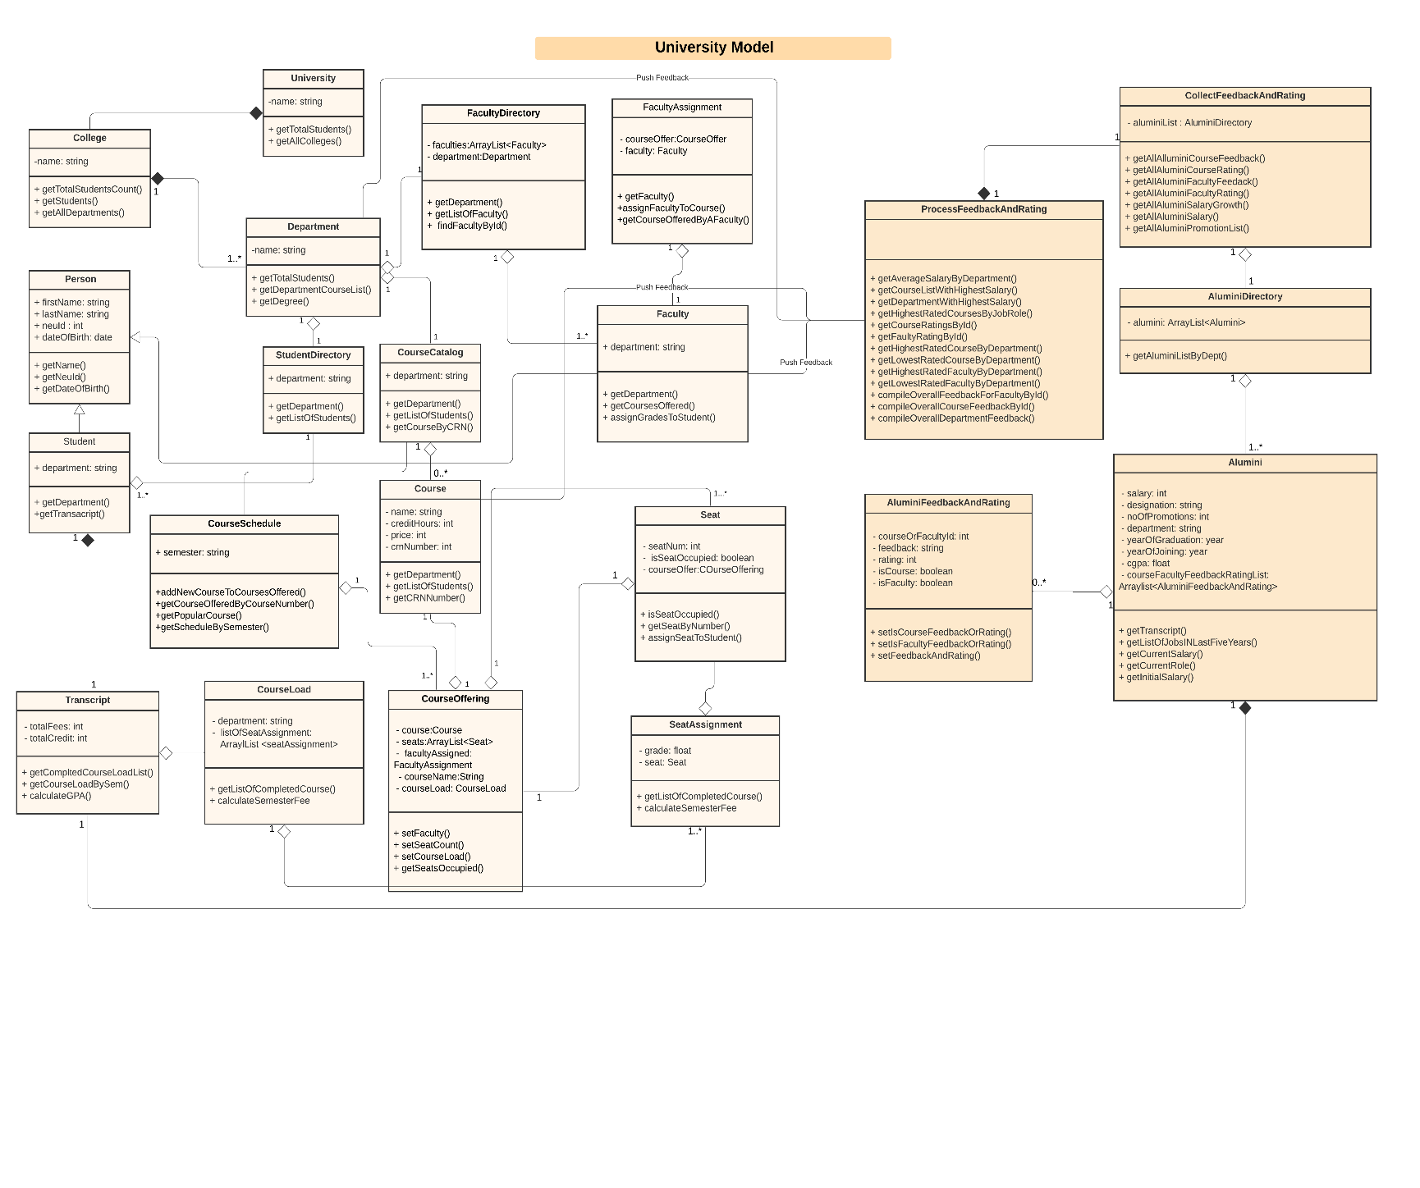

SEQUENCE DIAGRAM:
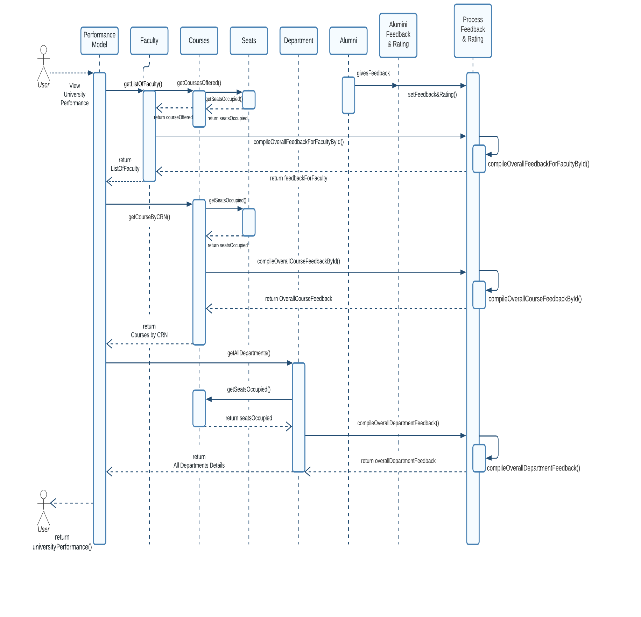
Feedback Module
- Input Components: Alumni will be provided with forms to provide feedback and rate their experiences with respect to courses and professors. The Alumni Feedback object will be collectively stored in collectFeedbackAndRating module as a data store.
- Generating Results :
  - getAllAlluminiCourseFeedback(): This method collects all course related feedback retrieved from all the alumni, acting one of the core methods during the feedback loop.
  - getAllAluminiCourseRating(): This method collects all course ratings retrieved from all the alumni, supplementary method for the above method.
  - getAllAluminiFacultyFeedack(): This method collects all faculty related feedback retrieved from all the alumni, acting one of the core methods during the feedback loop.
  - getAllAluminiFacultyRating(): This method collects all faculty ratings retrieved from all the alumni, supplementary method for the above method.
  - getAllAluminiSalaryGrowth(): This method collects all the compensation related information and the subsequent job growth from all alumni.
  - getAllAluminiSalary(): This method maintains a list of salary of all the alumni.
  - getAllAluminiPromotionList(): This method keeps a track of the career trajectory and progression of all the alumni.
These methods form the crux of the feedback module, acting as a important pillar in creation of the Performance Measurement Solution.
Performance Metrics:
- Input Components: Faculty Information, Course Information, Department information, Student information and the results generated from the feedback module.
Working:
- getAverageSalaryByDepartment(): This method uses the feedback module to capture all alumni salaries and later finds an average by the department.
- getCourseListWithHighestSalary(): This method uses the feedback module and the course ratings to correlate the common courses amongst the Alumni having the highest compensation package.
- getDepartmentWithHighestSalary(): This method uses the feedback module to capture all alumni salaries and later finds the department with the highest compensation package.
- getHighestRatedCoursesByJobRole(): This method uses the course ratings to fetch the highest rated course and filters the result by Job Role.
- getCourseRatingsById(): This method uses the unique identifier of CRN and retrieves the ratings of the subsequent Course fetched.
- getFacultyRatingById(): This method uses the unique identifier of NUID and retrieves the ratings of the subsequent Faculty.
- getHighestRatedCourseByDepartment(): This method helps in identification of the Highest Rated course by the Department Name, making use of the course ratings and the department that course belongs to.
- getLowestRatedCourseByDepartment(): This method helps in identification of the Lowest Rated Course by the Department Name, making use of the course ratings and the department that course belongs to.
- getHighestRatedFacultyByDepartment(): This method helps in identification of the Highest Rated Faculty by the Department Name, making use of the course, faculty ratings and the department that faculty belongs to.
- getLowestRatedFacultyByDepartment(): This method helps in identification of the Lowest Rated Faculty by the Department Name, making use of the course, faculty ratings and the department that faculty belongs to.
- compileOverallFeedbackForFacultyById(): This method uses all the feedback provided by various alumni for a faculty, processes it and recognizes the overall sentiments and returns the same for a particular faculty.
- compileOverallCourseFeedbackById(): This method uses all the feedback provided by various alumni for a course, processes it and recognizes the overall sentiments and returns the same for a particular course.
- compileOverallDepartmentFeedback(): This method uses all the feedback provided by various alumni for a department, processes it and recognizes the overall sentiments and returns the same for a particular department.
Every University portal will consist of 4 major stakeholders: student, faculty, alumni, and administrator. Each of these stakeholders will have a custom view that will display the key performing indicators (KPIs) of the University and help them make performance-oriented decisions.

DASHBOARD
