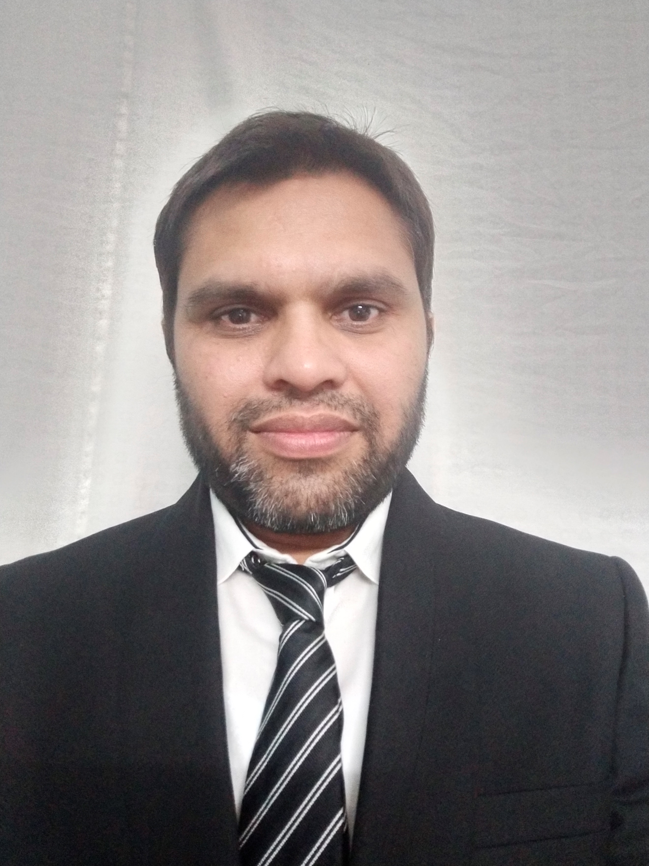

**PINTU KUMAR**

**Mobile** : +91 99450 59943

**Email** : [pintu.ping@gmail.com](mailto:pintu.ping@gmail.com) ; [pintu_agarwal@yahoo.com](mailto:pintu_agarwal@yahoo.com)

**LinkedIn**: <https://in.linkedin.com/in/pintu-kumar-agarwal-b73a31b>

|  |  |
| --- | --- |
| Overall Summary: | **More than 16+ years of experience in Embedded Linux product development** |
| Roles Played: | Individual contributor, Technical Leader, Troubleshooter, Mentor, Researcher |
| Major Work Background: | **Automotive/Telematics Linux Kernel development and support**, Tizen/Android smart phones/devices board bring up, feature enhancement/porting, investigation, prototyping, tools, **open source contributions**, **memory management** subsystem, robotics design. |
| Onsite visit and Visa: | South Korea, Taiwan, Japan, US (B1/B2 multiple entry visa: valid till 2023) |

|  |  |
| --- | --- |
| **Experience (2004 – 2020)** | |
| **Staff Engineer (Automotive Kernel/BSP), Qualcomm India, Bangalore** | **Dec/2019 – Till Date** |
| System Software Architect (Linux Kernel Team), **Sony** India, Bangalore | 2+ Years) Nov/2017 – Dec/2019 |
| Principal Engineer (Tizen Kernel/BSP), **Samsung** R&D India – Bangalore | (8+ years) Sept/2008 – July/2017 |
| Senior Engineer, **Sasken** Technologies Ltd – Bangalore | (4+ years) Feb/2004 – Sept/2008 |
| **Qualification (B.E. + MTech)** | |
| **M.Tech (Embedded System)**, Manipal University – Bangalore | (July/2012 – Feb/2015), **CGPA: 9.09** |
| B.E (Computer Sc. & Engg) – KIIT, Bhubaneswar, India | (1997 – 2001) SCORE: 73.6 % |
| IELTS Results (Oct/2019) | Overall Band: **6.5** [L:7,W:7,R:6.5,S:6] |

|  |
| --- |
| Skills Highlights |
| **C**, C++, **Linux kernel, device driver**, u-boot, smart phone bring-up, **Tizen**, Android, Ubuntu, **Telematics, Robotics** |
| Experience in **Linux** **Board bring-up** across various chipsets (SPRD, MEDIATEK, MSM, EXYNOS, OMAP) |
| Proven ability in **Linux Kernel development**, enhancement, issues investigation, feature porting and upgrades. |
| Majorly worked in **Linux Kernel Memory Management subsystem**: (prototype design and feature integration)  ION/DMABUF buffer sharing, Tizen DRM-GEM design, CMA, ZRAM, LMK, low-memory system design, etc. |
| Experience in Kernel code size reduction, boot time reduction, memory optimization, performance tuning, sluggish improvement, **Linux Robotics** and **Linux real-time** (preempt-rt, Xenomai) model design and demos. |
| **Linux** **kernel mainline contributions**, back-porting patches, reviews, bug reporting, proposals, discussions, participation and speaker in various **Embedded Linux Conference** (ELC) world-wide. |
| **New Technology Evaluation:** XENOMAI, RISC-V, PSI, OPEN-AMP, etc. |
| Good **kernel debugging skills** with ability to investigate and find the exact root cause of the issue. |
| **Others:** Agile/Scrum, git/gerrit, yocto, kselftests, perf, systemd, qemu, gdb, trace-32, ramdump, memps, rt-tools |
| **Major Interests:** Linux board bring-up, Kernel memory management, Kernel upstream contribution, Linux based IOT/Robotics/Drones/Automotive bring up, research topics or value additional with in kernel, etc. |

|  |
| --- |
| **Achievements & Awards** |
| **OPEN SOURCE CONTRIBUTIONS:**  **a) Linux Kernel Mainline:** [purely my own ideas]  <https://lore.kernel.org/lkml/?q=pintu>  <https://git.kernel.org/cgit/linux/kernel/git/next/linux-next.git/log/?qt=grep&q=pintu> ;  **b) Xenomai – Real time Linux Kernel:**  <https://gitlab.denx.de/Xenomai/xenomai/-/commit/c984901a833848ac29e6df1862cb9871b26b400b>  **c) Tizen open source:** <https://git.tizen.org/cgit/contrib/robotics/>  **d) Git Hub Contributions:** <https://github.com/pintuk> |
| Demonstrated ideas and technical papers in Qualcomm **Hackathon-2020** and **QBuzz-2020** events. |
| Received **Performance Excellence Award** in SONY-2019 for the outstanding contributions done previous year. |
| Technical showcase and **demo presentation in SONY Open House** – 2019 |
| Technical paper presentation in **Embedded Linux Conference** World-wide:  Tokyo [July/2019]: Xenomai based **real-time automotive model** – Link: [XENOMAI-RT-MODEL.pdf](https://events.linuxfoundation.org/wp-content/uploads/2018/07/OSS-JAPAN-2019-XENOMAI-BASED-REAL-TIME-MODEL-1.pdf)  San Diego [April/2016]: Tizen-based-Remote-Control-Robot – PDF - [ELC2016-TIZEN-RC-CAR.pdf](http://events.linuxfoundation.org/sites/events/files/slides/ELC2016-TIZEN-RC-CAR.pdf)  San Jose [March/2015]: [System-wide-Memory-Defragmenter.pdf](http://events.linuxfoundation.org/sites/events/files/slides/%5BELC-2015%5D-System-wide-Memory-Defragmenter.pdf) [***Samsung Best Paper Award****, 2015*]  Japan [June/2012]: [Linux Memory Fragmentation : Observation and Analysis on Smart Phones](https://linuxconjapan2012.sched.com/event/3e120298f39528e3b77a26a946003d0f) [[PDF here](http://events.linuxfoundation.org/images/stories/pdf/lcjp2012_kumar.pdf)] |
| Submitted many potential patents, ideas, proposal, and demos during my tenure in Samsung. |
| Complete architecture, design and coding of Tizen based **robotic model bring up** (both hardware and software):  Check Video demo here: <https://www.youtube.com/watch?v=n885XMAh7kI&feature=youtu.be> |
| Samsung **Employee of the month** award – Nov/2014 (for first time Tizen bring-up on Mediatek) |
| Presented Technical papers and demos in **Samsung Technical Challenge** (NIPUN) – 2010/2011/2012 |
| Presented a Technical Paper in **Sasken Technology Conference** – 2007 |
| Received **Spot Awards** during Sasken tenure – 2004/2006/2007 |

|  |  |
| --- | --- |
| Major Projects Highlights | |
|  | |
| Telematics/C-V2X Products (Linux Kernel/BSP Work) | **Dec/2019 – Till Date (QUALCOMM)** |
| * Working on Automotive-**Telematics Linux Kernel/BSP areas:** issues analysis, investigation, OEM specific customization, new feature development and proposals. * Resolved long pending Winbond DDR boot-up issue with QC SA2150P chipset. * Memory foot-print optimization/reduction for kexec/crash kernel feature on ARM64 and Linux Kernel 5.4. Reduced crash-kernel reserved memory size from 512MB to 96MB and successfully boot to login shell. * Linux Kernel open source contributions in progress. * Handling Kernel/BSP team (3) for supporting Qualcomm Telematics customer issues world-wide.   **Value Addition:**   * Presented an internal talk on Qualcomm C-V2X technology. * Demonstrated ideas (Linux Kernel-Memory optimization) in Qualcomm **Hackathon-2020**. * Presented technical E-Poster/paper in Qualcomm **QBuzz-2020**. * Linux Kernel open source contributions. | |
| **Used – C, Linux Kernel: 3.18/4.9/4.14, MDM chipset (9x50, SA415/SA515M, SA2150P), C-V2X, others** | |
|  | |
| SONY Contributions (Linux Kernel Team) | **Nov/2017 – Dec/2019 (SONY)** |
| * Several contributions in **Base Linux Kernel Development for Sony’s** future products. * Resolved many issues in **Sony Kernel feature** such as: page fault issue, cpu lock up issue, semaphore locking issue, smap issues, sync issue, rebooting issue, irqsoff latency issues, kernel oops, backtraces, etc. * Investigation about DRM/HDMI display bring-up after **snapshot boot resume** on i.MX6 with Kernel-3.10+. * Porting and improvement of **unique-page, zswap feature** from Kernel 3.0 to 4.9 to reduce snapshot-image size. * **Complete design and implementation of** **GPIO IRQ affinity feature** (including snapshot boot suspend/resume support) for i.MX7 board with Linux Kernel 4.1. Using this, now GPIO devices can use the dedicated CPU. * Detailed investigation of **Kernel vDSO** support for ARM-32 boards (i.mx7, pi2).   **Value Addition:**   * **Mentorship:** for M.Tech college intern to explore new technologies in Kernel areas. * **OpenAMP:** Investigation about OpenAMP and rpmsg/remoteproc interface in Kernel. * **PSI:** Investigation and experimentation about PSI feature in mainline Linux Kernel 4.20 🡪 4.9. * **REAL-TIME:** Xenomai 3.0 bring up, evaluation, prototype, demos with Kernel 4.9 on various x86/arm boards.   + First time Xenomai Kernel 4.9 bring up on Qualcomm chipset sdm845, Resolved many boot up issues.   + Complete architecture, design and implementation of **Xenomai based real time robotic model** using Raspberry Pi-3 and Linux Kernel 4.9. Demonstrated the working ideas in various forums. * **RISC-V:** RISC-V Linux Kernel 4.18 bring up and evaluation on QEMU environment. | |
| **Used – C, Linux Kernel, i.MX{6/7}, Raspberry Pi, Beagle Bone, Hikey620, QualComm Snapdragon-845** | |
|  | |
| TIZEN Smart Phone Development [SPRD chipset] | **April/2014 – June/2017 (Samsung)** |
| *[Complete ownership for India/Asia model release]*  **Samsung Z4 & Z2 Model (SC9830, 1GB, 4GLTE), Z3 (SC7730, 1GB, 3G), Z1 (SC7727, 768MB, 2G):**   * **Technical Leader** for Tizen Kernel/BSP team including **individual contributions below**: * **First time Tizen smart phone bring up** on Spreadtrum (SPRD) chipset with Linux Kernel 3.10. * Initial Zinitix touch screen driver bring up and customization for Tizen Z4 model. * Improving SPRD-DRM-GEM (drivers/gpu/drm/sprd) and **ION buffer sharing** mechanism. * Enhancing and tuning **memory management areas** [ION, CMA, ZRAM, OOM, LMK, vmpressure, etc.]. * Finding issues in vendor kernel, back porting patches from mainline to improve system stability. * Proposed and implemented **several new features in kernel**: reduced daemon swapping, dynamic low memory killer, automatic system-wide memory shrinker and compaction, slow path monitoring, oom kill count monitoring, cma tracking, sgt-list allocation fallback, exact mem-available feature, gem buffer tracking, etc. * Developed **sluggish-test utility** to quickly reproduce sluggish behavior and find root cause. * Others: mainline patches porting, gerrit code review, vendors follow-up, ramdump analysis, log analysis, issues investigation, boot time analysis, sluggish analysis, memory leak analysis, memory failure analysis, etc. * **Proposal to enhance Tizen ecosystem** for OEMs and thereby promoting chipset vendors to adapt Tizen. | |
| **Platforms/Software Used - C, Linux Kernel 3.10.xx, Tizen 2.3/2.4/3.0, Spreadtrum (SPRD) chipset** | |
|  | |
| TIZEN - MTK Bring up (MT6571 chipset, RAM: 512MB)[1 month onsite in Taiwan MTK HQ] | **Nov. 2014 – March 2015 (Samsung)** |
| * **First time Tizen smart phone bring up on Mediatek chipset** (MT6571) with 512 MB RAM, Kernel 3.4. * Kernel customization, console shell bring up, Kernel patches porting, Tizen sdb shell bring up. * **First time, complete architecture and design of MTK-DRM-GEM** (drivers/gpu/drm/mtk) for Tizen Graphics/Display bring up on Mediatek smart phones. * **Kernel memory optimization (~12 MB),** kernel boot time reduction, issues analysis and investigation. * Received “**Employee of the Month Award**” and appreciation from MTK folks. Finished bring up in 3 weeks. | |
| **Platforms/Software Used - C, Linux Kernel 3.4, Mediatek chipset, Tizen 2.3** | |
|  | |
| ULC Feature Phone Bring up (SC6821 chipset, RAM: 128MB) | **Aug 2013 – Jan 2014 (Samsung)** |
| * **First time Tizen bring up on Spreadtrum (sprd) chipset** with 128MB RAM, and NAND flash (UBIFS). * **First time, complete architecture and design of SPRD-DRM-GEM** (drivers/gpu/drm/sprd) interface for Tizen display/graphics bring up on smart phones and make it light weight and portable. * Kernel **code size reduction below 5MB**, reserved memory reduction below 40MB, boot time below 40s. * ZRAM driver integration, **CMA/ION backporting** (3.8 to 3.0) to save ~8MB reserved, performance tuning, etc. * Implemented SWAP field in Tizen memps utility to show used swap space by each process. | |
| **Platforms/Software Used - C, Linux Kernel 3.0, SPRD (sc6821)** | |
|  | |
| TIZEN Smart Phone Bring up on QUALCOMM (QC) chipsets 3 months onsite leader for base camp @ San Diego & Hyderabad] | **Sept 2012 – July 2013 (Samsung)** |
| * Co-worked with QC team for **first time Tizen menu-screen bring up** on QC chipset – 7x25, 8x10. * Reserved memory analysis and optimization. **CMA, COMPACTION, ION, ZRAM** porting and stabilization. * System stability issues analysis, OOM analysis, memory/fd leak analysis, **DRM-GEM/ION buffer sharing**. | |
| **Platforms/Software Used - C, Linux Kernel 3.4, MSM8974, MSM7x25, MSM8x10, MSM8x26** | |
|  | |
| TIZEN – ION/DMABUF Investigation and Integration | **Mar 2012 – Aug 2012 (Samsung)** |
| * **First time study and demonstration of ION and DMABUF** buffer sharing mechanism in Kernel. * Developed sample drivers to verify **zero-copy in Kernel/User space** using DMABUF and ION mechanism. * Co-work with HQ counterpart and Tizen Graphics/Multimedia team in integrating the whole solution for Tizen smart phones. | |
| **Platforms/Software Used - C, Linux, Kernel 3.0, Exynos 4420, MSM 8974** | |
|  | |
| SLP - Linux Memory Fragmentation (Analysis & Research) | **April 2011 – Dec 2011 (Samsung)** |
| * Detailed study, **experimentation and research about Memory Fragmentation problem** in Linux Kernel. * Developed sample modules and utility to measure fragmentation level across each zones and orders. * Conducted several experiments and implemented techniques in Kernel to **improve page allocation success rate by about ~90%.** Check ELC Paper [[here](http://events.linuxfoundation.org/images/stories/pdf/lcjp2012_kumar.pdf)] * Suggestion to backport memory compaction from mainline Kernel 2.6.36 to track memory fragmentation. | |
| **Platforms/Software Used - C, Linux, Kernel 2.6.32/36** | |
|  | |
| Samsung Boot loader Development (Loke3/s-boot) | **Aug 2010 – Mar 2011 (Samsung)** |
| * Complete development and **bring-up of Samsung Loke3 boot loader** (aka s-boot) for OMAP4 board. * S-boot customization, UART bring-up, i2c interface, USB and charging support, LCD bring up, partition management, ODIN protocol porting, binary flashing and downloading mechanism, kernel booting etc. | |
| **Platforms/Software Used - C, Linux, u-boot, X-loader, OMAP4430, omapflash, Odin** | |
|  | |
| CDR – SD Card Data Recovery Solution for Mobile Phones | **May 2010 – July 2010 (Samsung)** |
| * Complete architecture, design, porting and implementation of Samsung patented **data recovery solution for Linux** based mobile phone. * Implemented multi-threaded sector scanning capability to **speed up formatted card recovery by 1/4th times.** * **Implemented new features** such as: date/filename based recovery, listing deleted files, automatic detection of mount point, recovery progress status, automatic detection of memory leaks etc. | |
| **Platforms/Software Used - C, C++, Linux, FAT32 file system** | |
|  | |
| **SASKEN - PROJECTS** | **Feb 2004 – Sept 2008 (Sasken)** |
| **TUX4.0 - Linux Based VoIP Phone Development (Nortel Networks)**  VCOM driver porting, reduced licensing cost by **porting open source gcomm library to core upload module**, implemented ideas for **automatic core upload to MSC card during boot up**, resolved many critical issues such as initial clipping of voice.  **SHARP – GPS Driver Porting (Texas Instruments)**  Complete porting and integration of TI GPS Linux driver for sharp mobile including SUPL interface. | |
| **Platforms/Software Used - C, C++, Linux Kernel 2.4, 2.6, Shell scripting, PPC, OMAP3430** | |
|  | |