# Create the SQS queue
aws sqs create-queue \
--queue-name crypto-staging \
--attributes '{"MessageRetentionPeriod":"300"}' \
--region ap-south-1
--------------------------------------------------------------------------------------------
# Get queue ARN for next steps

QUEUE_URL=$(aws sqs get-queue-url --queue-name crypto-staging --region ap-south-1 --query QueueUrl --output text)
QUEUE_ARN=$(aws sqs get-queue-attributes --queue-url $QUEUE_URL \
--attribute-names QueueArn \
--query Attributes.QueueArn --output text --region ap-south-1)
---------------------------------------------------------------------------------------
# Allow EventBridge to send messages to this queue
aws sqs set-queue-attributes --queue-url $QUEUE_URL \
--attributes "{\"Policy\":\"{\\\"Version\\\":\\\"2012-10-17\\\",\\\"Statement\\\":[{\\\"Effect\\\":\\\"Allow\\\",\\\"Principal\\\":{\\\"Service\\\":\\\"events.amazonaws.com\\\"},\\\"Action\\\":\\\"sqs:SendMessage\\\",\\\"Resource\\\":\\\"$QUEUE_ARN\\\"}]}\"}" \
--region ap-south-1

----------------------------------------------------------------------------------------

# Then create 4 EventBridge rules to feed Spot interruption and health events into the queue:

# Spot Interruption Warning
aws events put-rule --name "KarpenterInterruptionRule-SpotInterruption" \
--event-pattern '{"source":["aws.ec2"],"detail-type":["EC2 Spot Instance Interruption Warning"]}' \
--region ap-south-1
---------------------------------------------------------------------------------
# Instance Rebalance Recommendation
aws events put-rule --name "KarpenterInterruptionRule-Rebalance" \
--event-pattern '{"source":["aws.ec2"],"detail-type":["EC2 Instance Rebalance Recommendation"]}' \
--region ap-south-1
------------------------------------------------------------------------------------
# Instance State Change
aws events put-rule --name "KarpenterInterruptionRule-StateChange" \
--event-pattern '{"source":["aws.ec2"],"detail-type":["EC2 Instance State-change Notification"]}' \
--region ap-south-1
-------------------------------------------------------------------------------------
# AWS Health Scheduled Change
aws events put-rule --name "KarpenterInterruptionRule-ScheduledChange" \
--event-pattern '{"source":["aws.health"],"detail-type":["AWS Health Event"]}' \
--region ap-south-1
-----------------------------------------------------------------------------------
# Add SQS as target for each rule (repeat for all 4 rules)
aws events put-targets --rule "KarpenterInterruptionRule-SpotInterruption" \
--targets "Id=1,Arn=$QUEUE_ARN" --region ap-south-1
# ... repeat for other 3 rules
--------------------------------------------------------------------------------
Issue 2 — Karpenter IAM Role (IRSA) Missing
No IAM role with karpenter in the name exists in your account. Without this, Karpenter has zero AWS permissions — it can't call EC2, SQS, SSM, or pricing APIs.
--------------------------------------------------------------------------------
Step 1 — Create the IAM role with OIDC trust:

cat > karpenter-trust-policy.json << EOF
{
"Version": "2012-10-17",
"Statement": [{
"Effect": "Allow",
"Principal": {
"Federated": "arn:aws:iam::794038238336:oidc-provider/oidc.eks.ap-south-1.amazonaws.com/id/8F6E24AD422CF070D9545112BDF13F9F"
},
"Action": "sts:AssumeRoleWithWebIdentity",
"Condition": {
"StringEquals": {
"oidc.eks.ap-south-1.amazonaws.com/id/8F6E24AD422CF070D9545112BDF13F9F:sub": "system:serviceaccount:kube-system:karpenter",
"oidc.eks.ap-south-1.amazonaws.com/id/8F6E24AD422CF070D9545112BDF13F9F:aud": "sts.amazonaws.com"
}
}
}]
}
EOF

aws iam create-role \
--role-name KarpenterControllerRole-crypto-staging \
--assume-role-policy-document file://karpenter-trust-policy.json
-----------------------------------------------------------------------------------

Step 2 — Attach the controller policy (grants EC2, SQS, SSM, pricing, IAM instance profile permissions — full policy available on request).
Add-Policy : AmazonEC2FullAccess
Add-Policy : AmazonSQSFullAccess
Add-Policy : AmazonSSMFullAccess

---------------------------------------------------------------------------------------------
cat > karpenter-supplemental-policy.json << 'EOF'
{
"Version": "2012-10-17",
"Statement": [
{
"Sid": "AllowEKSDescribeCluster",
"Effect": "Allow",
"Action": "eks:DescribeCluster",
"Resource": "arn:aws:eks:ap-south-1:794038238336:cluster/crypto-staging"
},
{
"Sid": "AllowPassNodeRole",
"Effect": "Allow",
"Action": "iam:PassRole",
"Resource": "arn:aws:iam::794038238336:role/KarpenterNodeRole-crypto-staging", # Assign Role of Ec2 Node
"Condition": {
"StringEquals": {
"iam:PassedToService": "ec2.amazonaws.com"
}
}
},
{
"Sid": "AllowInstanceProfileManagement",
"Effect": "Allow",
"Action": [
"iam:CreateInstanceProfile",
"iam:TagInstanceProfile",
"iam:AddRoleToInstanceProfile",
"iam:RemoveRoleFromInstanceProfile",
"iam:DeleteInstanceProfile",
"iam:GetInstanceProfile"
],
"Resource": "arn:aws:iam::794038238336:instance-profile/*"
},
{
"Sid": "AllowPricingGetProducts",
"Effect": "Allow",
"Action": "pricing:GetProducts",
"Resource": "*"
}
]
}
EOF
-------------------------------------------------------------------------------------------------
# Overwrite the existing inline policy with the updated version
aws iam put-role-policy \
--role-name KarpenterControllerRole-crypto-staging \
--policy-name KarpenterSupplementalPolicy \
--policy-document file://karpenter-supplemental-policy.json
-----------------------------------------------------------------------------------------------------
Step 3 — Annotate the ServiceAccount:

kubectl annotate serviceaccount karpenter -n kube-system \
eks.amazonaws.com/role-arn=arn:aws:iam::794038238336:role/KarpenterControllerRole-crypto-staging \
--overwrite
----------------------------------------------------------------------------
# Step 1: Install Karpenter via Helm
helm upgrade --install karpenter oci://public.ecr.aws/karpenter/karpenter \
--version "1.3.3" \
--namespace kube-system \
--set "settings.clusterName=crypto-staging" \
--set "settings.interruptionQueue=crypto-staging" \
--set controller.resources.requests.cpu=500m \
--set controller.resources.reques KarpenterNodeRole-crypto-staging ts.memory=500Mi
-----------------------------------------------------------------------------------------
# Step 2: Create a NodePool (replaces your ASG node groups)
#Create IAM ROLE FOR EC2 NODE
Role-Name : KarpenterNodeRole-crypto-staging
Add-Policy : AmazonEC2ContainerRegistryReadOnly
Add-Policy : AmazonEKS_CNI_Policy
Add-Policy : AmazonEKSWorkerNodePolicy
Add-Policy : AmazonSSMManagedInstanceCore
# ec2nodeclass.yaml
apiVersion: karpenter.k8s.aws/v1
kind: EC2NodeClass
metadata:
name: default
spec:
amiSelectorTerms:
- alias: al2023@latest # Always use latest EKS-optimized AL2023 AMI
role: KarpenterNodeRole-crypto-staging
subnetSelectorTerms:
- tags:
kubernetes.io/cluster/crypto-staging: owned
securityGroupSelectorTerms:
- tags:
kubernetes.io/cluster/crypto-staging: owned
tags:
Environment: staging
Cluster: crypto-staging
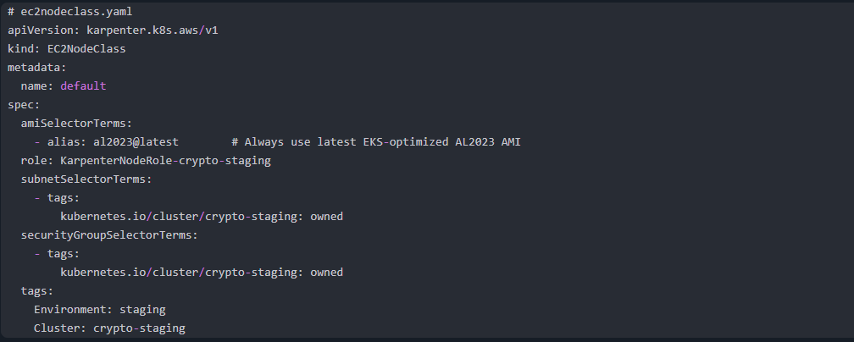
# nodepool.yaml
apiVersion: karpenter.sh/v1
kind: NodePool
metadata:
name: default
spec:
template:
spec:
nodeClassRef:
group: karpenter.k8s.aws
kind: EC2NodeClass
name: default
requirements:
- key: kubernetes.io/arch
operator: In
values: ["amd64"]
- key: kubernetes.io/os
operator: In
values: ["linux"]
- key: karpenter.sh/capacity-type
operator: In
values: ["on-demand"] # Start with on-demand for staging stability
- key: node.kubernetes.io/instance-type
operator: In
values: # Allow multiple sizes so Karpenter can right-size
- c5a.large
- c5a.xlarge
- c5a.2xlarge
- c5.large
- c5.xlarge
- c5.2xlarge
- m5.large
- m5.xlarge
limits:
cpu: 20 # Max total CPU across all Karpenter nodes
memory: 40Gi # Max total memory across all Karpenter nodes
disruption:
consolidationPolicy: WhenEmptyOrUnderutilized
consolidateAfter: 30s
----------------------------------------------------------------------------------------
# Step 3: Scale down cluster-autoscaler to 0 replicas
kubectl scale deployment cluster-autoscaler -n kube-system --replicas=0
-------------------------------------------------------------------------------------------
# Step 4: Gradually migrate workloads to Karpenter-managed nodes

