**A**

***Practical file***

**On**

***“Operational Research On Computer Science****”*

**Submitted By:**

Name: ***Pintu Ram***

Course: **B.Sc.(Hons.) Computer Science**

Semester: **5th**

Class Roll No: **2k17/cs/72**

Exam Roll No: **17013570029**

**Quesion1: Solve LPP using graphical method:**

Minimize: z=11x+3y

Constraints:

C1: 4x+y>=12

C2: 2x+2y<=18

C3: 4x-5y<=0

x,y>=0

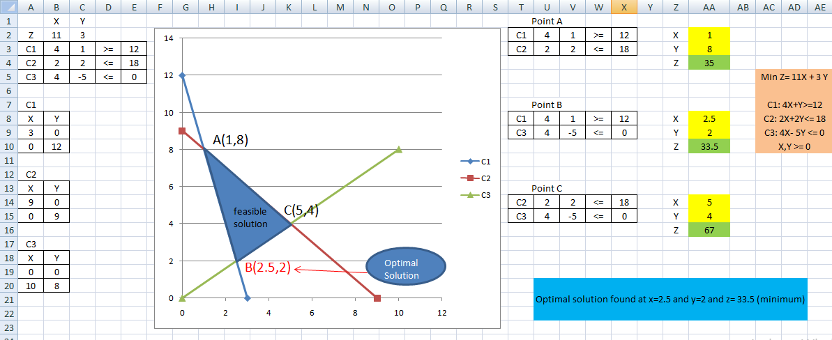

**Quesion2: Solve LLP using transportation problem:**

**Goal:** minimize cost (measured as total student miles traveled)

**Control:** student assignments from home district to school district

Fifteen variables (5 home districts, 3 school districts)

Each variable is count of students moved from one district to another

**Limits:** school capacity 900 students

Number of students in each home district

**Solution:**

In Excel:

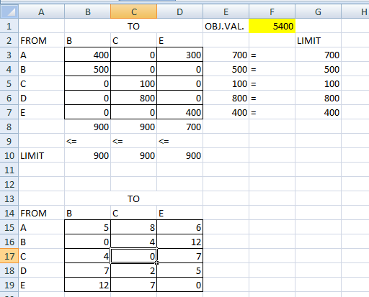

**Question 3: Solve LLP using Assignment problem (Hungarian Method):**

|  |  |  |  |
| --- | --- | --- | --- |
| 70 | 75 | 65 | 80 |
| 85 | 90 | 45 | 70 |
| 85 | 65 | 55 | 80 |
| 0 | 0 | 0 | 0 |

**Solution:**

In Excel:

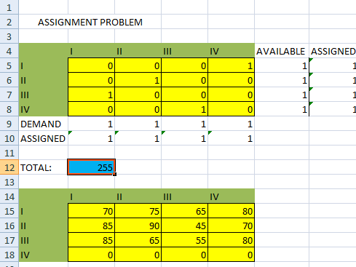

**Question4: Solve LPP using simplex method:**

Maximize z=3x+2y

Such that

Constraints

C1: x<=4

C2: y<=6

C3: x + y <= 5

x, y>=0

**Solution:**

In Excel:

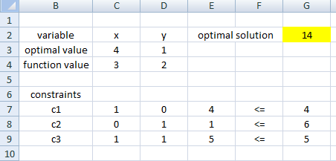

**Question5: Solve LPP using Big M method:**

P(x) = 4x1 + 5x2 -> max;

x1 - 2x2 <= 15;

4x1 + 3x2 <= 24;

-2x1 + 5x2 >= 20;

x1 >= 0; x2 >= 0;

**Solution: (in Excel)**

The problem given is equivalent to:

max *P* = 4*x*1 + 5*x*2 − *Mx*6

subject to

*x*1−2*x*2 + *x*3=15

4*x*1 + 3*x*2 + *x*4=24

−2*x*1 + 5*x*2 −*x*5 + *x*6=20

