Javac
RuleParser.jj
JavaCC
RuleParser.cc
RulExec.java
MemoryServer.idl
WMServant.java
RuleParser*.java
ParseException.java
SimpleCharStream.java
Token*.java
RuleParser*.class
ParseException.class
SimpleCharStream.class
Token*.class
IDLJ
. /MemoryServer/
WMGetSetObject*.java
_WMGetSetObject*.java
WorkingMemory*.class
WMServant*.class

. /MemoryServer/
WMGetSetObject*.class
_WMGetSetObject*.class
WorkingMemory.java
RulExec*.class
Javac
Javac
Rule parser written in javacc language
KBES source files template
Memory server GUI source file
CORBA interfaces of memory server
Memory server core source file
MORE IDE source file
MORE IDE module
Working memory server module

Parser module
RulExec.class
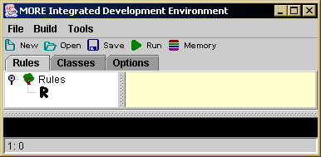
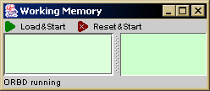
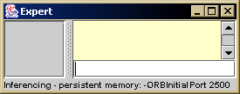
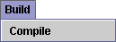
Javac
???.rul
???.idl
Expert.java
Rete*.java
IDLJ
. /ReteObjects/
*.java
Javac
Java
RuleParser

. /ReteObjects/
*.class
Java
Expert.class
Rete*.class
Java
WorkingMemory.class

objects

