Machine Learning Engineer Nanodegree
Capstone Proposal

Using artificial neural networks to localize and classify heartbeats in ECG.

Piotr Bazan
July 29th, 2017

Domain Background

Electrocardiography or ECG is the process of recording the electrical activity of the heart over period of time. Measurement is done using electrodes placed on various parts of the skin and is often represent as a graph.
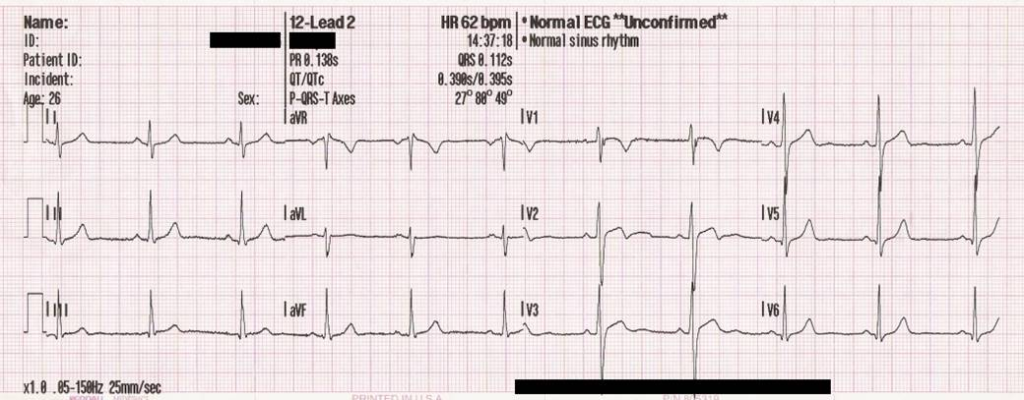
ECG graphs consists of series of patterns and is fundamental for understanding the electrical conduction system of the heart. Normal conduction starts and propagates in a predictable pattern, deviation from this pattern can be a normal variation or be pathological.
ECG dates back to 1901 when Willem Einthoven invented first practical electrocardiograph and assigned letters to the waveform. He also described the electrocardiographic features of cardiovascular disorder and won Nobel Prize in Medicine in 1924 for his discovery. For many years ECG required careful manual annotation of patterns in the graph. During computer era first programs were created to automatically annotate diagrams. These programs marked patterns but with some degree of precision and the results required manual correction. With the development of artificial neural networks new approaches were proposed and better results obtained.
First category of solutions use domain knowledge to process signal and then learn neural network e.g. the research [] uses specialized filters to clean ECG signal. Also authors use an algorithm to detect QRS patterns and create segments of data.
Another approach is to decompose ECG signal into time-frequency representations and based on that calculate statistical features which are fed into neural network e.g. []
An interesting approach is to avoid transformation into time-frequency domain and heavy signal post-processing []. Authors conclude that techniques such as frequency analysis, wavelet transform, filter banks, statistical and heuristic approaches, hidden Markov models, support vector machines, artificial neural networks (ANNs), and mixture-of-experts methods do not perform well due to the inter-patient variations of the ECG signals. They usually do not generalize well and have an inconsistent performance when classifying a new patient’s ECG signal and have high variations in their accuracy and efficiency for larger datasets. This leads researchers to use common data as well as patient specific data to learn 1D convolution neural network.
All those approaches have some drawbacks:
- they require advanced prior knowledge about the subject domain
- involve heavy signal processing and signal transformation
- do not generalize well for new/unseen data

Problem Statement
This is a classification problem, the goal of which is to localize and classify 2 types of beats: normal and atrial premature in ECG diagram. Also the project should avoid previous research drawbacks:
- do not use any domain specific knowledge to extract features, nor clean signal using advanced filters
- do not use time-domain transformation and heavy signal post processing
- learn neural network on one group of data and validate on other group of data
As a result potential solution should have the following advantages:
- fast inference since there would be no advanced signal processing
- learning features from data and not imposing domain knowledge
- better generalization for new data
The motivation for doing this project is to help people diagnose their heart. As there are more and more cheap ECG devices anyone can buy such a gadget. Most of them produce ECG diagram but apart from that they do not provide any useful information. Creating a model which could analyze and detect some abnormal beats could be beneficial.

Datasets and Inputs
I plan to use MIT-BIH Arrhythmia Database [] which contains 48 half-hour excerpts of two-channel ambulatory ECG recordings, obtained from 47 subjects studied by the BIH Arrhythmia Laboratory. This dataset is published under license [] and consist of two types of files:
- signal data in PhysioBank specific binary format - .dat files
- annotation data - .atr files
This dataset requires downloading and compiling PhysioNet software called WFDB Applications. The signal files have the following data:
sample | MLII | V5
0 | 995 | 1011
1 | 995 | 1011
2 | 995 | 1011

First columns is a sample identifier, other columns are ECG signal values. I plan to use MLII as this signal is the most common in the dataset. Data is sampled at 360Hz frequency.

Annotation files have the following data:
Time | Sample | Type | Sub | Chan | Num | Aux
0:00.050 | 18 | + | 0 | 0 | 0 | (N
0:00.214 | 77 | N | 0 | 0 | 0
0:01.028 | 370 | N | 0 | 0 | 0

The point of interest is Sample column which allows matching signal with annotation. Type column contains one of the annotation type described []. In my research two types are investigated: ‘N’ - normal beat, ‘A’ - atrial premature beat.

Solution Statement
Supervised learning techniques are used to solve the problem of classification and localization. At the beginning the signal and annotation files are used to generated features and labels. There are two datasets generated: one for training and one for validation. Train data is fed to different classifiers: neural network or convolutional. Validation data is used to asses quality of the models. During this process only subsample of data is used to speed up research. After top model is selected the full training and validation occurs. As an outcome there is a classifier which can be used to localize and classify beats by using moving window of ECG data. At the end proposed solution is compared to benchmark model.

Benchmark Model
Research [1], [2], [3] classify heartbeats and provide accuracy as a metric. They however either use advanced signal processing, time-frequency transformation, domain prior knowledge or patient specific data. On the contrary this project aims removing this disadvantages. On top of that it also tries to localize heartbeats by moving sliding window and running classifier.

The authors of [1], [2] report accuracy: 88.76%, 96,94%, the authors of [3] report accuracy, precision and recall for subset of beats. It is hard to compare this results to my project especially provided I have no knowledge regarding cardiology. Instead I plan to use DummyClassifier [] as a simple baseline.

Evaluation Metrics
The project will use accuracy, precision, recall and f1 score as a metric. For each normal/arrhythmia beat there are 2 non beats generated as described earlier. This ratio prevents skewing normal beat class.

Project Design

Each signal file is normalized to [0,1] range.
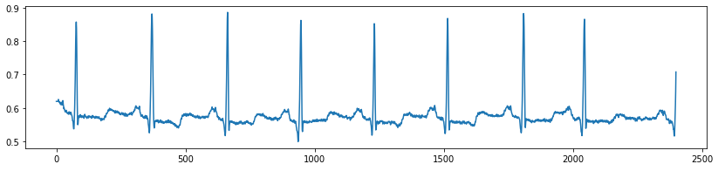
Normalized ECG signal
Then data is split for heartbeats: normal and arrhythmia. Specifically for each heartbeat in annotation file we get Sample identifier. Given this id we look into signal file and subsample range of 784 values centered at id. Given signal frequency of 360Hz and 784 values we have a frame spanning over 2 seconds which consists of a given beat and at least 2 adjacent beats. During this process we generate labels for a beat type.
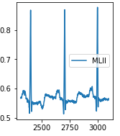
Beat frame. In the center POI beat, on the left and right adjacent beats
Apart from that we shift the window forward or backward by random value between 6-135 points which corresponds to 16-375ms to generate non beat frames. Also we generate labels of type non beat.

This procedure is done for two datasets: train and validation which are taken from different patients. Concretely the datasets do not intersect.

Even though ECG diagrams have similar patterns they seem to vary from patient to patient. Also taking into account that model should not only recognize N (normal) and A (atrial premature) beats but also non beats i.e. shifted frames of N, A beats learning neural network could be tricky.
I came up with the following idea:
- train neural network and/or convolutional autoencoder using unsupervised data to compress signal. TODO This should extract important features and diminish noise
Encoder
Decoder
- split autoencoder into encoder and decoder. The former would be frozen, fully connected layers attached and model would be trained in supervised way. Decoder would be discarded
Frozen encoder
Fully connected

Other idea would be to use sequential model: at the top convolution layers and then attached fully connected ones. TODO Model would be trained in supervised way end to end.
Conv layers
Fully connected

Those two approaches would be checked on smaller dataset. Based on the result on solution would be chosen and trained on full dataset.
Research [3] used 1D convolutions. I would like to use 2D convolutions but instead of mapping ECG frame as 2D image (first dimension signal, second time) I would like to take 784 values i.e. 1D signal and reshape it to 28x28 i.e. 2D signal. This would allow improving performance of learning and inference. Convolutional networks have nice property of scale and translation invariance. Also filters can learn complex patterns in deeper layers. Looking at the reshaped ECG signal CNN could take advantage of it.
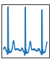
ECG beat frame
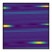
Reshaped ECG 28x28
I plan to use the following libraries:
- numpy
- pandas
- scikit-learn
- tenforflow/keras
- matplotlib

- http://citeseerx.ist.psu.edu/viewdoc/download?doi=10.1.1.495.4675&rep=rep1&type=pdf
- http://www.sciencedirect.com/science/article/pii/S0031320304002766
https://www.researchgate.net/profile/Serkan_Kiranyaz/publication/285493884_Convolutional_Neural_Networks_for_Patient-Specific_ECG_Classification/links/565e999f08aeafc2aac90822/Convolutional-Neural-Networks-for-Patient-Specific-ECG-Classification.pdf
https://physionet.org/physiobank/database/mitdb/
ODC Public Domain Dedication and License v1.0
https://www.physionet.org/physiobank/annotations.shtml
http://scikit-learn.org/stable/modules/model_evaluation.html#dummy-estimators

