**The investment strategy based on behavior of artificial earthworm for use in algotrading**

**Wiliński A., Bera A., Jarlaczyński M., Błaszyński P.**

This paper presents an innovative concept of investment strategy derived from the general ideas of artificial intelligence. The strategy has been tested in a number of simulations on historical data and on data outside learning periods. Tests were performed mainly in the selected currency markets, including the primary currency pair EURUSD. Presented approach opens long and short positions alternately during the closing of actual candles. Closing of position is based on recommendation which is deduced from changes in features of time series. The strategy has parameters that vary through time, and are adapted to the market changes. To present the strategy metaphor of an artificial earthworm, that feeds on a time series, was used. The goal was to implement presented strategy for trading platform to achieve the automatic trading effect. Implemented strategy allows to achieve interesting results.

Key words: investment strategy, machine learning, forecasting, time series, algotrading

**Introduction**

Algotrading is rapidly growing new form of trading on financial markets where investor (that makes decisions) is replaced with automaton (computer program) []. Such machine can perform operations (opening and closing positions, placing orders to open such positions that meet certain conditions) directly in an automated brokerage platform environment. It may also be a recommendation system that helps investor with making correct decisions.

Such computer applications (bots) require carefully prepared and tested software that most often needs to adapt to the changing situations on the observed markets. Modern trends, in the development of this software, include sophisticated methods of: artificial intelligence, pattern recognition, classification and machine learning. Those methods are interpenetrating and complementary and are also expanded with information based on fundamental analysis, for example, automatically extracted from the Internet[Schwager, Elder, … nasze hindawi].

Strategy presented in this paper is an example of a solution that can be used fully automated or with investor’s assistance, who makes the decision manually. To use this software, it is necessary to make sure that there are reasonable premises of achieving the success. These conditions can be achieved through inductive thinking, involving the assumption that multiple validation of decision on data from the past substantiates the correctness of the decision in the future.If a certain set of rules in the strategy used to seek the pattern, leads to the success then these rules are a pattern that is encouraged for repeated use. If repeated use of said pattern results in more successes than failures, then the basic premise to consider the use of the pattern is rational []. Unfortunately, changing market is causing the pattern to become outdated therefore it is necessary to constantly update it. Search in the historical patterns, that could be effective in the data space not used for their determination ( to identify these patterns ), is a major challenge also applied in machine learning which is used in this paper.

The article is organized as follows: at first authors describe an authored strategy based on an entirely innovative, according to the authors, concept of an artificial worm. Subsequently extensive studies of effectiveness of presented strategy in terms of prediction and the aspect of investment are carried out. At the end the conclusions resulting from the study are presented and also cited bibliographic sources are included.

**Strategy characteristics**

In presented strategy, a metaphorical procedure is often used to explain heuristic algorithms of artificial intelligence. Said procedure is a reference to an inspiration derived from the nature.

Let's consider an artificial worm, which behaves like its natural inspirer. Let this artificial worm have a length of p1 candles (vectors representing the knowledge about events occurring within the contractual part of the time series). Let her movement come down to the successive "eating" one candle and simultaneous "discarding" of one candle -  always having p1 candles. Thus the earthworm moves incrementally at length of time called the period of the candle. I-th candle is  defined as a row of data of values ​​ Oi, Hi, Li, Ci (Open, High, Low and Close). These values represent (in order): the value at the beginning of this period, the maximum value within the period, the minimum and the closing values - at the end of the candle.

Let's assume that candle can have color (often in a number of brokerage platforms, this procedure is used). Therefore candles may be red (when the opening of the candle is higher than its closing Oi> Ci) and green (when the situation is opposite Oi <Ci).

Let's also assume - it is a primary strategy rule - that when an artificial earthworm has a significant advantage of red candles, a short position is opened or continued. When earthworm has the significant advantage of green candles, a long position is opened or continued. Imprecise term "significant" is defined by the use of the second parameter p2 according to the rules:

If  Lr > p1/2 –p2 then short ; opening of short position will be suggested;   (1)

If  Lg > p1/2 –p2 then long ; opening of long position will be suggested;   (2)

If  Lg < p1/2 –p2 then  and if If  Lr< p1/2 –p2 then none   (3);  - the continuation of state will be suggested (position or no opened position);

In the rules above Lr and Lg are the number of candles, respectively "red" and "green" in the worm of p1 length, wherein p1 = Lr + Lg.

When dominance determined by another parameter p2 is undecided, as in (3), then worm takes the color white and the position will not be opened. When the worm continues to open position, investor does not incur costs. On many platforms, also in literature, symbolic marking of growing candles in white and decreasing in black is used . In this article, due to the occurrence of three values, green-red-white colors are used.

Earthworm is therefore supplied with artificial intelligence, which allows the accumulation of knowledge and decision-making:

- right after closing of the current candle, worm "swallows" the candle and "knows" what color is it;

- earthworm knows how many candles it is composed with;

- after absorbing and discarding one candle, worms knows how many candles inside it are red or green and how to determine its status - red, green or white;

- knowing its status, earthworm knows how to make a decision about opening or continuing position; the opening of a position (long or short) means the simultaneous closing of the current position (opposite) if such position is opened;

- earthworm observes cumulative profit curve and if it notices unacceptable drawdown, then opened position is changed to the opposite;

- unacceptable drawdown is defined by two other parameters p3 and p4. p3 is the number of previous candles, which sets a reference point in time series, in which the value of the accumulated profit for i-p3 is checked for comparison with the current value of the accumulated profit. p4 is permissible decrease of cumulative profit. If it is exceeded, the SL (Stop Loss - closes the currently open position) mechanism is activated;

- worm also observes current course changes during  each next candle and reacts to unprofitable changes. If the current exchange rate causes a loss on the opened positions greater than p5 then the SL mechanism is triggered - the position is closed and to the end of the candle worm remains in the state without an open position. p5 is therefore the fifth strategy parameter.

These features of the worm's intelligence may be extended, however, for this work they were limited to the foregoing.

It is assumed that the time series is Si where i = 1, 2, ..., and each word is a vector Si = (Oi, Hi, Li, Ci) called candle consisting of  four values: Open, High, Low and Close of time between the time t and t +1. I is the final index of word which is the last word in time series that was taken under consideration.

Figure 1 presents, as described above, earthworm in three successive states. After "swallowing" the next candle worm loses the last one. Candles inside the body of the worm have different colors (presented in the form of solid lines (green) and dashed (red)).

Artificial worm executes the following algorithm.

The strategy is built on the principle of classical machine learning. Before starting to run the algorithm, on data located outside the environment that investor knows (like on the current market segments - out-of-sample), it is necessary to "teach"  the values of parameters. Since we are dealing with time series,  the natural solution is that the period of learning preceding testing period. This principle is presented in Figure 2, which shows examples of learning periods and following them testing periods. Data from testing period was not used during learning. This figure shows also that in learning periods, the same data can be used several times by successively moving time frame by the number of steps corresponding to the length of the test window (of course only when  the length of the test period is shorter than the learning).

In both periods the same algorithm based on the intelligent behavior of worm is used. Of course, the typical problem of machine learning is the proper selection of the length of learning and testing period [], what will be a subject of further research.

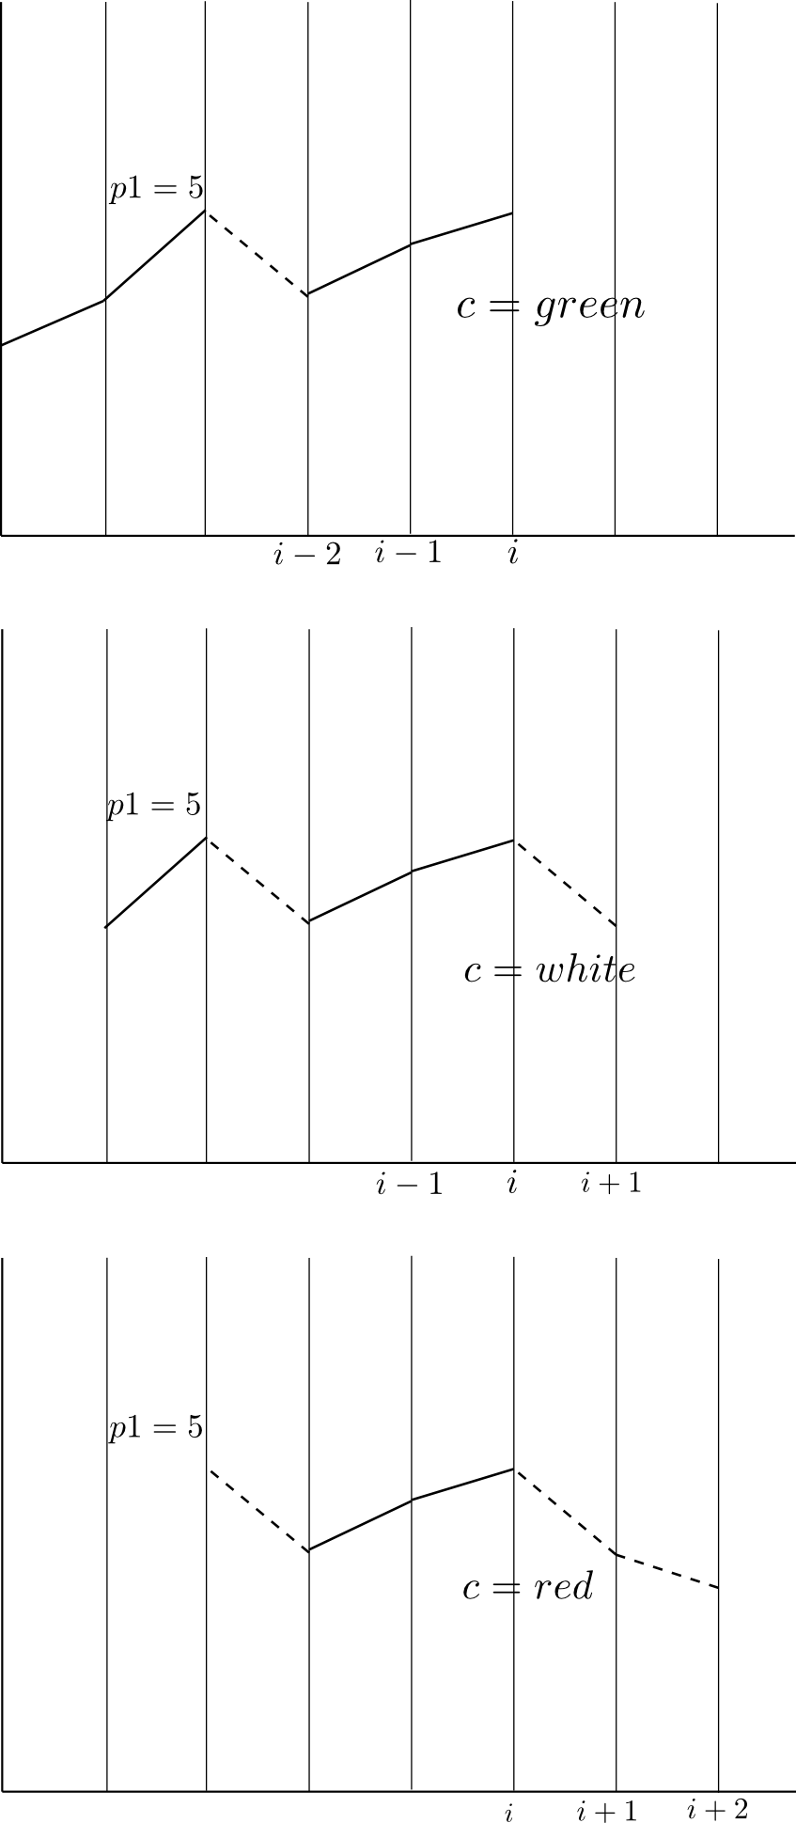

Fig. 1. An example of changes in fixed-length p1 (number of candles) worm, which is traversing the time series.

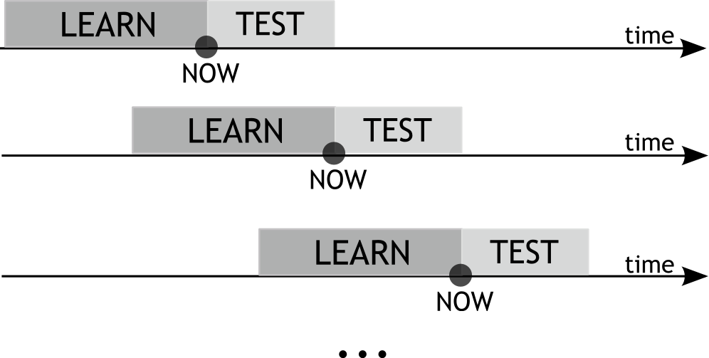

Fig. 2. An example of the arrangement of learning and testing periods of strategy parameters in time series

This repeatable algorithm, located in both periods - learning and testing, has the following structure. In learning period the optimal value for five parameters p1, p2, ..., p5 was determined. In test period these designated values of parameters were used to perform the algorithm in the new environment. In each i-th step (candle) of time series following activities were performed:

*For each i = p1, p1 +1, p1 +2, ..., I and for j = 1, ..., p1 check whether the candle located at a distance i-j backwards from the current candle is:

green when Oi-j <Ci-j,

red when Oi-j> Ci-j

where p1 - is the first parameter which is the length of the artificial worm - the number of candles of different colors that make up the "body" of the worm;

Oi-j - is the opening value of (i-j)-th candle

Ci-j - is the closing value of (i-j)-th candle;

I - is the length of the test window, after which it is necessary to change the parameters values to the new, learned in the machine learning phase;

*In each i-th step, the loop j = 1, ..., p 1 is performed in which a number of green Lg, red Lr candles is calculated so the sum of  Lg and Lr is p1 (to avoid the situation when Oi = Ci, it is assigned arbitrarily to one of the candles sets, for example green);

*A condition for the existence of a Rg recommendation to open a long position (or to continue it if it is open) is checked. This condition is arbitrarily adopted (one can of course consider different one):

                                                             if lg> p1/2 - p2 then Rg=1 (4)

If this condition is fulfilled, then depending on the current position status PositionState (where PositionState is a variable which takes values {long, short, 0}) at the opening of the next candle, a position is opened or continued as follows:

if Rg=1 and PositionState =long then PositionState =long;   (5)

(costless continuation of opened position)

if Rg=1 and PositionState =short then PositionState=long;  (6)

if Rg=1 and PositionState =0 then PositionState =long;   (7)

Similarly check the condition of recommendations Rr to open or continue short position:

If lr>p1/2 – p2 then Rr=1  (8)

if this condition is fulfilled, then depending on what the current position status PositionState is, at the opening of the next candle, position is opened or continued as follows:

if Rr=1 and *PositionState* =long then *PositionState* =short;    (9)

if Rr==1 and *PositionState* ==short then *PositionState*=short;   (10)

  (costless continuing of opened position)

if Rr==1 and  *PositionState* ==0 then  *PositionState* =short;   (11)

In formulas above there is a parameter p2. It is the second parameter of the strategy which is an arbitrarily separated part of the worm, which depending on size causes the direction of investment not to change. Large p2 causes long positions to change into short positions (or vice-versa) rarely. Small value of p2 leads to a higher frequency of these changes. The optimum value of p2 is chosen similarly like p1.

*When opening long position, profit after one candle (this does not mean that position was closed after a single candle) can be calculated as:

Zi = Ci +1 - Ci - spread; (12)

where the spread = 0, when opened long position is continued;

and spread = cost, when long position was opened after closing or opening a short position in case when there was no open position.

cost is a variable that depends on the particular brokerage platform that was used for testing the strategy; in this case, for the currency pair EURUSD cost = 0.00016 was assumed and for the currency pair GBPUSD cost = 0.00028.

*When short position is opened, profit after one candle (it does not mean that position is closed) can be calculated as:

Zi = Ci-Ci +1- spread; (13)

where the spread = 0, when opened short position is continued;

and spread = cost, when short position was opened after closing or opening a long position in case when there was no open position.

Below, the definitions of profit within a single candle in case of opening (or the continuation of long and short position) are explained.

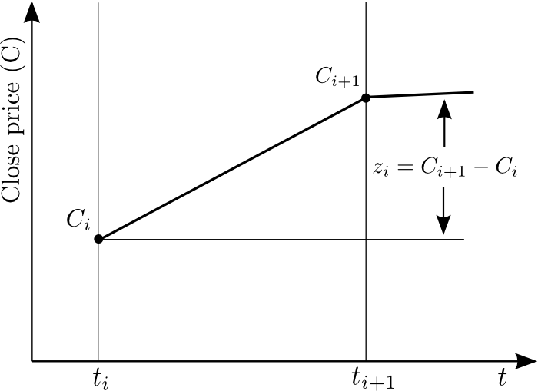

Fig. 3. Method of calculating profit in the (i +1)-th candle, in which long position was opened

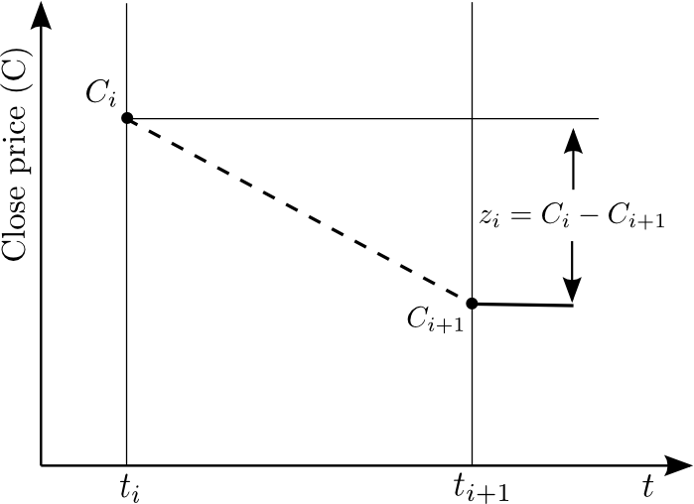

Fig. 4. Method of calculating profit in the (i +1)-th candle, in which short position was opened

Both figures show symbolically the changes of course, combining simple value at the opening and closing of the candle, ignoring the oscillations inside the candle.

*If as the result of the test the number of red and green candles in the body of the worm had not obtained any advantage from the color that would recommend to open defined position (worm was white), it is assumed to continue the position, which is open, without any cost of the transaction (with the value of spread = 0). If at the beginning of the candle, at the time of checking the recommendation, there was no open position then it can be assumed to continue without any position.

*Each of the profits calculated above is verified in terms of exceeding the allowable local position drawdown (within one candle). This additional risk management is widely used in automated trading and is called limiting losses - Stop Loss (SL). In this algorithm, SL was introduced as the fifth parameter of the strategy - p5.

Presented strategy was tested if:

- in the case of opening at the beginning of the i-th candle or continuation of a long position presented condition did not occur:

If Li-Oi<SL then Zi=-SL  (14)

where Li – the lowest rate value in the i-th candle; SL – absolute value Stop Loss appearing as p5 parameter;

- in the case of opening at the beginning of the i-th candle or continuation of a short position presented condition did not occur:

If  Oi-Hi<SL then Zi=-SL   (15)

where Hi – the highest rate value in the i-th candle;

This way p5 parameter was used for securing in strategy the strong local changes in exchange rate within a single candle;

The meaning of p5 parameter to the behavior of the worm and the occurrence of the closing position is explained in Figure 5 and Figure 6. This time, unlike in Figures 3 and 4, changes in exchange are inside the candle.

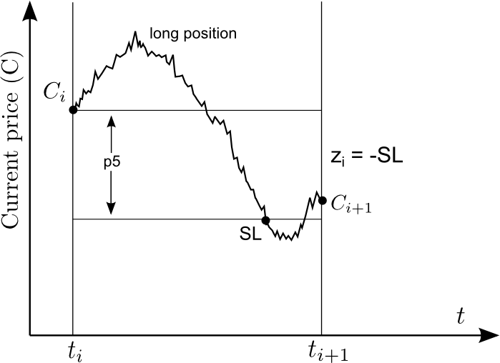

Fig. 5. Method of calculating the profit (here: loss) in the case of necessity to use p5 parameter actuating mechanism SL for long positions.

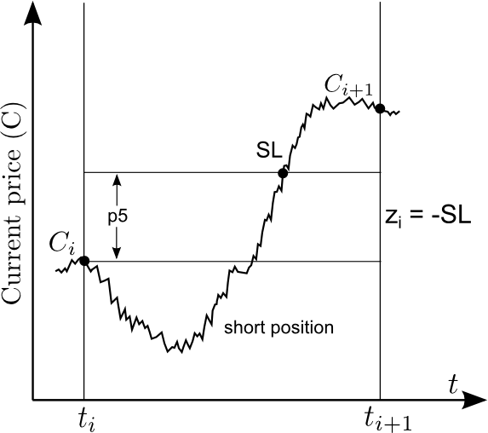

Fig. 6. Method of calculating the profit (here: loss) in the case of necessity to use p5 parameter actuating mechanism SL for long positions.

* To determine the current quality of the strategy and risk management summation of current gains/losses (the accumulation) is performed  
  Zci = sum ( Zi ) from i = 1 to the current value, and (16);
* There is a possible local subsidence Zci capital by introducing two additional parameters to manage the risk .

p3 - the number of steps back on the curve of the cumulative profit for the determination of Zci - p3 for comparison with the present value of Zci ;

p4 - maximum size of the capital subsidence (eg for the currency pair EURUSD measured in pips ) , which if exceeded will trigger the closure position :

if ( Zci - p3 - Zi ) <- p4 and PositionState not equal 0 then PositionState equal 0 (17 )  
where PositionState - is the type of open position (long or short) and PositionStates equal 0 means resignations from the opening position to the beginning of the next candle.

So, the above-described algorithm uses 5 parameters, as many as 3 of which are devoted to risk management strategy.

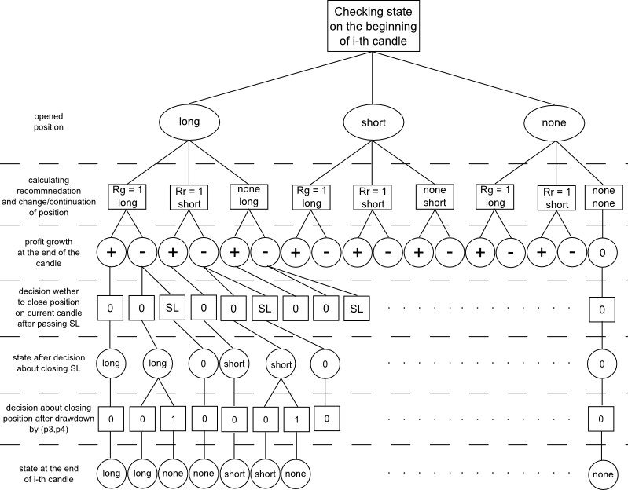

Rys. 7. Decision tree for the states and decisions in one step (candle) in the learning phase and testing

The complexity of the algorithm is illustrated in Figure 7, which in the form of a decision tree shows the individual steps and decisions made ​​in the iteration on a single candle. This iteration was carried out both in the search for optimal parameters p1, ..., p5 and in the process they use in the testing phase for data not used in learning.

The figure shows in a tree further decisions taken at the beginning of the candle and then reactions to any unacceptable change in course. The first examines the state of the position taken over from the closure of the previous candle. The next step is to work out decisions / recommendations as to the direction of the opening from the set {long, short, none}. After opening position is observed return of the open position. It can be positive or negative. If it is positive, it does not take up any additional decisions. If it is negative, it checks if it is not achieved the level of SL. In the case of a negative return of the items, except for testing, SL is not exceeded within a candle tested is also a condition resulting from the use of parameters (p3, p4). Tree is a state of complete items transmitted at the beginning of the next candle.

Described algorithm is implemented the in Matlab and using the platform Metatrader MQL4 language. The study was conducted both in the historical data (of course with the principles of machine learning - testing was carried out using data not used in the learning phase) and a real "live" market. Between the communities, there are also important differences that affect the diversity of simulation results.

**The study of strategies**

The study was conducted primarily on the basic EURUSD exchange rate at candlelight 1h. This market was chosen because of its popularity, a huge liquidity and also due to the possession by the authors many experiences in other machine learning strategy for this particular market such as []. These experiments suggested initially, carrying out many tests with a long learning period, about 1000 candles, then 500 candles and testing time windows of 50 to 200 candles. All these attempts have proven to be very effective and led to continuing losses. After months of trying in many markets noted that over long periods of learning, eg the order of 1000 candles strategy variability is very large. Therefore, the tests started with a decidedly shorter periods of learning and testing.

Finally, the authors decided to present the results for the two markets - currency pairs EURUSD and GBPUSD sampled at 1h in machine learning aspect ratios matched to the reduced scope of both the learning phase and testing.

In Table 1 summarizes the results for different time periods. The study was conducted at approximately constant number of candles testing period, e.g. if the testing period was 10 candles, is to perform the test algorithm 1300 candles optimal parameters were calculated 130 times. If the testing period was 20 candles are the parameters were changed 65 times, etc., if it was available long test period is not used it.

Tab1. The test results of the algorithm for different configurations of learning and testing periods for a couple EUEUSD

|  |  |  |  |  |
| --- | --- | --- | --- | --- |
| Learning\Test | 8 | 10 | 15 | 20 |
| 40 | -0.0261 | -0.0759 | -0.1424 | -0.0653 |
| 60 | 0.0044 | -0.0156 | 0.0275 | 0.1647 |
| 80 | -0.0234 | 0.0989 | **0.2401** | 0.0618 |
| 100 | 0.0290 | 0.0529 | -0.0104 | 0.0018 |

The table shows that the best results were obtained for the ratio of the learning period to test period as 80/15. For this comparison periods was performed to study the market in EURUSD and shown in the graph 8 For the 800-hour candles obtained result 0.2401 (2401 pips). Chart is definitely a growth course with a maximum of 600 pips from falling, which gives a very good, according to the authors, the criterion of Calmar (ratio of profit to capital najwiekzsego slips) about nearly 4.0.

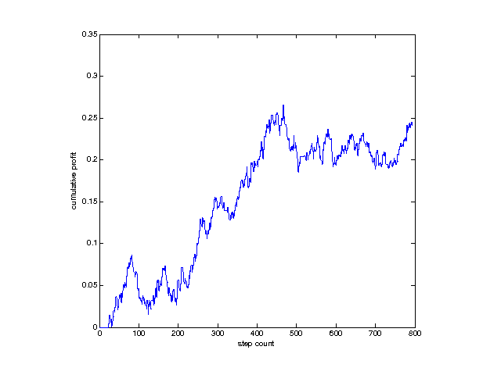

Rys. 8. Mileage accumulation of capital for 800 steps after 15 candles made ​​of uses of the algorithm for the currency pair EURUSD 1h

Tests were also made for another great importance and the currency pair GBPUSD 1h. The results are shown in Tab. 2 and in Figure 9

Tab2. The test results of the algorithm for different configurations of learning and testing periods for GBPUSD.

|  |  |  |  |  |
| --- | --- | --- | --- | --- |
| Learning\Test | 8 | 10 | 15 | 20 |
| 40 | -0.1706 | 0.0084 | -0.1566 | -0.0877 |
| 60 | -0.1321 | -0.1668 | -0.0070 | -0.0644 |
| 80 | -0.0175 | -0.1375 | **0.0870** | -0.0983 |
| 100 | -0.0744 | -0.0699 | -0.0174 | -0.1178 |

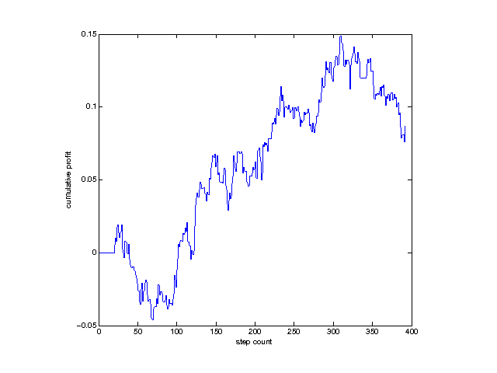

Rys. 9. Mileage accumulation of capital for 400 steps after 15 candles made ​​of uses of the algorithm for the currency pair GBPUSD 1h

Results for the currency pair are worse than for EURUSD, however, reaffirm the overall efficiency of the algorithm.

It was also decided to test the effectiveness of the algorithm in terms of one candle 1h. The results are shown in Table 3 and tab. 4

|  |  |  |  |  |
| --- | --- | --- | --- | --- |
| Learning\Test | 8 | 10 | 15 | 20 |
| 40 | -2.207E-06 | -6.443E-06 | -1.219E-05 | -5.641E-06 |
| 60 | 3.695E-07 | -1.327E-06 | 2.358E-06 | 1.425E-05 |
| 80 | -1.989E-06 | 8.427E-06 | **2.062E-05** | 5.3549E-06 |
| 100 | 2.465E-06 | 4.517E-06 | -8.981E-07 | 1.571E-07 |

Tab3. PerCandle EURUSD

|  |  |  |  |  |
| --- | --- | --- | --- | --- |
| Learning\Test | 8 | 10 | 15 | 20 |
| 40 | -2.949E-05 | 1.457E-06 | -2.768E-05 | -1.578E-05 |
| 60 | -2.289E-05 | -2.912E-05 | -1.250E-06 | -1.162E-05 |
| 80 | -3.043E-06 | -2.408E-05 | **1.551E-05** | -1.780E-05 |
| 100 | -1.299E-05 | -1.228E-05 | -3.110E-06 | -2.143E-05 |

Tab4. PerCandle GBPUSD

The best results are obtained in both cases (for both markets) for the ratio test to the learning period as 80/15. Result for EURUSD this means achievement of profit over 100 pips per month (approximately 550 hours of trading). This result is in terms of risk at Calmar ratio around 4 should be considered as engaging. Not much is worse than the result obtained for the other test pairs - GBPUSD.

In addition, efficacy studies were carried out and optimized for different test periods. To these results can be compared with each other, has been carried out their link, and the results were divided by the length of the test period, expressed by the number of candles. The following results were obtained: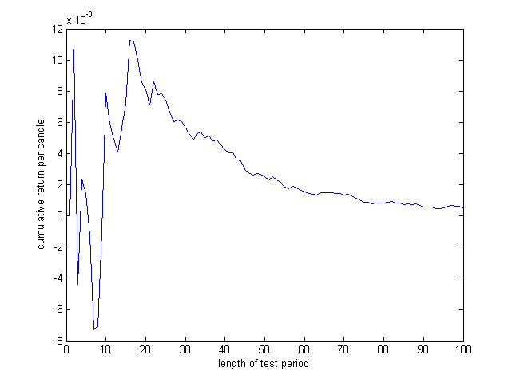

Rys. 11 EURUSD Results per candle.

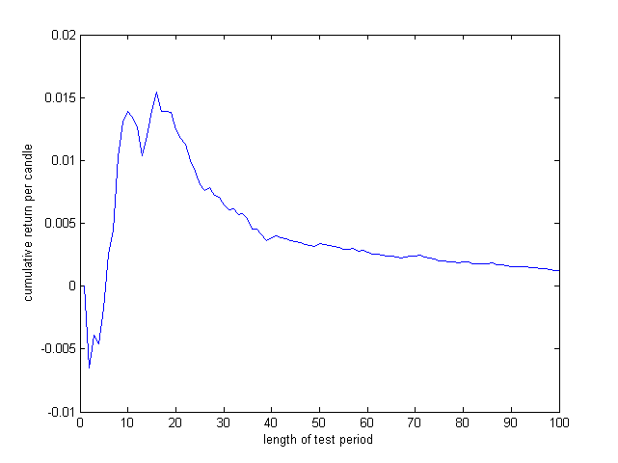

Rys 12. GBPUSD Results per candle.

From these results it can be concluded that the strategy is working with a short shelf life characteristics. The best results are achieved in periods of about 10-20 candles, it is unlike any other strategy presented in [Hindawi] where the best results were achieved for the test periods with a length of 80-100 candles.

All the above presented results refer to simulations in Matlab.

**Strategy Verification Using Online Trading Platform**

From a conceptual point of view implementing automated trading strategies in Matlab environment is one of proper approaches. Matlab provides a number of features to rapidly prototype such algorithms, for e.g. built-in computation functions and charting tools. What is more, Matlab enables also intuitive operations on vectors and matrices as well as flexible insight into variables values that are produced by the algorithm which greatly facilitates computing process management.

However in such approach it is very important to make sure that an algorithm that has been developed in Matlab can be used also regarding to real market conditions, which means a number of rules, validations and limitations, which obviously are not natively implemented in Matlab as it is just an open computing environment.

To make sure that those market conditions are met in the algorithm, Matlab script was converted manually to MQL4 expert advisor for trading platform of MetaTrader 4, which platform is commonly used to perform the real market operations.

The main differences between the implementation of the artificial earthworm in Matlab and in MetaTrader are listed below:

* Matlab
  + Calculation of balance and other standard market statistics is implemented manually, including also calculation of profit and loss related with opening / closing position;
  + SL handling is implemented manually, including trailing stop;
  + Lack of built-in market validations for opening / closing position;
  + Calculations are done using only 4 discrete price values for each candle;
  + Implementation approach from technical point of view is a matter of developer decisions;
* MetaTrader
  + Balance and other standard market statistics are calculated automatically, including also a strictly defined API for opening / closing position;
  + SL handling is a built-in feature, including trailing stop;
  + There are built-in market validations for opening / closing position;
  + Prices are changing smoothly for current candle (not only final fixed OHLC values);
  + Implementation approach from technical point of view is a not only a matter of developer decisions, but is also enforced by MetaTrader conventions (phases of initialization, candle execution, deinitialization etc.);

The elements listed above could cause some variations in the fragmentary as well as the final results of the algorithm execution.

In the article, implementation for MetaTrader4 has covered only the testing part of the algorithm, using fixed set of parameters that have been previously computed in Matlab in the learning part of execution for every test period. It is imporntat to note that implementing full algorithm, along with the learning part in MQL4, is obviously possible, however in that in the article the main objective was to confirm that the artificial worm can run on a real market with results similar to those achieved in Matlab.

Below are presented balance comparisons in Matlab and MetaTrader environments:

1) for GBPUSD currency pair using 1h candles values in time period of 2013.01.09 - 2013.12.30 in two different approches:

* with fixed parameters: p1=27, p2=4, p3=1, p4=-0.0060, p5=0.0060 (Rys. 10 i 11). Optimal parameters in that case were computed in Matlab for the first testing period and then were used for all testing periods.
* with dynamic parameters that were changed every testing period, regarding to their values computed in Matlab that were put to MetaTrader (Rys. 12 i 13)

In both approaches following assumptions were done:

* spread was 0.0028
* initial deposit was 50000 EUR
* size of the opening positions was 1 lot
* each testing period lasted 15 candles

2) for EURUSD currency pair using 1h candles values in time period of 2012.01.20 - 2013.01.01 in two different approches:

* with fixed parameters: p1=34, p2=4, p3=3, p4=-0.0060, p5=0.0060 (Rys. 14 i 15) Optimal parameters in that case were computed in Matlab for the first testing period and then were used for all testing periods.
* with dynamic parameters that were changed every testing period, regarding to their values computed in Matlab that were put to MetaTrader (Rys. 16 i 17)

In both approaches following assumptions were done:

* spread was 0.0016
* initial deposit was 10000 EUR
* size of the opening positions was 1 lot
* each testing period lasted 15 candles

Results of the algorithm execution in both environments for both currency pairs are presented in Tab. 5.

|  |  |  |  |  |
| --- | --- | --- | --- | --- |
|  | Total net profit in MetaTrader [EUR] | Total net profit in Matlab  [EUR] | Difference [EUR] | Difference [%] |
| GBPUSD in time period 2013.01.09 - 2013.12.30 | | | | |
| Fixed p1-p5 | -8 823.76 | -7 987.00 | 836.76 | 10.48 |
| Dynamic p1-p5 | 6 057.82 | 5 555.00 | 502.82 | 9.05 |
| EURUSD in time period 2012.01.20 - 2013.01.01 | | | | |
| Fixed p1-p5 | 2 305,18 | 2 695,00 | 389,82 | 14,46 |
| Dynamic p1-p5 | 13 669,40 | 17 260,00 | 3590,60 | 20,80 |

Tab 5. Results of the algorithm execution in both environments for both currency pairs and various parameters values

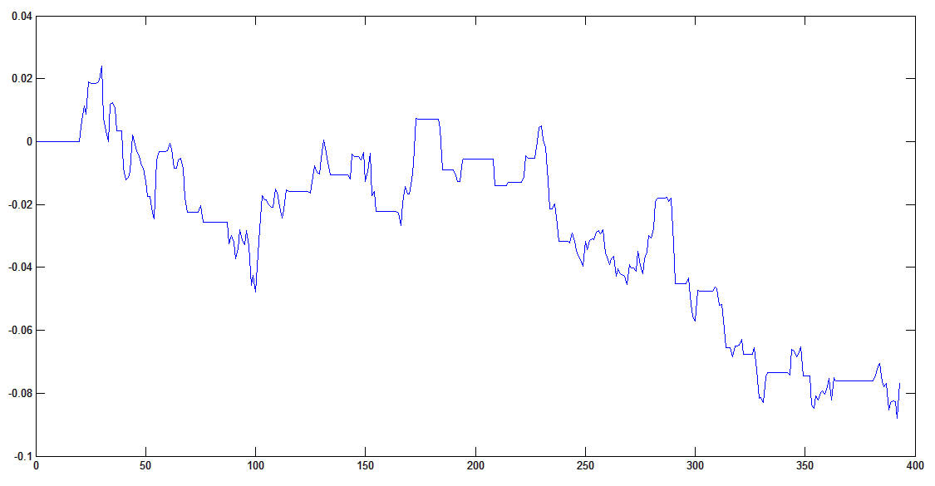

Rys. 12 Balance (relative value) in Matlab for GBPUSD [1h] in period 2013.01.09 - 2013.12.30 with fixed parameters p1-p5

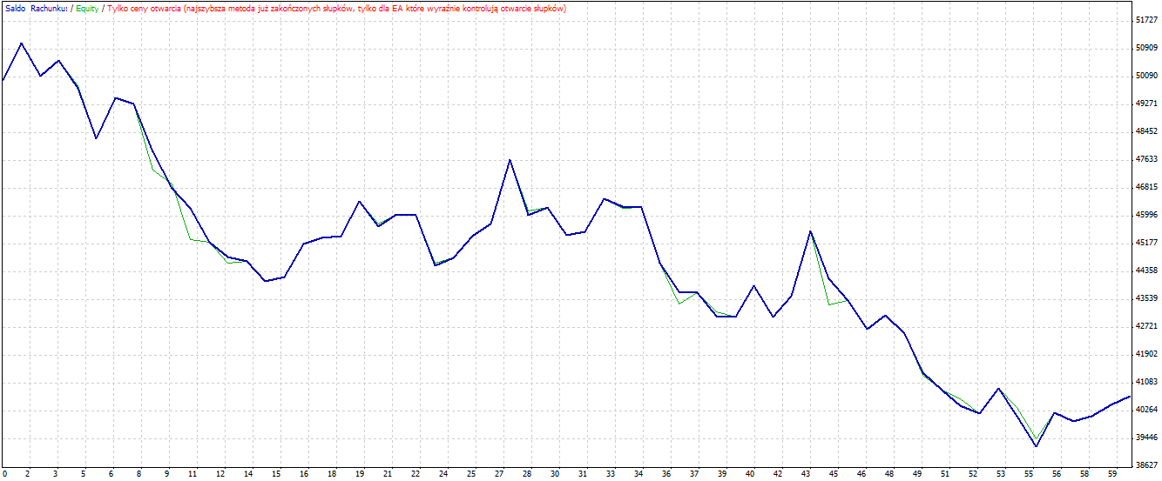

Rys. 13 Balance (absolute value) in MetaTrader for GBPUSD [1h] in period 2013.01.09 - 2013.12.30 with fixed parameters p1-p5

When following charts are respectively compared:

* Rys. 10 with Rys. 11
* Rys. 12 with Rys. 13
* Rys. 14 with Rys. 15
* Rys. 16 with Rys. 17

it is important to note that every first chart from each pair above was done in Matlab and every second chart was done in MetaTrader. In Matlab chart context, every point of abscissa axis represents testing period, while on ordinate axis there is a result of testing period (relative value), so that it can be assumed that chart was done in time domain. On the other hand, every abscissa on MetaTrader chart represents each opening of position, which means that chart is not linear related with time (however in cases presented in the article it is really similar to time domain), so that chart begins with first position opening and it is denoised in comparison to Matlab chart as every line are determined by opening and closing position, no matter how long this position has lasted. Despite those differences, corellation between Matlab and MetaTrader charts for the artificial worm algorithm executions is indisputable.

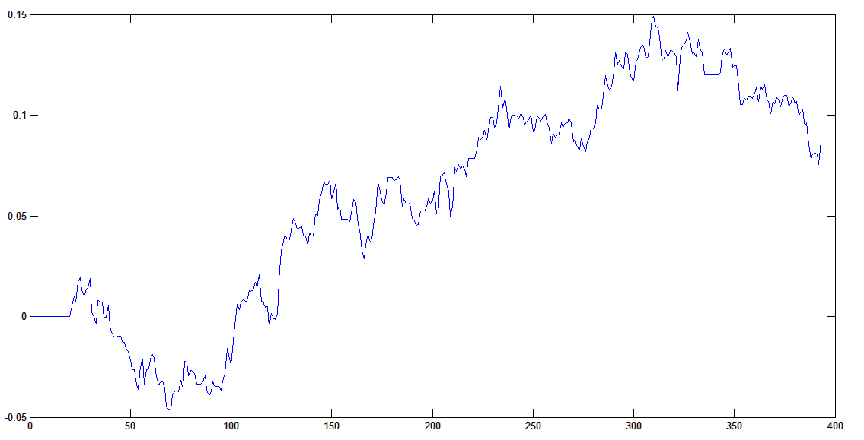

Rys. 14 Balance (relative value) in Matlab for GBPUSD [1h] in period 2013.01.09 - 2013.12.30 with dynamic p1-p5

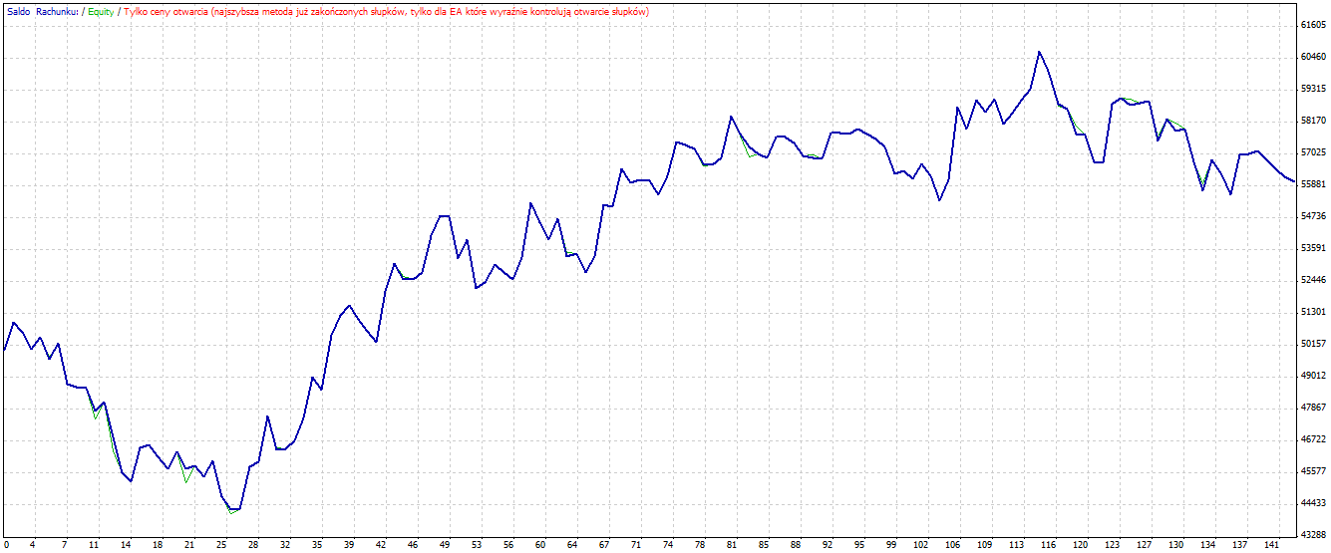

Rys. 15 Balance (absolute value) in MetaTrader for GBPUSD [1h] in period 2013.01.09 - 2013.12.30 with dynamic p1-p5

Differences in results for the algorithm for Matlab and MetaTrader presented in Tab 2. by level of 9-21% are significant, but it is important to note they do not contest convergence in the algorithm execution in both environments. It is possible to do more detailed research on differences for balance accumulation for particular positions to align the algorithm execution. However for the article purposes conversion of scripts that has been done is sufficient and gives solid base to admit that the algorithm is applicable for market regarding its conceptual assumptions.

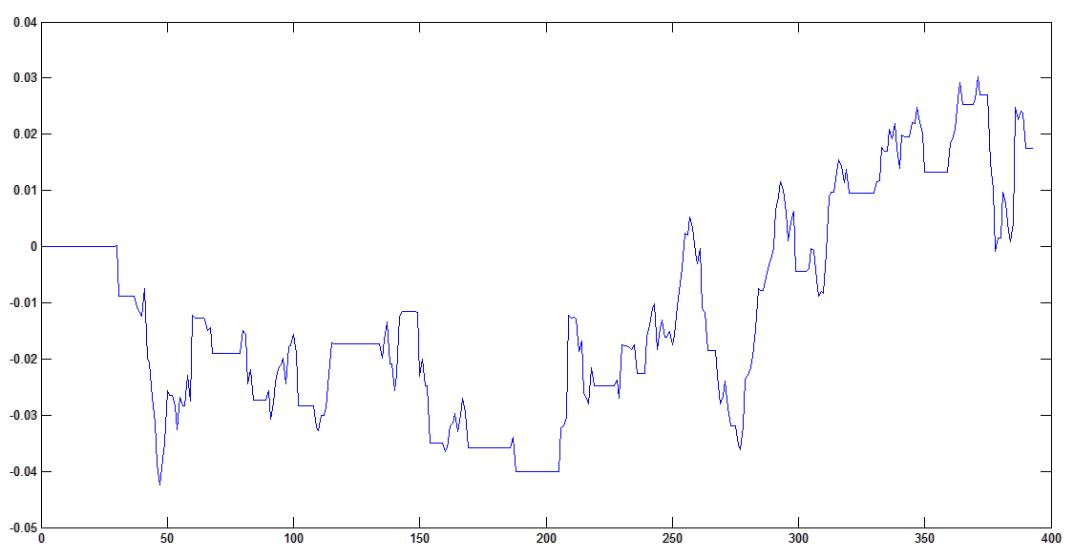

Rys. 16 Balance (relative value) in Matlab for EURUSD [1h] in period 2012.01.20 - 2013.01.01 with fixed p1-p5

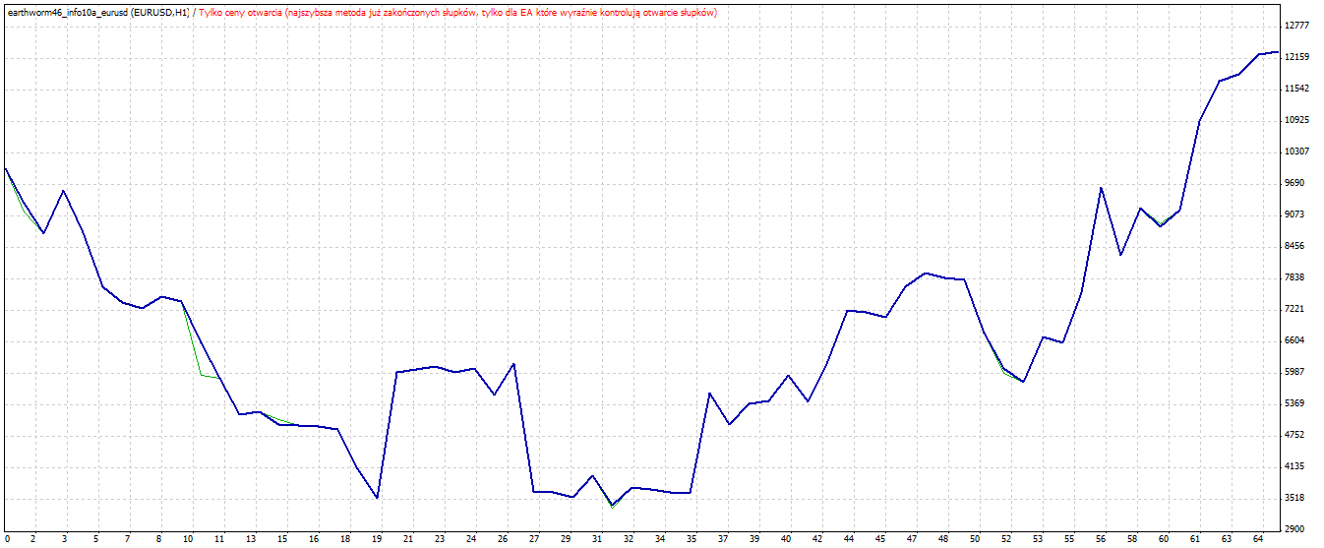

Rys. 17 Balance (absolute values) in MetaTrader for EURUSD [1h] in period 2012.01.20 - 2013.01.01 with fixed p1-p5

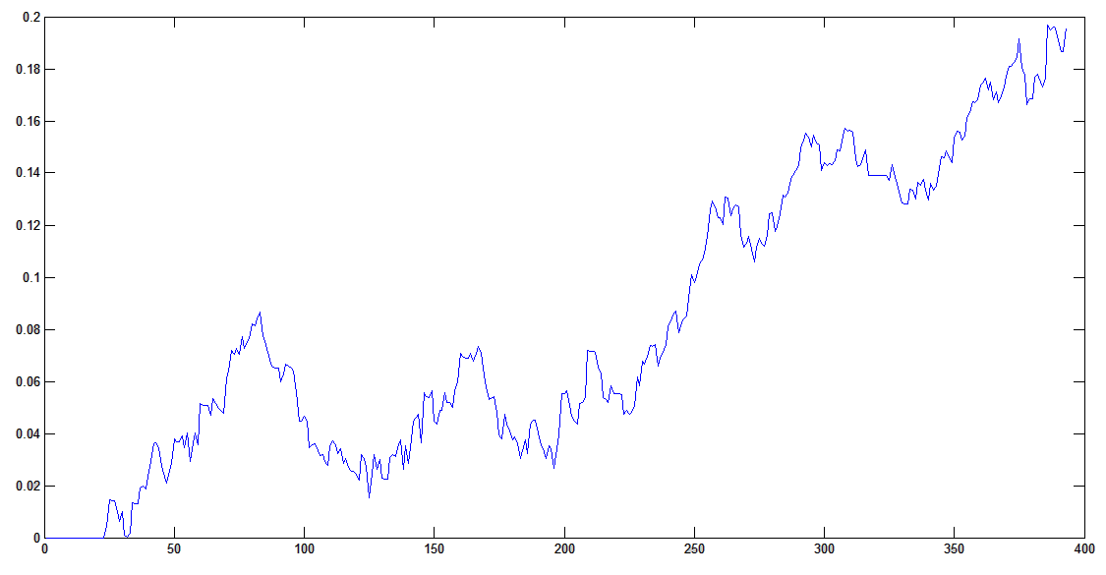

Rys. 18 Balance (relative values) in Matlab for EURUSD [1h] in period 2012.01.20 - 2013.01.01 with dynamic p1-p5

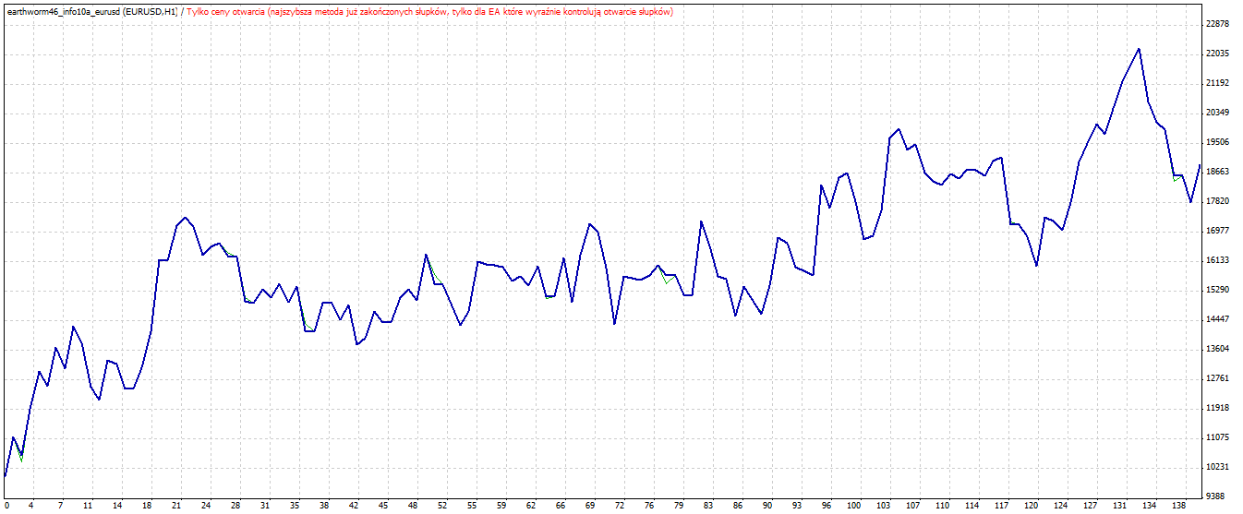

Rys. 19 Balance (absolute values) in MetaTrader for EURUSD [1h] in period 2012.01.20 - 2013.01.01 with dynamic p1-p5

Conclusions

Presented in the paper the concept of an innovative investment strategy gave satisfactory results for a certain pair as the result of periods of machine learning. For example, in the studied data for two key market currency pairs sampled every hour , the best value is 80 hours of teaching and 15 hours of testing. One can assume that this relationship may change in a different environment (for other markets, for other periods) by becoming a sort of next parameter that optimal values ​​should be sought. It should be emphasized that the study was conducted on data not used in the learning phase and for the basic principle of machine learning achieved results that would have satisfied many a practice. It should also be noted that outside research conducted in environment completely specified (for constant unchanging data stored in Matlab ) was also performed simulations in terms of actual brokerage platform. The results obtained in both environments are similar in the sense of direction changes and logic behavior caused by the user received by the algorithm implemented in the Matlab and Metatrader. Differences explained in this work .  
The direction of further research will test the hypothesis that the variability periods to test the learner can improve the quality of prediction. This hypothesis seems to be interesting against the background of previous experiences and results, eg for different studied strategies, including [ Hindawi ] obtained surprisingly different optimal length of periods of learning and testing.

[1] W. Brock, J. Lakonishok, and B. LeBaron, “Simple Technical Trading Rules and the Stochastic Properties of Stock Returns,” *J. Finance*, vol. 47, no. 5, pp. 1731–1764, 1992.

[2] C. T. Cheng, J. Y. Lin, Y. G. Sun, and K. W. Chau, “Long-term prediction of discharges in Manwan hydropower using adaptive-network-based fuzzy inference systems models,” *Adv. Nat. Comput. Pt 3, Proc.*, vol. 3612, pp. 1152–1161, 2005.

[3] D. L. Donoho, A. Maleki, I. U. Rahman, M. Shahram, and V. Stodden, “Reproducible Research in Computational Harmonic Analysis.,” *Comput. Sci. Eng.*, vol. 11, no. 1, pp. 8–18, 2009.

[4] G. C. Friesen, P. A. Weller, and L. M. Dunham, “Price trends and patterns in technical analysis: A theoretical and empirical examination,” *J. Bank. Financ.*, vol. 33, no. 6, pp. 1089–1100, 2009.

[5] R. Gencay, “Linear, non-linear and essential foreign exchange rate prediction with simple technical trading rules,” *J. Int. Econ.*, vol. 47, no. 1, pp. 91–107, 1999.

[6] Huang and Chau, “A new image thresholding method based on Gaussian mixture model,” *Appl. Math. Comput.*, vol. 205, pp. 899–907, 2008.

[7] A. G. Ivakhnenko, “An Inductive Sorting Method for the Forecast of Multidimensional Random Processes and Analog Events with the Method of Analog Forecast Complexing. Pattern Recognition and Image Analysis,” vol. 1, no. 1. pp. 99–108, 1991.

[8] D. Kahneman, P. Slovic, and A. Tversky, *Judgment Under Uncertainty: Heuristics and Biases*. Cambridge University Press, 1982.

[9] P. Klesk and A. Wilinski, “Market Trajectory Recognition and Trajectory Prediction Using Markov Models,” in *ICAISC (1)*, 2010, pp. 405–413.

[10] J. Krutsinger, *Trading Systems: Secrets of the Masters*. McGraw-Hill, Inc., 1997.

[11] A. Muriel, “Short-term predictions in forex trading,” *Phys. A Stat. Mech. its Appl.*, vol. 344, no. 1, pp. 190–193, 2004.

[12] K. P. Murphy, *Machine learning: a probabilistic perspective*. Cambridge, MA, 2012.

[13] W. Pedrycz, *Computational Intelligence: An Introduction*. CRC Press, 1998.

[14] C. Satchwell, *Pattern Recognition and Trading Decisions*. McGraw-Hill, 2005.

[16] R. Taormina, K. Chau, and R. Sethi, “Artificial neural network simulation of hourly groundwater levels in a coastal aquifer system of the Venice lagoon,” *Engineering Applications of Artificial Intelligence*, vol. 25. pp. 1670–1676, 2012.

[17] A. Wilinski, “Prediction Models of Financial Markets Based on Multiregression Algorithms,” *Comput. Sci. J. Mold.*, vol. 19, no. 2, pp. 178–188, 2011.

[18] K. Fujimoto and S. Nakabayashi, “Applying GMDH algorithm to extract rules from examples,” *Syst. Anal. Model. Simul.*, vol. 43, no. 10, pp. 1311–1319, 2003.

[19] B. Cai, C. Cai, and K. Keasey, “Market Efficiency and Returns to Simple Technical Trading Rules: Further Evidence from U.S., U.K., Asian and Chinese Stock Markets,” *Asia-Pacific Financ. Mark.*, vol. 12, no. 1, pp. 45–60, 2005.

[20] B. LeBaron, “Technical Trading Rules and Regime Shifts in Foreign Exchange,” 1991.

[21] R. Raghuraj and S. Lakshminarayanan, “Variable predictive models-A new multivariate classification approach for pattern recognition applications,” *Pattern Recogn.*, vol. 42, no. 1, pp. 7–16, 2009.

[22] G. Tian, G. Wan, and M. Guo, “Market Efficiency and the Returns to Simple Technical Trading Rules: New Evidence from U.S. Equity Market and Chinese Equity Markets,” *Asia-Pacific Financ. Mark.*, vol. 9, no. 3–4, pp. 241–258, 2002.

[23] A. Wiliński, A. Bera, W. Nowicki, and P. Błaszyński, “Study on the Effectiveness of the Investment Strategy Based on a Classifier with Rules Adapted by Machine Learning,” *ISRN Artif. Intell.*, vol. 2014, pp. 1–10, 2014.