Department of Computing
ITT Dublin

M.Sc. in Distributed and Mobile Computing
M.Sc. in Information Technology Management

Software Development and Process Management

Spring 2014

CA1

Out: 25/02/2014
In: 06/05/2014
Value: 70%

Type: Individual

Lecturer: GC

Delivered by:
Piotr Bodziachowski
X00077517

Iteration 2
Table of content
Introduction 3
Application diagram 3
The main RESTful application 3
It supports GET: 3
It supports UPDATE: 4
It supports DELETE: 4
NoSQL Database Connection 4
Source Code Control 4
Restful Client application 5
How to use the client 5
Source Code Control 5
Summary 5

D

Introduction

The RESTful application created supports a credit card industry and organizations that use credit card payments. The CreditCard application presents a particular card number risk level based on the data fetched by other companies and organizations. This way it is easy to say if the specific card holder performs many chargebacks.

Application diagram
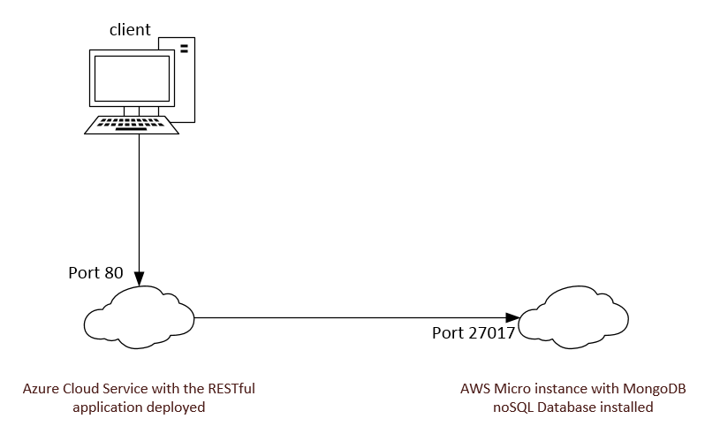

The main RESTful application

The CreditCard application software presented can be accessed by Azure services at the address: http://x00077517.cloudapp.net/Help

It supports GET:

- Listing:
http://x00077517.cloudapp.net/api/CreditCard

- Specific credit card information by the card number: http://x00077517.cloudapp.net/api/CreditCard?number=1234%205678%201234%205678

- Specific credit card information by its id:
http://x00077517.cloudapp.net/api/CreditCard/5367be454fdd720038250010

It supports UPDATE:
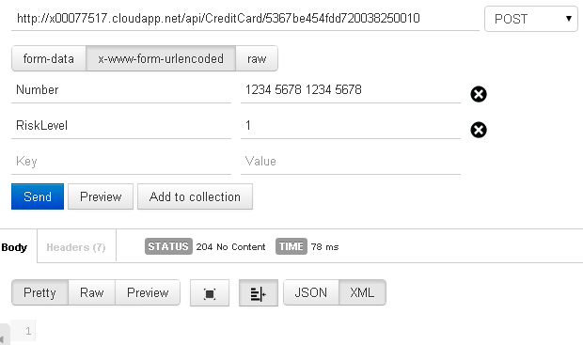

It supports DELETE:
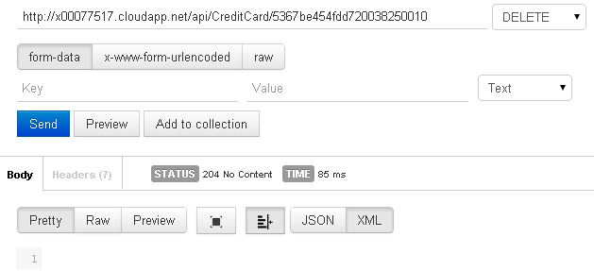

NoSQL Database Connection

It connects to the MongoDB database installed on the publicly available server: 54.247.178.80

Source Code Control

The source code of the application is stored in the GIT repository: https://github.com/piotrbod/itt-project-for-gc

The source code of the application is stored also in the Google Code repository: https://peter.bod@code.google.com/p/itt-google-code-rest-api-for-gc

Restful Client application

The RESTful client created supports all functions described in the main application section. It can be run from:

C:\the_zip_file_unpacked\Client\itt-project-for-gc-client\CreditCardClient\bin\Debug\CreditCardClient.exe

How to use the client

Please see the main method below and description how to use it. After the change is performed start the client and the changes will be implemented.

static void Main(string[] args)
{
GetAllAsync().Wait();

//AddAsync("1234 5678 1234 5678", 1).Wait();
//GetAllAsync().Wait();

UpdateAsync("5367b8284fdd72003825000f", "7890 1234 7890 1234", 2).Wait();
GetAllAsync().Wait();

//DeleteAsync("53677427c904797da8946202").Wait();
//GetAllAsync().Wait();
}

To add a new credit card uncomment AddAsync, enter the credit card number and after comma the risk level between 1 – 3.

To update existing credit card use its id, the same or updated card number as well as the risk level between 1 – 3.

To delete the card from the database uncomment DeleteAsync and enter the credit card id.

Source Code Control

The source code for the client application is stored in GIT and GoogleCode accordingly:
https://github.com/piotrbod/itt-project-for-gc-client.git
https://peter.bod@code.google.com/p/itt-google-code-rest-api-for-gc-client

Summary
The main application has been deployed within the Azure Cloud environment using the Visual Studio features. The application supports functionalities like: adding new cards to the system, modification of those cards as well as deletion of the cards from the database. The console client application has been written to facilitate the database control.

