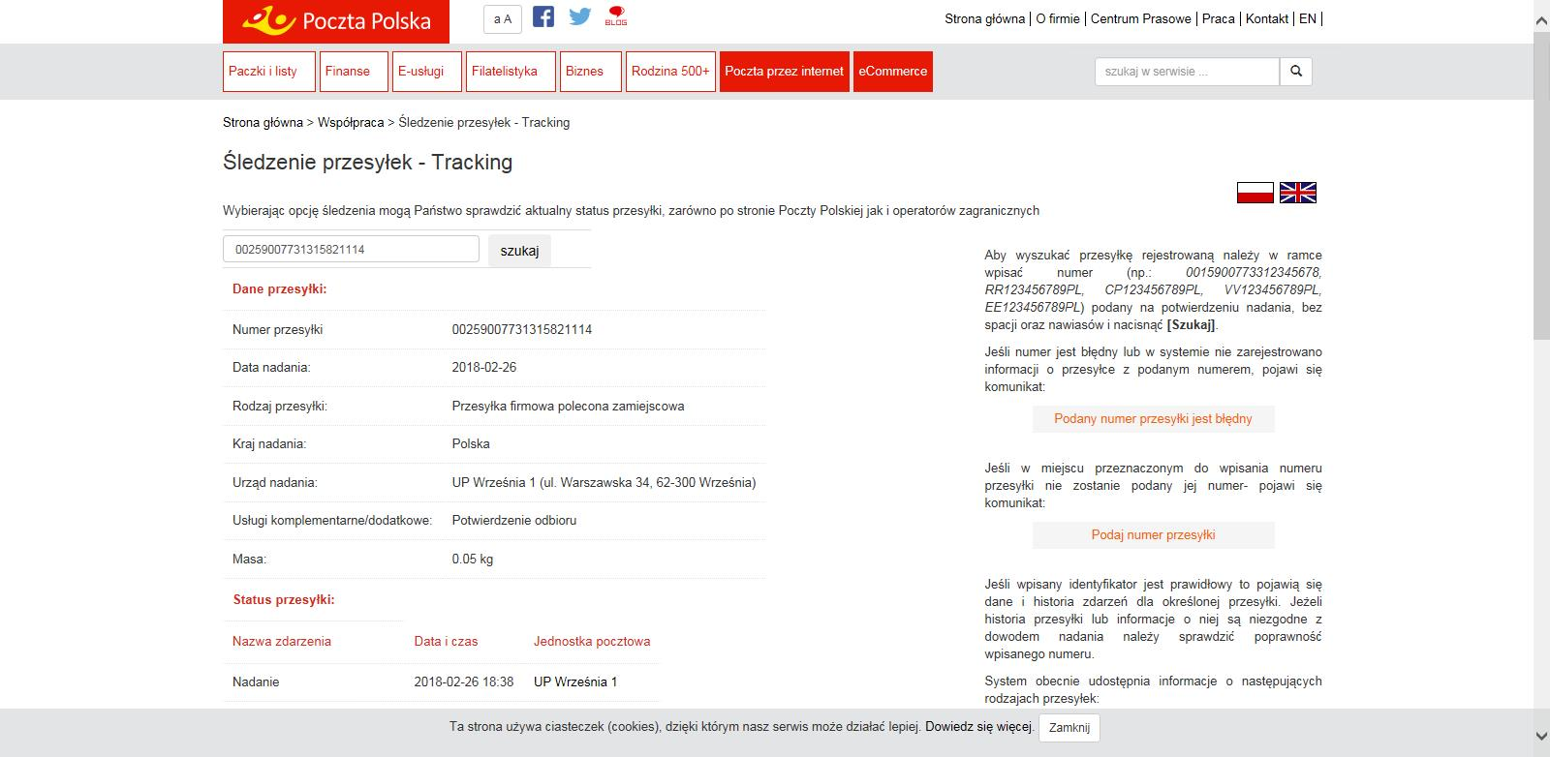GemBox.Document is a .NET component that enables developers to read, write, convert and print document files (DOCX, DOC, PDF, HTML, XPS, RTF and TXT) from .NET applications in a simple and efficient way.