Projekt układu sterowania z wykorzystaniem PLC i mikrokontrolerów

**Schemat podłączenia sterownika PLC i mikrokontrolera do urządzenia sterowanego**

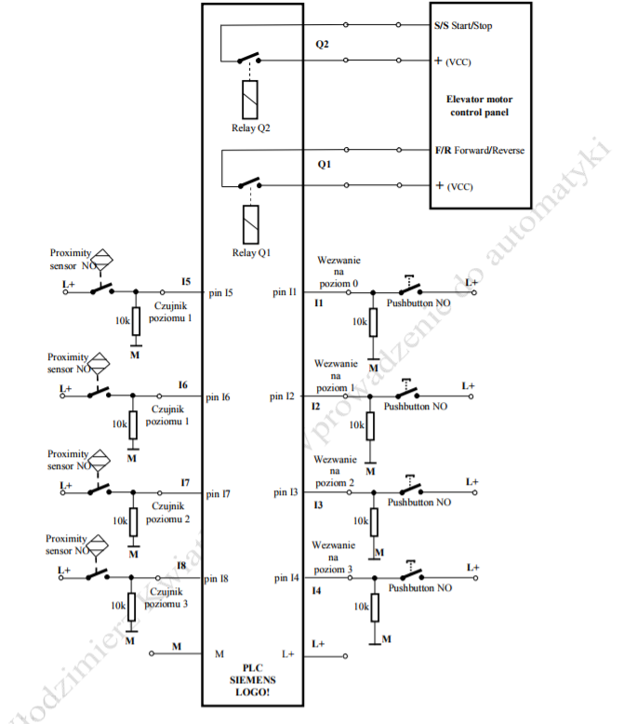

**Schemat podłączenia sterownika Arduino i mikrokontrolera do urządzenia sterowanego**

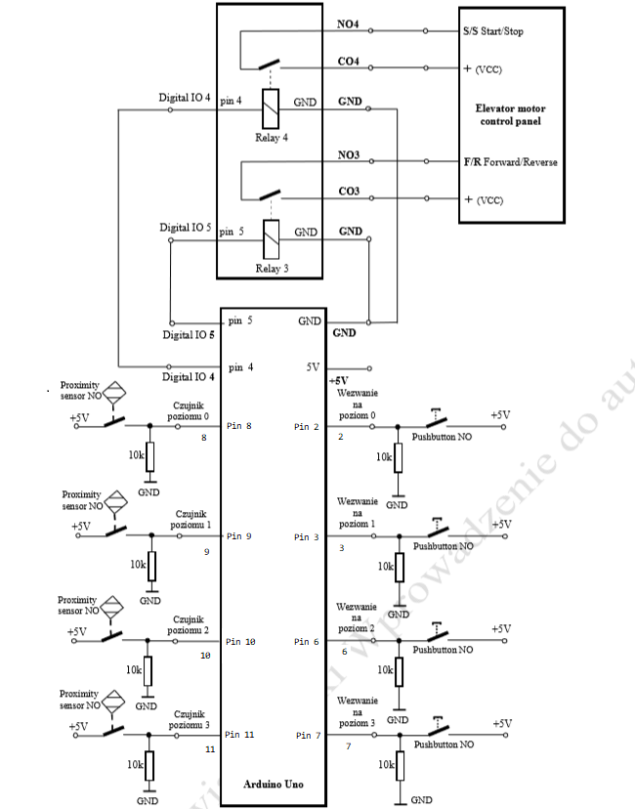

Diagram przejść stanów FSM:

Winda porusza się między trzema kondygnacjami: 0, 2, 3. Zadany jest stan początkowy – winda ustawia się na 3 kondygnacji. Uwaga: przed uruchomieniem programu na sterowniku, winda zostaje ustawiona na 3 kondygnacji.

M1 – winda stoi na zerowym piętrze

M2 – winda stoi na drugim piętrze

M3 – winda stoi na trzecim piętrze

M4 – winda jedzie z zerowego piętra na drugie

M5 – winda jedzie z drugiego piętra na trzecie

M6 – winda jedzie z zerowego piętra na trzecie

M7 – winda jedzie z trzeciego piętra na drugie

M9 – winda jedzie z trzeciego piętra na zerowe

M10 – winda jedzie z drugiego piętra na zerowe



Tabela przejść stanów:

|  |  |  |  |  |  |  |  |  |  |  |  |  |  |  |  |  |  |  |  |  |  |  |  |
| --- | --- | --- | --- | --- | --- | --- | --- | --- | --- | --- | --- | --- | --- | --- | --- | --- | --- | --- | --- | --- | --- | --- | --- |
| **M1** | **M2** | **M3** | **M4** | **M5** | **M6** | **M7** | **M9** | **M10** | **I1** | **I3** | **I4** | **I5** | **I7** | **I8** | **M1'** | **M2'** | **M3'** | **M4'** | **M5'** | **M6'** | **M7'** | **M9'** | **M10'** |
| 1 | 0 | 0 | 0 | 0 | 0 | 0 | 0 | 0 | * | 0 | 0 | * | * | * | 1 | 0 | 0 | 0 | 0 | 0 | 0 | 0 | 0 |
| 1 | 0 | 0 | 0 | 0 | 0 | 0 | 0 | 0 | * | 1 | 0 | * | * | * | 0 | 0 | 0 | 1 | 0 | 0 | 0 | 0 | 0 |
| 1 | 0 | 0 | 0 | 0 | 0 | 0 | 0 | 0 | * | 0 | 1 | * | * | * | 0 | 0 | 0 | 0 | 0 | 1 | 0 | 0 | 0 |
| 0 | 1 | 0 | 0 | 0 | 0 | 0 | 0 | 0 | 0 | * | 0 | * | * | * | 0 | 1 | 0 | 0 | 0 | 0 | 0 | 0 | 0 |
| 0 | 1 | 0 | 0 | 0 | 0 | 0 | 0 | 0 | 0 | * | 1 | * | * | * | 0 | 0 | 0 | 0 | 1 | 0 | 0 | 0 | 0 |
| 0 | 1 | * | 0 | 0 | 0 | 0 | 0 | 0 | 1 | * | 0 | * | * | * | 0 | 0 | 0 | 0 | 0 | 0 | 0 | 0 | 1 |
| 0 | 0 | 1 | 0 | 0 | 0 | 0 | 0 | 0 | 0 | 0 | * | * | * | * | 0 | 0 | 1 | 0 | 0 | 0 | 0 | 0 | 0 |
| 0 | 0 | 1 | 0 | 0 | 0 | 0 | 0 | 0 | 0 | 1 | * | * | * | * | 0 | 0 | 0 | 0 | 0 | 0 | 1 | 0 | 0 |
| 0 | 0 | 1 | 0 | 0 | 0 | 0 | 0 | 0 | 1 | 0 | * | * | * | * | 0 | 0 | 0 | 0 | 0 | 0 | 0 | 1 | 0 |
| 0 | 0 | 0 | 1 | 0 | 0 | 0 | 0 | 0 | * | * | * | * | 0 | * | 0 | 0 | 0 | 1 | 0 | 0 | 0 | 0 | 0 |
| 0 | 0 | 0 | 1 | 0 | 0 | 0 | 0 | 0 | * | * | * | * | 1 | * | 0 | 1 | 0 | 0 | 0 | 0 | 0 | 0 | 0 |
| 0 | 0 | 0 | 0 | 1 | 0 | 0 | 0 | 0 | * | * | * | * | * | 0 | 0 | 0 | 0 | 0 | 1 | 0 | 0 | 0 | 0 |
| 0 | 0 | 0 | 0 | 1 | 0 | 0 | 0 | 0 | * | * | * | * | * | 1 | 0 | 0 | 1 | 0 | 0 | 0 | 0 | 0 | 0 |
| 0 | 0 | 0 | 0 | 0 | 1 | 0 | 0 | 0 | * | * | * | * | * | 0 | 0 | 0 | 0 | 0 | 0 | 1 | 0 | 0 | 0 |
| 0 | 0 | 0 | 0 | 0 | 1 | 0 | 0 | 0 | * | * | * | * | * | 1 | 0 | 0 | 1 | 0 | 0 | 0 | 0 | 0 | 0 |
| 0 | 0 | 0 | 0 | 0 | 0 | 1 | 0 | 0 | * | * | * | * | 0 | * | 0 | 0 | 0 | 0 | 0 | 0 | 1 | 0 | 0 |
| 0 | 0 | 0 | 0 | 0 | 0 | 1 | 0 | 0 | * | * | * | * | 1 | * | 0 | 1 | 0 | 0 | 0 | 0 | 0 | 0 | 0 |
| 0 | 0 | 0 | 0 | 0 | 0 | 0 | 1 | 0 | * | * | * | 0 | * | * | 0 | 0 | 0 | 0 | 0 | 0 | 0 | 1 | 0 |
| 0 | 0 | 0 | 0 | 0 | 0 | 0 | 1 | 0 | * | * | * | 1 | * | * | 1 | 0 | 0 | 0 | 0 | 0 | 0 | 0 | 0 |
| 0 | 0 | 0 | 0 | 0 | 0 | 0 | 0 | 1 | * | * | * | 0 | * | * | 0 | 0 | 0 | 0 | 0 | 0 | 0 | 0 | 1 |
| 0 | 0 | 0 | 0 | 0 | 0 | 0 | 0 | 1 | * | * | * | 1 | * | * | 1 | 0 | 0 | 0 | 0 | 0 | 0 | 0 | 0 |
| * | * | 1 | * | * | * | * | * | * | 0 | 0 | 0 | * | * | 1 | * | * | 1 | * | * | * | * | * | * |

M1’=M1 $\overline{I3}$ $\overline{I4}$ + M9 I5 + M10 I5

M2’= M2 $\overline{I1 }\overline{I4}$ + M4 I7 + M7 I7

M3’=M3 $\overline{I1}\overline{I3}$ + M5 I8 + M6 I8

M4’= M1 I3 $\overline{I4}$ + M4 $\overline{I7}$

M5’=M2 $\overline{I1}$ I4 + M5 $\overline{I8}$

M6’=M1 $\overline{I3}$ I4 + M6 $\overline{I8}$

M7’=M3 $\overline{I1}$ I3 + M7 $\overline{I7}$

M9’=M3 I1 $\overline{I3}$ + M9 $\overline{I5}$

M10’=M2 I1 $\overline{I4}$ + M10 $\overline{I5}$

# Tabela funkcji wyjścia:

Q1= $M7+M9+M10$

Q2= $M1+M2+M3$

Program w LDD:

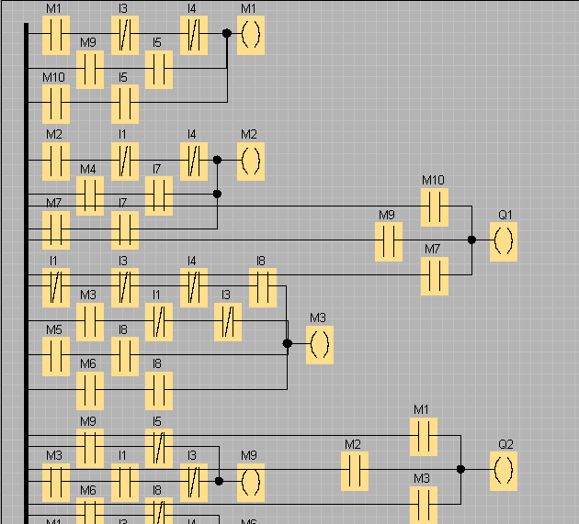

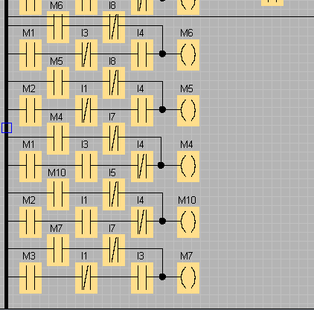

Program w FBD:

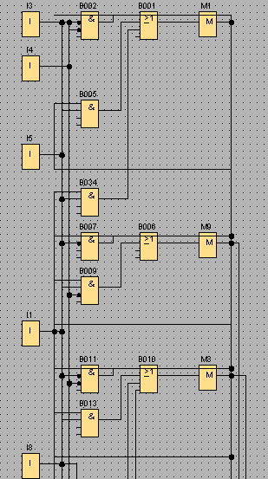

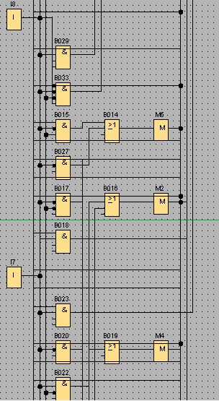

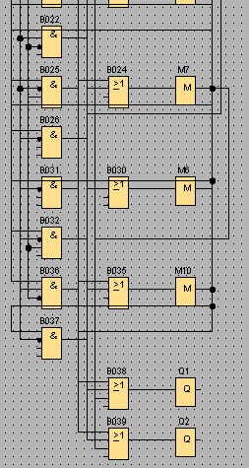

Program w Arduino:

