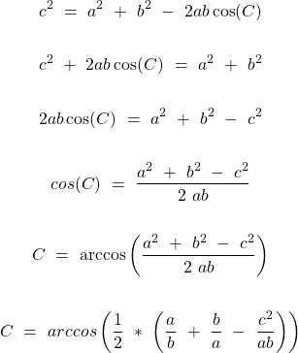

https://www2.clarku.edu/faculty/djoyce/trig/formulas.html
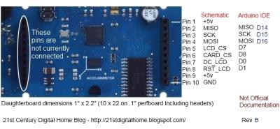
http://www.billporter.info/2011/05/30/easytransfer-arduino-library/
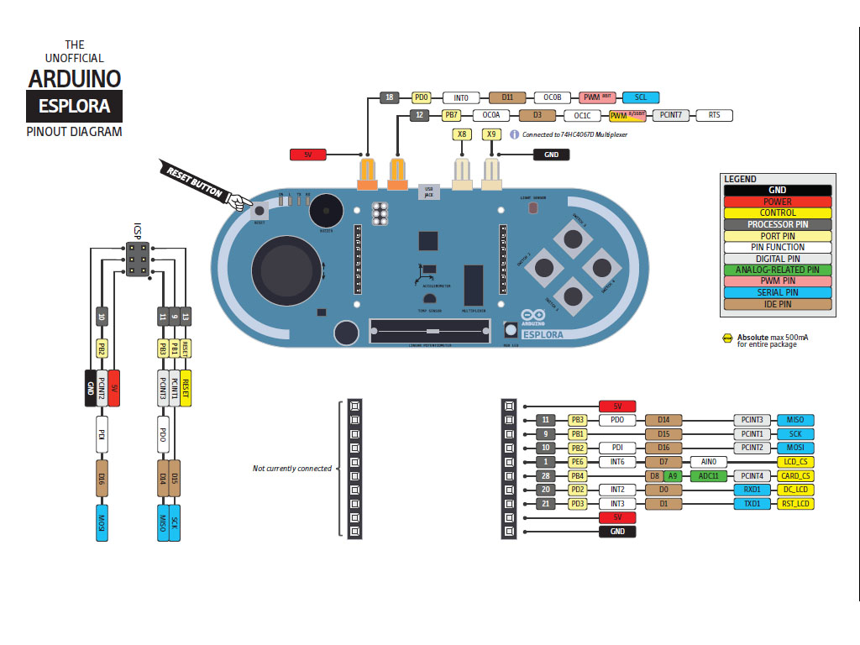
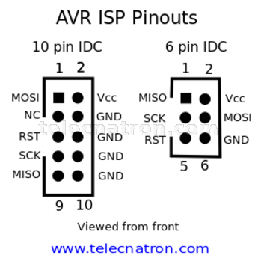
https://arduino.stackexchange.com/questions/56596/serial-communication-between-an-uno-and-an-esplora-by-connecting-their-usb-ports

