- Selected Times-Roman and Red

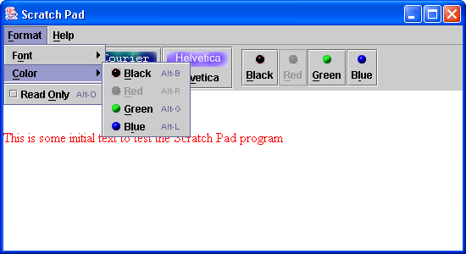

- Helvetica font and green color are selected from the Format menu.

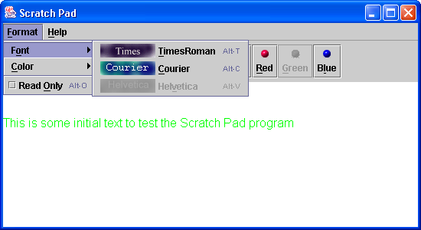

3. Courier font and blue color are selected from the toolbar
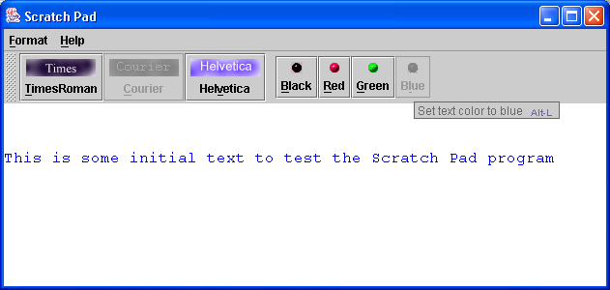

4. Read-Only menu item has been selected.
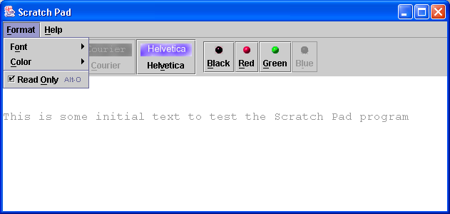

5. “About Scratch Pad” dialog is selected.

