Bootstrap

The layout is made up of 12 columns

include normalize.css in your css files, it is much less intrusive than reset

Use bootstrap.css for dev purposes, but once uploaded on the server, put bootsrap.min.css cuz it's faster performance.

There are also meta tags that enter into action when setting up your bootstrap environment

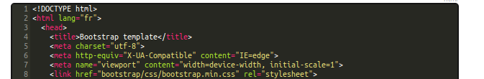
viewport: screen size > browser size (smartphones consider the browser usable space is smaller than the actual screen size)

Media Queries

There are four different medias

The grid

A row takes the size of the highest element that it contains (like excel)

There are four different types of columns:
- col-xs-#
- col-sm-#
- col-md-#
- col-lg-#

xs, small, medium, large.
Each type corresponds to a media type (smartphone, tablet, laptop and desktop computer)

so, col-xs-4 means how many of the available 12 columns it will take up (here, 1/3 of the body)

col-md-4
col-md-8
means that if you pass on a screen that is smaller than md (>laptop), the two elements will break out of row and will empile on top of each other.

Container

container is a class that sets up the maximum width of the content, depending on the media used
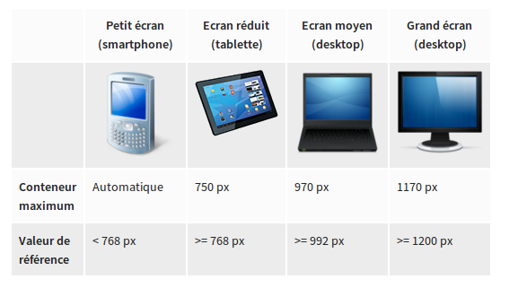
Offset

You can set up a blank space between two of your divs by adding a offset to the right div:

<div class=”col-lg-offset-6 col-lg-3”>content</div>

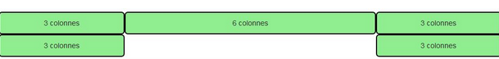
The numbers in the col-* classes refer to the width of the closest parent element (ex: col-lg-3 takes up ¼ of the width of the row it is contained in)

NB: <abbr title="Société des Amoureux des Tigres">SAT</abbr>

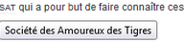

Responsive classes

Add visible or hidden-(xs,sm,md,lg) to your class
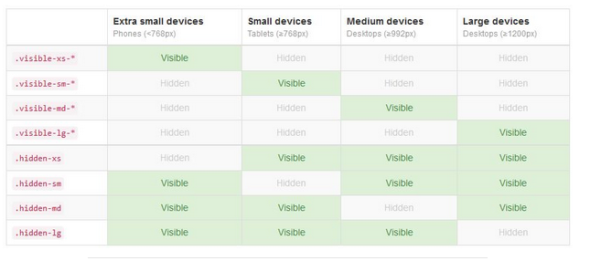
Or add visible or hidden to the beginning of your display classes
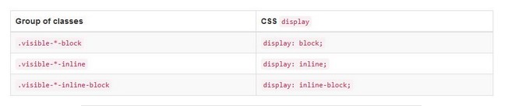

Forms

Use the class .form-control on your inputs/select
Wrap each label/input in a div classed .form-group

Use the class .well on your form, .radio on your checkboxes and .button button-primary on buttons

For inline forms (ex: search bar) use .inline-form

.input-group-addon

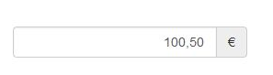

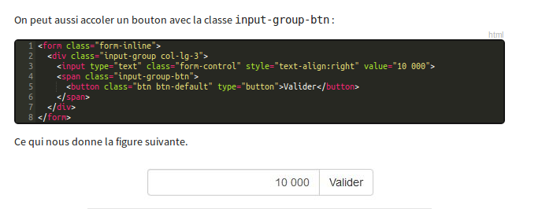
Styling with events

You can change the style of the input by creating three distinct form-groups: .has-error, .has-warning and .has-success + .has-feedback and adding for=idError, idWarning or idSuccess in Label and the glyphicon

