=> myArray.push(“new value”);

Delete first element only
=> myArray.shift();

Delete last element only
=> myArray.pop();

Create an array out of a string
=> myArray = myString.split(' ');

IN js, an object is simply an associative array

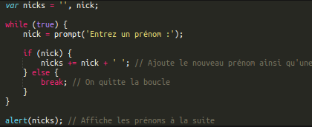

Just like in ruby, javascript can understand this syntax for if:

DOM modifications

never forget to specify document before using selectors.

Document Object Model is in fact an API for HTML and XML. Everything, window, document, is treated as an object with methods attached to it. The document object, for example, has three main methods:

getElementByID()
getElementsByTagName()
getElementsByName()

this last refers to the name attribute you give to some tags, like form inputs.

There are two new methods to document that have appeared recently:

document.queryselector(tag name)
document.querySelectorAll(tag name)

use it with css selectors. For example, this selects all the tags span contained in a div class “item”

=>document.querySelectorAll(.item span)

Once you selected an element of the DOM, you can use the setAttribute and getAttribute() properties
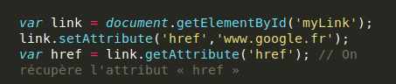
This will set the link towards google.fr

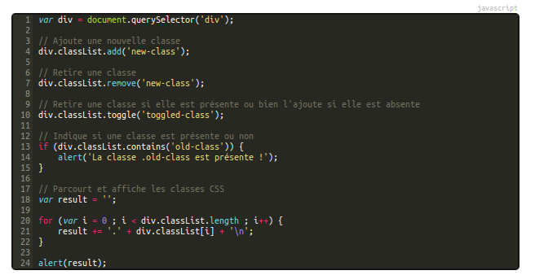
Navigating the DOM

accessing the parent of an element

element = document.getElementById('myElement')
parent = element.parentNode;

Accessing the name of an element
=> element.nodeName

Accessing the siblings of an element:
=> element.nextSibling

Create a window with an “X” button
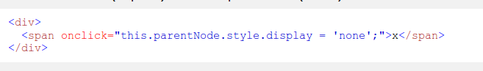
Creating a new element
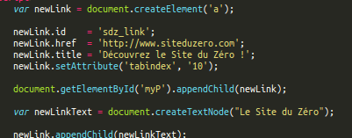

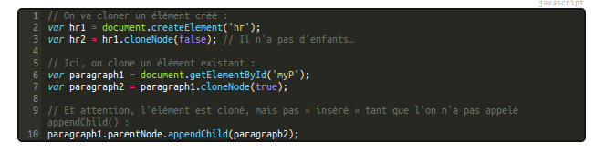
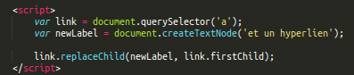

EXERCISES:

Remember, when creating elements of a DOM, we always go from bottom to up. Bottom being the #text element and appedning our way to the top.

Events

Here is a list of events that js recognizes
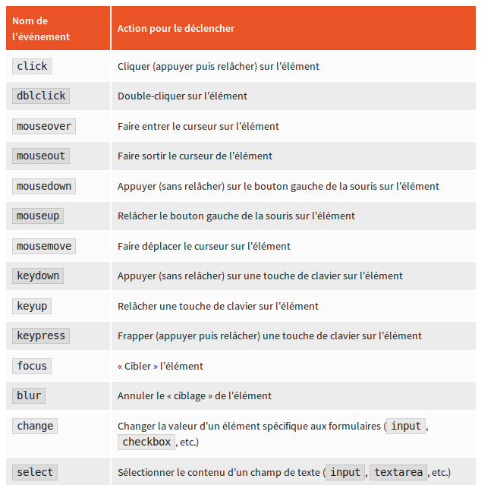
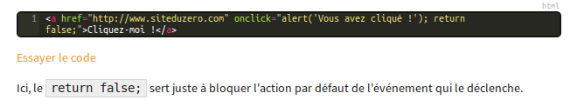
DOM-0 : <tag onclick=”thing”>
element.onclick
DOM-2 (better):
element.addEventListener(“click”, function(){};)

The event object

The event object is accessible only when an event is triggered and gives you info on the latter. It is the “e” in the following code
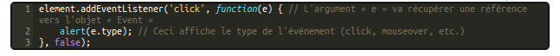
When we log “e”, we see that it has the following properties
You can access for example the X and Y coordinates of where there was a mouseclick with
e.clientX
e.clientY

Instead of using this.value, you can use e.target.value to select the element the event is targeting

Recuperer les touches frappées par l'utilisateur

There are three events here:

keydown
activates when you press a key

keyup
activates when you let go of a key

keypress
returns a key when that key is alphanumerical

Then, once you are listening to these event, get the code of the key by using
e.keyCode

This is a little in browser type writer that clears the text when you press suppr (46):
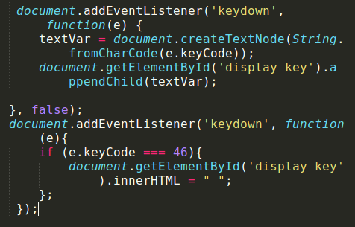
Inheritance problems

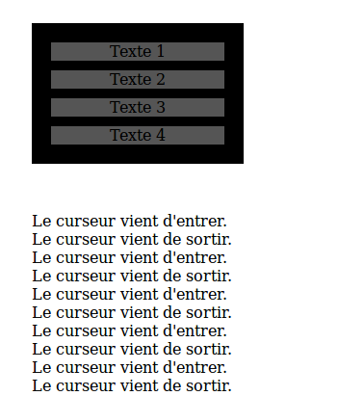
We can see the problem: the event is triggered each time we enter one of the child nodes. We need to brute force javascript into thinking that the target of the even is always the parent div (relatedTarget is a method that comes in handy here)

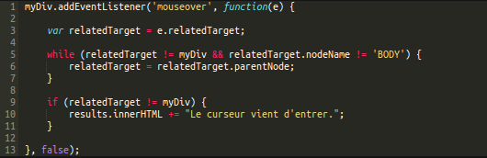

Forms

You can disable an input, making the text area grey
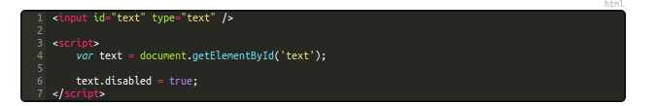
We can see the disabled property is a boolean

Radios:
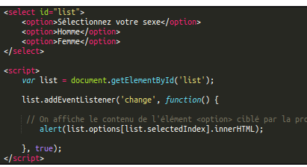
Notice how the event listener is set on change, since it is a radio input.

Methods that are specific to the form elements

Submit a form without the user pressing the submit button
=>element.submit()

reset the fields
=>element.reset()

CSS and Javascript

Instead of doing setAttribute each time, you can access a css property like a method for that elements
=> element.style.width = 40px;

But, instead of setting the style values, what happens when we want to get these values. It is impossible to access them simpy with element.style.width, because js doenst have access to the stylesheets. Instead, we are going to use getcomputedStyle()

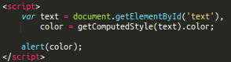
If you are looking for style attributes, use offset properties instead
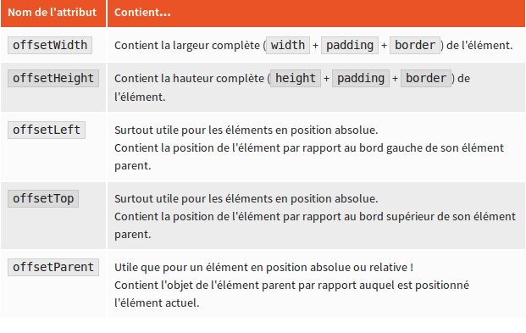

In this example, we have a square in absolute position inside another square, and we want to add the positions to get the absolute offset of the little square (otherwise, offsetTop and offsetLeft give us the offset inside the big square only

Draggable boxes exercise

There are two important parts:

- declare a buffer storage empty object
- select all the boxes
- looping through the boxes, add to each one of them a mousedown and mouseup listener.
- in the mousedown listener, if the mouse is pressed on the box, store it in the storage empty object. Create offsetX and offsetY variables that store the offset between the mouse cursor and the top left of the box (for esthetic purposes).
- in the mouseup listener, empty the storage object
- out of the loop, add a mousemove document.eventlistener. Inside, if there is an object in the storage object, make it that its left and top offsets be the clientX and ClientY

=>add css property to .draggable-boxes user-select:none; (moz, webkit and ms)

If filetype image then continue:
