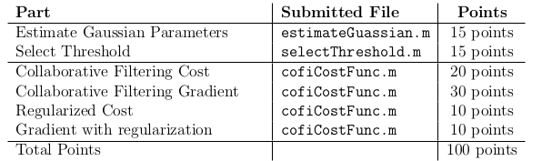
Anomaly Detection

Estimate Gaussian

Estimating parameters of a Gaussian distribution with a diagonal covariance matrix. We are working in 2D analyzing anomalous behavior in server computers. The features are bandwidth (mb/s) and latency of response of each server (ms), and there are m=307 examples

We use the fact that the sum function in effect sums all the row together, yielding a column vector, and that you can use the .- operand to sum columns of two matrices together
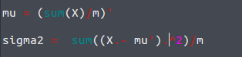

Estimate threshold epsilon

One way to determine which examples are anomalies is to select a threshold based on a cross validation set. In this part of the exercise, you will implement an algorithm to select the threshold ε using the F 1 score (2*P*R/(P+R)) on a cross validation set.

For this we will compute the fscore of the prediction that an example is an anomaly being correct, so we will need the true pos and false pos that (pval < epsilon). Fortunately, octave allows to create logical matrices
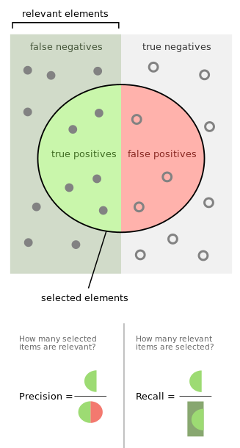
Creating logical matrices:
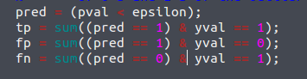

Note that we are only using one & for the logical comparison, not 2

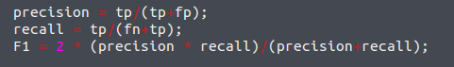

We are looping over the values of pval until we find the highest F1 score for the best epsilon
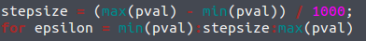

Recommender Systems

The objective of collaborative filtering is to predict movie ratings for the movies that users have not yet rated, that is, the entries with R(i, j) = 0.

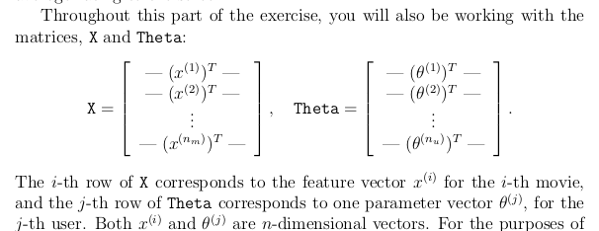
The cost function is just a simple double sum on the matrix of square errors with a twist, as we are only summing together values in the matrix for which the corresponding value in R is equal to 1 (so logical operation)

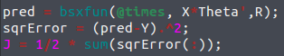

to avoid having to write a double sum we vectorize the matrix sqrError instead

Computing gradient

We then return both gradients at the same time. Notice that because these are derivatives, the x and thetas in the second member of the product in the sum are the inverse of what is being computed
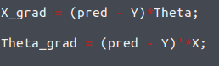
Now with the regularization parameters:
