Basic Operations

First we prototype in octave, then implement in Java, C++…

Logical operators:

not equal to: 1 ~= 2 => TRUE

AND : 1 && 2 => FALSE

OR: ||

XOR: xor(1,0). Is equal to 0 if an even number of features is equal to 1.

Creating a range:
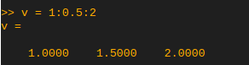

Generating a matrix of ones:
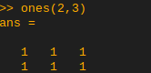

Generating a row of random numbers:
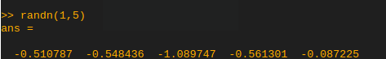
Generating a matrix of random numbers:
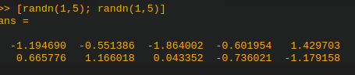

Display distribution of values in a matrix (hist(ans)):
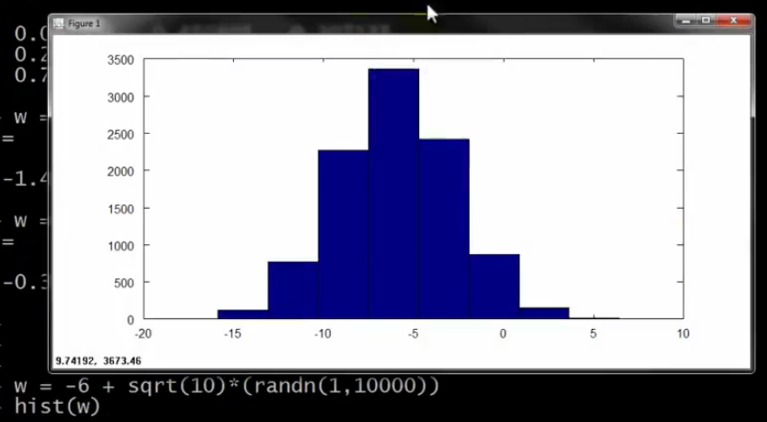
Display same histogram with more bars (hist(ans, 50)) :
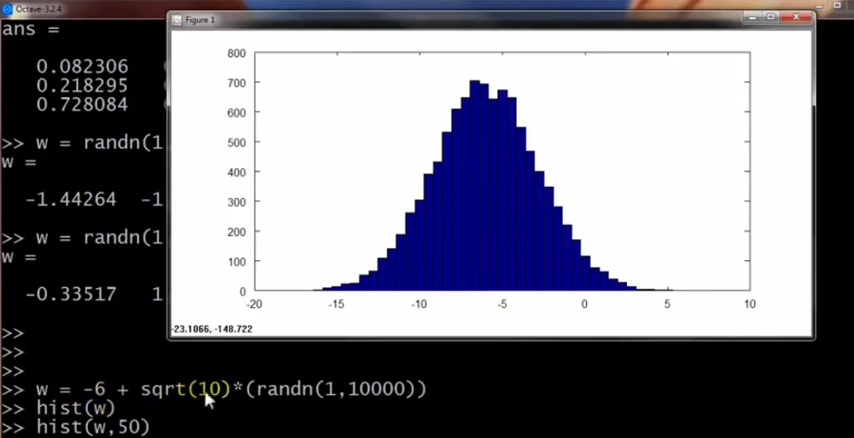

Generating identity matrix (eye(x)):
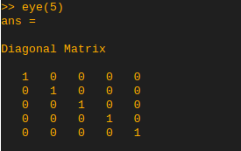

Checking size of a matrix: size(A)

Moving data around:
the terminal behaves like a classic terminal on linux with cd, ls etc.

Display current directory: pwd

Loading external file: Matrices come in .dat files and we simply use load command to load them

Displaying variables: who shows the variables currently in scope
whos gives more details

saving matrix or variable into a file: save file.mat variable

Display a value in a matrix:

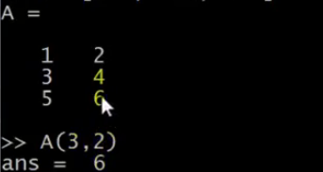
Display a column:
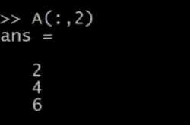
Append a column:
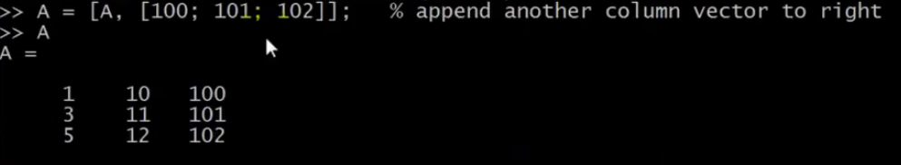
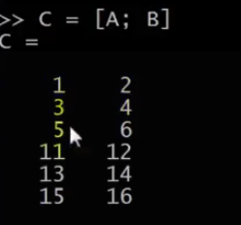
Append lines:

Computing Data

Multiply each element with the corresponding element of another matrix: A .* B
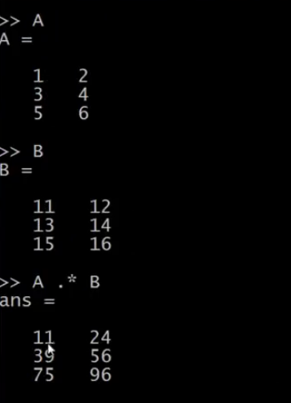
Element-wise divide: A ./ B

Increment all elements of a vector by one: v + ones(length(v),1)

Increment all elements of a matrix by one: A + ones(size(A),1)

Comparing each element to a logical statement: A < 3 (is Aij < 3, output [1 0 .. 1]
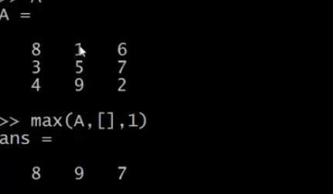
Take maximum of each column:

Plotting Data

Plotting several graphs at the same time:
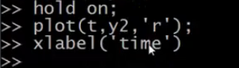

Represent matrix with temperatures in 2d:
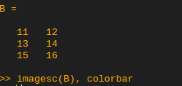
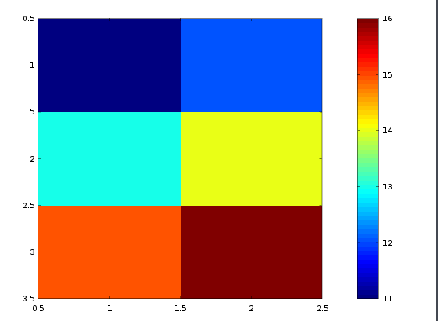

Functions

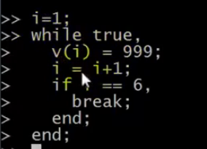
while loop:

Functions: functions are created in separate files .m extension

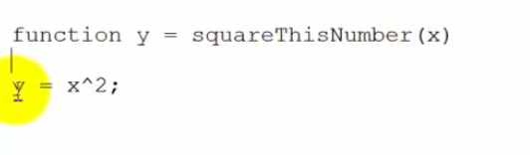
Note: the filename must be the same as the function name inside the file. Then as long as you are in the same directory as the function file in your octave terminal, it should recognize the function automatically

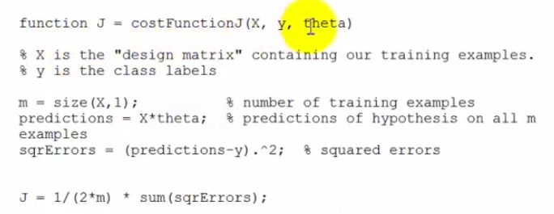
example: Cost functions

Notice that the sqrErrors are calculated by squaring each values individually, not the matrices themselves (cf the .^)

Vectorization: a sum of products can be seen as an example of vectorization

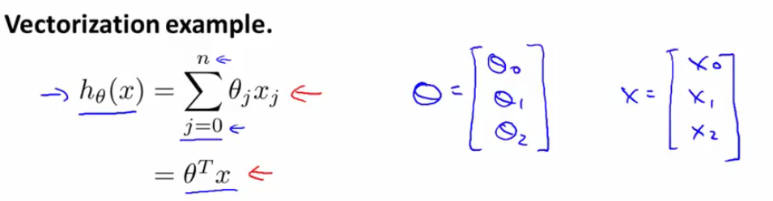
Note: for loops start at 1 for octave

Update algorithm for linear regression:
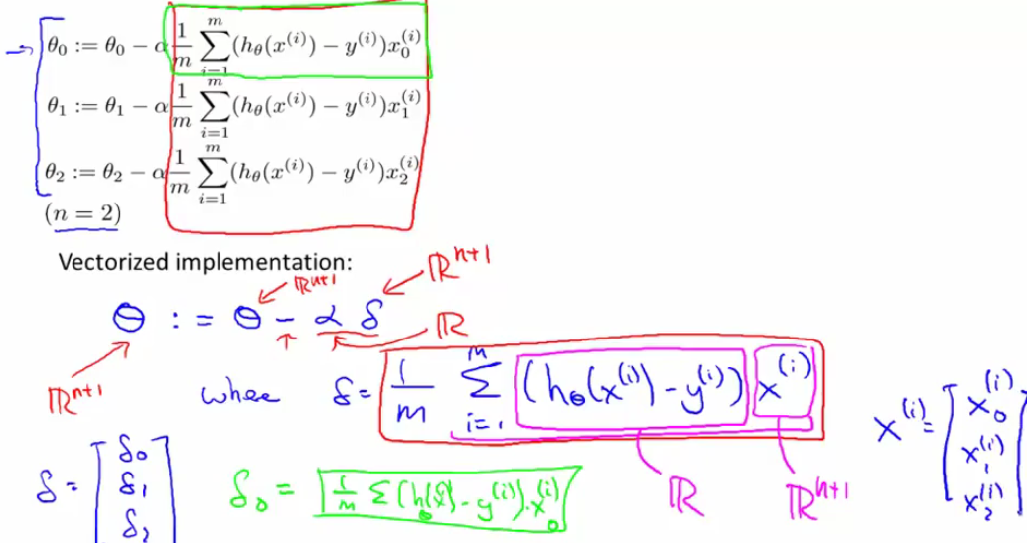
each xj(i) from 1 to m is one single feature taken for each training example. Each x(i) is the vector of all features for one training example. Theta is a function that goes from R^n to R, and y is a real number.

From this we gather that we first need to create a vector made of the values of the cost function for the m training examples (given by the sum for each X) and then multiply the

http://www.lauradhamilton.com/tutorial-linear-regression-with-octave
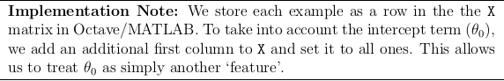
Initializing theta: we start off by creating a vector of zeroes of dimension n = number of features

