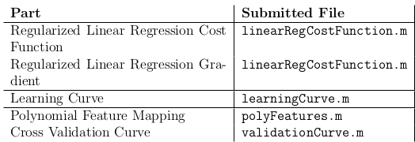
Objectives:
- Predict amount of water flowing out of a dam relative to water level in reservoir
- diagnose and debug learning algorithms (bias vs variance)

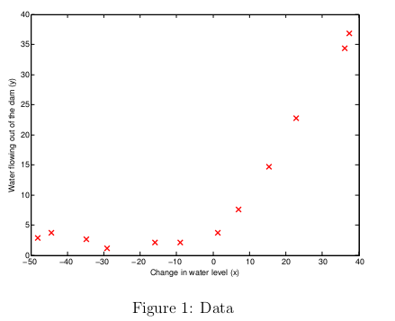
Note: an important concept in machine learning is bias Vs variance trade-of. Models with high bias are not complex enough and tend to underfit (training error and validation error both hig and close to each other), while models with high variance fit the training data near perfectly, but don't do so well in a real situation application.

Learning curve

How testing works with the learning curve is with are gonna use a for loop to train m (increasing the number of features each time by 1) models and see the errors for each of our thetas

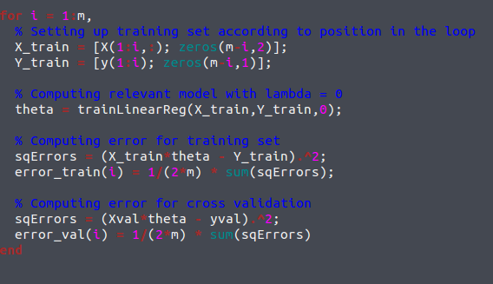
IN our case the model we chose is too simple, which produces a high biased result, so we are going to use a polynomial model (exhibit 2)
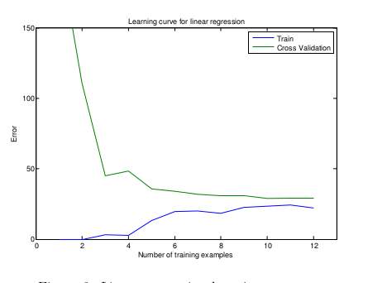
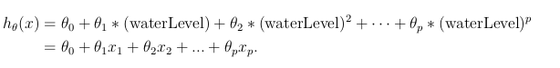
Note: Numel(X) returns the number of elements in X

Given a vector X, return a matrix X_poly where the p-th column of X contains the values of X to the p-th power
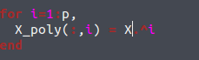

We now have a lot more features, using only one original parameter (water level).

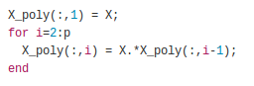
This function is a recursive way of achieving this.

This is a more direct approach
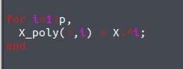

Now that we have done that, we have solved the high bias pproblem, but we have now a case of overfitting
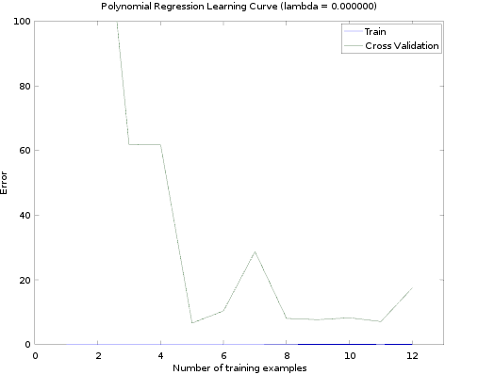
This requires normalization of the features

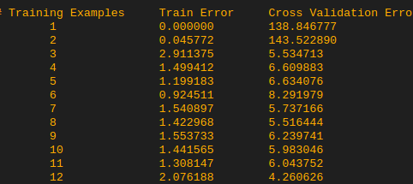
Plugging in lambda = 1 shows a better cross validation error progression

Whereas plugging in lambda = 100 shows that the model doesn't fit the data anymore (we have gone too far into underfitting again)
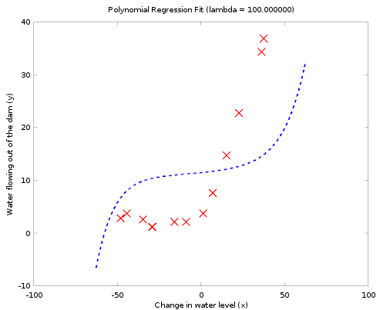
Evaluating a good lambda automatically

