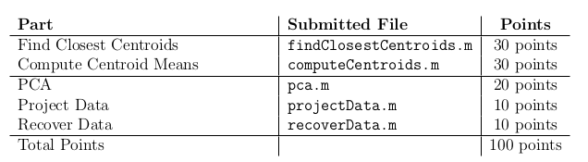
K-means algorithm

Find closest centroids and compute centroid means
We are going to apply K-means to a png image for image compression to reduce the number of colors to only those that appear the most often in the image. The K-means algorithm is as follows:

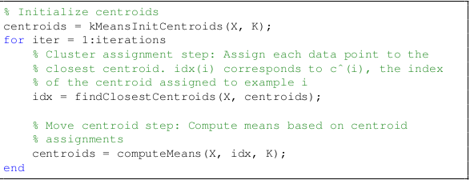
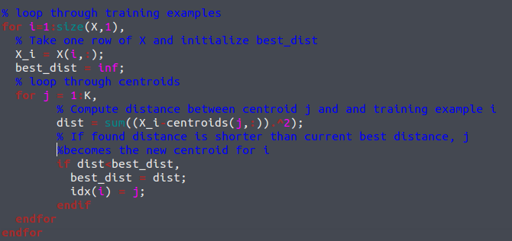
Next we compute the mean point of all the training examples assigned to a centroid

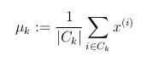
where |C| is the cardinal of the gorup C.

To implement a vectorial notation, we are going to use our trick from neural networks (create a binary matrix that stores in its positions which training example is assigned to which centroid)
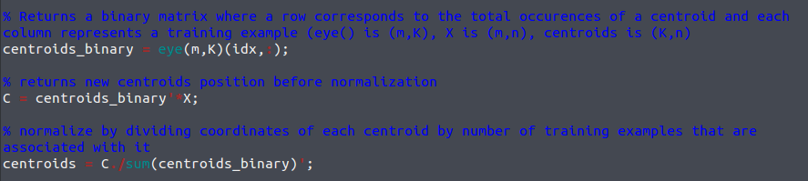
By doing this, centroids_binary' * X makes it so that for each row of the resulting matrix, we only sum together points that are assigned to the current centroid.

The whole algorithm is pretty simple and holds in a few lines
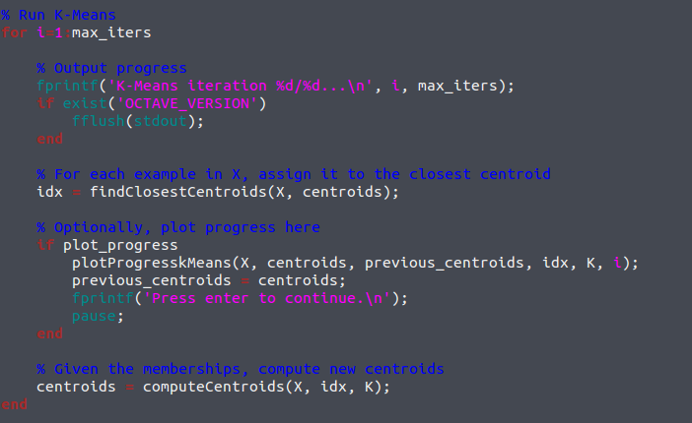

Random Initialization

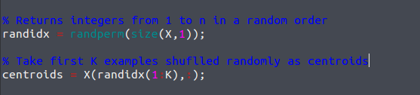
Image compression with K*means
In a straightforward 24-bit color representation of an image, 2 each pixel is represented as three 8-bit unsigned integers (ranging from 0 to 255) that specify the red, green and blue intensity values. (so matrix X is number of pixels X 3). Our job is to reduce the thousand of colors that appear to simply 16 colors (So it's a clustering problem where we want 16 clusters that group similar colors together). We'll store the RGB values of those 16 colors and for each pixel we store the index of the color in question

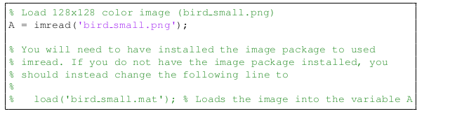
The previous code works as well with images, so it doesn't matter the dimensions of our problem.

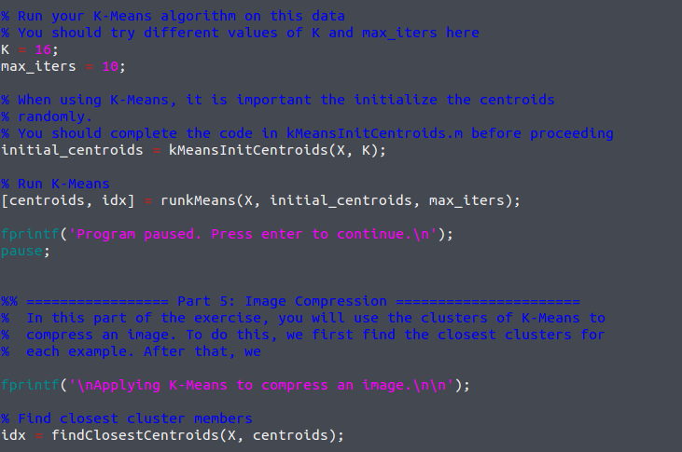
It can even run on our own images as such. Worth checking out.

Principal Component Analysis

There are (three) two computational steps: (normalize data), compute covariance matrix and compute+extract eigenvectors with svd().
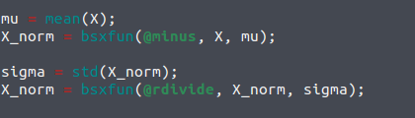

Note: the feature normalization is done through the bsxfun function, which Apply element-by-element binary operation to two arrays with singleton expansion enabled. IN the previous exercise, centroid normalization could look like this

Compute covariance:

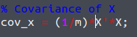
(cov is a nXn matrix where n is the number of training examples.)

Finding eigenvectors:

[U, S, V] = svd(Sigma)

Because we are in 2D, there is only one eigenvector.
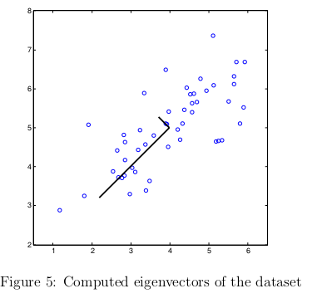

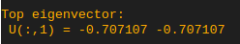
Project data

now, doing X * U(:,1) will yield z, a one dim vector that is the reduction of our original vector X.

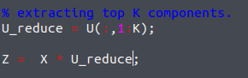

Recover Data (x_approx)

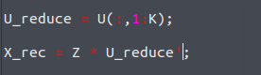
Note how we take the transpose of U-reduce in this case

Next parts (automatic)
In this part of the exercise, you will run PCA on face images to see how it
can be used in practice for dimension reduction. The dataset ex7faces.mat
contains a dataset 3 X of face images, each 32 × 32 in grayscale. Each row
of X corresponds to one face image (a row vector of length 1024).

Here are displayed the 36 most important variations for each photos (36 top eigenvectors), instead of having 1024 rows per photo originally
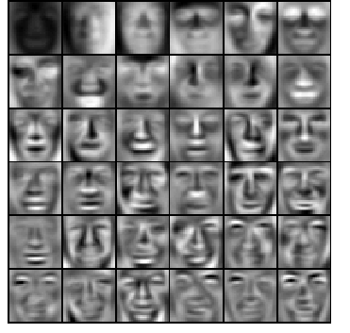
This is a remarkable reduction (more than 10×) in the dataset size that can help speed up your learning algorithm significantly.
For example, if you were training a neural network to perform person recog-
nition (gven a face image, predict the identitfy of the person), you can use
the dimension reduced input of only a 100 dimensions instead of the original
pixels.

PCA for vizualisation (nD→3D or →2D)

