Linear Regression

Provided you have the data in a two column matrix, set

x = data(:,2);
y = data(:,1); (first column)
m = length(x);

First, you need to write a function that plots the data:

plot(x,y,'rx', 'MarketSize', 10);
xlabel('your label for x');
ylabel('your label for y');

Next comes the cost functions

function J = costFunction(X,y,theta)

m = length(X);
prospects = X * theta

sqrErrors = (prospects – y).^2;

J = 1/(2*m) * sum(sqrErrors);

Then comes the time for the cost functions

function C = costFunction(J, theta)

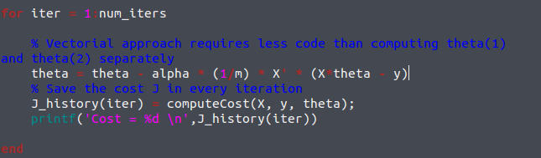
Multi-variable linear regression

The difference with a simple linear regression is that we are going to need to normalize the values for the features

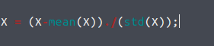
(it might be a good idea to store the mean and the std into separate variables for later).

Cost function for:

alpha = 0.3; num_iters = 50;

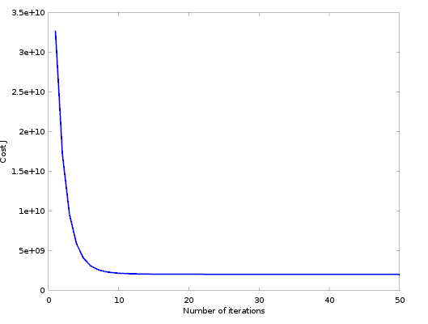
The shape looks good at first glance, but as we can see there is way too many iterations here (horizontal asymptote at x=10, very early)

alpha = 0.1; num_iters = 50;
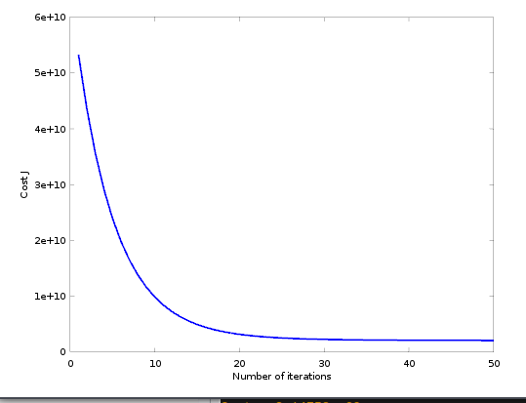
Seems legit.

IMPORTANT: It is important to remember that when you have your theta and are about to compute y for a given value of the vector X, you must remember to normalize that vector X as well with mu and sigma.

Stochastic

Because we are only computing one example at a time, we'll want to return a vector instead of a sum for our actualization of theta

Simple implementation computing each theta(i)
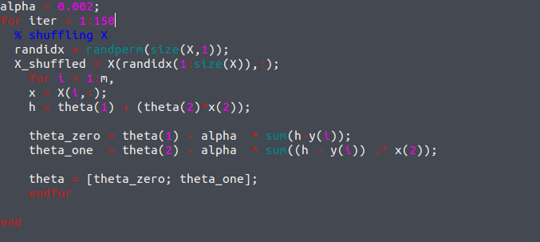
Be careful that alpha is really small

