That's right. All images are gone. Fuck. This piece of shit freetard-ware
And the fucking formatting. The text above was supposed to be in bold.

Logistic Regression

Plotting a scatter plot:
Plotting a scatter plot can be a bit tricky. First thing you need to do is define the classes (negative and positive) and find the training examples that satisfy them (y=0 and y=1)

Once we have classified our training examples, we can extract them from X. Remember for this part how we used to write X(:,1) to take the whole column (that's what the colon is doing). If we write pos instead of the colon, it will extract only the lines that satisfy y == 1

Sigmoid function for all types (matrix, vector, scalar):
Even though the sigmoid expression is fairly simple to implement, remember that it has to work for all sizes:

We are using the . Operator to conciliate scalars and matrices.

And by some ungodly miracle, it appears we got it right on the first try:

The cost function and gradient (we write both in the cost function file) are like this
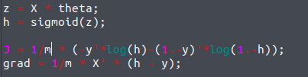
To satisfy this:
and this

Using octave fminunc instead of gradient descent:
Octave/MATLAB’s fminunc is an optimization solver that finds the min-
imum of an unconstrained 2 function (constraint as in p(y=1| c<5))

That's all you need to know. I guess.

Plotting decision boundaries:
This part will require conditional statements

Logistic regression prediction
This verifies the accuracy of our model

Case 2: predicting failure of chips
Given two datasets of manufactured chips, we want to predict what percentage will be in working order and what percentage won't.
We get the following graph

Here, a simple line won't be a good representation for the Decision boundaries. This is a case of underfitting, which means we will have to populate the model with more thetas (feature mapping). To do this, we multiply in every combination the x1 and x2 until we reach degree 6.

However, we are afraid we might have gonna a little bit too far. To avoid overfitting, we will regularize our cost function accordingly.

Recall that you should not be regularizing theta0 (so don't regularize theta(1) in octave)

To do this we are first going to truncate the first value of theta from the matrix ( shift_theta = theta(2,size(theta));)
and then replace that truncated value with zero (to keep the size): theta_reg = [0;shift_theta]
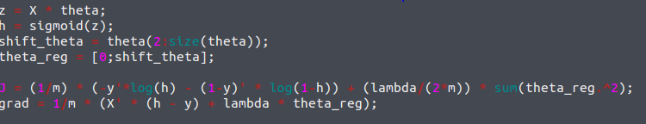

Plotting the data:

This is a classification problem, so we want to separate the data into positive and negative points. The data is plotted relative to the first coliumn of X (abcisses) and the second column of X (ordonnées), but we first need to separate y into a vector of positives and negatives (yi = 1 or yi = 0), we then compare each row of X1 and X2 to those vectors to only plot the relevant cases
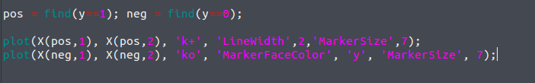
predict function:
We want to generate a vector p that takes the values 0 and 1 depending on the output of theta sigmoid. Concretely, what this will depend on is whether or not a given training example's output is above or below the threshold (here 0.5)
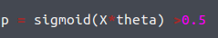

Regularized logistic regression
IN this example, the boundary is not a line, but a circle, and thus the dataset cannot be separated into positive and negative examples by a straight line.
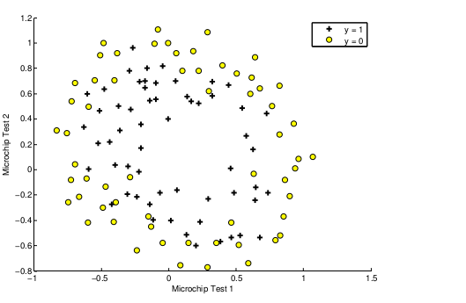
Therefore, a straight-forward application of logistic regression will not perform well on this dataset since logistic regression will only be able to find a linear decision boundary.
One way to circumvent this is to add more features by interweaving the existing ones together (Feature mapping)
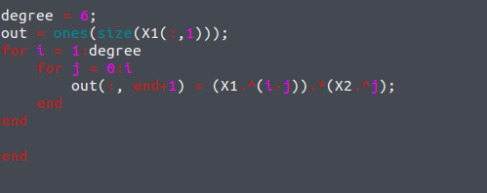
Code to map features quadratically
This allows us to build a more expressive qualifier, but the cost function has to be updated:

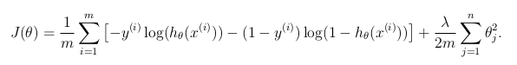
(the bias is not regularized!)

We obtain the second member of the equation with:
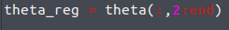
By taking all the rows, and the columns from the second one to the end.

