Feedforward Propagation and Prediction

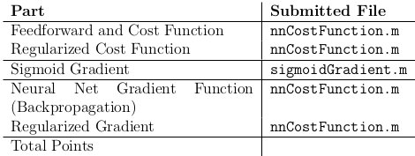

first let's dive into how the algorithm is implement to predict what value a training example will have. In this example the algorithm has already been 'trained'. We have two matrices theta provided, meaning there will be two layers. With each layer we have to remember to add a column or line of ones to account for the constants

the procedure is then pretty straightforward, as you multiply thetaI with the matrix and then apply sigmoid to it before starting it again with the next layer

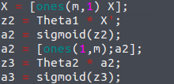
The reason why we apply sigmoid before going to the next layer is that we want to 'reset' the feature values before going from one layer to the next (by reset we mean set them to a value between 0 and 1). Eg the XNOR gates take the input of x1 and x2and pass them through first an AND gate (-30,20,20) , so the output is either 10, -20 or -30 . We want to reset it to a value between 0 and 1 before passing it to the NAND gate (30,-20,-20).

The final output is then the the one that corresponds to the maximum prediction in the label vector, ie the label that is the most likely correct
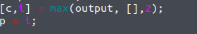
Backpropagation

We start off by computing the forward propagation algorithm
Which will then serve us to compute the cost function
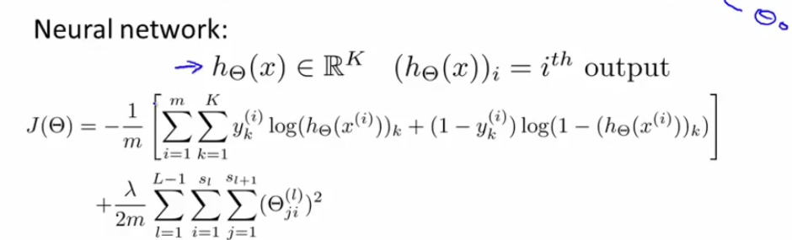
IN this case, however, we can't just multiply h(x) by y, because of all the different labels. We are going to transform y to be a binary matrix

This makes it so that ry is a training_set_size X num_labels matrix, and if y of the training set i is equal to 10, the first line will look like:
0 0 0 0 0 0 0 0 0 1 (← 10th position)

We then implement it into the cost function equation itself:
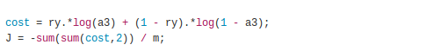
NOTE: the function sum sums only the rows with each other. IN case of a nXm matrix you will be left with a 1Xm vector
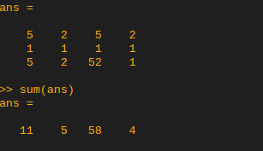
The regularized version is this:

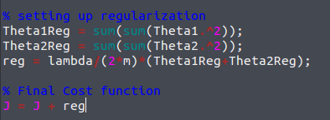

After completing the cost function, we initialize random weights:
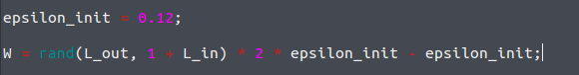
the size is indeed L_out for rows (output size) and L_in + 1 for columns (input size + the bias term we introduce through the activation). It is then time for the backpropagation algorithm proper:
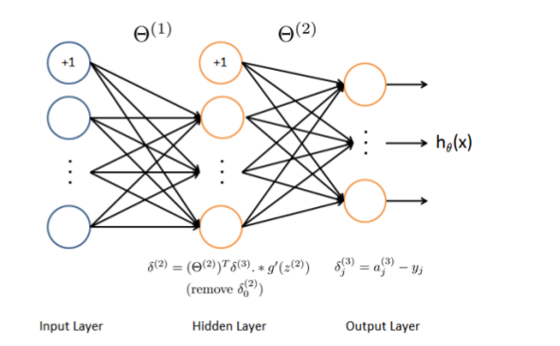
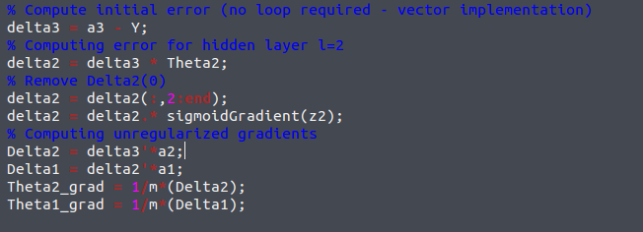

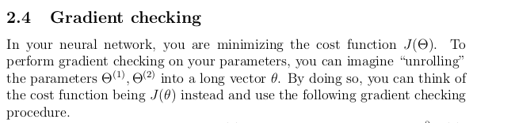
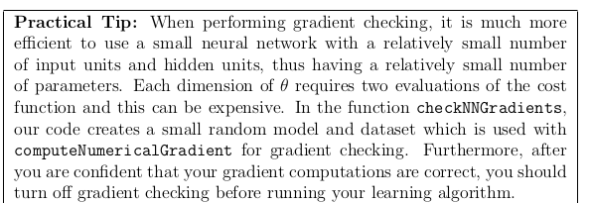

When regularizing, remember to exclude the first column of thetas (the bias terms) for the cost function AND exluding the first column of thetas and replacing it with zeroes in the gradient regularization
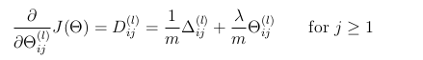

Notice j>=1

Note on hidden layers:
If we take our theta1 and discard the bias term, we notice that there are 400 columns; we can thus convert it into 25 grayscale images, which gives this representation:
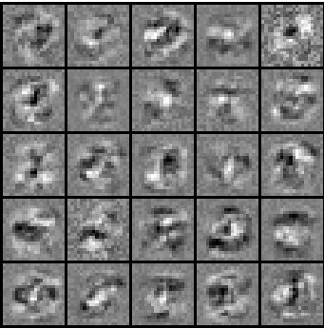
Visualization of hidden units.

