In this exercise, you will implement one-vs-all logistic regression and neural
networks to recognize hand-written digits.

Multi-class classification:
Note: if a data file has the extension .mat, it is already in a matrix state, so don't assign it to a variable (it will result in a scalar structure). Just input 'load(data)' and a new variable will appear

Each training example is a 20X20 grayscale image of a digit and each of those training examples becomes a row in the matrix X. Because this is a 20X20 image, each training example has 20^2 features (400), so the matrix is of 5000 X 400 dimension

The vector y has 5000 values labeled from 1 to 9 and 10 being replacement for the value 0

Because there are ten possible values, using one-vs-all, we will have to implement ten logistic regression classifiers, so we'll have to compute h(x) for each of those regressions.

At first we start by implementing the vectorized version of the cost/grad function for logistic regressions

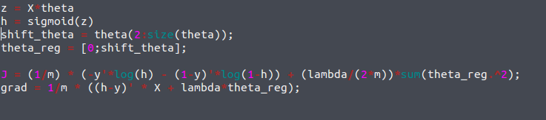
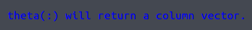

One vs. all:
First we compute the cost function and grad, then we us fmincg, another regression algorithm to compute thetas and then we test the thetas against the existing training examples. There must be one set of thetas per layer so the dimension of theta will be number(layers)*(features)

Careful with the cost function, it should look like this:
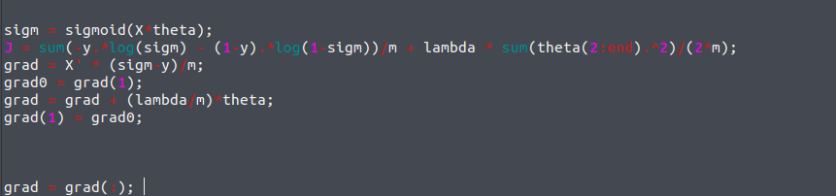
Before, when it was looking like this, it did an error
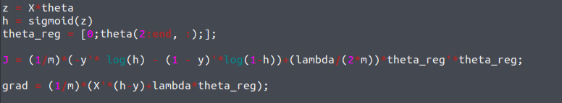
we see it is vital to store lambda(0) , here lambda(1) because octave starts counting at 1

Everything up to this point is identical to a classic logistic regression problem. The difference is that we will have to reduce the problem to a series of binary problems. To do this we will act on the y vector, and effectively transform it into logical vectors through a for loop
In each iteration of c, (y == c) returns a vector z where zij = 1 if yij was equal to the label c in its current iteration and 0 otherwise.

