Support vector machines

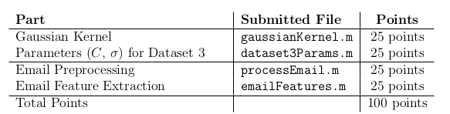

In the first part of the exercise, we are presented with a linear decision boundary classification problem in two dimensions, with the positive class having one outliner on the far left of the plane. Initially, that example is left out in the plotting of the decision boundary

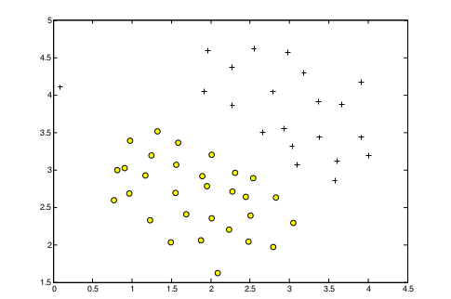
As we adjust the value of C to be higher, we lower the bias and the model takes into account that outlier, but the boundary doesn't seem right for further predictions.

Gaussian Kernels

You can think of the Gaussian kernel as a similarity function that measures the “distance” between a pair of examples, (x (i) , x (j) ). The Gaussian kernel is also parameterized by a bandwidth parameter, σ, which determines how fast the similarity metric decreases (to 0) as the examples are further apart.

We first write our gaussian transformation
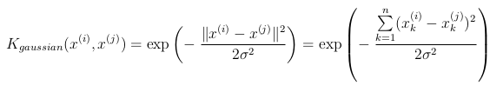
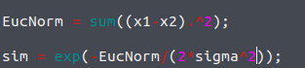
Finding best C and sigma

Using Xval and Yval (cross validation set) we will now try to set the best C and sigma. First we set best error to inf, the we loop through the combinations of several values of sigma and C (incrementing by a factor of 10)
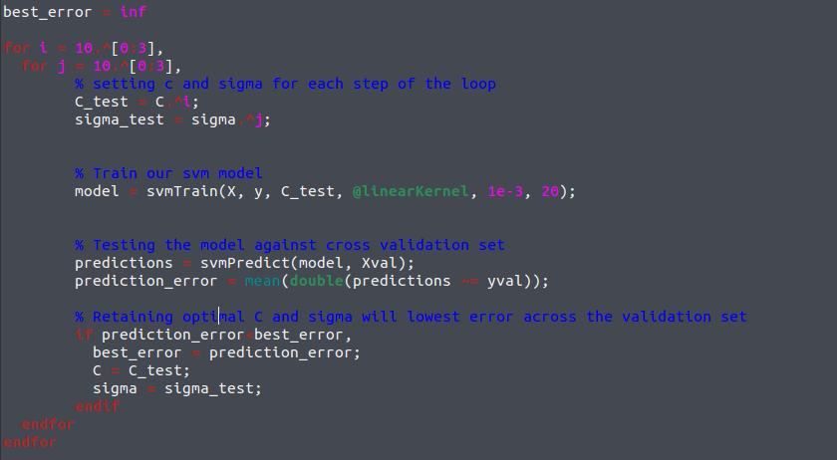
The prediction error is the Fscore?
Spam Classification

http://spamassassin.apache.org/publiccorpus/

example of a spam msge
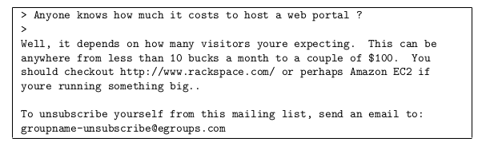
Normalizing values: we replace groupname-….org by “httpadr” as a property, 100$ by 'dollarvalue', etc. The presence in a msge of those newly created properties are what is going to define whether or not it is a spam.

This has the effect of letting the spam classifier make a classification decision based on whether any URL was present, rather than whether a specific URL was present. Here is what we do before hand (processEmail.m)
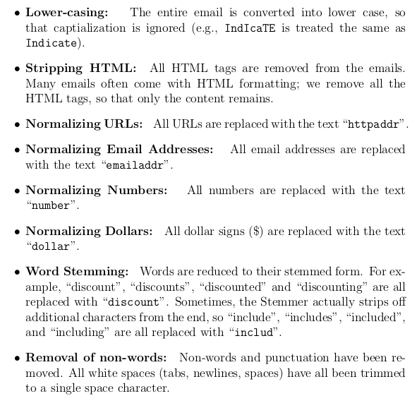
This is how the mail looks like afterwards
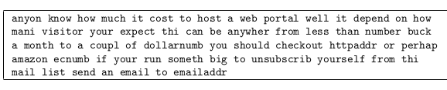
Using a vocabulary list of several thousand words, we map each word in the message to its index in the list
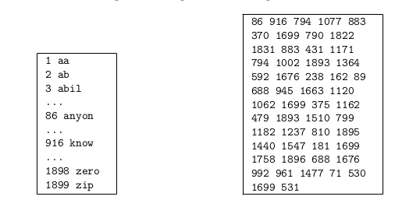
The code looks like this

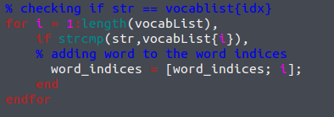

Extracting features from emails

We will have n features, where n is the number of words in the vocab list.
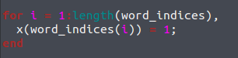
The next step of ex6 spam.m finds the parameters with the largest
positive values in the classifier and displays the corresponding words (Figure
12).

In other words, it looks at the theta and extracts the features which have the highest parameters: these are the best candidates which presence will determine whether a mail is a spam or not.

