Import numpy as np

matrix : np.array[(1,2),(1,2)]

Getting first N integers in an array:

a = np.arange(15)

reshape array into matrix

a = np.reshape(3,5) (3 rows 5 columns)

Create a matrix n,m with random values

a = np.empty((n,m))

Shuffle a matrix

Take random integers as indices, inject x into random indices
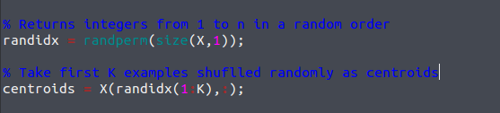
Return dimension of matrix
if matrix is [n m] dimension, X.shape[0] returns n and X.shape[1] returns m

Concatenate two matrices
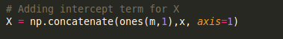

axis = 1 makes it concatenate columns, else lines

Logistic Regression

in this example we'll focus on maximizing the log likelihood instead of minimizing the cost function
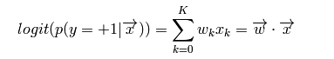
Logit is the logarithm of the odds for an event of propbability p

Cross validation:
we set aside 1/K * N samples from dataset (heldout data) fold splits a vector or matrix between heldout and remaining portion
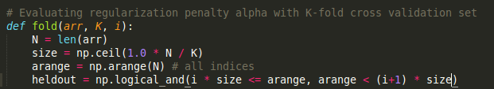
argmax() En mathématiques, l'argument du maximum, noté arg max ou argmax, est l'ensemble des points en lesquels une expression atteint sa valeur maximale. If you build an np.array [someFunction(arg1…)] and summon all_arg1.argmax(), it will return the value in all_arg1 that maximizes someFunction

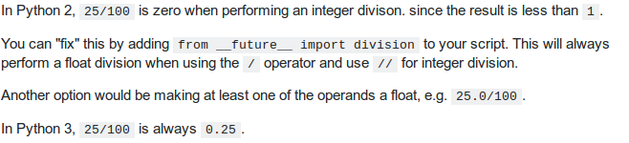
Predicting accuracy
Zip:
Takes two tuples as parameters, returns merged tuples
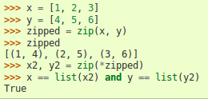

Getting current dir:
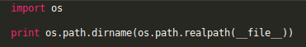
List files in a dir and puts them in a list

Reading files:
with open(file) as f

is better than open(f) because it automatically opens and closes the file

np.roll

Rools elements around a pivot in an array
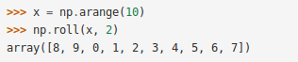

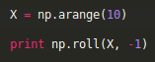

If multiarray, swaps either rows or columns around a pivot

Changing values in a list:
for index, value in enumerate(list)

Changing each string in a list to int:
list = map(int, list)

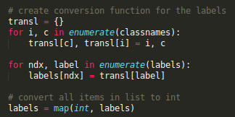

See methods of an object:
object.__dir__
OR
dir(object)

