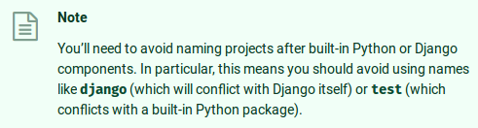

Well fuck

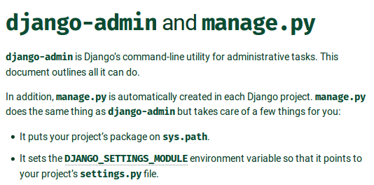

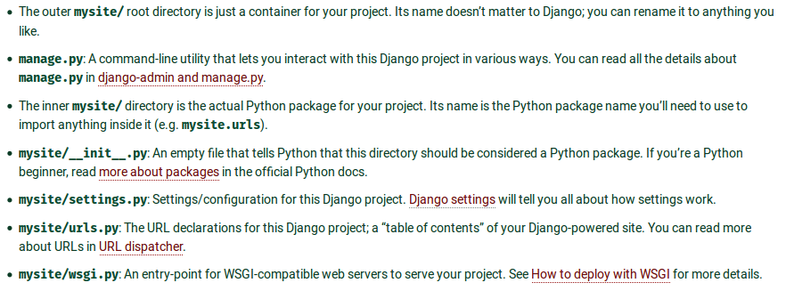

→ Create an app (~ symfony's bundle) within the project
→ views.py returns html code and is mapped by urls.py

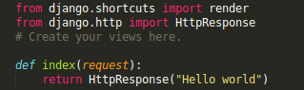
app/views.py

app/urls.py
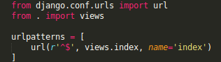

project/urls.py
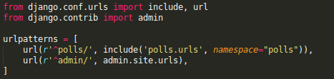

The urlconf module is given a namespace (to avoid crashes in the future)
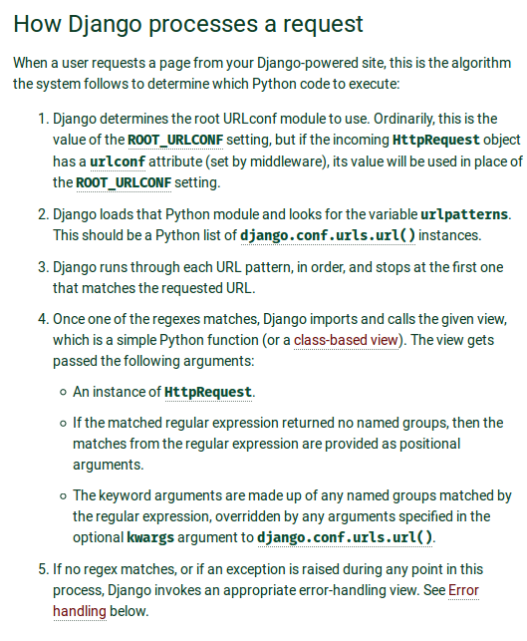
URLs from inside an app are groupped in an urlconf module that can be included in the main project's urlconf
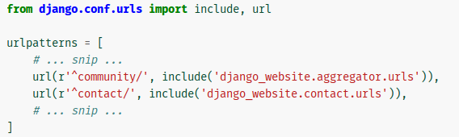

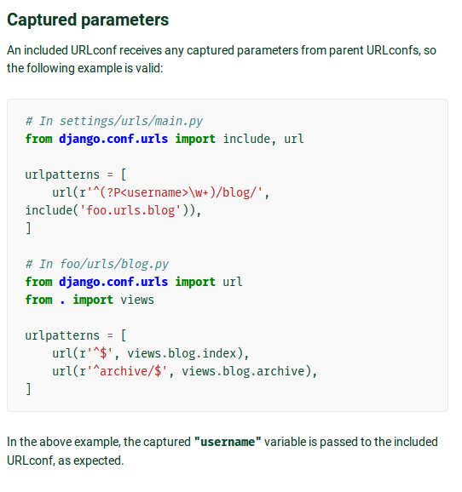

Database

Model definition at app level (two tables)
polls/models.py
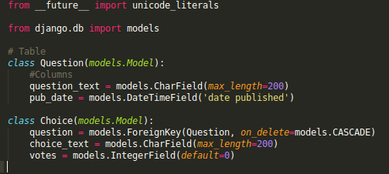
Model indexation at project level
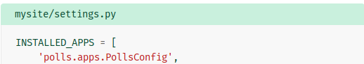
Activating migration
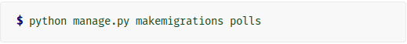


Evolved models with basic repository
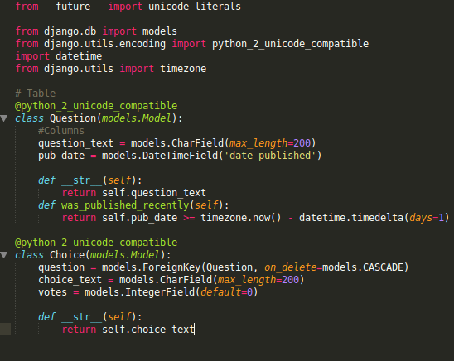
accessing db through python manage.py shell

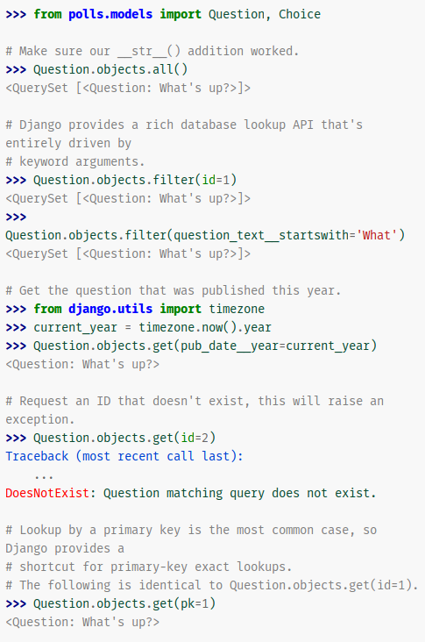

Views

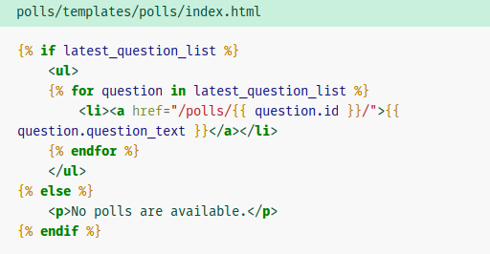

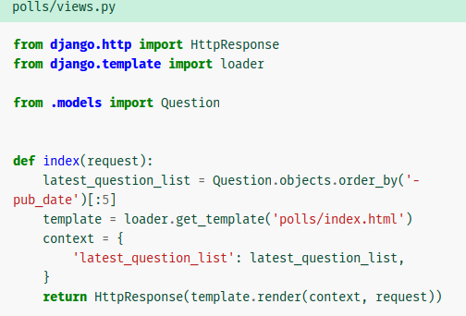

Form Processing
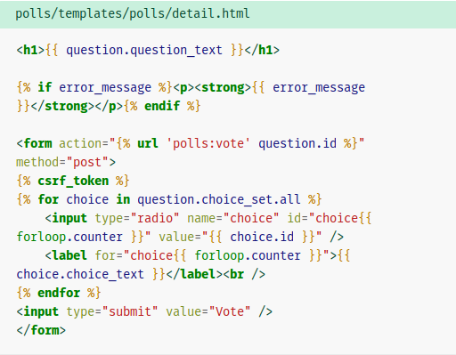

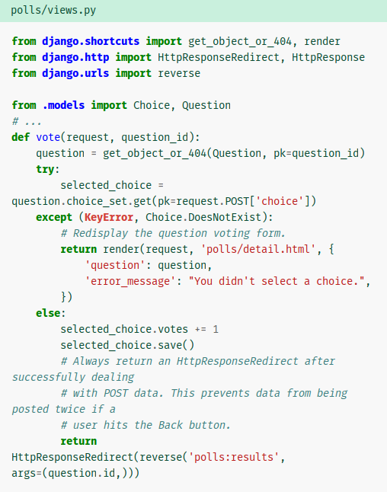

TESTS

Writing automated tests script
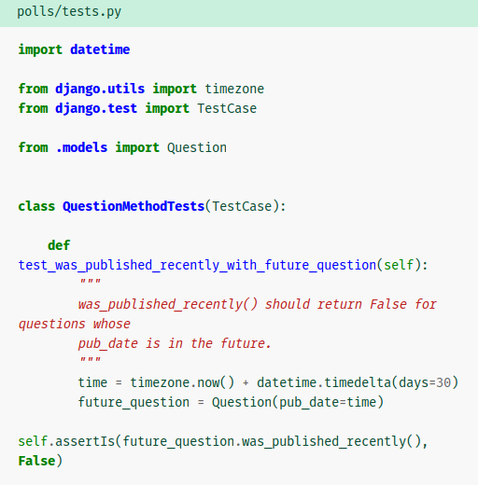
firing off tests scripts


tests views
