Basics

→ install virtualenv

→ setup virtualenv in folder

→ install flask
→ create controller file and __init__ file
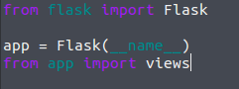
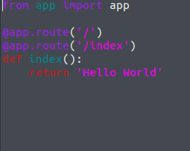
app/views.py app/__init__.py

→ create server script
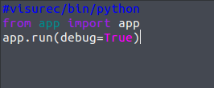
run.py

Deploying to Heroku
→ install gunicorn
→ edit the procfile

