After installing, type
symfony new siteName
And change the authorization for symfony
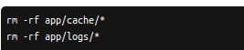

this will clear the logs. Then
HTTPDUSER=`ps aux | grep -E '[a]pache|[h]ttpd|[_]www|[w]ww-data|[n]ginx' | grep -v root | head -1 | cut -d\ -f1`

sudo chmod +a "$HTTPDUSER allow delete,write,append,file_inherit,directory_inherit" app/cache app/logs
sudo chmod +a "`whoami` allow delete,write,append,file_inherit,directory_inherit" app/cache app/logs

grep is used to search and match the text in brackets
ps aux returns the command line of a process.

If that doesnt work, just write
chmod 777 -R app/cache
chmod 777 -R app/logs
Application folders
/app/
Does not contain any of the source code, but the routing, the logs, the config
/src/
this is where the source code is, it is the logic of your website
/dev/
all the libraries you are using are stocked here.
(ex: swiftMailer is a library that helps you send emails.)
/web/
all the files that will end up being visible to the public.

We'll mostly work in /src/ and /app/.

Frontal controllers
There is one we know very well: index.php. But Symfony has 2. The first one is called app.php (it is the “prod” version of the frontal controller), it is used to load th page, the second one is app_dev.php.
For example, the “dev” version of the site gives you access to the profiler, which can trace IP behaviour, provide help in case of exception and so on.
/web/app_dev.php/_profiler/
While working on the site, we will pass by the app_dev.php controller.
If there are bugs in the prod version, you will have to check the logs in
/app/logs/prod.logs
Here is how a request is processed in symfony, when the user asks for a URL called “/patform” (for example), and the data we want to display are some kind of adds (annonces)

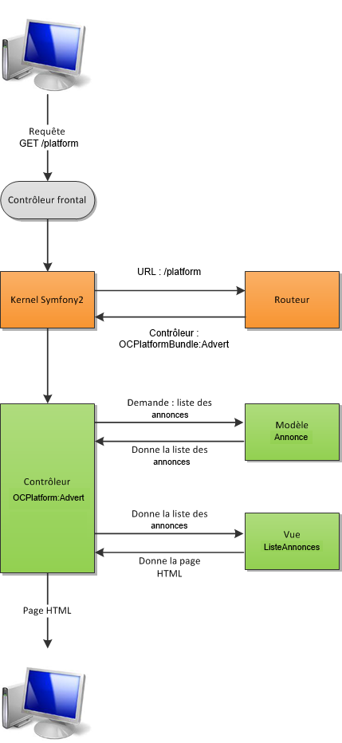
Bundle
A bundle is a controller-model-view trifecta that affects only a certain part of the site: you can have a bundle users, or a bundle forum.
Each bundle will contain a full stack directory tree, managing dependency injections, controller, views
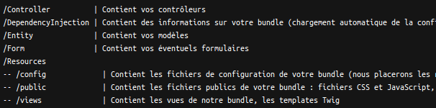
config is where routes will be for example.
Creating a Bundle
Bundles are created via the console. A bit tedious to be honest, each command has to be prefixed with php app/console apparently (it runs the script app/console.php that links our app to the terminal). The code for creation of a bundle is:
php app/console generate:bundle
The first step in creating a bundle is defining its namespace. It should have a specific name, like vendor\Bundle\Bundle_name (instead of vendor you can put your company name or whatever.)
When asked for the format of the bundle, yml is a good choice!
You can now see the structure of your new bundle (called OC/Platform)
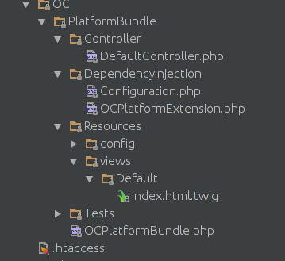

sudo chmod -R 777 src/Bundle
-R makes sure all the files and folders inside src/Bundle are also unlocked.

So what happened during the creation of the bundle? First, symfony got into a talk with the kernel and declared our new bundle to him, and the kernel decided to acknowledge him (you can see he did in the definition of the registerBundle() function (app/AppKernel.php), ours now proudly appears.
Then, symfony creates routes for our bundle. Each bundle has its own route, and the only one we have now is the one that makes the site go “hello world!” on index when we write /hello/{name} in the adress bar.
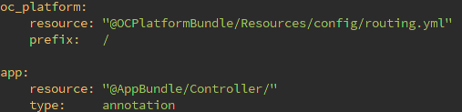
Below that we have specified to which bundle this route refers to.

Routing
The routing file in symfony allows you to rewrite URL script side.
We are going to learn how to do a mapping file of the routes in a bundle. The file is located in Bundle/Resources/config/rounting.yml
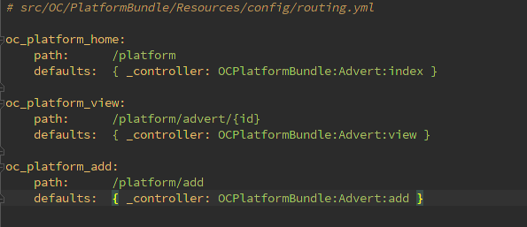
Twig templates
Twig is a variation on classical embedded PHP code, but we have come across it many times in websites coded in vanilla (prestashop).
Controller for the bundle
The router file tells the kernel towards which controller does a specific request lead.
Here is how the controller looks like
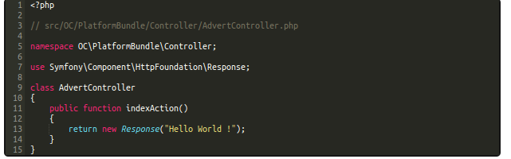
What happens? (line by line)
First of all, we put ourselves in the namespace of the controllers on line5
We are gonna use the object called “Response”, so we call the corresponding scrit with “use” on line 9
The name of the class has to be the same as the name of the file
our action (method) is supposed to be a response to a certain route. The convention of symfony is to name these methods with the name of the method (index) followed by -action in camelCase on line11.

OK, but there's not much we can do with that controller. The class is almost empty. Better extend that as being a controller object (line11). Now we can use the controller's inner properties and generate a response that is not just text, but a whole template we have created in views.
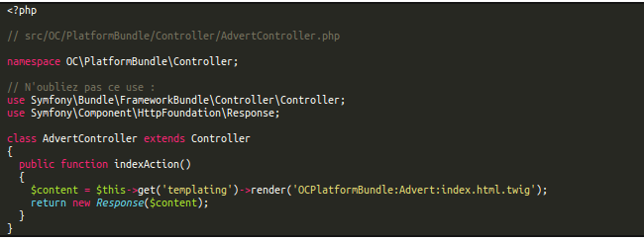
Notice how we have an object inside another object: templating is an object inside of the object Controller. Now let's spice things up and pass a variable to that method:
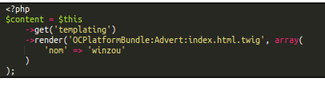
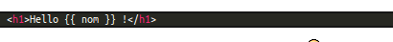
Cleaning the cache
After a set of modifications to your app, clear the cache to make sure they are taken into account.
To do this, type in the console:
php app/console cache:clear
php app/console cache:clear –env=prod

Routing: advanced
Le paramètre {_locale}
Lorsqu'il est utilisé, il va définir la langue dans laquelle l'utilisateur souhaite obtenir la page. Ainsi, si vous avez défini des fichiers de traduction ou si vous employez des bundles qui en utilisent, alors les traductions dans la langue du paramètre {_locale} seront chargées. Pensez à mettre un requirements: sur la valeur de ce paramètre pour éviter que vos utilisateurs ne demandent le russe alors que votre site n'est que bilingue français-anglais

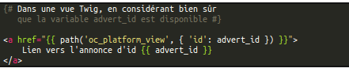
Passing variables GET, POST and COOKIE through the controller
We sadly can't use the $_POST, $_GET etc. Instead, we are going to use the request module
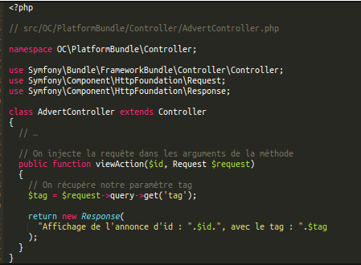

Type de paramètres | Méthode Symfony2 | Méthode traditionnelle | Exemple
Variables d'URL | $request->query | $_GET | $request->query->get('tag')
Variables de formulaire | $request->request | $_POST | $request->request->get('tag')
Variables de cookie | $request->cookies | $_COOKIE | $request->cookies->get('tag')
Variables de serveur | $request->server | $_SERVER | $request->server->get('REQUEST_URI')
Variables d'entête | $request->headers | $_SERVER['HTTP_*'] | $request->headers->get('USER_AGENT')
Paramètres de route | $request->attributes | n/a | On utilise $id dans les arguments de la méthode

For instance, if you want to send out info via a form from A to B, you create a request handler called $tag and pass it as parameter in response
Cookies

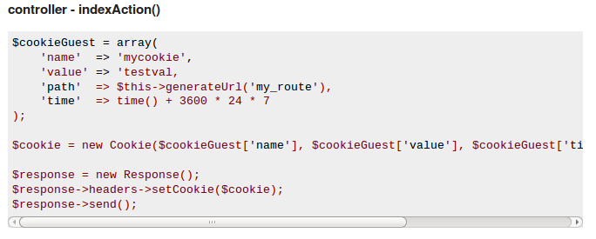
cookie creation ^

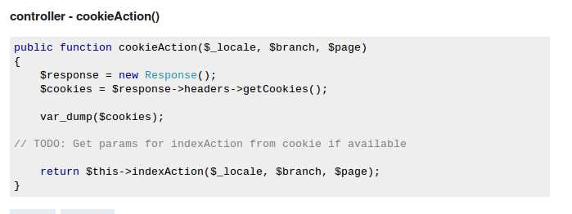
Cookie retrieval ^
Sessions
Create a session using →getSession() method
Destroy using →invalidate() method
If you want to redirect to another page, stack the url in a variable a create a new object Redirect response
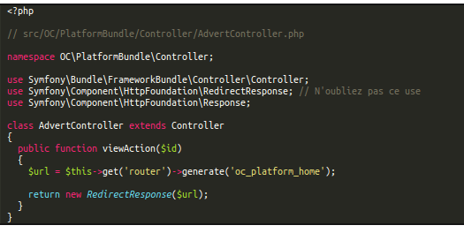
Conditionnal redirection
It's super useful. Now we have a page that displays the info you entered via a form. But what happens if someone tries to access the page via another type of request, without passing by the form? To remedy this:
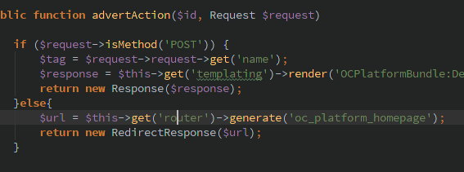
oc_platform_homepage refers to the route in routing.yml
Sending json format
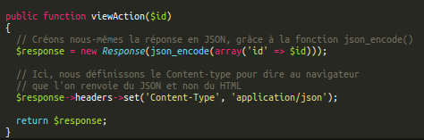
Manipulating a session
Sessions are treated through the request object
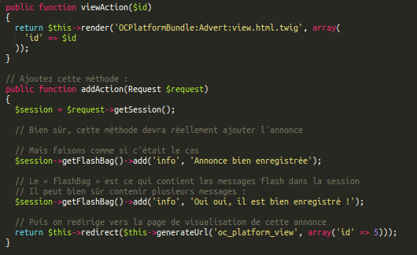

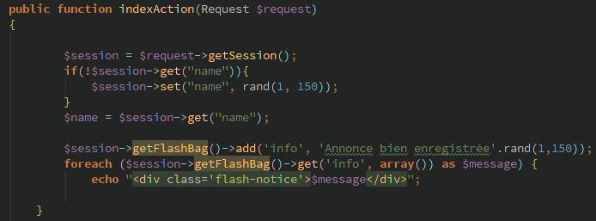
Twig templates
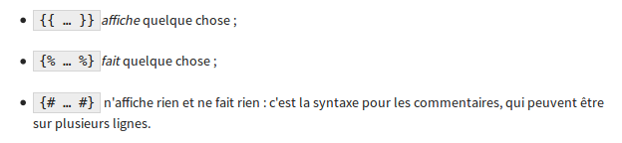
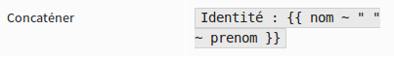
You can set up global variables that will be accessible throughout all of your twig templates
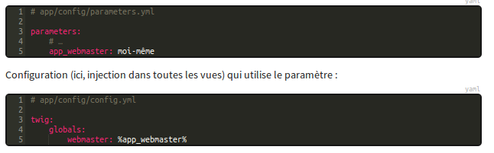
That bullcrap doesnt work. ^
Using a {% for … %} loop allows you to access certain properties of that loop directly in the tempate
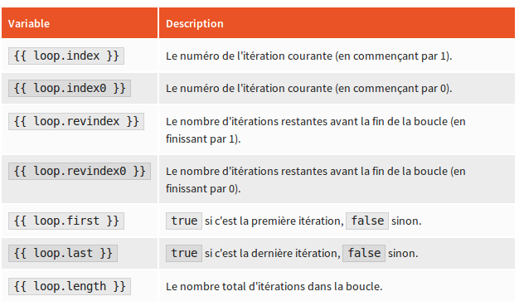
Checking whether a variable is defined
=>

Template inheritance
You can define a main layout template and include other so that each subsequent twig template only contains the minimum data necessary.
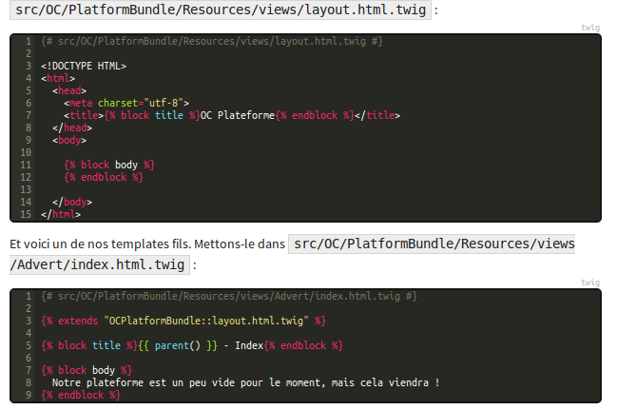
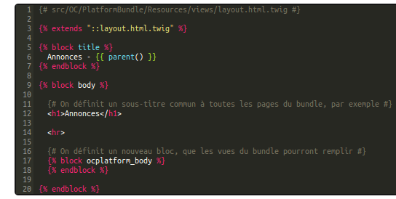
Case 2 : extends general app layout
There is a double inclusion there in the title part, {{ parent()}} displays OC plateforme while being included in the generic {%block title%}
You can even define a meta layout that will be the same for all your bundles
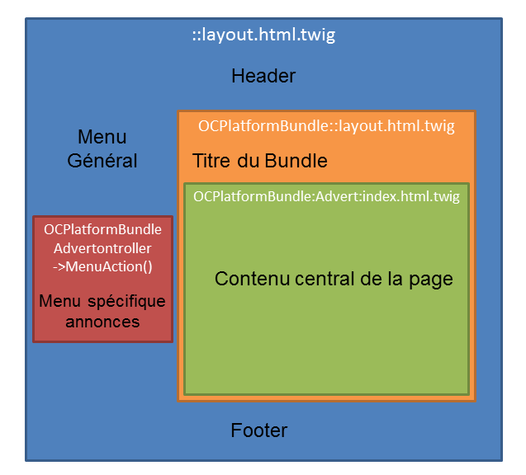
If a sub-layout will be present in many different pages (ex: add/ and edit/), we use include instead:
Twig allows another very powerful feature: you can include controllers. That way you can declare variables and get data in a controller independently of the routing controllers and separate these two tasks
Services
Services are created in two places:
first, in Bunlde/config/services.yml
There, you declare the service and its namespace and send him the arguments needed. Here we are sending the service swift mailer, the language, and the min length of the message
Second, you define the class. We can see that the three arguments correspond to the ones we passed in the yml file
dependency injection
The first argument in the yml is @mailer. That is because we are asking for the help of another service in our service. It's reflected in our service script by the inclusion of the namespace in front of the first argument.
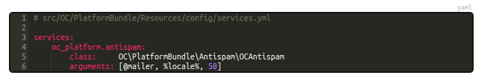
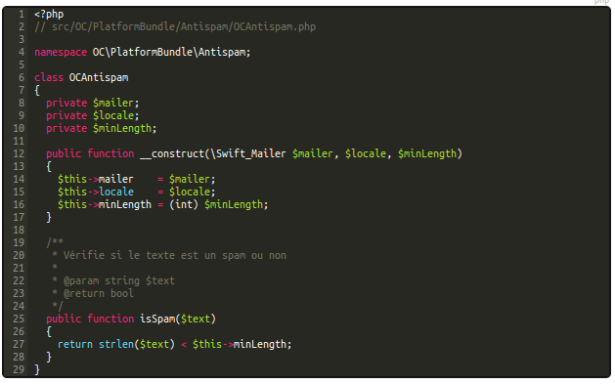
How do we call this service?
We declare it in our controller, in the controller action we want.
To do this, we will need to create a new object from the class of our service, and by doing so, will have access to all its methods.
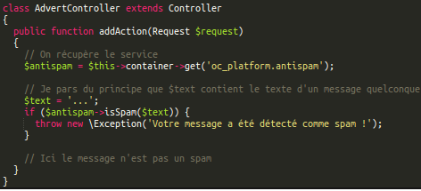
We are “getting” the antispam service from the service.yml file, just as we get our controller action depending on the url in routing.yml.

Databases
Db transactions are fully managed by Doctrine2 in symfony (Doctrine si an ORM, or Object Relation Mapper). It allows you to pass requests as simply as writing a method
$orm→save($user) INSERTS a user for example. Whenever you want to create a script that will interact with the database, you in fact are creating an entity, a class that will hold all the information about how the script should interact with the table, how the table is constructed, etc. That class uses commentaries in order to function, and this is where you specify things like this column is an integer.
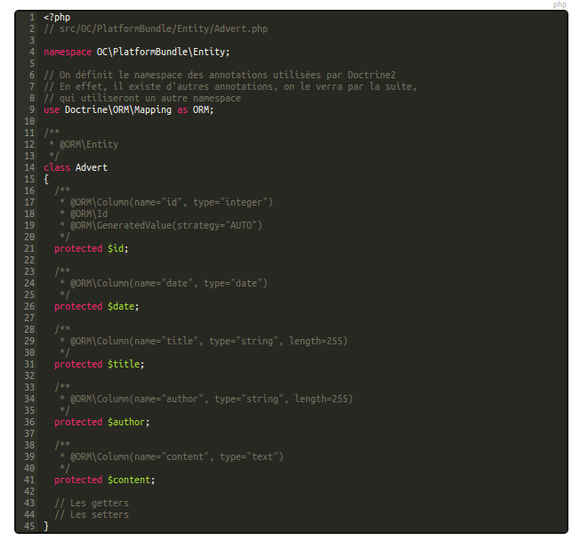

Normally its done with the console but if you do it manually remember to start your comments with two stars (/**) instead of one.

So how do you create an entity? With the console, once again. Type
=> php app/console doctrine:generate:entity
and follow the instructions. When asked to chose a format, a good idea is to do it in annotations (so it will be in the form of comments)
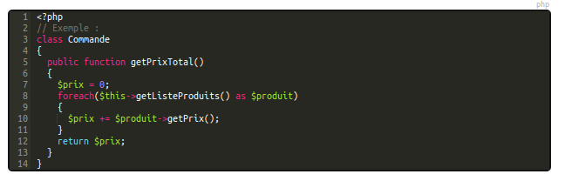
You can include (and it is recommended) in your class getters that include several parameters, like computing the total price of an order (business rules):

=> Create table
- Create entity using php app/console generate:doctrine:entity
- update database with php app/console doctrine:schema:update – force

See twig blocks

DQL (document query language)
=> table relations https://www.youtube.com/watch?v=HQ3-TocGYsc 55th min
Forms
there are two types of validation:
- front end (input submit), not to be trustred
- server side validation (prevents cross side request forgeries)

User Interface
IIn order to use this class in the security system, it must implement UserInterface. This forces the class to have the five following methods:
- getRoles()
- getPassword()
- getSalt()
- getUsername()
- eraseCredentials()
Serialize returns all the info of the instance of an object, but not the methods of the object itself. If you want to access the methods, you have to unserialize.
Implement AdvancedUserInterface in order to be able to ban people with the isActive property (if equal to 0, user still exists, but can't connect)
Allowing the user to login by username OR email:
(repository class)
$user = $this->createQueryBuilder('u')
->where('u.username = :username OR u.email = :email')
->setParameter('username', $username)
->setParameter('email', $username)
->getQuery()
->getOneOrNullResult();
Similarity between trigger in jquery and throw new exception in PHP
Also, we are gonna add a plainpassword variable to user object that won't be persisted.
Also, for the date joined, instead of adding hidden type with the current date, add listener to the form
Also, getting the current user with FOS is FUCKINg complicated.
Need to keep user authenticated when he leaves the profile page? Set the firewall to /* and add access_control rules (both role_user and anonymous for those pages) (http://stackoverflow.com/questions/16289164/my-website-home-for-authenticated-users-and-anonymous)
Redirect to previous route – user a referer
Symfony 3
- Now, it's bin/console instead of app/console
- You can encrypt hard coded users with console as of 2.7
- The UserLoaderInterface was introduced in 2.8.
- Route parameters now as controller arguments
- Use data transformer class to get user object from user id
DB Migration
IN prod use the migration bundle
https://symfony.com/doc/current/bundles/DoctrineMigrationsBundle/index.html
Na początek , król muzyki pop, Filip Kirkorow, chwilami awanturnik, niekiedy artystyczny oportunista, ale co za artysta. Piosenkę „Śnieg”, która przyniosła mu tegoroczną nagrodę rozgłośni Ruskoje Radio „Złoty Gramofon”, napisała ukraińska artystka o oczach koloru nieba Irina Biłyk. To smutna historia:
<italic>Kocham cię na zawsze... Na białym śniegu twoje ślady. Jeśli chcesz odejść, odejdź, jeśli chcesz zapomnieć, zapominaj. Ale musisz wiedzieć, że z tej drogi nie ma powrotu. </italic>
<video>https://www.youtube.com/watch?v=J0l0WFtA9Xs</video>
Życie bywa smutne, mówią nam niektóre dobre piosenki. Tak Ed Szulżewski o utraconym szczęściu: <italic>Już nie będziemy rozmawiać do rana o miłości, czekając na zorzę i tając ze szczęścia. Szczęście podzieliło się na części... Śliczne szczęście o imieniu Nastia, wkrótce żona innego.</italic>
<video>https://www.youtube.com/watch?v=Gt_WHxEUGGU</video>
Autorem piosenki o Nastii jest Denis Majdanow, którego zwykle nie opuszcza melancholijny nastrój: <italic>Pocisk leci, wolno, wolniutko, serce bije jak szalone, jeszcze nie boli ta kula, twoja kula, wszystko w swoim czasie…</italic>
<video>https://www.youtube.com/watch?v=5ie3aiD23HM</video>
Majdanow to wyborny głos do miłosnych rozterek, do czego zupełnie nie nadawałby sie głos Grigorija Lepsa, <bold><italic>одного из могучих грузинов</italic></bold>, którzy rządzą na rosyjskiej estradzie. To zresztą nie tylko sprawa głosu, o rozległej skali i byczej sile, ale także kwestia wieku i dojrzałości: tacy mężczyźni płacz zostawią młodzieży, nawet jesli im sie tylko tak wydaje. (Co bolało minęło) Grigorij zatem ułozy swe rozterki w niespieszną dydaktykę, udawaną nonszalancję, z jaka potwierdzi złożonośc kobiecej natury: Jesteś prawdziwą kobietą, raz chcesz, raz nie... sama ogarnieta paniką uczuc, mnie przywodzisz do szalenstwa. Stąd jednak juz tylko krok do deklaracji wojennej: jestes delikatna, głupia, grzeszna i z twarzą anioła...
<video>https://www.youtube.com/watch?v=rKjMlhmn9D0</video>

