An abstract class is a class which cannot be instantiated. An abstract class is used by creating an inheriting subclass that can be instantiated. An abstract class does a few things for the inheriting subclass:
- Define methods which can be used by the inheriting subclass.
- Define abstract methods which the inheriting subclass must implement.
- Provide a common interface which allows the subclass to be interchanged with all other subclasses.

AJAX and symfony
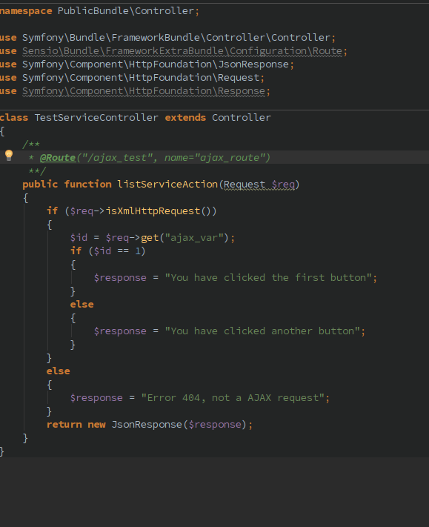
Just put the route, not the actual file (so here /ajax_test)
Then, using jquery (works), get the response. The controller for ajax is separate from the controller of the page you are on right now
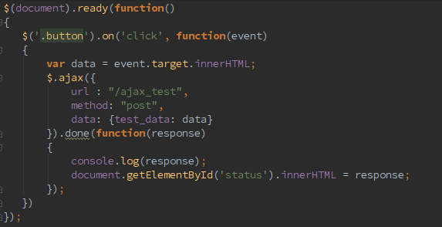

Building a login system:
- create protected bundle
- Create firewall
- create user entity
- create login, register forms

Create firewall
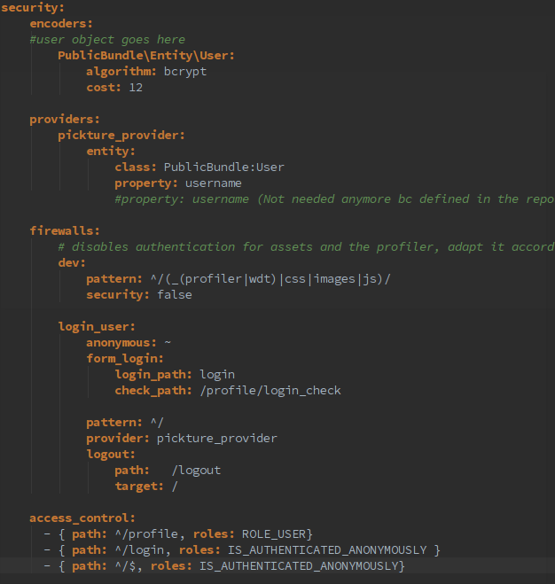
This goes to security.yml. Here we have created already the user entity and put a user with a hashed password

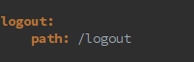
Don't forget to put logout route in routing.yml as well as login_check inside the protected zone
Controller:
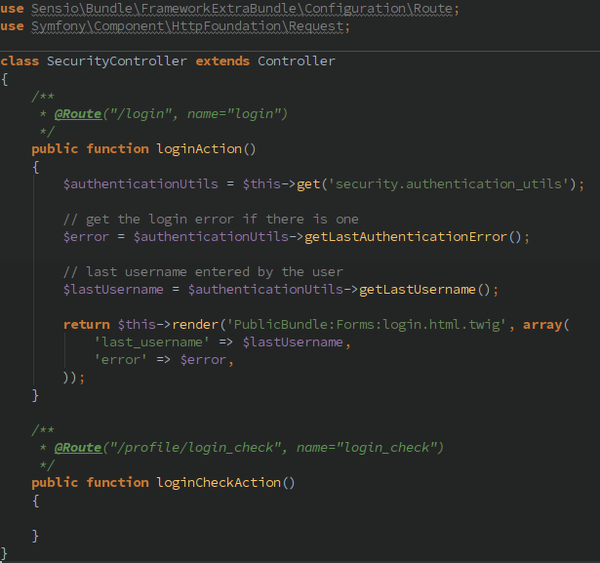

and finally the login form
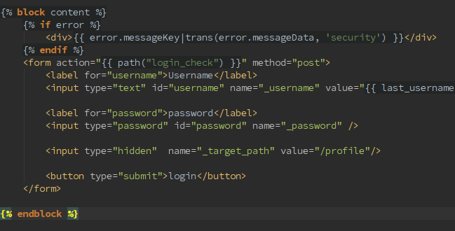
Custom User Interface

A user class must contain these five methods:
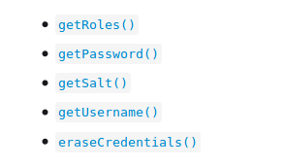
This is what makes the difference:
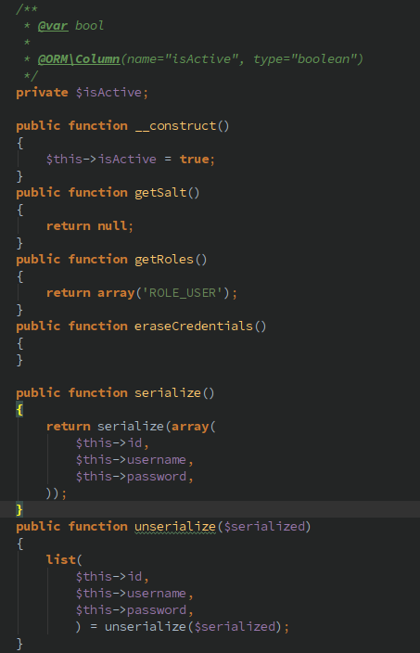

Create Register Form
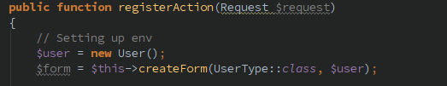
Usertype:
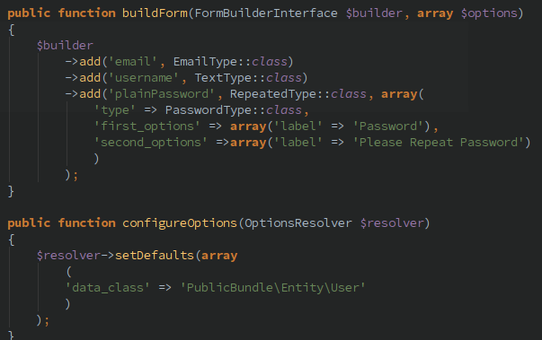
Listener:
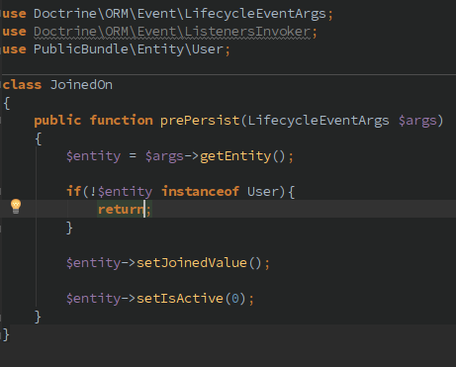

Swiftmailer
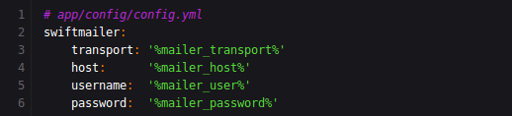

Then change parameter.yml
