Large Scale Machine Learning

Gradient descent with large Datasets

What makes today's models so much better is simply the staggering amount of data we have at our disposal.
Learning rates are important because they allow us to know by testing on small subsets whether gathering more data will help (high variance)
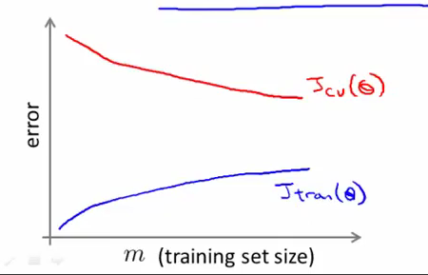
Or if something else will help (high bias)

Stochastic Gradient descent

Large datasets often can't be held in RAM, which makes vectorization much less efficient. Rather, each sample or batch of samples must be loaded, worked with, the results stored, and so on. Minibatch SGD, on the other hand, is usually intentionally made small enough to be computationally tractable.
This variation of Batch gradient descent scales much better for big datasets. While batch gradient descent works on all the training examples together at the same time to do just one step, we define the cost as being the sum of the cost function for each parameter theta
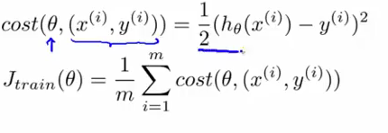
and we then randomly shuffle the dataset and perform the gradient descent loop

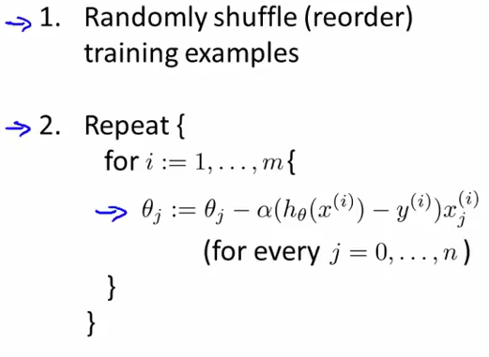
As we see there is a double for loop (which we repeat 1-10 times), so apparently it is still O(nm) running time. It will move inn a slightly more chaotic way, doing smaller and more random steps along the way
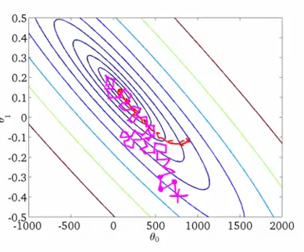
So while it looks like the same algorithm, the fact is that there are m more steps to a single iteration, whereas before you were updating the gradient with one whole sum at a time, now you are updating with one example at a time, which allows for more movement on the curve for the addition of that single sum. It won't converge, instead it will meander around the minimum. Single samples are really noisy, while minibatches tend to average a little of the noise out. Thus, the amount of jerk is reduced when using minibatches. A good balance is struck when the minibatch size is small enough to avoid some of the poor local minima, but large enough that it doesn't avoid the global minima or better-performing local minima. SO you are trying to find a good trade off between noisiness and computational time. SGD performs frequent updates with a high variance that cause the objective function to fluctuate heavily.

Mini Batch Decent

Somewhere in between the two previous algorithms.
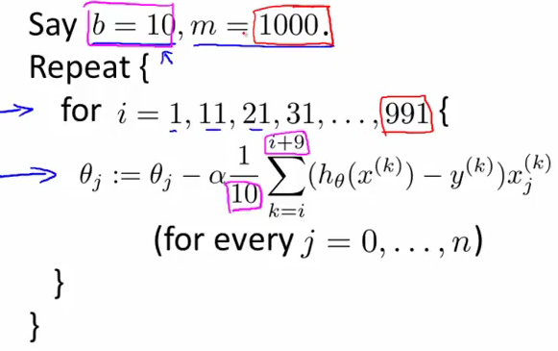
Notice the step here is from 10 to 10.

Stochastic Gradient Descent Convergence

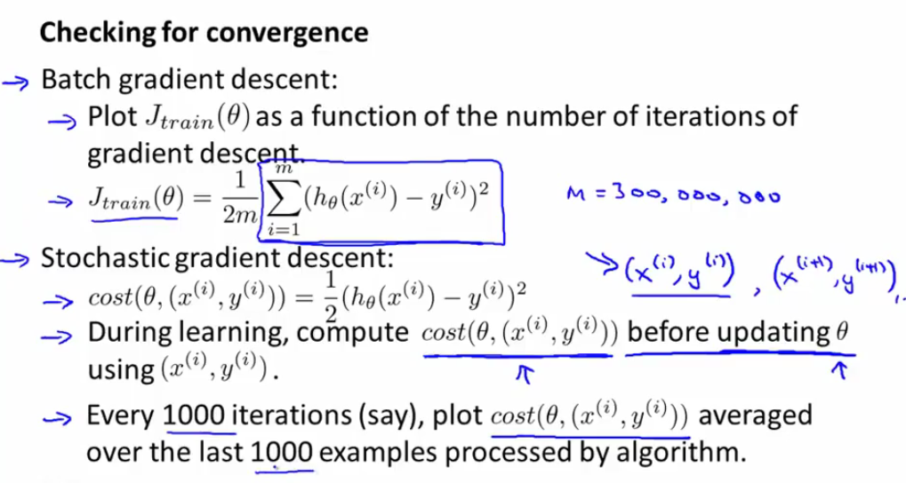
Even though we are plotting for a different example at each point, it gives us an idea of how the cost function evolves.

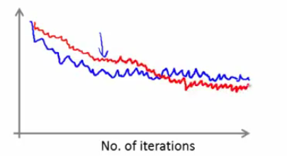
The red line represents using a smaller learning rate, we are able to reach a better approximation of the minimum in the end. The disadvantage of this method of plotting the evolution of cost is that you only get one plotting point per 1000 iterations.

If the function looks like this, then the gradient is diverging
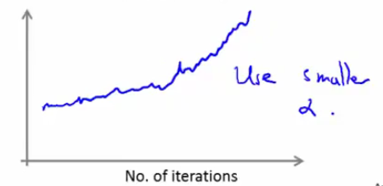
A way to make sure gradient converges is to gradually decrease the learning rate alpha overtime but it needs to be tuned well.

Online Learning Algorithms

Let's say we have an online shop and we want to predict whether a customer will decide to use our shipping service (y=1) or not (y=0) based on his origin, destination and asking price. We want to find
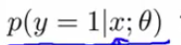
in order to optimize the price of shipping. Let's say we use logistic regression. Here is what our online algorithm would do:

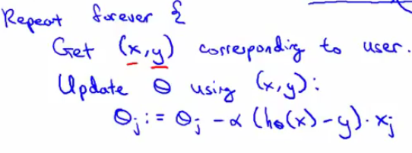
We discard the notion of having a fixed training set, once the gradient is computed, the training example is discarded, so we don't have to store it anywhere afterwards. This model has the advantage of being able to adapt to the evolution of user behaviour and changing user preferences (the parameters theta will just slowly adapt as more new people come to the site)

Other example, search engine
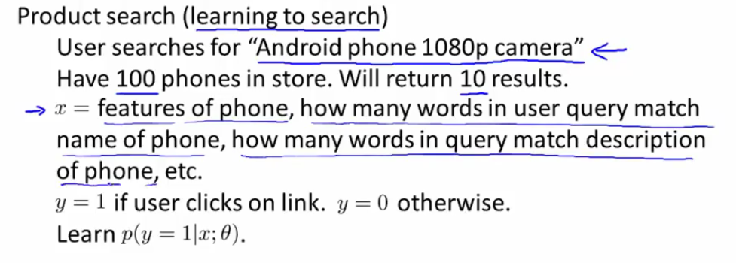
We would like to estimate the probability the user will click on the phones returned by the searched in order to choose the best phones he will most likely click on. For each time we return a given batch of ten phones (one training example x), we associate with a y equal to if the user has clicked, equal to zero If he hasn't.

Map Reduce and Data Parallelism

Map reduce is a method for when you are using more than one machine. Let's suppose we are building a batch descent model and you have K machines at your disposal. You start by dividing your training set in K parts and let the machines compute a sub-batch gradient actualization for each of their sets
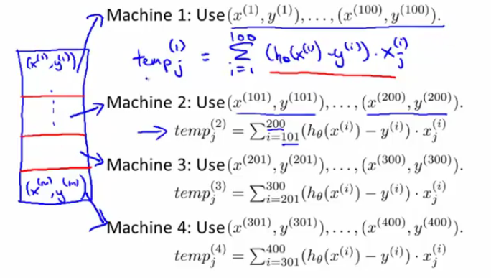
We then send the resulting temp values to a central server which will combine them

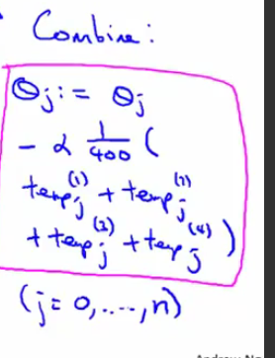
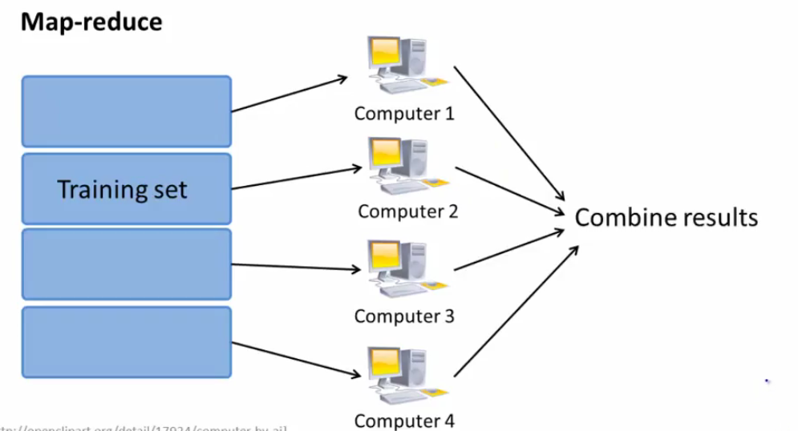

One loop of batch descent with map reduce:

Before applying it to algorithms other than gradient descent, make sure that it can be expressed as a sum over the training examples (although a neural network could and has been expressed as such http://papers.nips.cc/paper/3150-map-reduce-for-machine-learning-on-multicore.pdf for each of the ten machines,
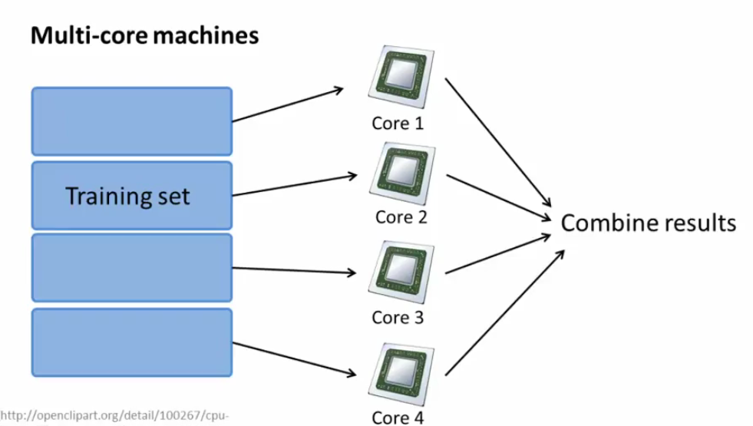
This is the same as before but with one machine (with the added bonus of no network latency).

