Multivariate linear regression

We go back to our real estate example, but this time, we would like to work with more variables: the age of the house, number of floors, etc., because we think that will give us a more precise approximation of the prices. What we will have for a given house of the training set is a vector containing all this information

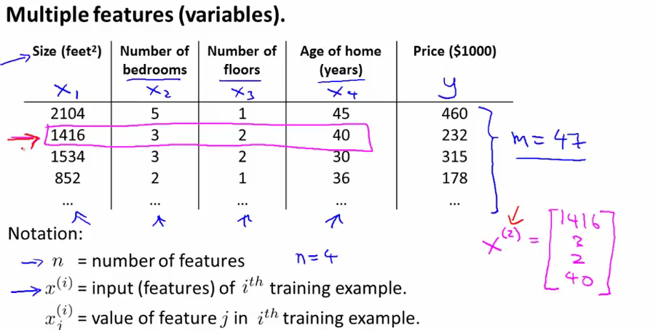
Because this is still linear regression, our hyptohesis is that the function h will still be a linear sum of those features

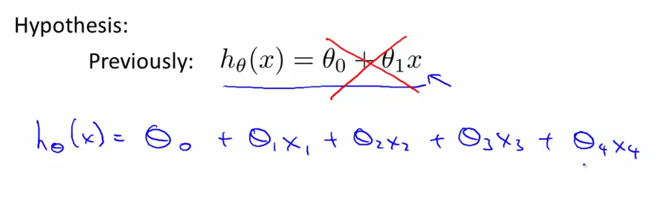
By convention, we suppose x0 equals 1. The gradient descent here is identical to what was happening with only two features.
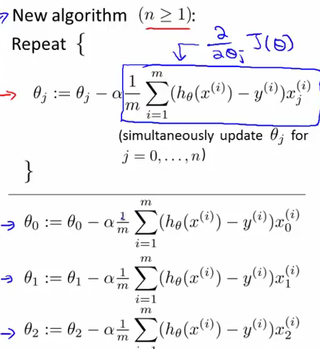

Feature scaling: If we have multiple features, we will want them to be on the same scale, so as to have it converge quicker. For eg number of floors and surface in m^2, one is in the units, the other in the hundreds. In that case, the contours may take a very skewed elliptical shape:

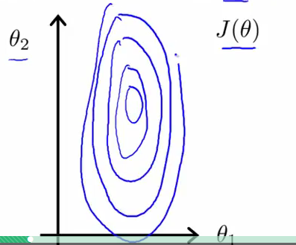

A solution to this is to make both features end up in the range between approximatively -1 and 1 by dividing each one by the range of the training examples. You can even go further with mean normalization
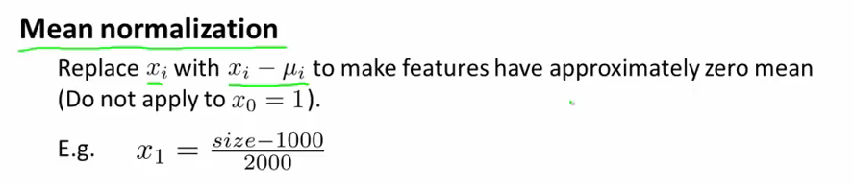
Learning rate: How do we chose it? The progression of the algorithm looks like the following if it is working:
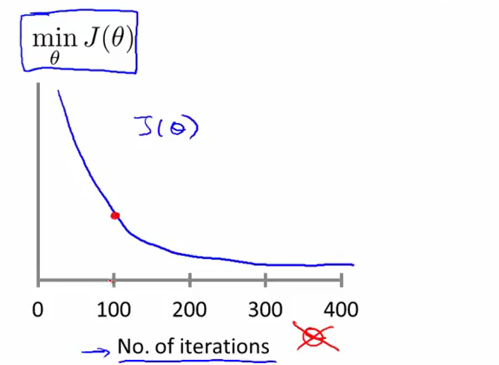
The value of J(theta) for the subsequent thetas should decrease as we the number of iterations grows and we get closer and closer to the minimum as the curve flattens out. IN other words, we declare that the gradient descent starts converging if each subsequent iteration decreases by a value smaller than a chosen sigma.

If the curve doesnt look like this (it grows instead of decreasing for eg), we change allpha.

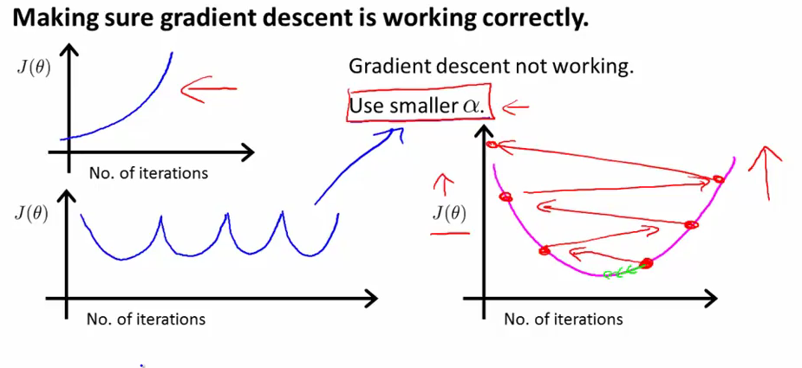
Examples where it can go wrong; as we see on the third one, it can even increase with each iteration. In graph A, the learning rate is set too high, and the cost function is increasing

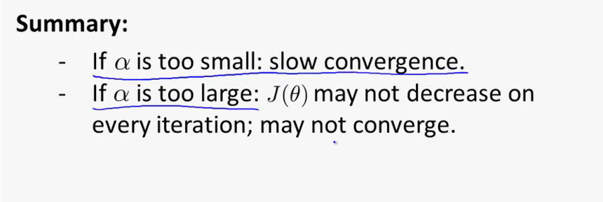

Features and polynomial regression: Instead of using default features, we might sometimes be tempted to use our own. For example, if we go back to the housing example, we might want to replace two features like width and depth of the house with a single feature area (which is width X depth)
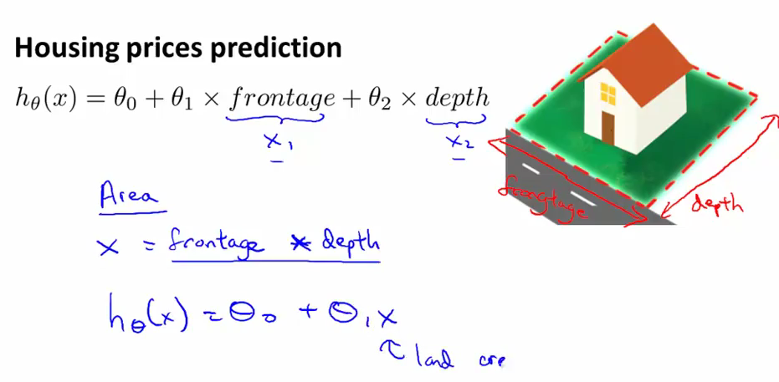
Polynomial regression
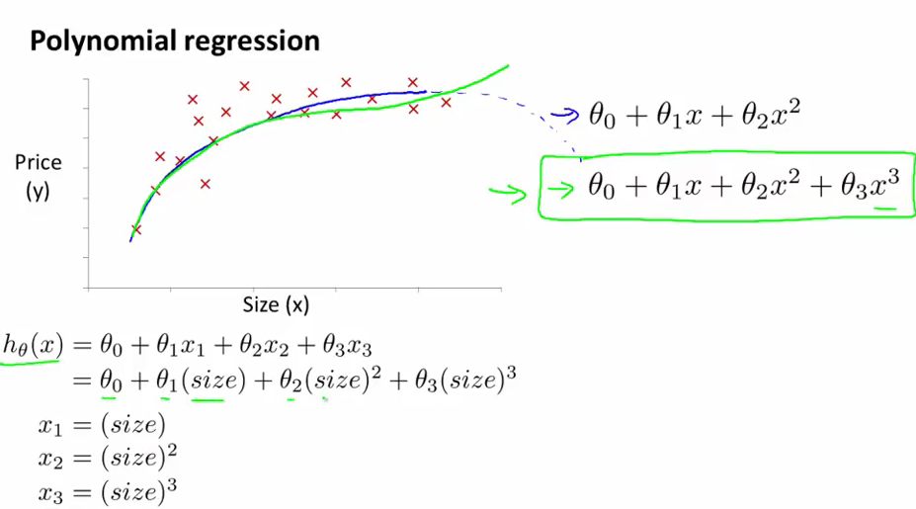
In this example, all three of the features refer to the surface, the first is the surface, the second is the surface squared, etc., and this gives us a more precise approximation of the model than a straight line from a linear function.

Computing parameters analytically: This is an alternative to gradient descent. Instead of going throught iterations to approximate the minimum, we can also use calculus and find local optima by taking the partial derivatives and solving theta for dJ(theta)/theta = 0.

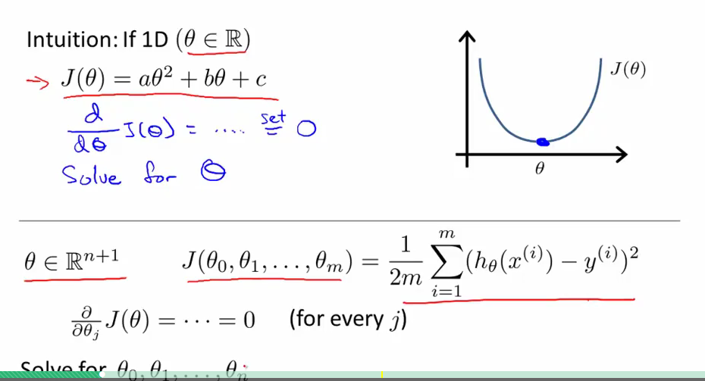
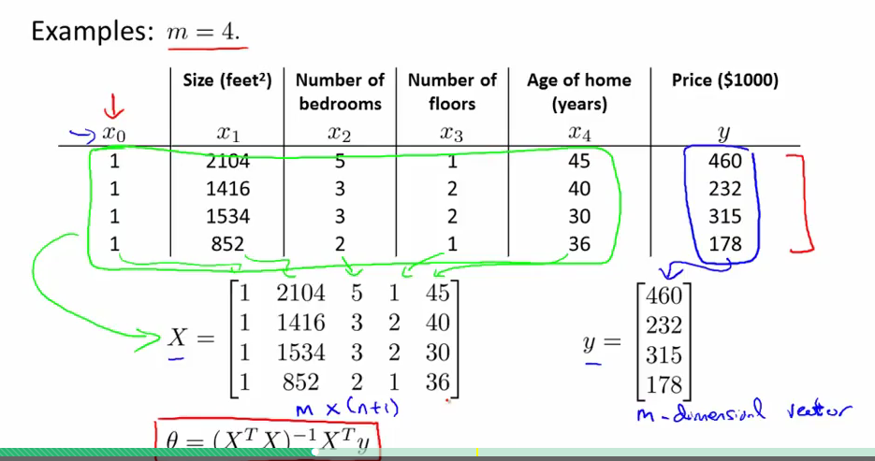
X is called the design matrix. Each column is one feature, each line is one training example.
The formula in red gives the optimal value for theta

For a reminder on Matrices, see page 8 of course notes (trace, gradient).
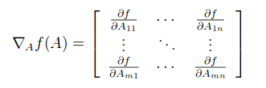

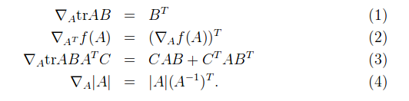
(proofs for 1-3 are relatively simple, and can be reproduced by reader)

In the rest of the course, it helps to visualize tr as a function from R(m x n) to R (which has derivatives and behaves like a normal function)

The trade off with this method is that you have to compute the inverse matrix, which grows exponantially with the number of features.

(1): by multiplying AB and taking tr AB, we get a linear function av + bx + cw + dy. If we take each partial derivative for (a,b,c,d), we are left with the coefficients (v,x,w,y), which, once plugged into the gradient matrix, give us indead the coefficients of B rearranged to give Bt.

(2): is proven just by taking a linear function f(A) = av + bx + cw + dy and plugging in the values.

In short:

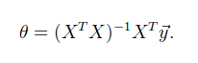
The proof for that is started with this equation:
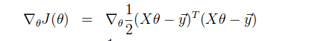
note: don't use feature scaling with the normal equation method

How to chose the correct method:

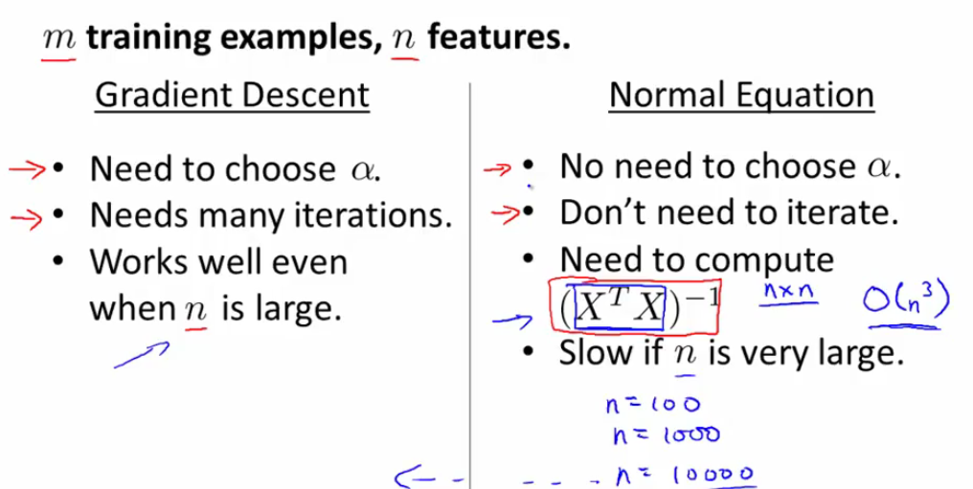

Normal equation non invertibility: There are cases when Xt X is non invertible but there is a workaround as we will use a pseudo-invert function in octave
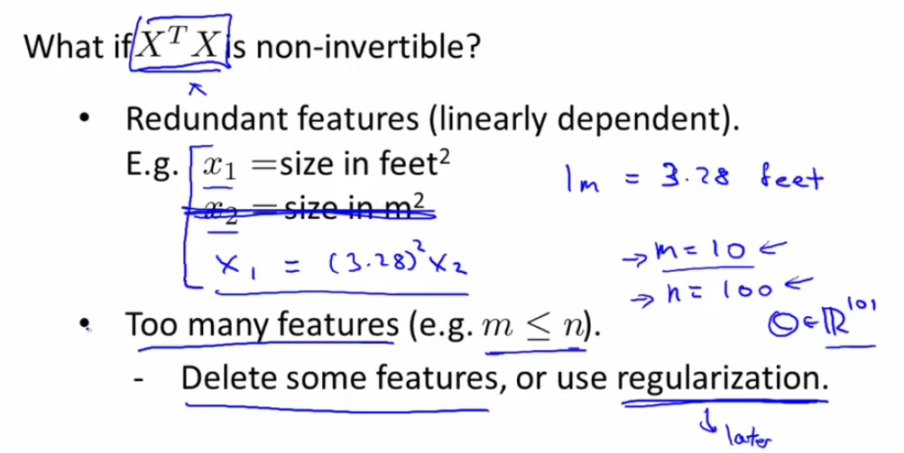
A good thing to remember is that if we have a lot of features, we are going to need a lot of training examples to compensate; if we don't have enough empirical data, the normal equation method might not work.

