Logistic Regression

Classification and Representation

This week we are going to learn how to classify data into discrete outcome, like for example to determine whether or not a mail is spam or not.
Binary classification problem:
Y will take the value of {0,1} (positive class (presence of something) and negative class(absence of something))

Typically we will want to separate the data into two categories (eg malignant tumor and benign tumor) and the line of separation is called the threshold.
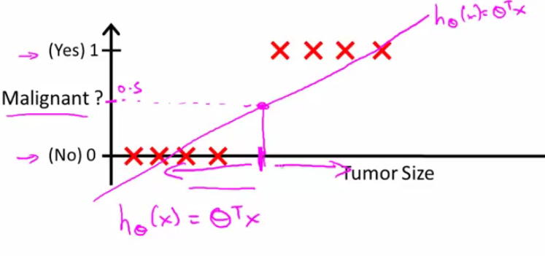

Here the treshold is y = 0.5

Problem with linear regression: If we take the previous example, we see that adding some extreme cases will change the slope of the curve, and thus change the outcome of our predictions, while the training set remains the same, and that can make us question the validity of our model: here we add only one extra training example but the predictions change significantly
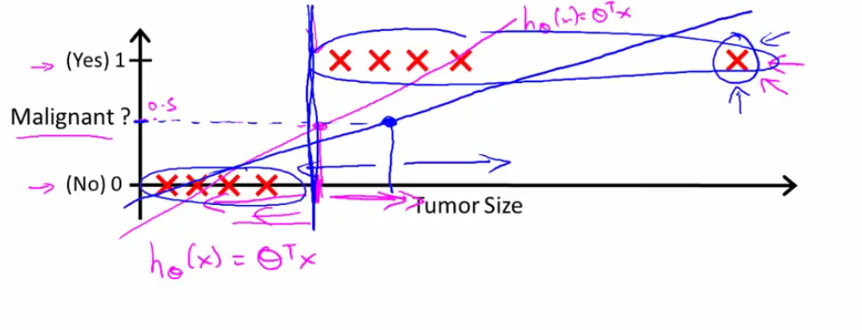

Because of those problems, we will use the logistic regression algorithm instead of the classic linear regression. This model modifies somewhat the theta' * X:
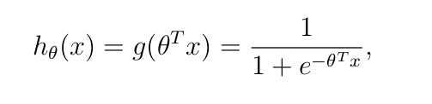
g is called the logistic function.
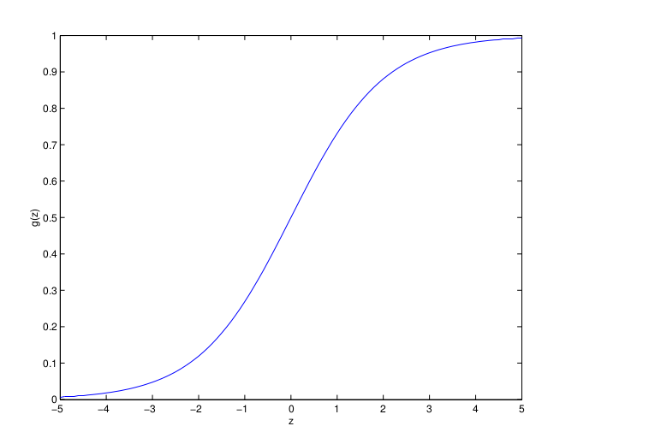
View of the logistic function. G tends towards 1 in +8 and towards 0 in -8

We are gonna throw in some probabilities
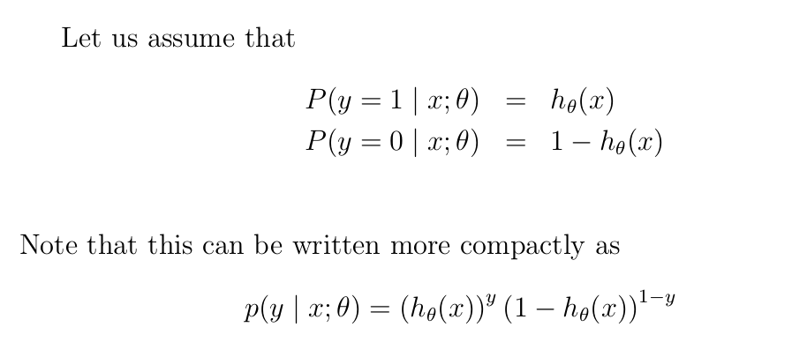

The likelihood is represented by the product of those probabilities for all values of the training examples (in other words, the vector y). We won't be minimizing a function anymore, but rather directly maximizing the likelihood

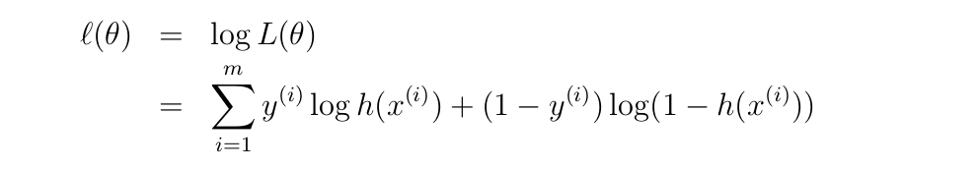
That's why the update algorithm for theta will be:
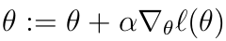
See course notes page 19 for proof

IN the end, we are left with an equation that looks almost identical to the linear regression model
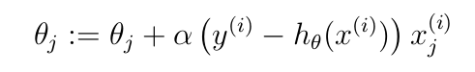
But it isn't, because h is now a non linear function of theta'*X . Still, we are left wondering: why is it so similar?

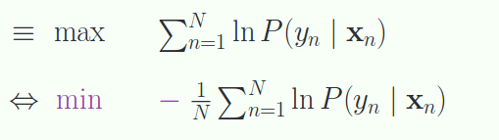
But we would like a minimization problem instead of a maximization one. By multiplying the likelihood by -1 we do just that

Interpretation of hypothesis:
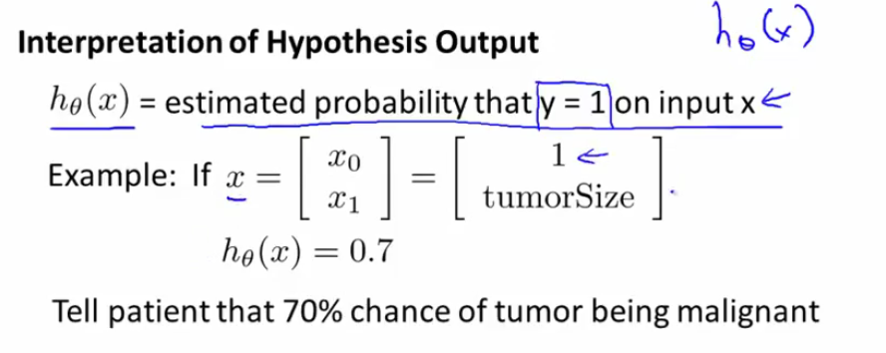
Or a 70% probability of being above the threshold of malignence. This means we are no longer working on the plotted data from the training examples, but rather on a probabilistc curve that represents the distribution of the queries and the probability of the being above the theshold.

Decision Boundary

We will assume that the moment the function h is greater than a certain value (for eg 0.5), the tumor is considered malignant, in other words, y is equal to one. Because of the properties of the sigmoid function, we know that h is greater than 0.5 for x being superior to 0. In other words:
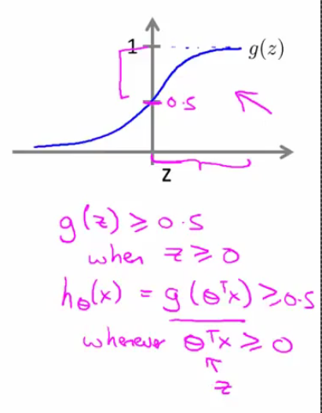
For example, let's take theta' * X as alinear function of three parameters:

-3 + x1 + x2 (theta equals the vector -3,1,1). Predicting when y will equals 1 (when the tumor will be malignant is the same as predicting when this function -3 + x1 + x2 will be greater than 0, in other words, when x1 + x2 will be greater than 3
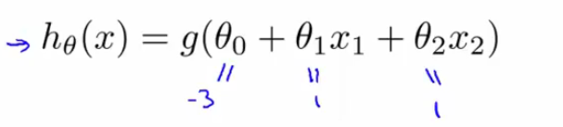
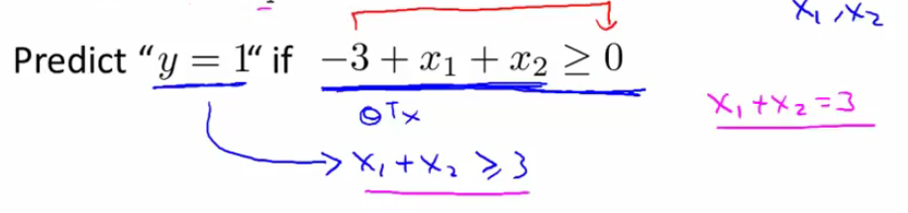
This is like drawing a line that, as we see, cuts the graph in two and separate the training examples into two groups
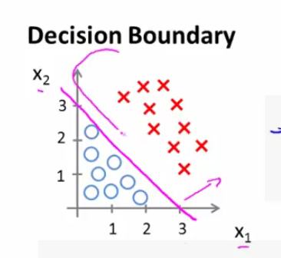
That purple line is precisely where h is equal to 0.5

Non linear decision boundaries:
If we take a non-linear function with three features once again, but this time only the second degree thetas are different than zero, we will have the equation of a circle for the decision boundary:

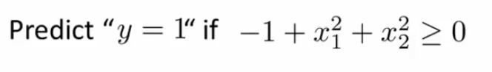
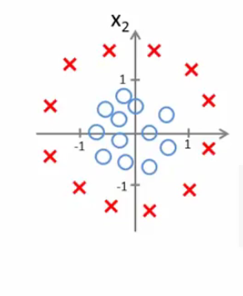
With higher polynomial parameters, the decision boundaries will be more complex shapes.

Logistic Regression and cost function:
IF we were to keep the original definition of the cost function for our exponential function h, the cost function would not be convex, it is not guaranteed that gradient descent will converge to a global minimum. Instead, we are going to use a two tier function depending on the value of y
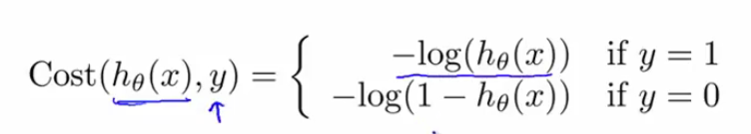
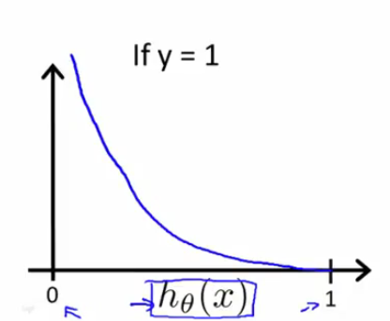

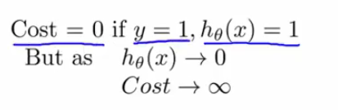
This blue curve is the cost of the prediction

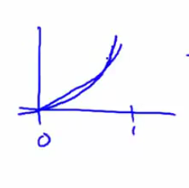
Same if y = 0. If h takes the value 1 instead, the cost blows up to infinity

We will want to squeeze that cost function into a single expression in order to be able to work on it. Because y can only take on of two values, we can write:

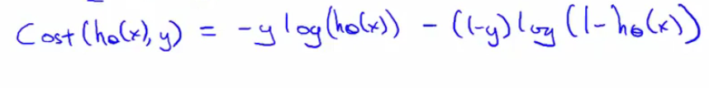
And the update algorithm looks like this:
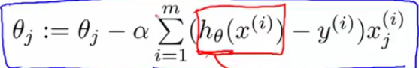
Even it is cosmetically identical, h is different here, so we can't just plug in theta' * X (although this is the first step, we still have to plug this into our sigmoid function)

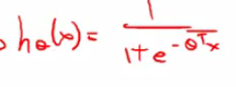
Vectorization:
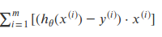
This is our vector. The tricky part is to determine h(x). It is done with the sigmoid

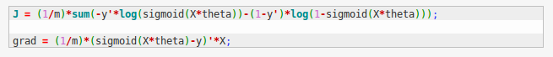

Optimization thourgh other methods:
There are other algos out there that are more efficient than gradient descent:
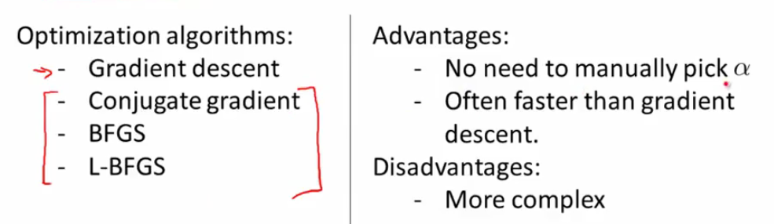
When writing our cost function in octave, we'll want something that return J and the different gradients at the same time

Multi-class classification problem:

This problem arises when we are trying to classify something automatically into different classes (eg classify incoming emails into different folders). IN other words, y can be equal to 0,1,2,…
Here is a visual representation of a multi class classification
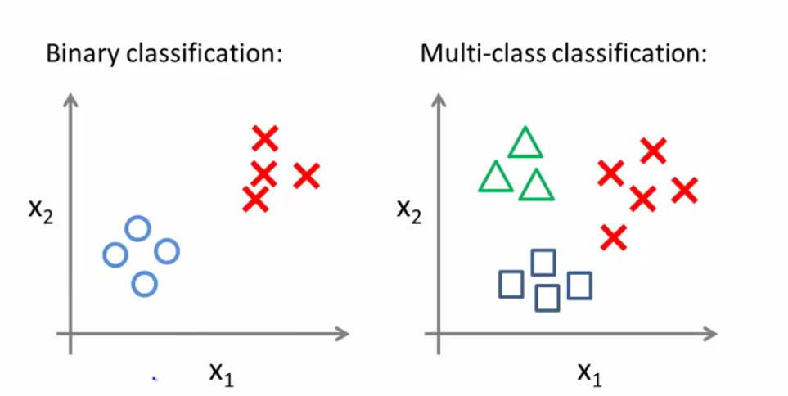
One-vs-all: This algorithm basically takes one of the classes and puts it against all the other; by doing this we regress the problem to a binary state (triangles vs the rest)
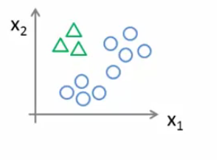
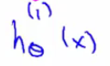
In this case, the supescript (1) refers to the first class (triangles) IN the end we have three decision boundaries
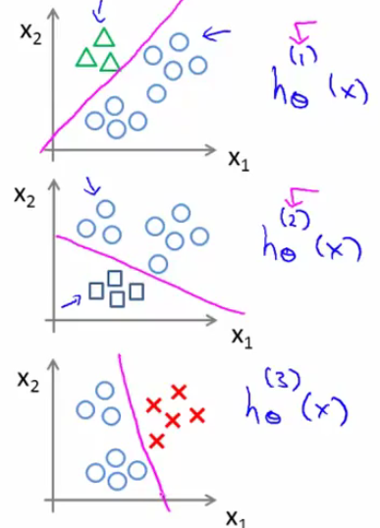
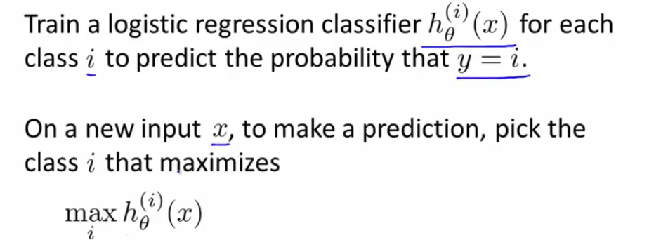

The problem of overfitting:
Overfitting happens when you use too many features to fit the model. Adding complexity means the model has high variance. It makes predictions for the training set well, but does not generalize well to make predictions on new, previously unseen examples.

To adress it, we can reduce the number of features to keep, but the disadvantage is that we are throwing away information about the problem and we can inadvertently throw away important bits of information.

Suppose we artificially tell theta3 and theta4 to be very small by adding 1000*theta3 and 1000*theta4 to the equation
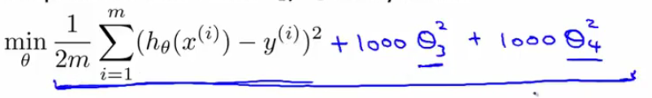
Having smaller values for our parameters will result in simpler hypothesizes and make the model less prone to overfitting. Another way of regularization is housing, where we add an artificial term to the cost function that is the sum of all parameters with a lambda multiplier
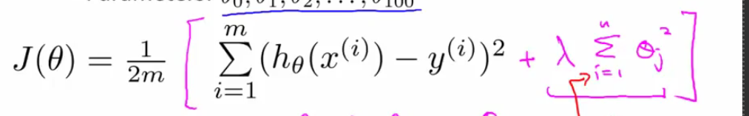
The choice of lambda matters, because if it is to big, we may not be able to fit the model properly, resulting in the opposite problem of underfitting.

Regularization

Regularized linear regression:
Here is how the update algorithm looks like regularized
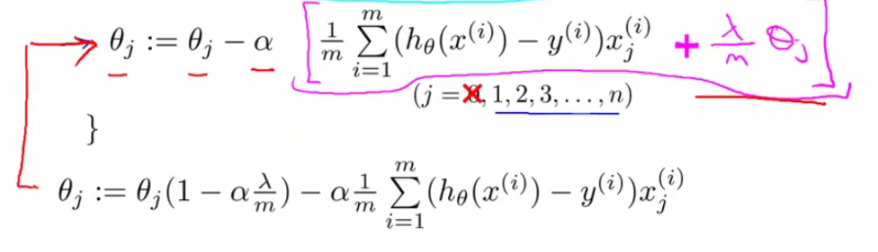
IN this case, because we want to make the thetas smaller, we can see that the first member of the equation has to satisfy the following rule
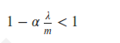
This is how it looks like for the normal equation
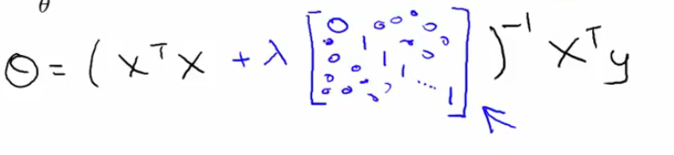

Regularized logistic regression

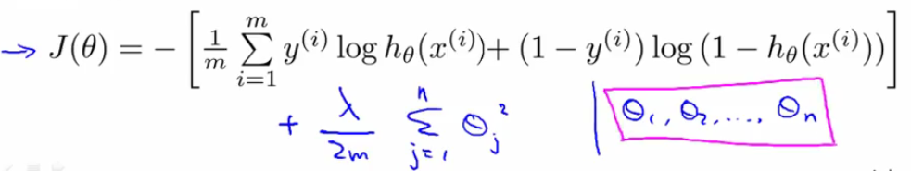
This should allow us to have a decision boundary that looks more reasonable

