NEURAL NETWORKS

Non-linear hypothesis: As you have more and more features, the size of the problem will grow very fast (quadratically to be precise) because the model will contain those features plus quadratic combinations of those features (x1*x5, x3*x1, x1 ^ 2 etc.)

Machine learning can be used for example in an algorithm designed to recognize if a picture is a picture of a car or not.(give it pictures of cars and not cars, then present it with an unkown image and ask whether it is a car or not)
Here is a simplified version with only two pixels (so two features), but in reality it is clear that there will be an astounding number of features:
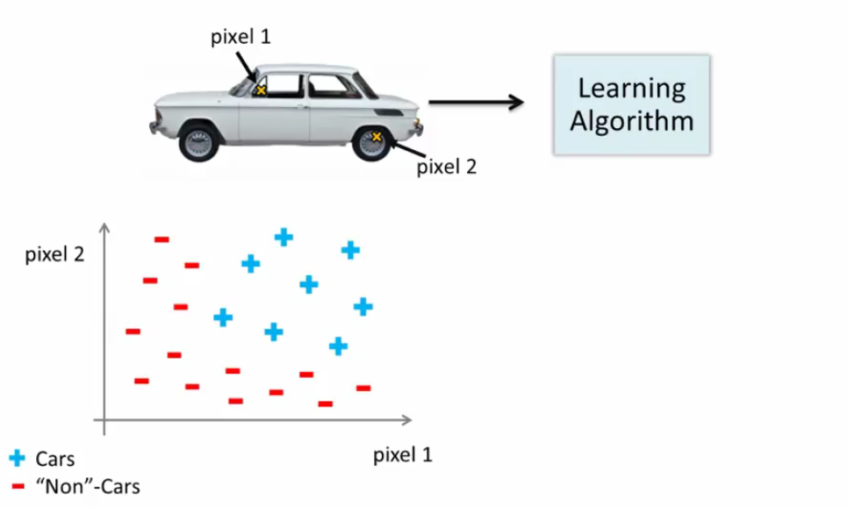
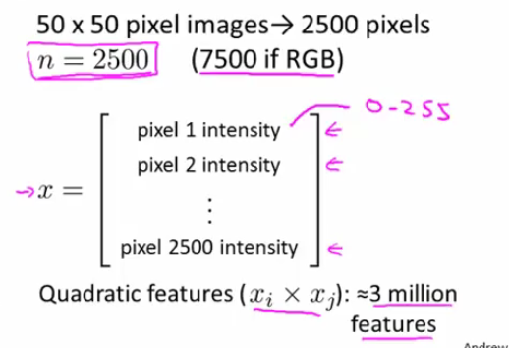
As we can see, this would be way too much to handle for a logistic regression model.

Model Representation:
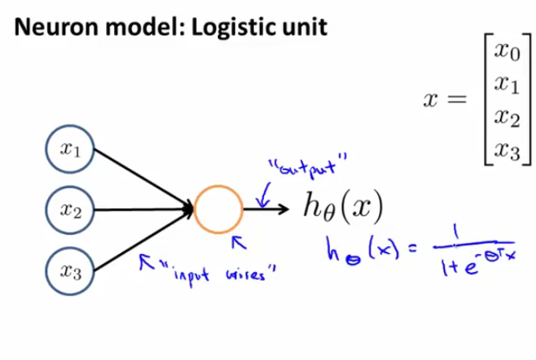
This representation mimics the structure of the neuron:
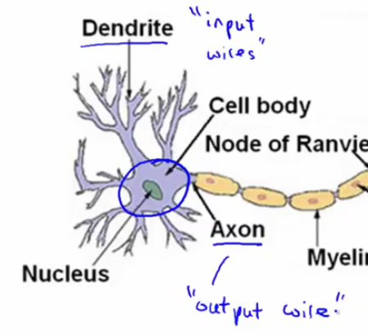

But that's just a single neuron. When we talk about neural networks, we are talking about several of these tied together

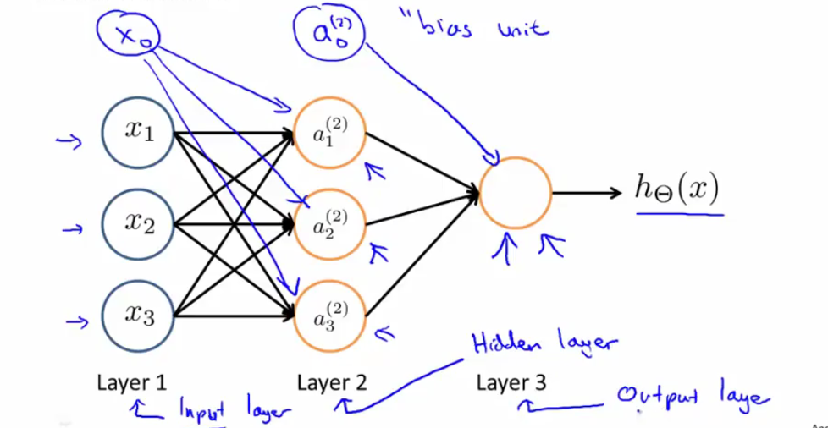

There can be more than one hidden layer. The activation nodes (a1 etc) are functions that output intermediary values that are then sent to the final output level
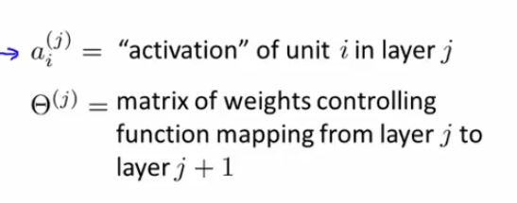
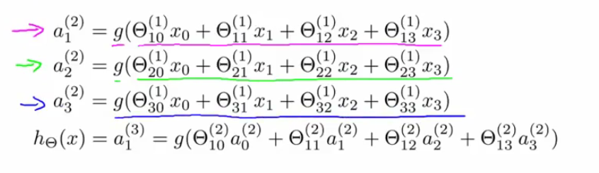
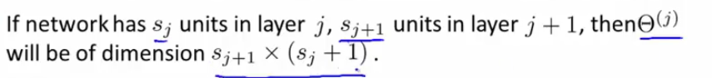
(because of x0=1).
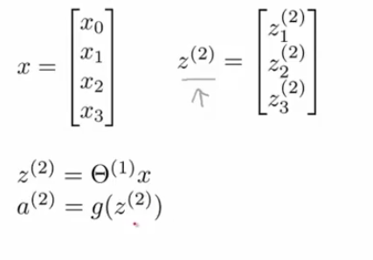
every a is the product of a function passed to all xi
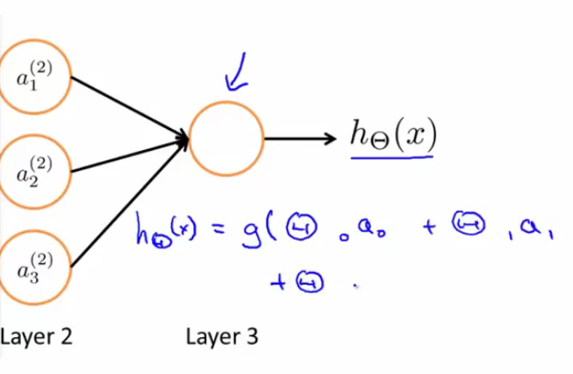
Then same same, we are gonna add a0=1 when resuming the forward propagation (passing from input to layer to output layer through hidden layer). Each step here looks an awful lot like logical regression (we apply a sigmoid function to a vector product)

So instead of having to use quadtratic combinations of features to get from our training examples to h in one hoop, we instead repeat that procedure on simple x. The equation from getting the vector from one layer to the next one is this:
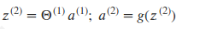

Non linear classification problem (xor/xnor)

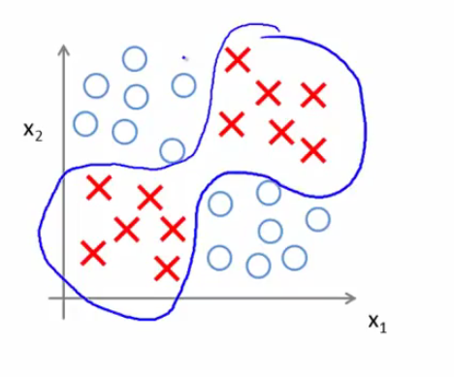
xor takes the value of 0 all inputs are 1 or if there is an even number of inputs that are equal to 1, so there will be several 'regions' with positive examples and several with negative examples.

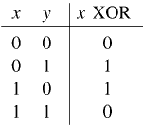
Let's go back to a simpler example: the AND functions

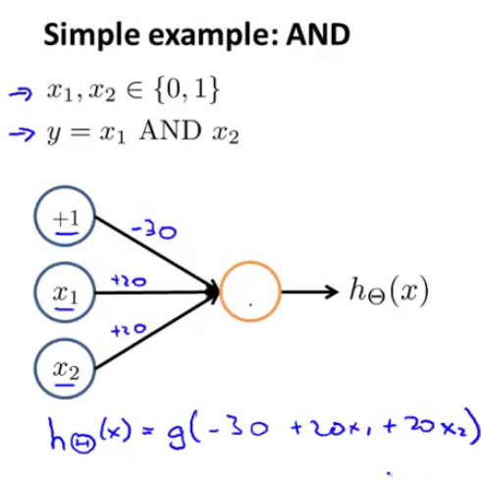
The only time theta' * X is positive (required for g to output 1), is when x1 = 1 AND x2 = 1
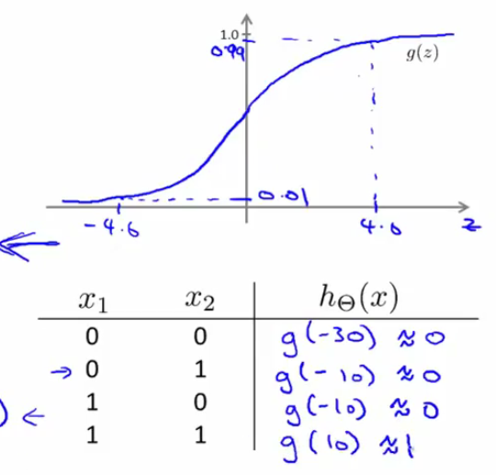
Note: this is called a 'truth table'
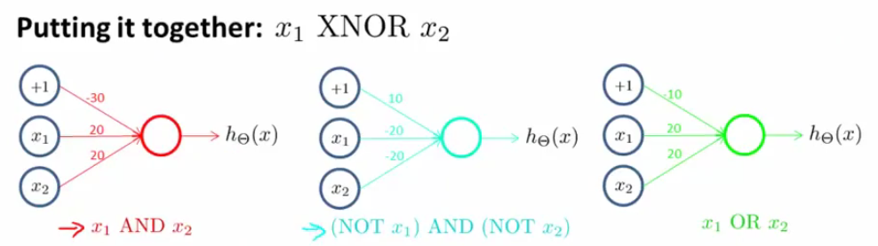
The two first gates are used to compute in the first gate, and then we use OR gate to give our final output that computes XNOR (only x1 = 1 and x2 = 0 or x1 = 0 AND x2 = 1)
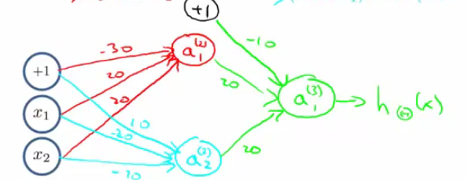
This is an example of a complex non linear function. The more complex the problem is, the more layers we will have.

Multi-class classification:
Let's imaging we present the algorithm with pictures and we want it to determine whether the image is one of a car, a man, a motorcycle or a truck (4 outcomes)
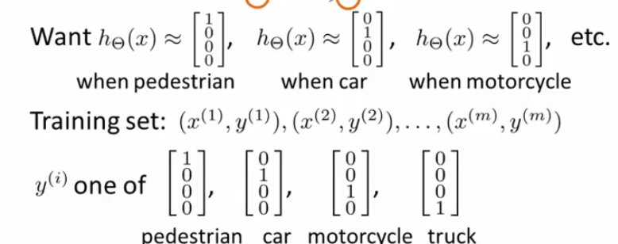
So we don't represent y as a scalar anymore (values {1,2,3,4}), but a binary 4X1 vector

Summary:
In neural networks with many layers, we think of each layer as outputting features that are able to be used by subsequent layers in order to tackle complex non linear classification problems.

The ai are called output units

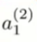
Note: the superscript represents the layer, while the subscript represents the unit. Here, we are at the first unit of the second layer.

Example of a neural network in octave:
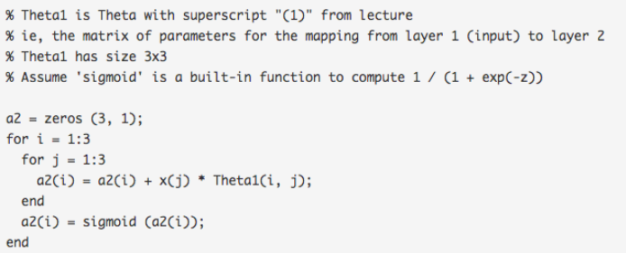
IN this bit of code we have the activation of layer2

Here for the vectorial application
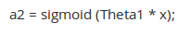
Swapping lines in the activation matrices:
(page below)
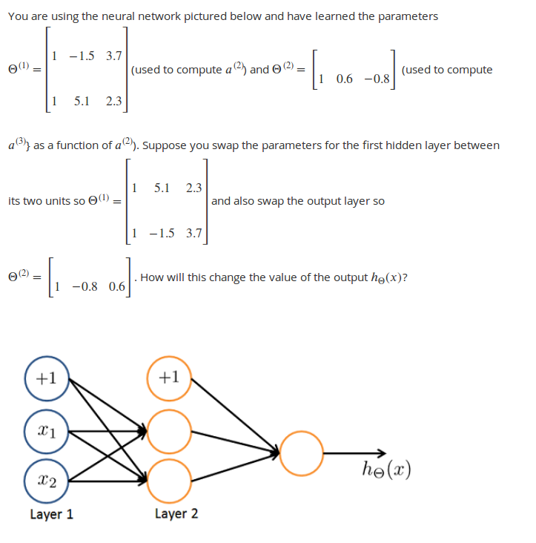
Because in effect, we are just swapping the position of our output units in the same manner throughout the layers (a11 becomes a12 and a21 becomes a22 and vice versa), the final output remains the same.

The potential problem of overfitting remains, thus if we are faced with it with some layer, we can regularize with lambda

Ocasionnaly, the theta parameters will be called weights

