Neural Networks

Cost function of a neural network:
We define a neural network algorithm as such:
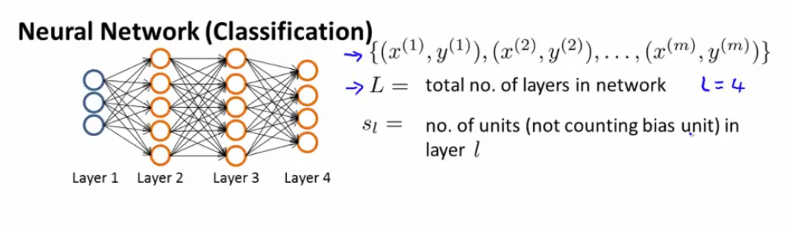
Let's remember the final output is either a scalar (single class classification problem, in other words K = 2) or a K vector (K multiclass classification)
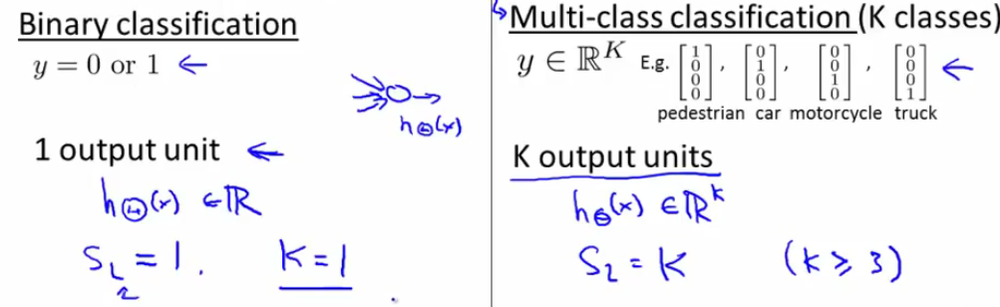
The cost function for a multi class classification is a generalization for the classic logistic regression cost function. Because we have K different outcomes, we have in effect a double sum of our likelihood sums
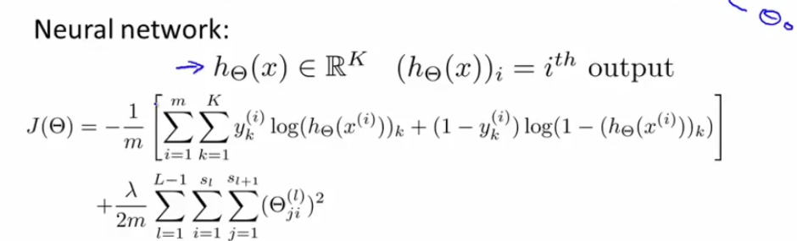
By ith output we mean the ith element of the K-vector h(x). In the second term we are simply summing every single term squared in each of the theta matrices with each other.

Backpropagation algorithm

Just like with every algorithm that minimizes the cost function, we need to provide the cost function J(theta) on the one hand, and the partial derivatives on the other hand. Because there are multiple thetas, here, we will need to provide multiple partial derivative matrices, or multiple gradients

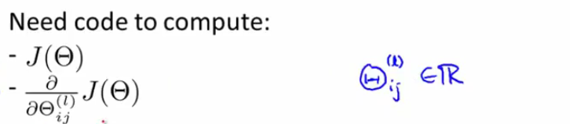
Let's put ourselves in the layer l. The first step will be to calculate the error delta of each node j in l (ie the value of that node aj – yj). We start with what we know, the error in the final layer.
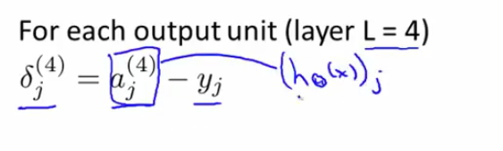
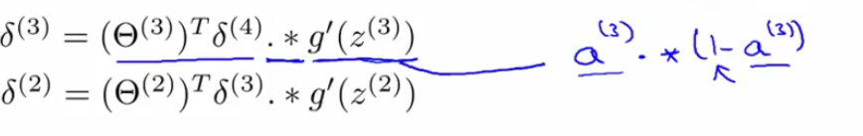
This is the same as writing:
The name backpropagation comes from the fact that we start by computing the delta for the final layer and then backtrack to compute the previous deltas.
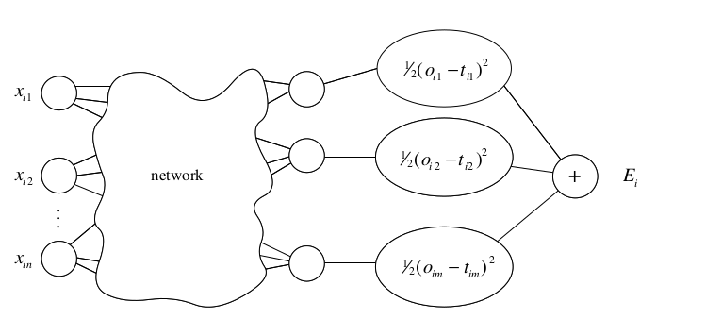
Visualization of the problem in its initial state. We are looking to minimize the quadratic errors at layer i. We want to minimize the error function where p is the number of layers and o is the output of unit j in layer i:
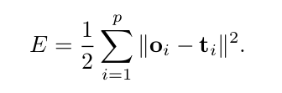

The algorithm is composed of two steps: forward feeding and back propagation
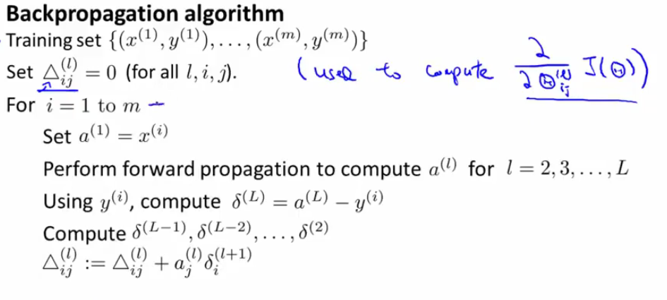
First, for each pair x,y of the training set we need to compute the activation states ai for all layers, then the last layer error, and then we go on to the back propagation step.

Finally, once the for loop is complete, we compute
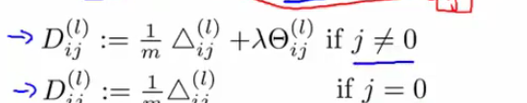
Were D is the partial derivative in respect to the I j parameters
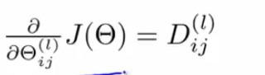
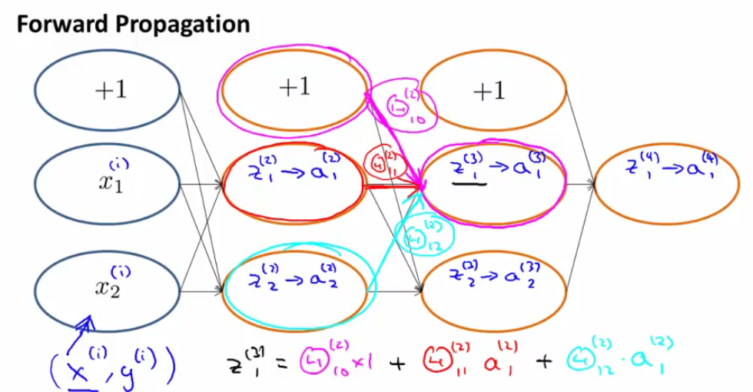
Intuition:

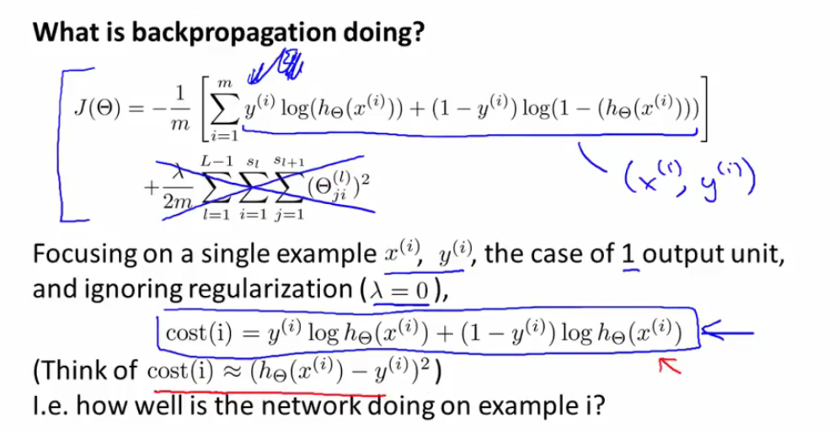
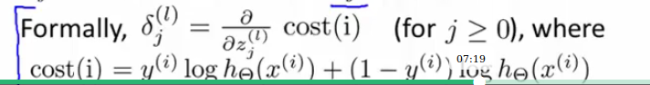

the deltas symbolize how much we are willing to change the weights in order to get values of z so as to affect the final output of h(x) and therefore the total cost.
The intuition is to position oneself behind the error function, not the cost function, which is given by E, and represents the square distance between the output points and the data points and you are looking to minimize it. E is the error of the network for a single training operation)
https://www.youtube.com/watch?time_continue=5&v=aVId8KMsdUU
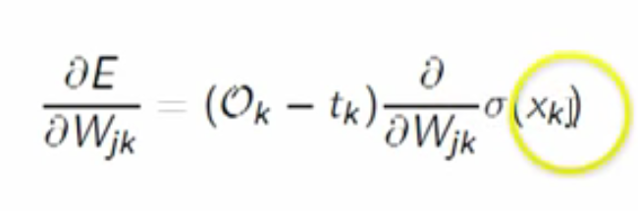

Implementation:

The matrices theta used in back propagation are not suitable for advanced optimization functions as we know because the latter only accept thetas as vectors, hence the need to unroll the thetas into vectors:
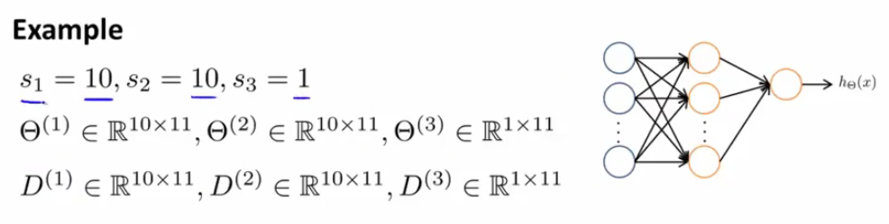
We use the vectorize function that looks like this: theta(:)
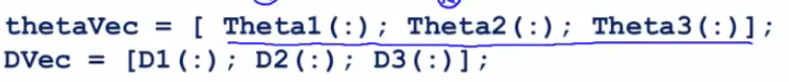
Then we reshape with the original parameters of each matrix theta
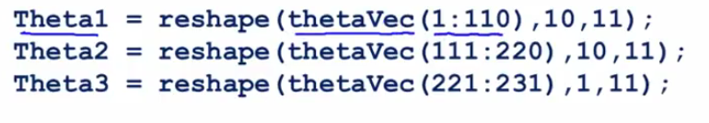
The final algorithm is composed of two phases: computing the thetas into a vector, and once we have them, reshaping the thetas and using them to compute the deltas matrices

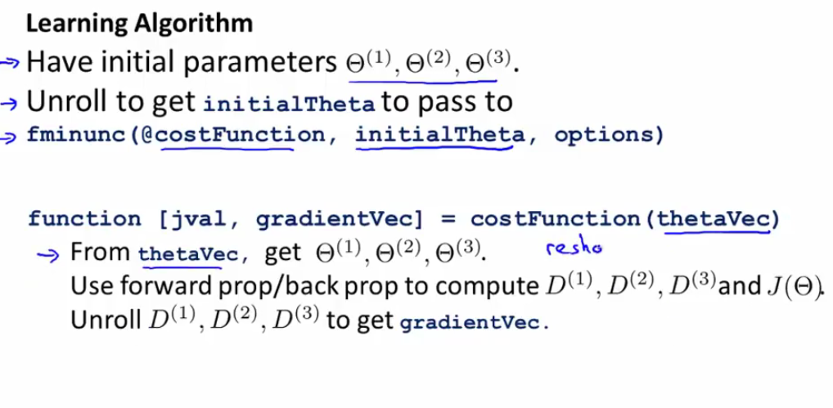
Gradient checking:
It is important to check the gradient is working properly because the optimization is prone to errors in backprop

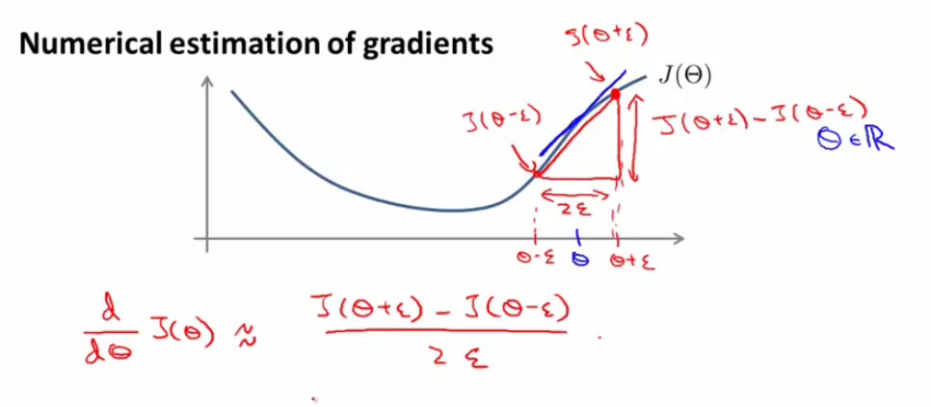
To check that we are indeed computing the correct values of gradients (slope of the cost function), we can compare it to a secant that is parallel to the tangent in theta in the cost functions

In the case of an unrolled theta of several thetas, we will add/substract the epsilon to the relevant thetai in the cost function:
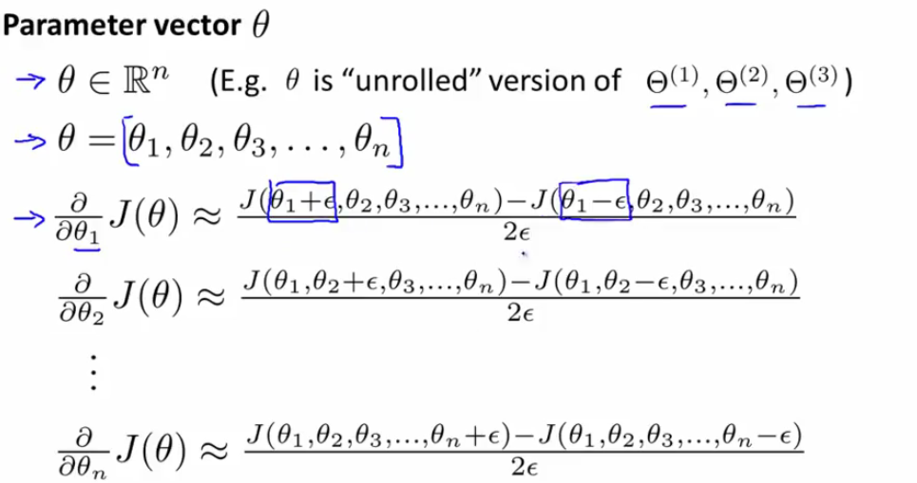
Implementation

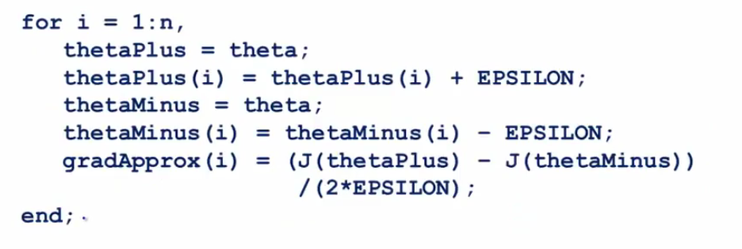
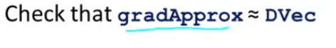
Then,
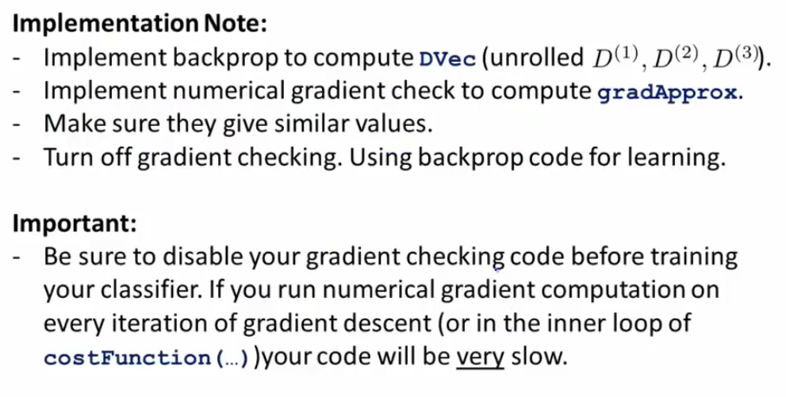
So disable gradient checking before starting gradient descent

Random Initialization:

We used to set the initial value of theta to a matrix of zeroes (here zeros(n,1)). This will not work here because each input node is passed through different weights to give different output nodes. But if all the weights are equal to zero in the first iteration, that means that all the output nodes will be equal to each other, as well as the deltas.

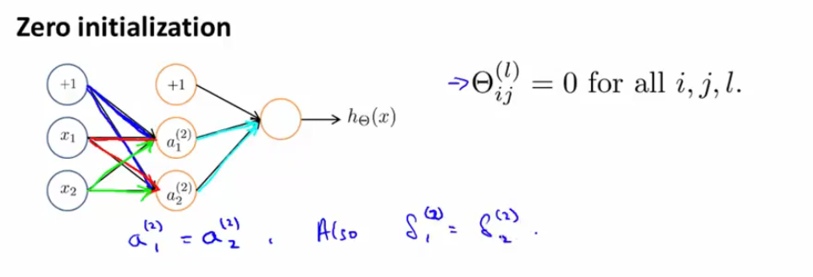
As a result, the weights will end up equal to each other in the subsequent iterations. One solution is to use random numbers instead

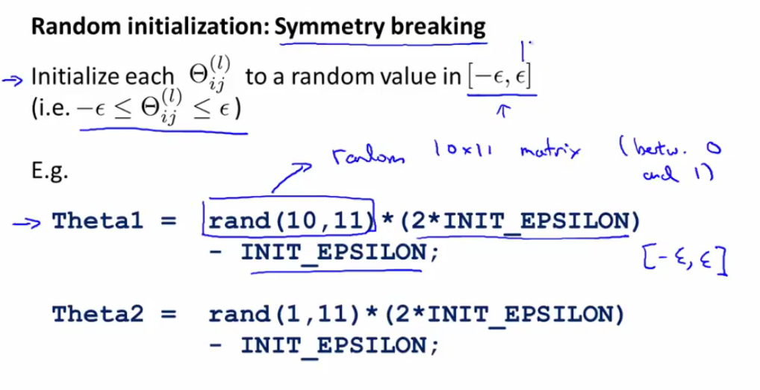
It looks like this because we want to make sure the values of theta1 and theta2 are in the interval [-epsilon, epsilon]

Putting it Together:
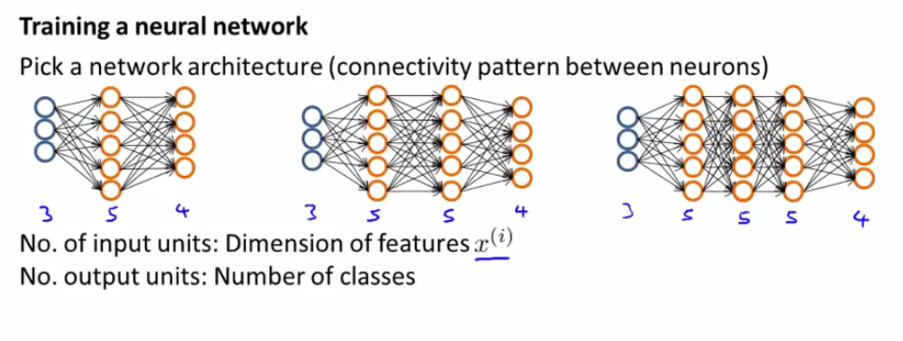
By default, a reasonable approach is to have only one hidden layer. If we need to have more than one, make sure that each hidden layer has the same number of output units.
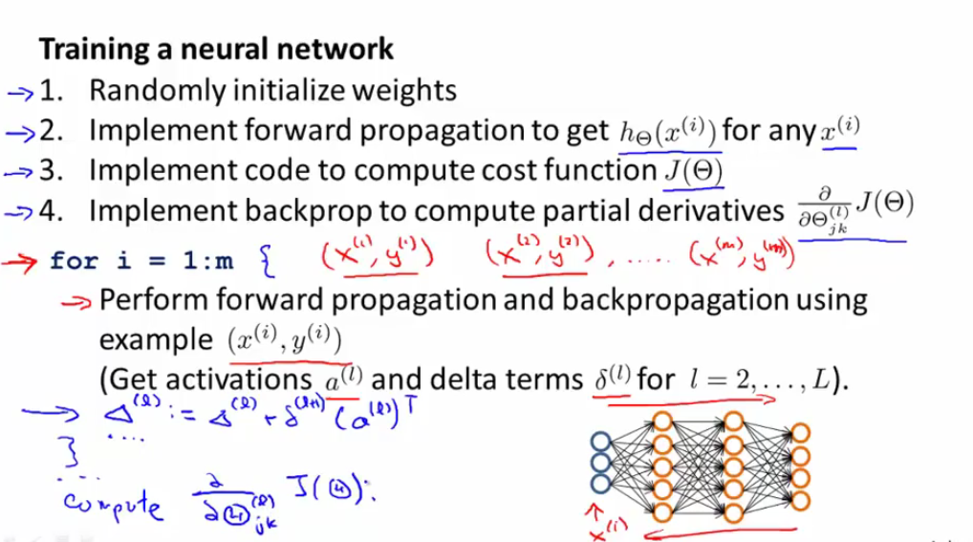
You can train the neural network using advanced vectorization instead of a for loop, but for training purposes it is better to use the for loop.
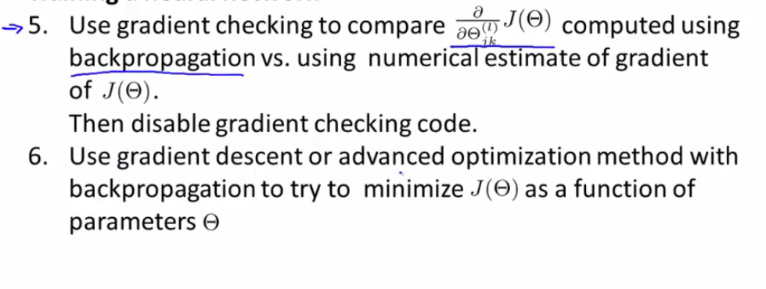

So, to summarize:
1) Randomly initialize weights
2) Forward Feeding using random weights
3) Compute cost function J
4) Back propagation
5) Gradient Checking
(disable checking!)
6) Gradient Descent or advanced optimization

Note: J(theta) is not necessarily convex, and can be subject to local minima; that's why gradient descent can sometimes fail to pinpoint the global min but not a huge problem in practice.

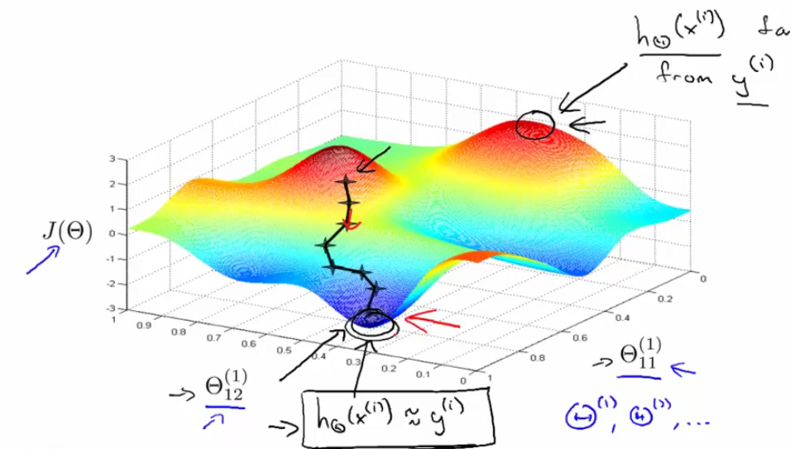
Visualization of the cost function. What back propagation is doing is computing the direction the steps should be going and gradient descent is in effect making those baby steps.

