Spam Filters

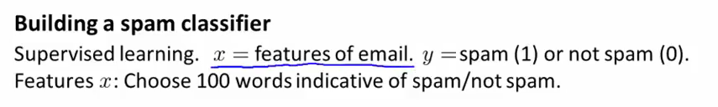
Eg, deal, buy => y = 1
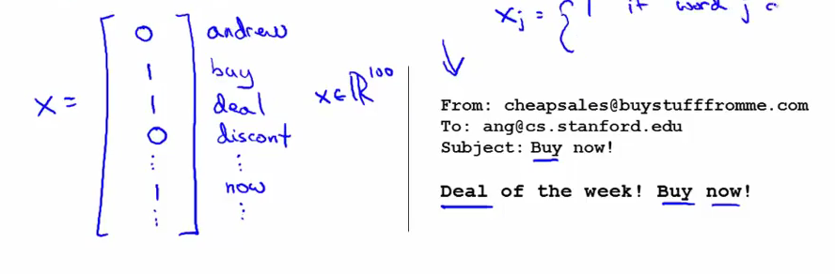
The features are chosen based on the most used words

You could also develop a more sophisticated system of features based on analyzing the header of the mail (sender, email routing information)

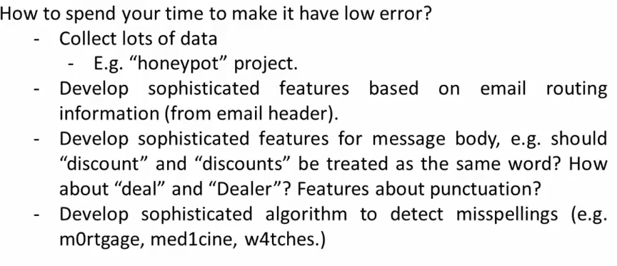

Error Analysis

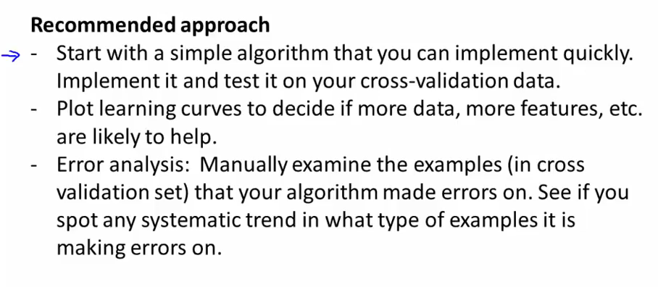
IN other words, manually examine the training examples that don't fit the model.
http://snowball.tartarus.org/algorithms/porter/stemmer.html

Sometimes you can have a low training error, even as low as 1%, but if the classes are skewed (ie only 0.5% of the patients of the training dataset have cancer), that result is not impressive anymore. One method of dealing with that is Precision Recall

Precision/Recall:
Let's say we have a set with a rare class, and we use our model to predict if a new example will be of that class or not. There are 4 possible outcomes:
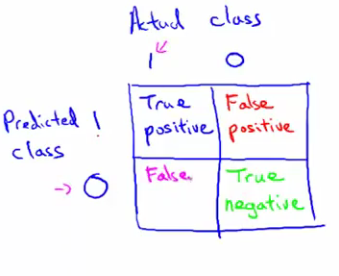
The precision of a model is the number of true positives/predicted positives

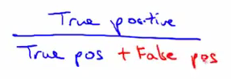
Recall is taking the problem from the opposite angle, and seeing the actual number of true positive, see what fraction of it we predicted (True pos/Actual positives)

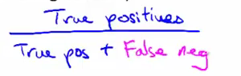

Accuracy, finally, is true pos and true neg/ total examples

Trading off Precision and Recall

If we want to increase precision, we will make our hypothesis more strict (y = 1 only if h(x)>0.7 instead of 0.5), thus decreasing the number of predicted positives, but potentially increasing the number of false negatives, and thus the decreasing the recall

Conversely, if we want to increase the recall, we decrease the threshold.

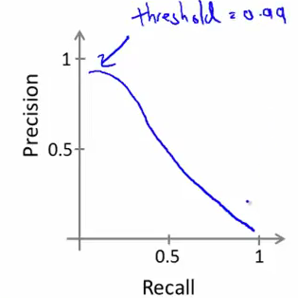
Precision vs recall. If threshold = 0.99, we don't make mistakes, but we miss out on a lot of stuff (false negatives)

We end up comparing both parameters to synthesize a score per threshold as 1/mean * P*R.

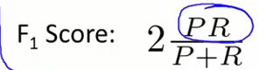
Conclusion:
When designing an model, first wonder whether a human operator would be able to make the predictions given the features we have (if he can't do it, the AI won't be able to either), second make sure you can have a large training set.
ON skewed datasets (positive are much larger group than negatives), accuracy is not a good way of measuring efficiency, instead refer to the F score of the classifier.

