Machine Learning Diagnostics

What if our model works on a set of training examples, but further usage proves that is makes a lot of mistakes? How to choose which method to choose to improve the model?
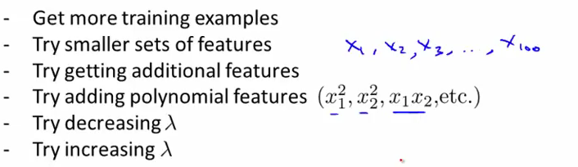
Evaluating the hypothesis
First what we want to do is split the training set into two subsets, one test set and one standard set
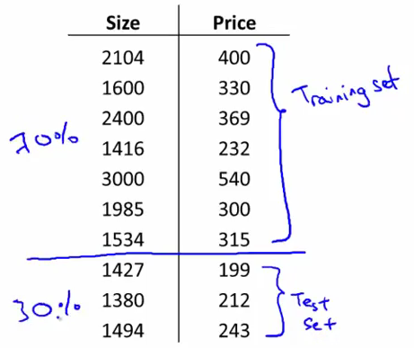
The standard set will be used to draft our model (define the parameters theta), and the test set will be used to verify it. Eventually we will compare the cost function in the case of the training set (which should be low) and the test set (which can be high if our model isn't correct or in case of overfitting) (training error vs test error)

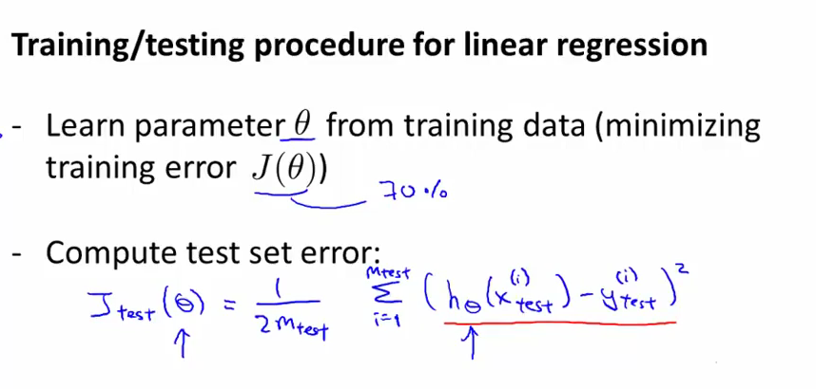
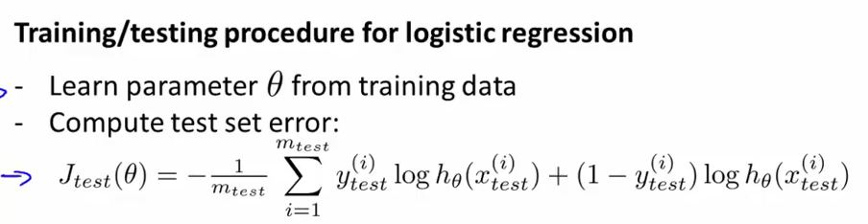
OR
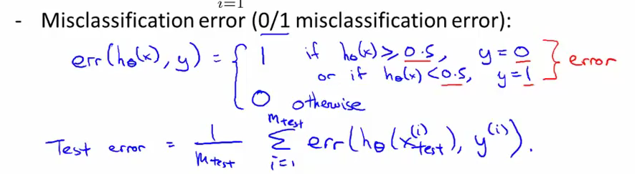
Which is a linear sum of members all equal to 0 or 1

Model Selection

What degree of polynomial do we want to pick?
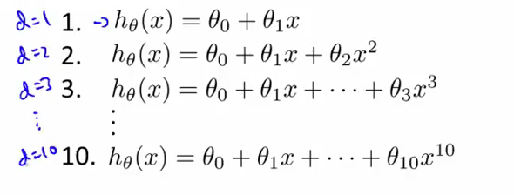
We pick several, and we compare the test errors for each one of them; however, this comparison is biased to work good on the test set anyway
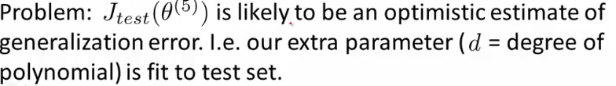
(The parmaters were chosen to do well on the training set, so they might not do well on other sets)

One solution is set to separate the training set even further into three categories (third one being the cross-validation set 60%-20%-20%)

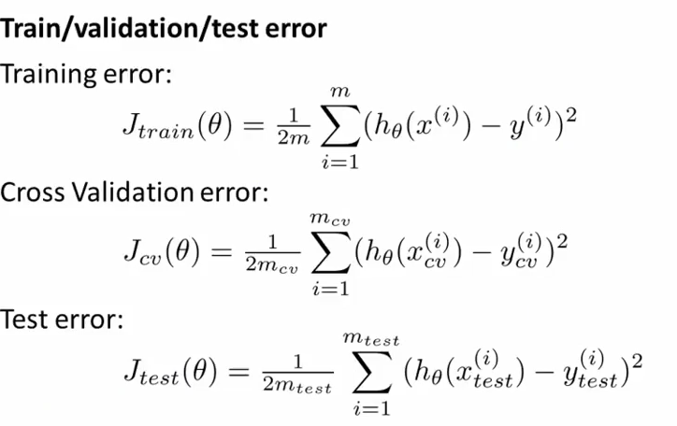
How this works is we are first gonna train our models for different polynomial levels, and then test the resulting thetas against the cross-validation training set.
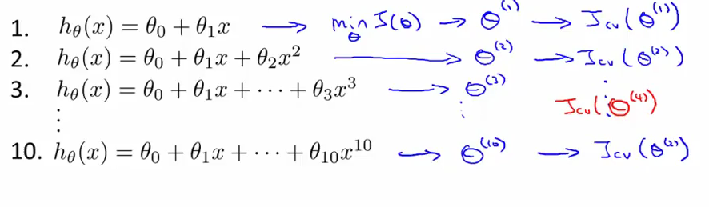
We then use the test set to evaluate the predicted error for generalized sets.
In conclusion, don't use the test sets to establish the model

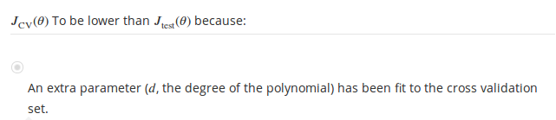
Bias vs. Variance

In other words, over-fitting vs under-fitting.
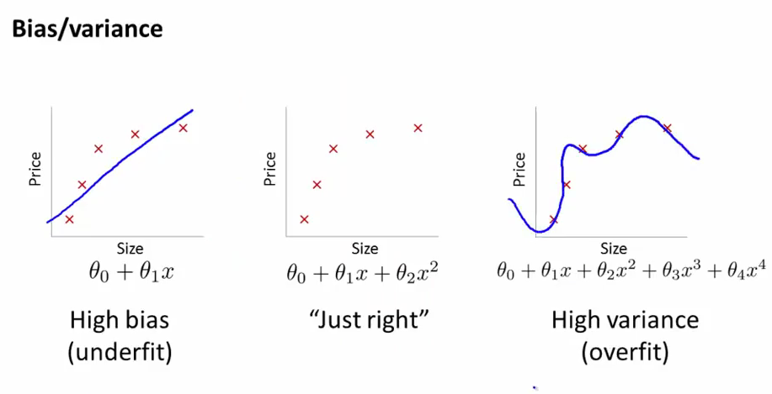
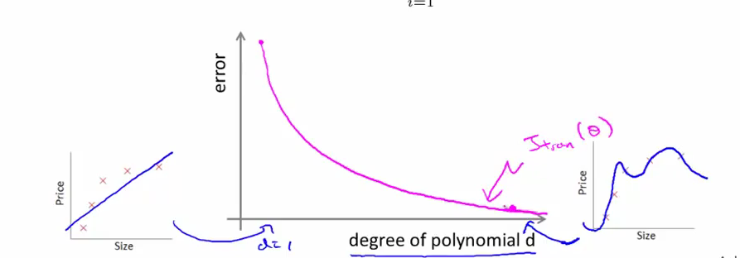
This J is for the training set only. Because the theta we find is not tailored for the cross validation set, the corresponding curve will actually pick up as the degree of polynomial rises
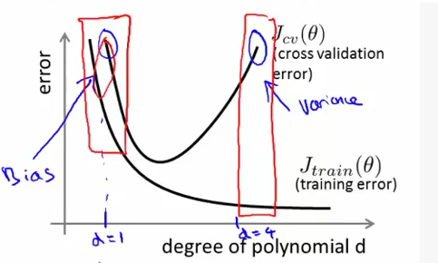

Depending on the combination of errors (low training, high cross validation; high training, high cross validation), the model will be respecctively over-fitted (high variance) or under-fitted (high bias)
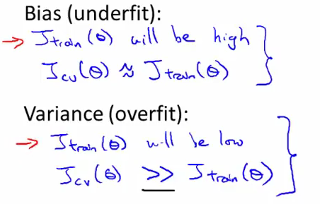
Regularization Vs Bias/Variance
The choice of lambda will determine whether over fitting, under fitting or “just right”
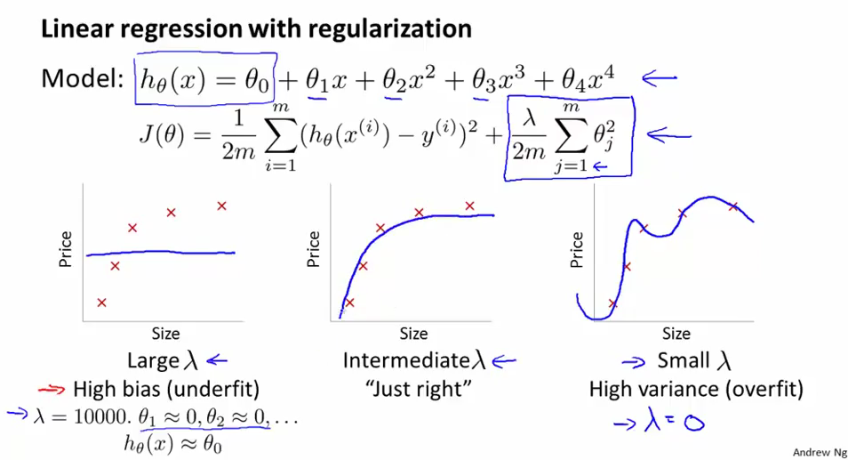
Same as for choosing polynomial degree, we try out different values of lambda and the test them against the cross validation set
And then we test the corresponding theta for the chosen lambda with the test set. Note lambda only appears in the original training set

Linear regression cost functions
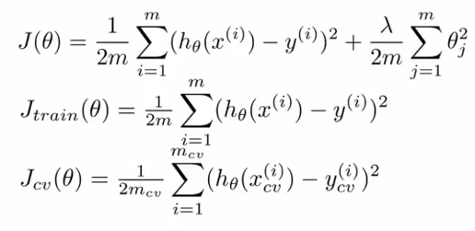
Logistic regression cost functions

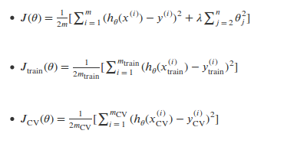

Note
J_train continually increases as lambda increases, but J_cv takes an inverted dumb bell shape
Here, under fitting and over fitting are inversed (if lambda is high there is a chance of underfitting) so the bias and variance markers on the curves are inverted as well and bias is on the right instead of being on the left in the previous graph (cost against polynomial degree)

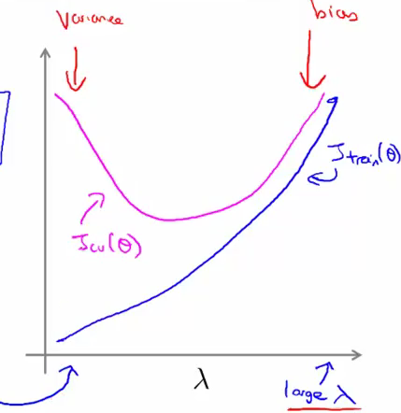

Learning Curves

A learning curve depicts the evolution of the error given a certain model we choose in relation to the number of training set examples. (If we choose a polynomial function to be our model and we have only two training examples, the we will be able to fit it perfectly, hence error = 0; but if we have a 100 training examples, then the parable of our model won't fit perfectly, hence error>0)
Contrary to intuition, the error grows logarithmically, not exponentially

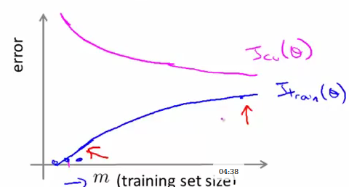

Learning curve with high bias

In case of under fitting, we get the same evolution for the J_cv and J_train but the two will end up closer
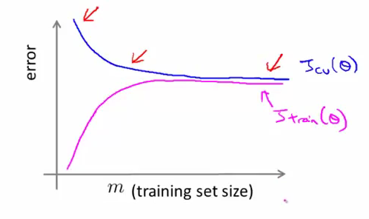
This shows that if your bias is high, collecting more training data won't be as efficient because the model is already struggling with a few training examples.

Learning curve with high variance

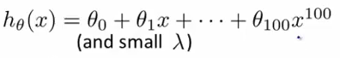
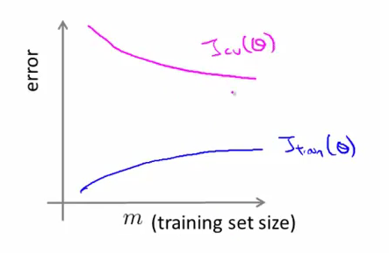
The indicative diagnostic that we have too much features compared to the set is that gap we have between J_cv and J_train
In this case, getting more data is likely to help
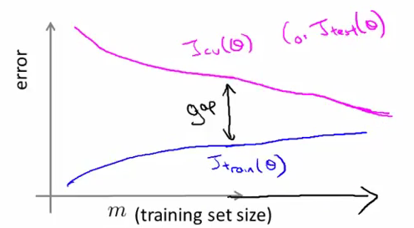

Conclusion

