Let's say we want to minimize a multi-variate function with constraints

One way to solve this is by using langrangian multipliers, which means we add the constraint function to the objective function
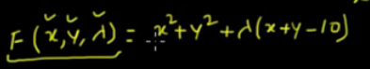
We know do the partial derivatives and set them to 0

