Support Vector Machine Algorithm
Pros:
  - It works really well with clear margin of separation
  - It is effective in high dimensional spaces.
  - It is effective in cases where number of dimensions is greater than the number of samples.
  - It uses a subset of training points in the decision function (called support vectors), so it is also memory efficient.
- Cons:
  - It doesn’t perform well, when we have large data set because the required training time is higher
  - It also doesn’t perform very well, when the data set has more noise i.e. target classes are overlapping
  - SVM doesn’t directly provide probability estimates, these are calculated using an expensive five-fold cross-validation. It is related SVC method of Python scikit-learn library.

SVM is using the kernel trick to make sure data is linearly separable in order to apply optimal margin classifier on data

Also called Large Margin Classifiers. The landmarks discussed later in the course are also called support vector (hence the name of the algorithm)

21 down vote | For a general kernel it is difficult to interpret the SVM weights, however for the linear SVM there actually is a useful interpretation:  1) Recall that in linear SVM, the result is a hyperplane that separates the classes as best as possible. The weights represent this hyperplane, by giving you the coordinates of a vector which is orthogonal to the hyperplane - these are the coefficients given by svm.coef_. Let's call this vector w.  2) What can we do with this vector? It's direction gives us the predicted class, so if you take the dot product of any point with the vector, you can tell on which side it is: if the dot product is positive, it belongs to the positive class, if it is negative it belongs to the negative class.  3) Finally, you can even learn something about the importance of each feature. This is my own interpretation so convince yourself first. Let's say the svm would find only one feature useful for separating the data, then the hyperplane would be orthogonal to that axis. So, you could say that the absolute size of the coefficient relative to the other ones gives an indication of how important the feature was for the separation. For example if only the first coordinate is used for separation, w will be of the form (x,0) where x is some non zero number and then |x|>0.

Prerequisites: If we look at the cost function for logistic regression, each member will actually be either log(sigmoid) or log(1-sigmoid), because y is equal to either 0 or 1, thus canceling one of the terms. By regrouping our terms with this in mind, we can rewrite the cost function for linear regression as the sum of the cost functions for y = 0 and for all the y that are equal to 1

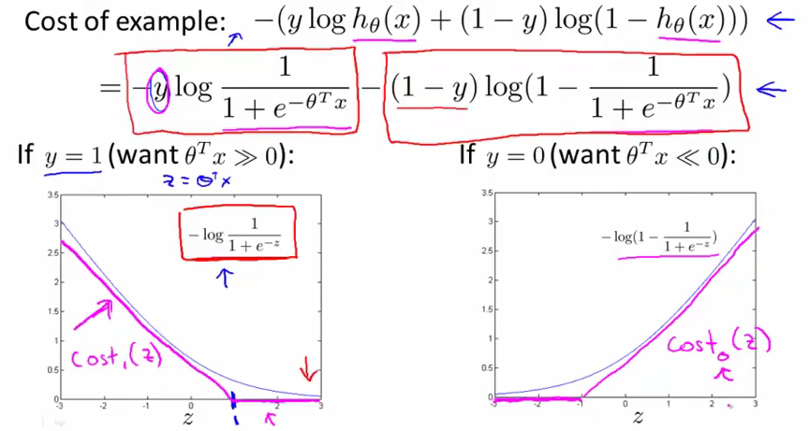
where z = Theta' * X

Because m is a constant we can get rid of it as it won't change the minimum.

Apart from that, we are also going to switch our regularization method. Instead of adjusting lambda to adjust overfitting, we will instead work on a term C that is a multiplicand of the first term of the equation (the sum). For all intents and purposes this term will be 1/lambda

Hypothesis:
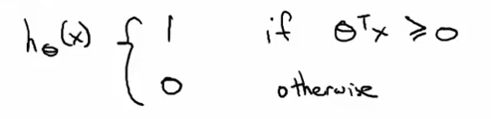
That is the basic hypothesis, but we can do better, seeing how the cost(z) in the previous graphs tends to 0 if z > 1 and z < -1 respectively

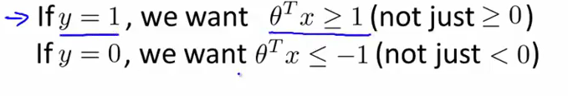
This is the first element of our new hypothesis. We want to solve the cost function knowing these two constraints.

Let's go one further and set C (1/lambda) to be really large (so lambda to be really small). This will induce our algorithm to make the sum(cost1(z) + cost2(z)) to be close to 0 to compensate. This will in turn 'force' our theta' * X values to be in that 'close to zero' region when z < - 1 and z > 1.

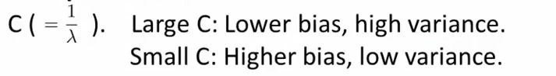

In the end we are left with the following problem (only the regularization term remains):
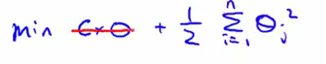
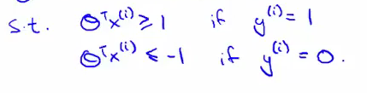
We are left with a slightly different optimization problem, with a simpler cost function (single quadratic sum) and a set of constraints, so it can be resolved analytically.

Consequences on the decision boundary:
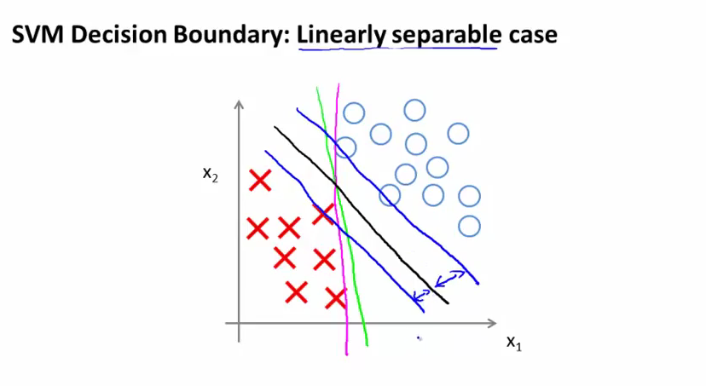
Not only is the SVM decision boundary (black) more 'accurate', it also has a bigger no-man's land zone on each side of the boundary between it and any point of the training set (this is why it is also called large margin classifier). This margin could reflect the interval of z we are not using in our optimization ( ]-1;1[ )

In case of outliers (isolated training examples all over the place), the SVM is expected to also perform well and keep the optimal decision boundary, ignoring these exceptions

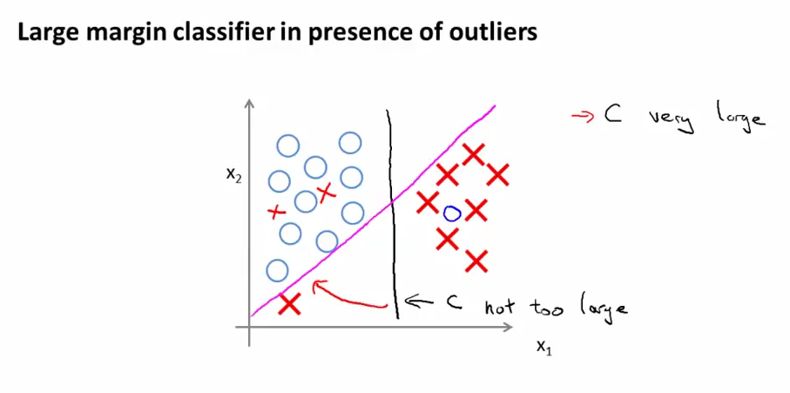
Reminder on vector inner products:
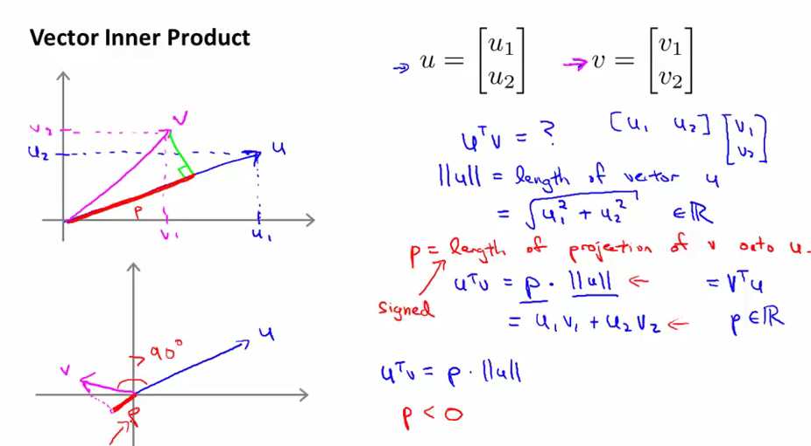
Mathematic proof:
Let's work with a model with only two features theta1 and theta2 (we set theta0 to 0). The cost function, reduced to the regularization term, is actually equal exactly to the formula of the length of theta
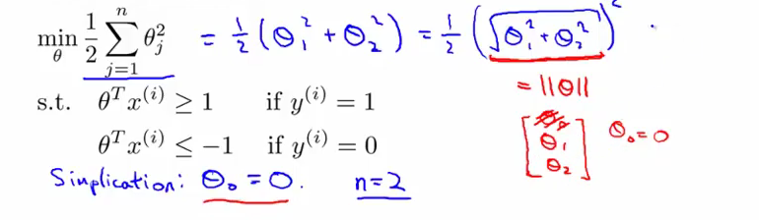
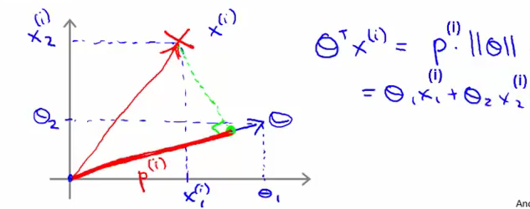
Because theta' * X can be considered as a vector inner product, we can apply cauchy schwarz inequality for colinear vectors. But Theta' * X is also simply our linear function H(X). We are left with our two equation being equivalent

Knowing that, we can also rewrite our constraints for the optimization problem:
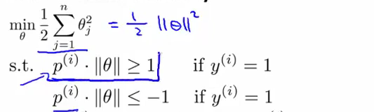
(second line: if y = 0)

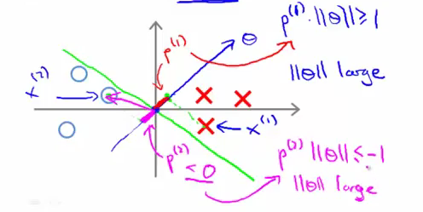
But we want solve this to actually minimize the norm of theta (because we want to minimize the cost), so this decision boundary seems to be ill-chosen.
Conversely, if we choose the following decision boundary (notice that the vector theta is perpendicular to the boundary), the lengths of the projections are much bigger, and the norm of theta can be smaller:

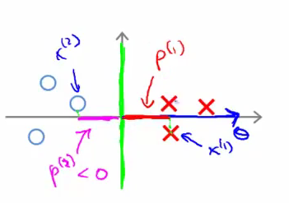
We can use that as a hyptohesis for the model: the projection of X onto theta has to be large. Note that the theta vector is always orthogonal to the margin.

Those projections are actually the margin:
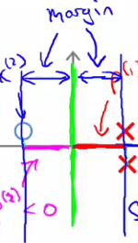
This should force p to be large, and our boundary to be more accurate (by forcing bigger margins)

Kernels

A kernel is the process of choosing complex features (non-linear) to simplify a
non linear decision boundary problem
https://www.quora.com/What-is-the-intuition-behind-Gaussian-kernel-in-SVM
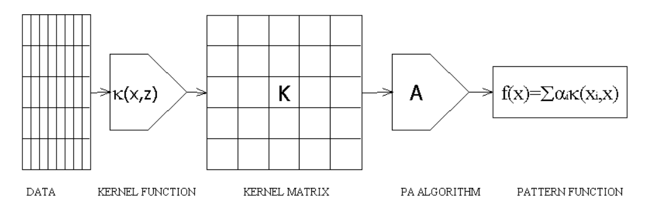
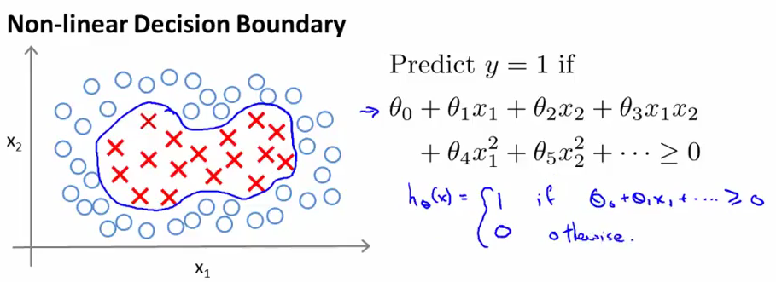
Because of the computational problem related to numerous features, we might be tempted to replace these n features with a smaller number of more complex ones. For this example, let's pick three points on this graph and analyze our training examples regarding to their proximity to these points.

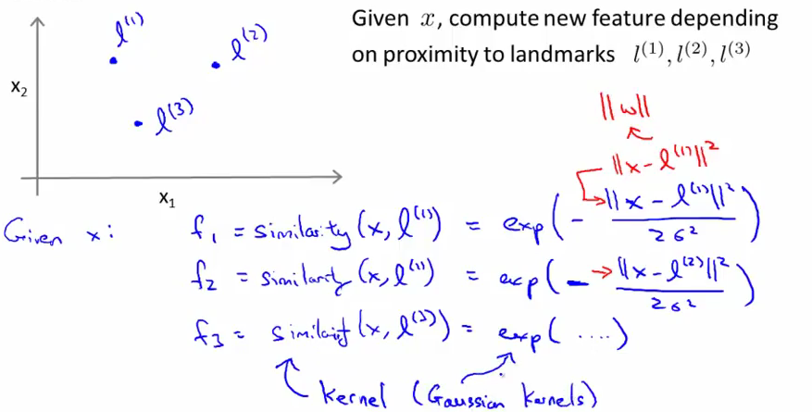
Sigma is a parameter chosen for f. If x is close to l, then f will be equal to 1. If x is far from l, the term inside the exp is nearing negative inf, and f is equal to 0
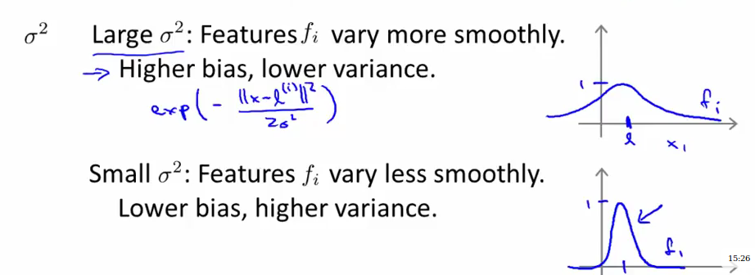

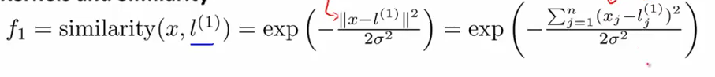
Let's take an example in two dimensions, with l being a point on the 2D feature space, and let's see how adjusting the parameter sigma will affect the kernel f

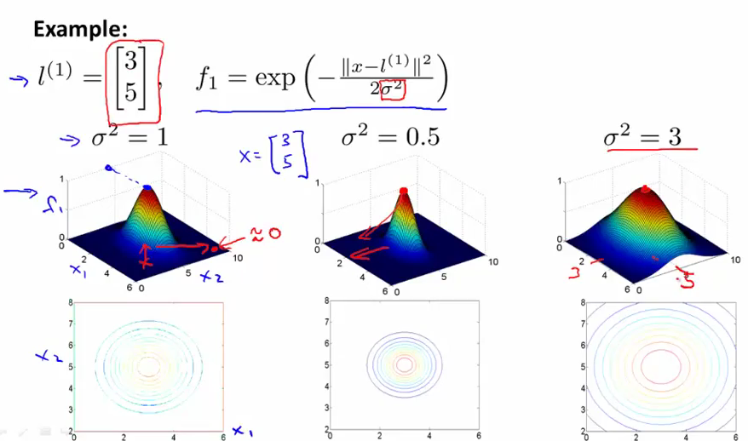

As sigma gets bigger, the value of f falls away much more slowly

Having more than one landmark, we will want to check whether the vector inner product of the landmarks and theta is bigger or smaller than 0. If it is bigger, predict one (because we pass that vector inner product by sigmoid), and if it is smaller than 0, predict 0

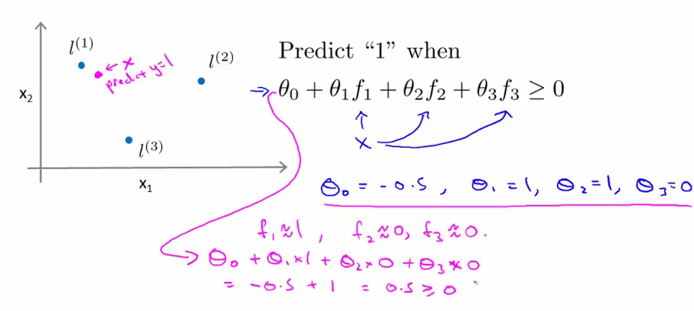
IN the end, though, we are going to end with one landmark per location, and each landmark will have only one neighboring training example for which the kernel application gives 1.
We end up with a vector f(i) for each training example x(i)
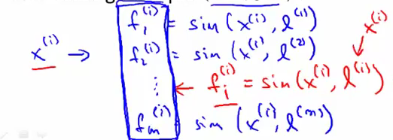

Our hypothesis:
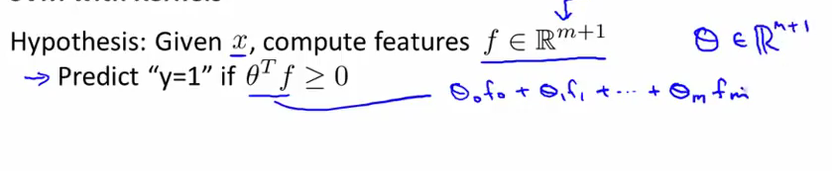
In the end, the cost function will having f's instead of x's:
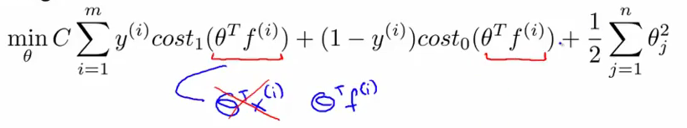
Notice that the number of features will automatically be m with this method.

Sometimes, for the algo to be more effective, we write Theta' * M * Theta where M is a 1,m vector instead of theta' * theta for the quadratic sum.

Because of complexity, Kernels won't run well with traditional logistic regression

SVM in practice:

Use software package to solve for parameters theta (libsvm, liblinear). Almost no one writes software themselves. Your job is to specify the choice of C, the choice of kernel, or absence thereof (linear kernel, predict y=1 if theta' * x > 0). Choose what performs best on the Cross validation set.

Note: Remember to perform feature scaling before using the gaussian kernel (translating vector X into F), otherwise you won't find a set of landmarks that can be applied to all features equally
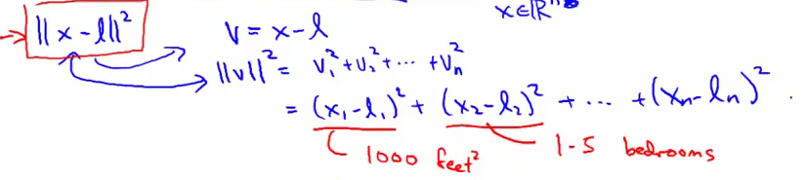

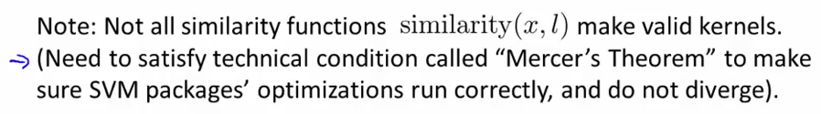
The gaussian kernel and the linear kernel are the most widely used. Some Kernels have built-in multi-class functionnality.

Logistic regression vs. SVM:
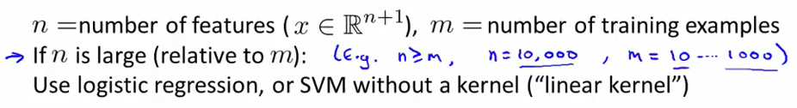
Example: spam classifier, where number of features prevails over number of training examples

If a lot of features, logistic regression, if intermediate training examples and small features, use SVM with Gaussian Kernel

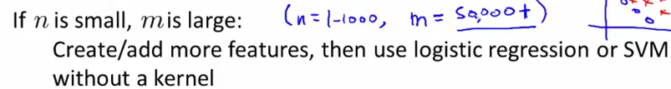
if a lot of features, don't use a kernel (similarity function f too complex)
A gaussian kernel can best be understood by its throwback to the gaussian function (y = e^(-x^2)), as this is how the proximity between a training example and a support vector are represented.
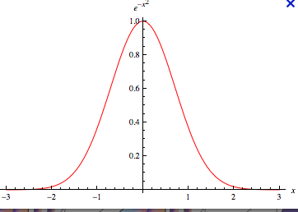

More on feature mapping
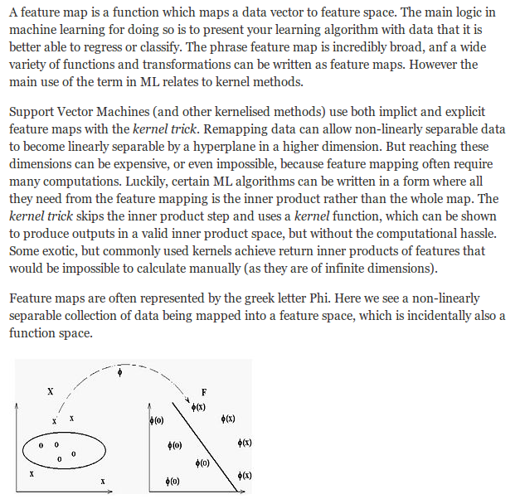
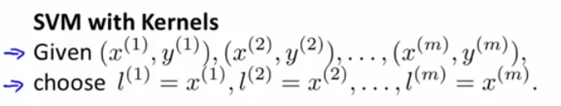
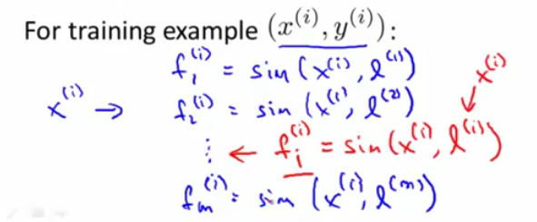

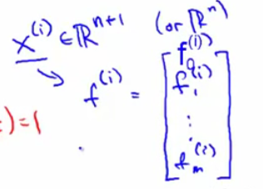

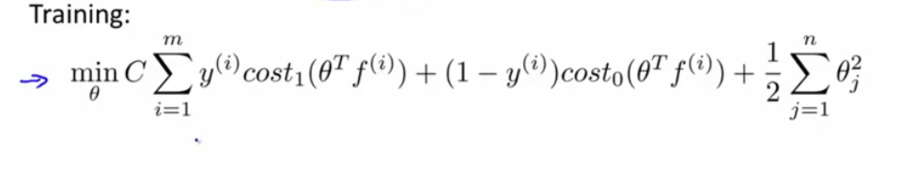
with here, n == m

SVM is working on the second term instead of the first (because we put C instead of lambda)

http://crsouza.com/2010/03/kernel-functions-for-machine-learning-applications/#linear

The main characteristic of Kernel Methods, however, is their distinct approach to this problem. Kernel methods map the data into higher dimensional spaces in the hope that in this higher-dimensional space the data could become more easily separated or better structured. There are also no constraints on the form of this mapping, which could even lead to infinite-dimensional spaces. This mapping function, however, hardly needs to be computed because of a tool called the kernel trick. (this is why we say gaussian kernels map into infinite feature space, although the process is nowhere near as complex as the name would suggest it)
So KERNEL map the features into a higher dimension space in order to find a linear separation if that is not possible in our objective function space. Think 2D dataset with a circular separation, red dots dotted all around blue dots, that we project on a 3D space; red dots on top and blue dots now on the bottom: it is now linearly separable.

https://www.youtube.com/watch?v=3liCbRZPrZA

Kernel trick

Now, the Kernel trick is really interesting because that mapping does not need to be ever computed. If our algorithm can be expressed only in terms of a inner productbetween two vectors, all we need is replace this inner product with the inner product from some other suitable space. That is where resides the “trick”: wherever a dot product is used, it is replaced with a Kernel function. The kernel function denotes an inner product in feature space and is usually denoted as:
K(x,y) = <φ(x),φ(y)>
Using the Kernel function, the algorithm can then be carried into a higher-dimension space without explicitly mapping the input points into this space. This is highly desirable, as sometimes our higher-dimensional feature space could even be infinite-dimensional and thus unfeasible to compute.

In the gaussian Kernel, instead of computing the vector of X mapped into god know where (hence infinite dimension space), we instead compute its proximity to the support vectors (real number)

go for linear kernel if you have large number of features (>1000)

http://www.mblondel.org/journal/2010/09/19/support-vector-machines-in-python/
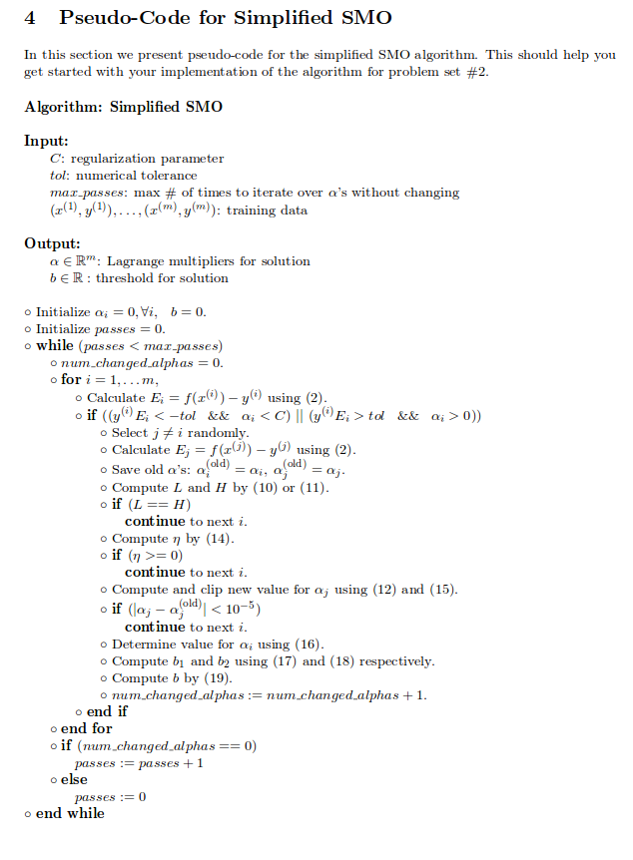
https://github.com/karpathy/svmjs/blob/master/lib/svm.js
https://github.com/mazefeng/ml/blob/master/svm.py

(implementation of above algorithm in js (the absolute madman))

alphas are the lagrangian multipliers that optimize the quadratic sum of the norms of the weights while ensuring that the norm of the prediction for X[i] is further away from the decision boundary than a certain margin (1)

Compute graham before the iterations speeds up process? (looking up a value each time we compute dot product in iterations in O(n) time instead of having to compute it individually)?

https://www.quora.com/What-does-the-alpha-mean-in-the-dual-form-of-SVM-optimization-problem

alpha is the weight of the contribution of each training vector in determining w

