Unsupervized learning

We only have the training examples and the features, but we don't know what are the categories (x, but not y)

Clustering:
Clustering is the process of analyzing an uncategorized set of data and gathering the examples into categories.

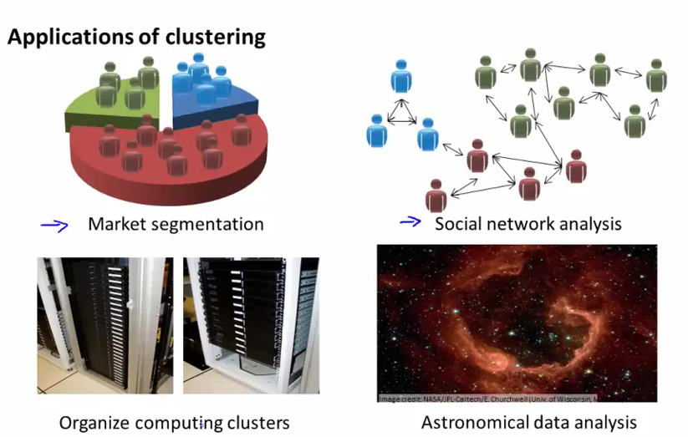
K-means algorithm
http://stanford.edu/~cpiech/cs221/handouts/kmeans.html

It is composed of two steps: the cluster assignment step and the move centroid step.
The first step is to randomly initialize two points (the cluster centroids).
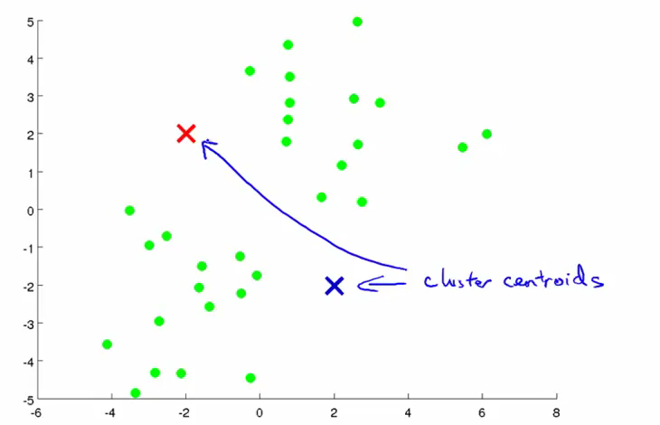
The algorithm is going to assign one of the two points to each training example depending on whether it is closer to one or the other.
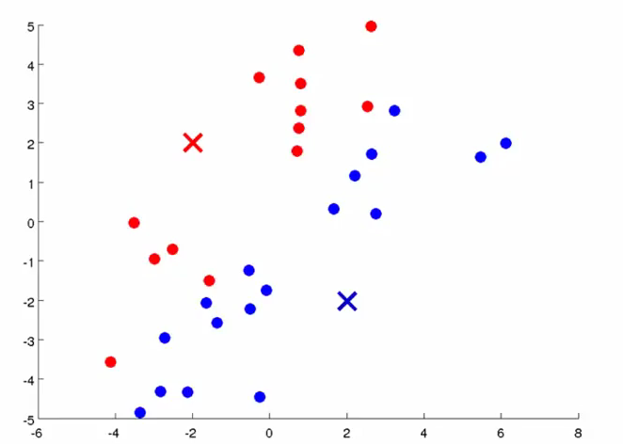
Once this is done, we take the average of each of the two newly formed groups and move the centroids there.

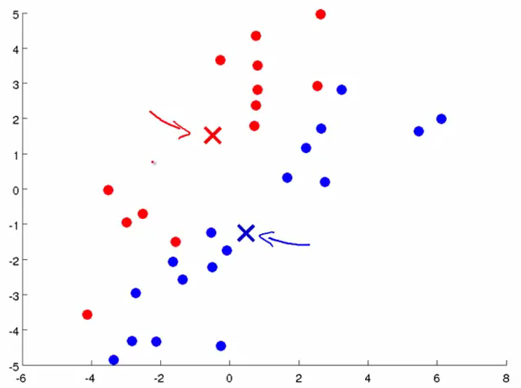
And then we repeat step 1 (color points depending on distance to new centroids)
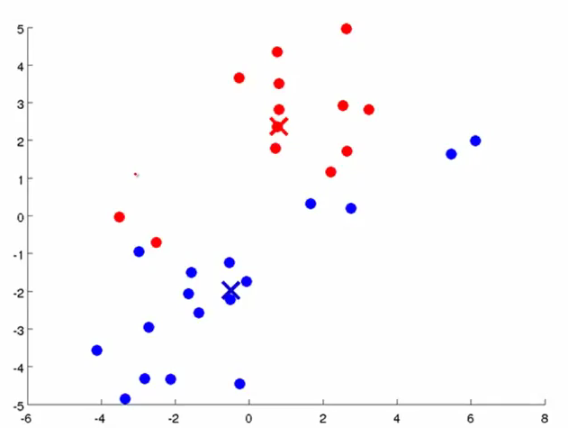
.
.
.
Until convergence of the centroids and the color codes on the points.
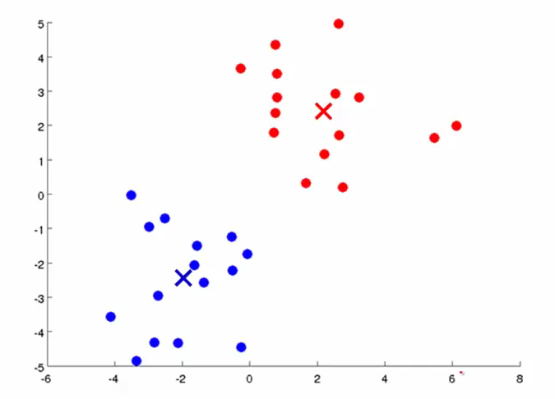
Input: K clusters (for K labels) and m R^n vectors x.

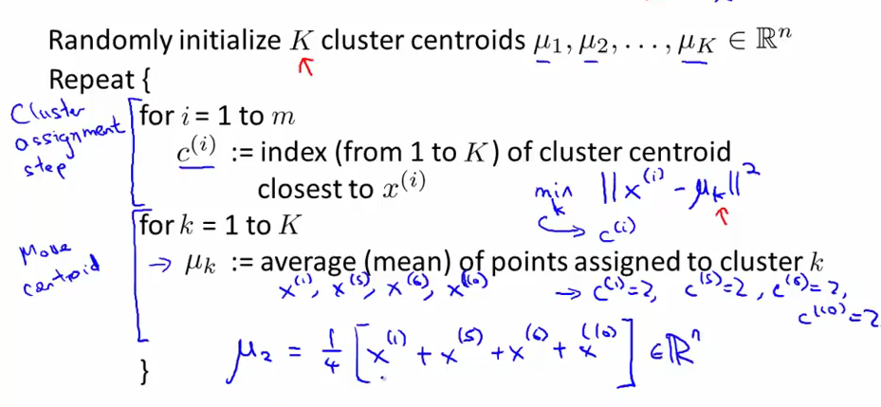
c(i) takes the value for each training example of the cluster centroid which has minimal distance to that x(i)

( Cluster that are 'pointless' at the end of an iteration are usually deleted)
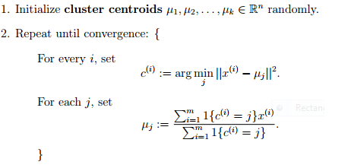

Non-separated clusters
What happens if there is no clear separation between the clusters?
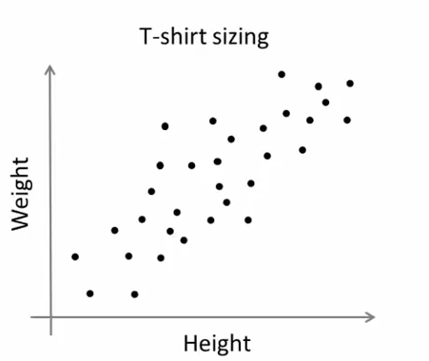
Optimization objective
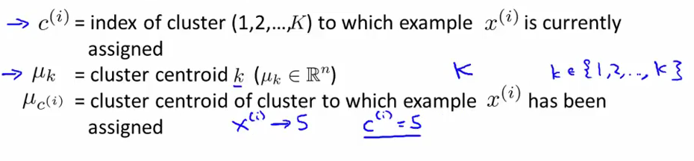
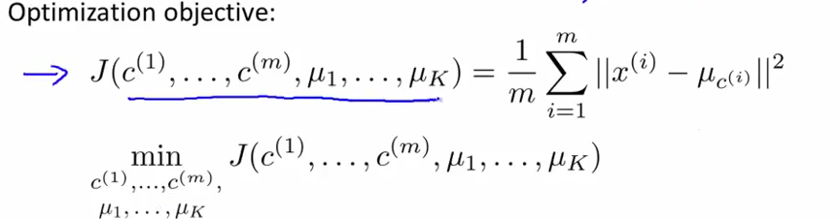
This is the distortion cost function, and does not give us a model at the end. The first step of the minimization is what the cluster assignment step in the previous algorithm is doing, it minimize the function with respect to C, while the second step (move centroid) minimizes the function with respect to mu

Random initialization

K should be set less to m. We can then randomly pick k training examples and set mu(1) … mu(k) equal to these training examples.

Sometimes K-means will get stuck in local optima of the distortion function, where to quadratic sum of the distances between x and mu's is minimal, but not optimal, such as here

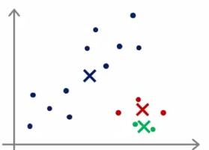
A workaround is to run several instances of the algorithm for several random initializations (just like Karger's minCut. For notes on how to set edges and similarities between training examples for minCut for bipartition, for eg using gaussian kernel, see pdf page 3→)
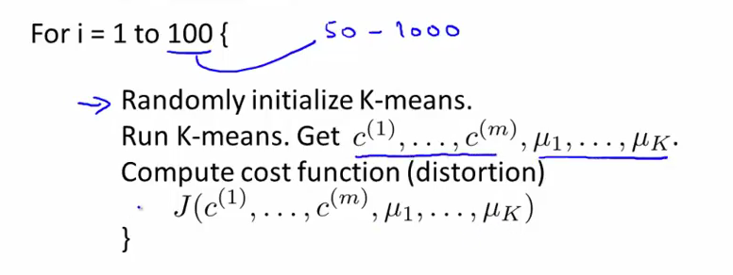
We then pick the clustering that gave us the lowest cost.

Choosing the number of clusters
Just like choosing optimal lambda for logistic regression, we can run several simulations and see how the cost function evolves
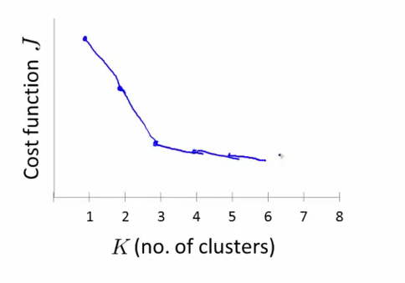

Elbow method:
we look for the “dip” in the above function. Increasing the number of mu's will only marginally optimize the cost function minimum and reducing k revolves in a sharp increase in the distorsion cost function.
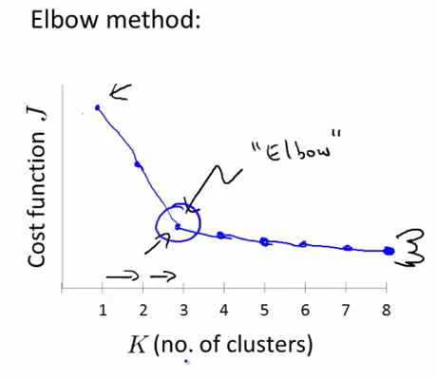
Sometimes this method won't work very well because there is no clear 'elbow' on the plot.

(if k=5 yields a higher cost than k=3 on the previous graph, it can mean that in k=5 the clustering got stuck in a bad local minima, and k-means should be re-run with multiple random initializations)

Downstream purpose:
if evaluating size of t-shirts, use existing categories that will be relevant down the line (size s, l, m) as a basis

Principal Component Analysis

Data compression: Reduce the dimension of your input data , which will be used in a supervised learning algorithm (i.e., use PCA so that your supervised learning algorithm runs faster).
Ex: we want to build a model predicting if a car will break or not. Unbeknownst to us, two features are usury of motor related to speed in kph, and the other one, usury of motor related to speed in mph. They are almost linearly independent, and as such, redundant. We want to simplify this using PCA

http://ufldl.stanford.edu/wiki/index.php/PCA
http://sebastianraschka.com/Articles/2014_pca_step_by_step.html

Dimensionality reduction
eg compressing image. Allows to speed up algorithm.
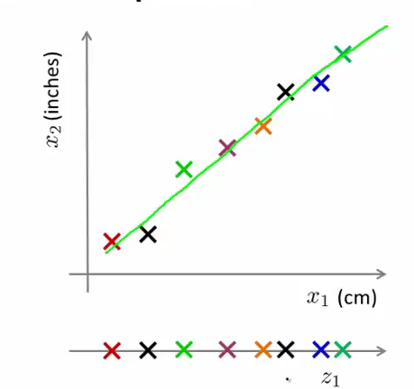
Here, reducing from 2D to 1D, we reduced our features x1 and x2 into a single feature z1
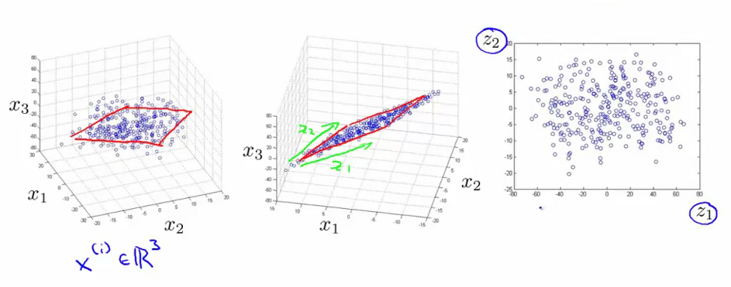
Here, reducing from 3D to 2D. In the intermediary step we project all the 3D points onto a z1, z2 plane in the 3D space.
Ideally, we would like to reduce a R(n) problem into 3D or 2D so that we can visualize it.

PCA Algorithm:

Let's say we have a 2D problem and we are trying to reduce it to 1D.
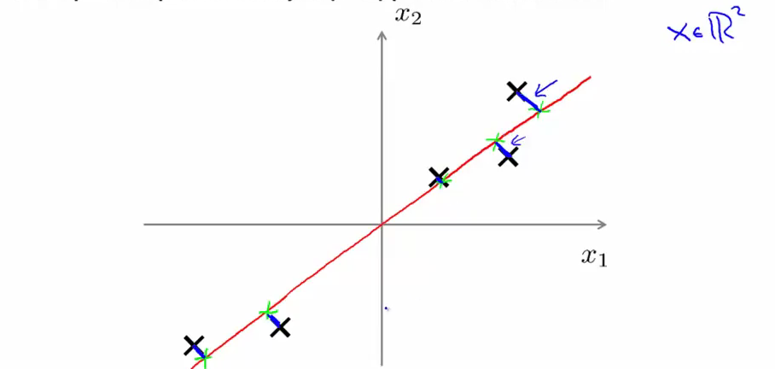
PCA will try to find a lower dimensional surface (a line in this case), such as to minimize the distances between the points and that surface (blue lines). The resulting vector U that will define our subspace could be seen in 1D as the principal direction of variation of the data

Differences with linear regression (OLS): In OLS, you compute the norm of the the vector formed by the point and its 'vertical' projection onto the subspace, in PCA you compute the norm of the vector formed by the point and its orthogonal projection onto the subspace

We proceed to do Mean normalization and feature scaling

The problem then is to find n-1 vectors onto which to project the R(n) data as to minimize the error. One thing will be to compute the n-1 vectors defining the subspace and then the m vectors that are the projections of our x1...xm vectors unto the subspace.

Preprocessing (mean normalization)
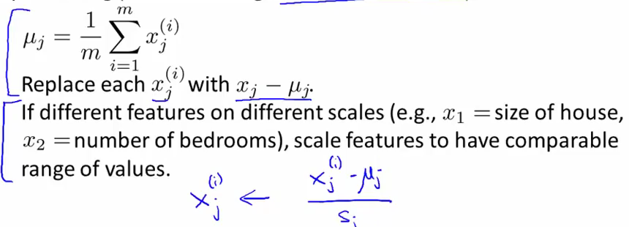

Computing the covariance matrix (nXn)
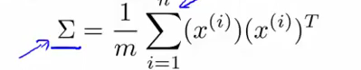
This matrix sigma is the covariance because the mean of each x is equal to zero (feature normalization), so E(x) = 0, so variance E(X-E(X)^2) is equal to E(X^2)
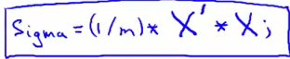
Computing Eigenvectors of matrix sigma
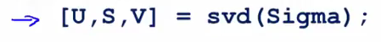

(svd = single value decomposition, eig could also be used)

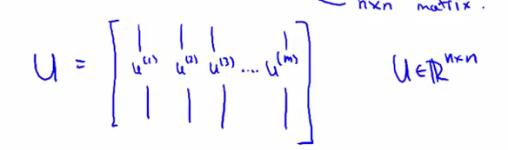
U will be composed of our defining vectors for the subspace (we take the first k columns), and Z = U' * X will be our (k,n X n,n = k,n) dimensional vector
For j appartenant (1...k):

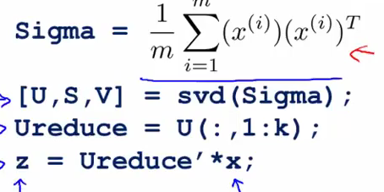
(we don't use the x0 convention)

Reconstruction from Compressed representation

if
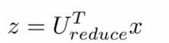
then
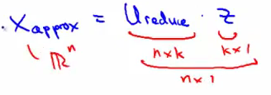
That's because U is orthogonal

Choosing the number k of principal components

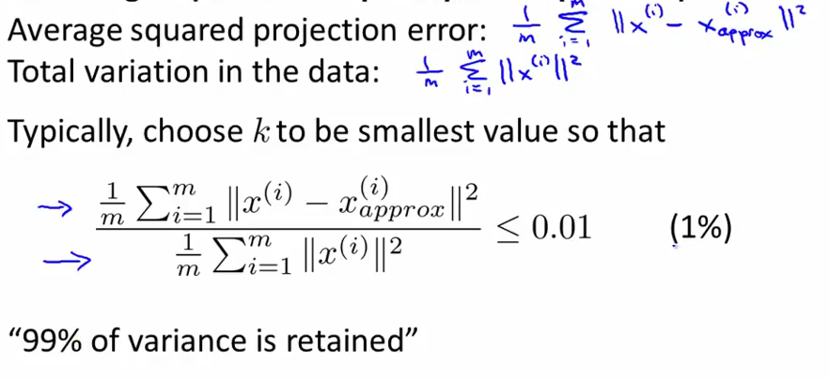
averages squared projection error / variance in the data < 0.01. Run the algorithm for a value of k and if the percentage of variance retained is less than 99% then we try again for a higher value of k, but this is a very time consuming method. Alternatively, we can take the S matrix in the [U,S,V] result

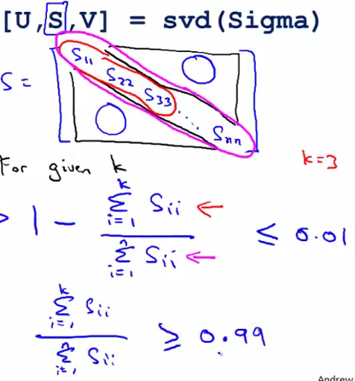

and change k to minimize that. The values of S are called the eigenvalues of SIGMA

Conclusion

Procedure: extract inputs from our (x,y) pairs.
Apply PCA
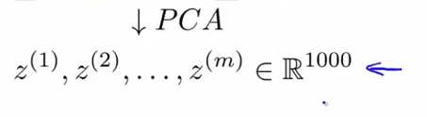
We have a new training set
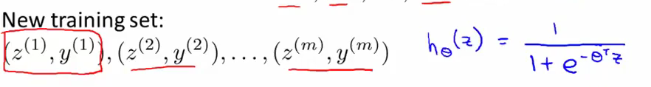
The PCA should be defined only by the training set, but can be applied to cross validation set and test set.

Applications
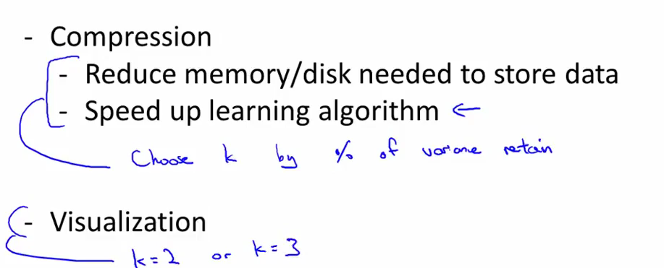
NOTE:
Do not use PCA to avoid or counteract overfitting. It throws away information that could be valuable without knowing the values of the labels y. Use regularization instead

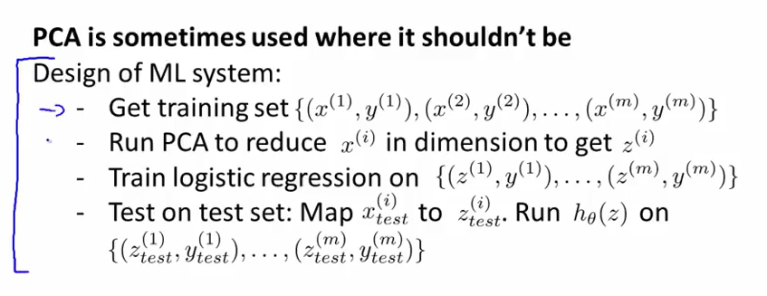
First try or at least consider the whole thing without PCA

Another way of explaining PCA is that (z) is an dimensional vector, where the first few components are likely to be large (e.g., in our example, we saw that takes reasonably large values for most examples ), and the later components are likely to be small (e.g., in our example, was more likely to be small). What PCA does it it drops the the later (smaller) components of , and just approximates them with 0's.

