Anomaly detection

Analyzing a dataset to highlight anomalies and discrepancies, by modeling it with a Gaussian distribution.

Density Estimation

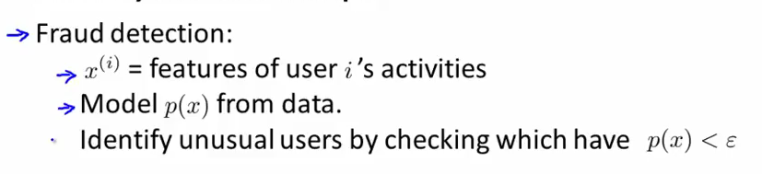
(how often does he log in, what is the typing speed of the user?)

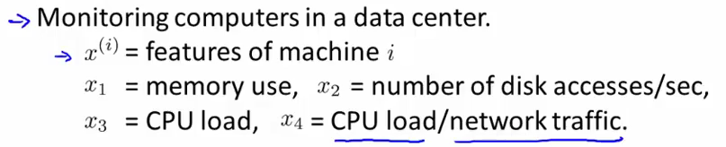
Gaussian distribution
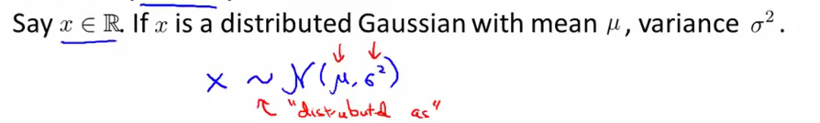

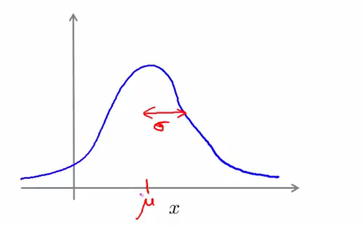

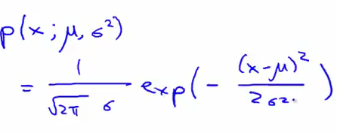
Example of gaussian distribution: if mu is equal to zero and sigma is equal to one, this corresponds to a 0 centered gaussian distribution where the width of one 'half bell' is 1 (whiff).

Parameter estimation

Maximum likelihood estimates

Algorithm

For a dataset of size m in a space of dimension n, the probablity of an example x is the product
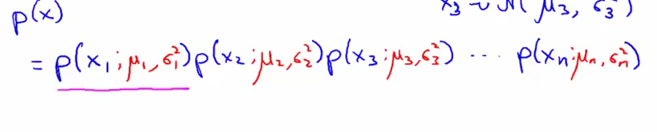
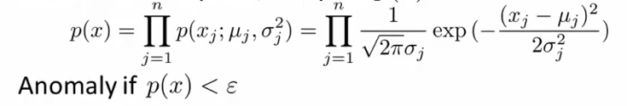

We assume that each of those variables are independent and follows a gaussian
distribution with each its own parameters mu and sigma. Note that mu and sigma refer to the features, not the training examples.
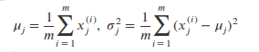
Vetorized formula:
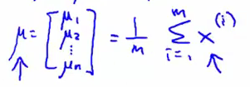
One way to visualize that p(x) is the product of gaussian distributions is this graph:
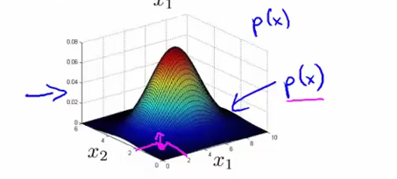
We can see that x also follows a gaussian distribution.

Visualization of p(xi, mu, sigma). Given a feature that takes different values depending on the training example, we can plot the density of that feature:
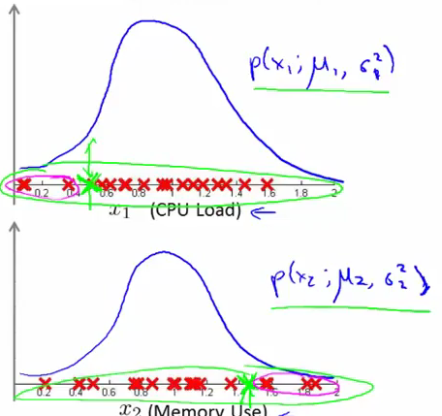
The top of the bell are the values that the feature takes the most often

Building an anomaly detection system

Having a known training set with a known number of anomalies, we often build our training set to not include the anomalies, but the cv and test set do.
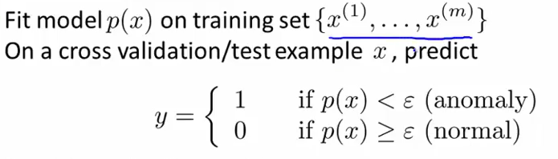
Note that the distribution of y will be skewed because there is much more normal examples where y = 1 than anomalies, so accuracy alone is not a good metric for evaluating the algorithm
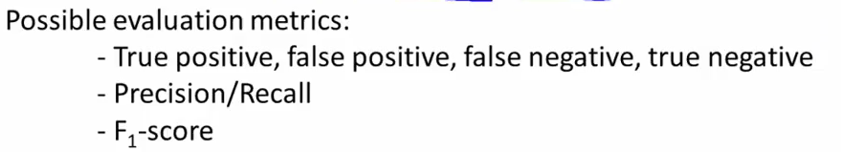
Anomaly detection vs supervized learning

Those two methods are alternatives.
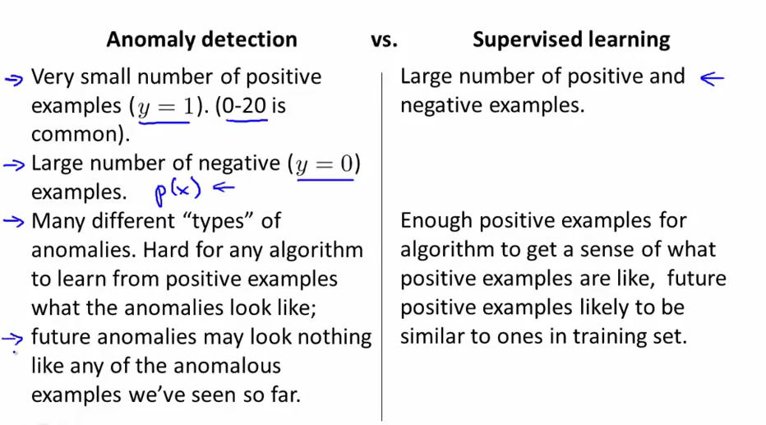
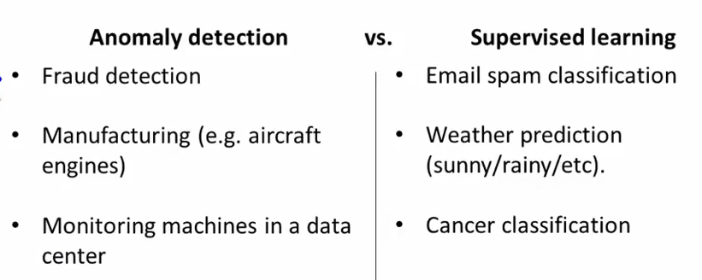

Aka anomaly detection for the more boring ones (most of the time)

Choosing what features to use

Check if a feature 'looks' gaussian : hist function on octave. If it appears not to be gaussian, we can transform our features (take log, and check hist of that log for eg). There are of course other transformations
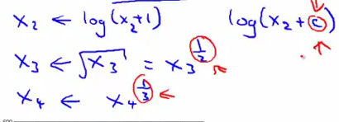

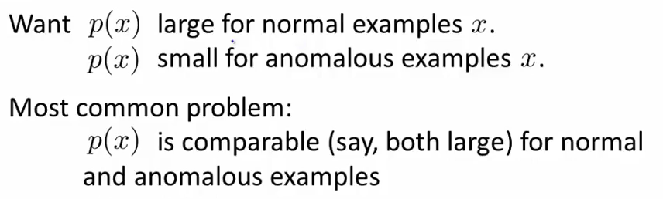
→ create a new feature
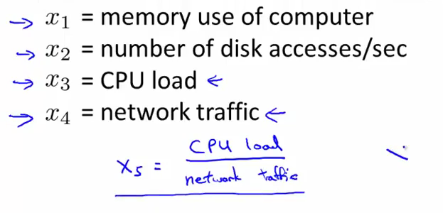

Multivariate Gaussian Distribution

For computing p(xi, mu, sigma) for multivariate gaussian distribution we will compute p(x) all in one go by computing the covariance matrix

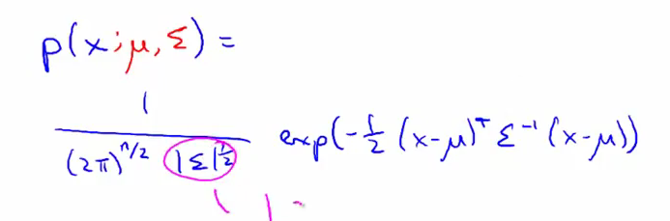
(not necessary to remember)

2d examples - visualization

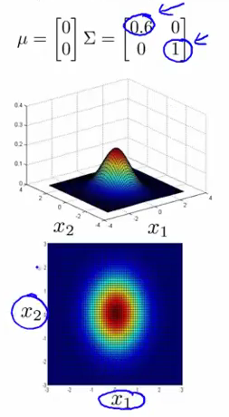
Here p(x) is highest when x1 and x2 are equal to 0. If we decrease sigma, the curb 'shrinks' on itself on one side. We can model that x1 has a smaller variance than x2.

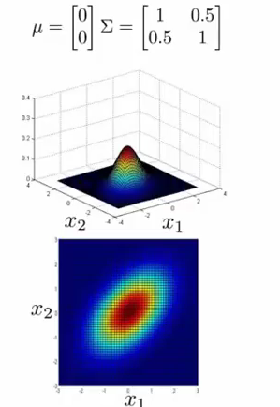
Here we can see there is a correlation between x1 and x2 because the circles are not 'vertical' (they are not axis-aligned), because x1 and x2 evolve 'together' (in the other side if correlation is negative)

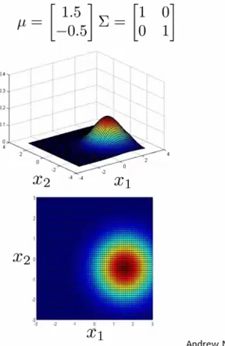
Finally, a variation in mu shifts the distribution around
Algorithm
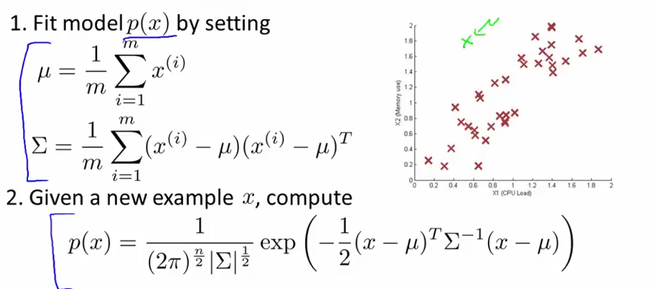
We see that the original algorithm in the previous part is just the application of this one but for features whose covariance is zero (so sigma covariance matrix is a diagonal matrix)

The original model does not capture the relation between x1 and x2 variations if there is, so you need to create a feature that modelizes this (ex x1/x2), but this model scales better with high dimensions (no need to compute inverse of sigma and can do with a small m (doesn't require m to be > n (in order for sigma to be invertible)))
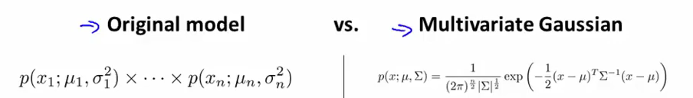

Recommender Systems

Predicting movie ratings

Let's imagine we have fours users and five movies, and the users have rated some of those movies from zero to five stars
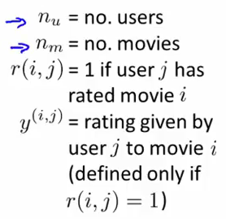

Content based recommandations:
We create features that will help us classify the movies (x1 = 1 if action movie, 0 if no action at all, x2 = 1 if comedy, etc). Note that we will use an interceptor term x0 just like for logical gates
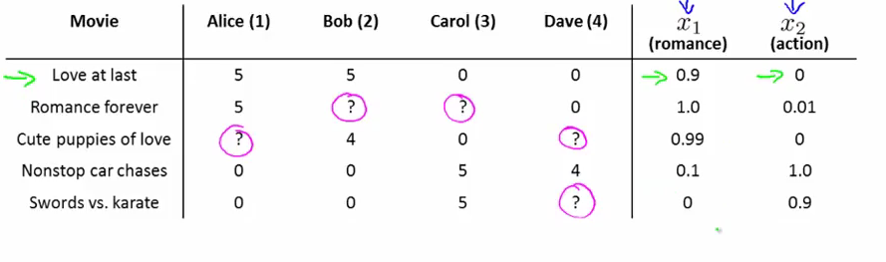
If the genre score for a movie is x(i), [x0, action_score, comedy_score], the user is j, y(i)(j) can be seen as the matrix product of a parameter theta(j) and x(i)
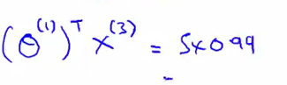
We are applying a different copy of linear regression to each user. Specifically, given a certain movie score for a group of movies and the score we know the user has given to those movies, we want to predict theta so as to draw a funnction that can extrapolate the user's tastes in movies
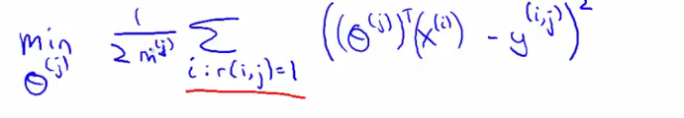
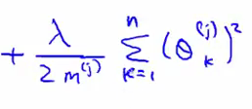

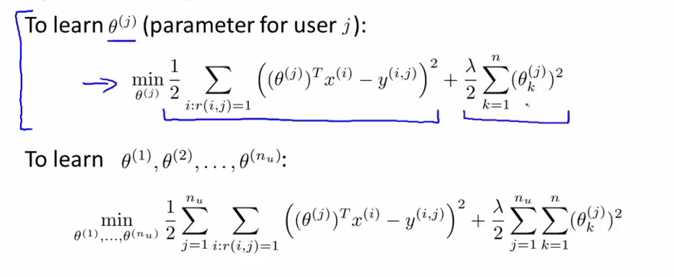
So we want theta that minimizes the above expression
We want to predict the movies for all the users, so we sum all the objectives and minimize the overall cost function, and we get thetas for each of our users.
So here, we don't look for a model that given a new set of x, gives y, we are looking for a theta per person, a model per person.

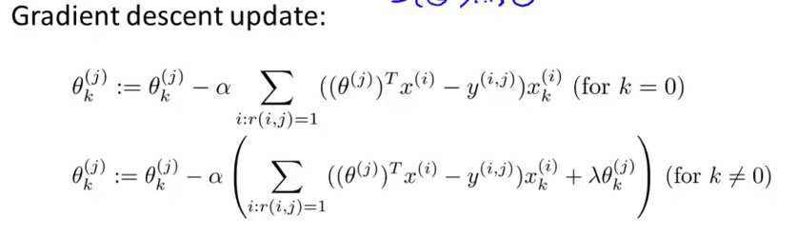

Problem formulation

Collaborative Filtering

Establishing all those movie scores (the features x in our problem) can be time consuming. If we have already the behavior of some people for these movies, we can infer their genre directly as well the how the user will rate new movies

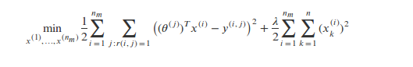
Although we are minimizing the same cost function, now we are doing it with respect to x, so the gradient descent will be :
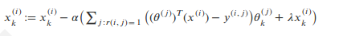
Note that the second term regularization is not equal to zero as we are taking the derivative for x

Algorithm
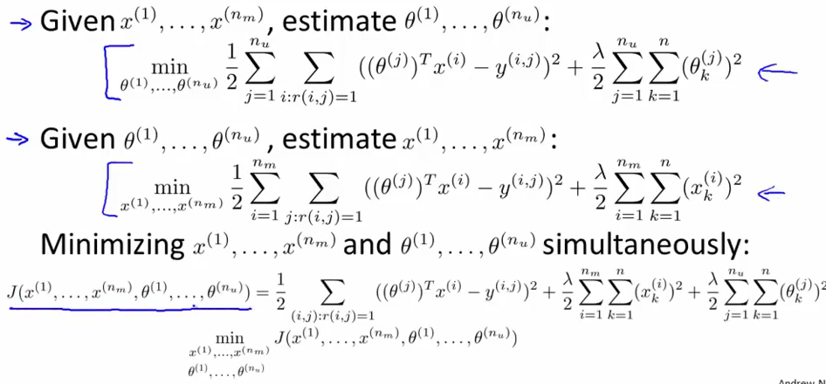
Instead of doing these two optimizations separately we are going to merge them together and do them in one go

In the first sum we sum over every user j, and every choice I he made, and in the second we sum over each movie and each couple j, r; so it's the same but inverted. We are not going to go sequentially between the two parameters x and theta, however, setting one to be constant as we are computing the other, but do both simultaneously. X is Rn, theta is Rn (we get rid of x0)

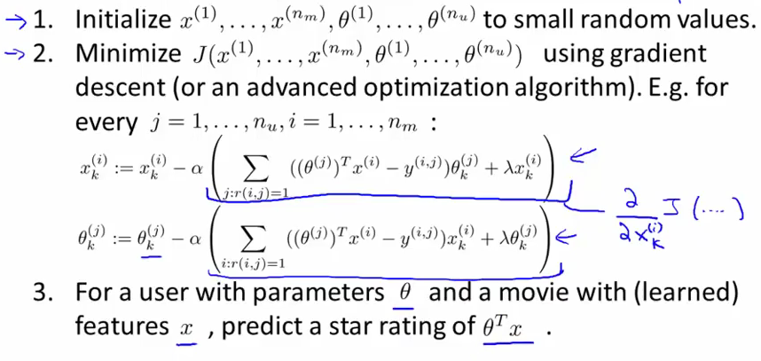

Low Rank Matrix Factorization

This is an alternative to writing the predicted scores for the users. Instead of

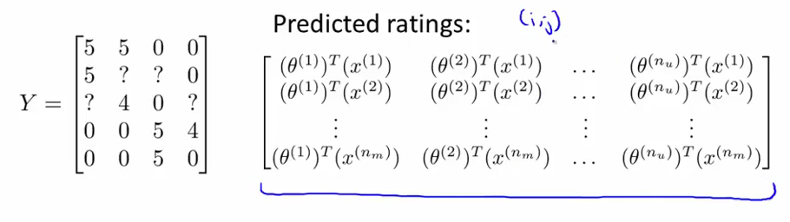
We write

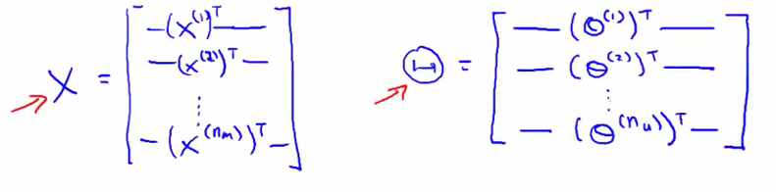
And we can write that big matrix as X*Theta', which has the property of being low rank

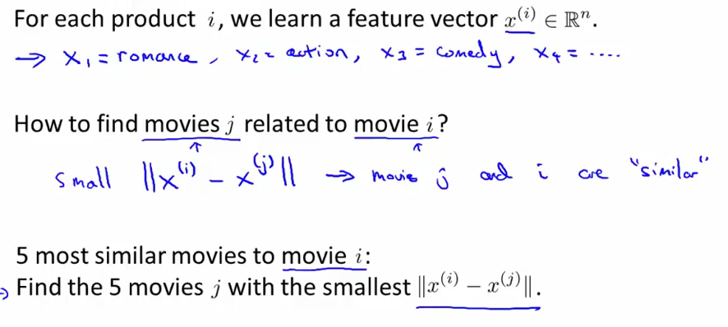
If a user didn't vote for any movie yet, only this term is different from zero
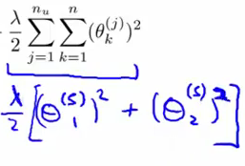
To have it different than zero, we have to implement mean normalization

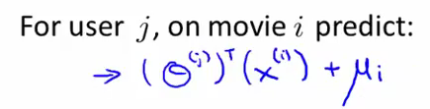

So we take into account the mean of the user's predictions when we are dealing with a relatively new user, which makes sense inuitively

