Binary tree and other data structures:
from pythonsd import *

Binary trees:
a binary tree is a data structure in which each node has at most two children (left and right).
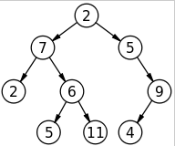

Unction that deal with binary tree use the stack object, which will likely process one node each turn and takes a tree_root as parameter. The tree root is a node object which contains parameters like node.left or node.right (the next node to the left or right of the parent node)

.
.
.
v

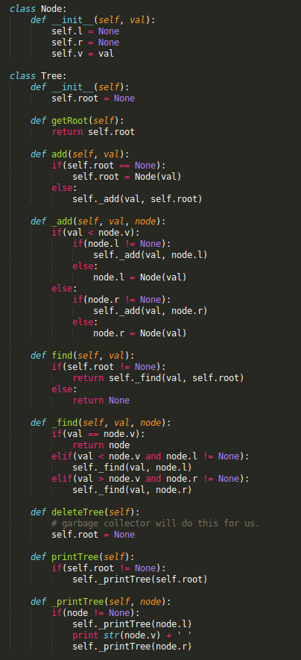
Implementation and tree structures

Balanced binary tree → It's a leaf parent if it only has One child
a tree is balanced if the leaves are all on the same depth or have a difference of depth of max 1

We do a DFS from the root, gathering the leaves along the way, and as soon as there are more than two levels of leaves or diff of depths for leaves is greater than 1, we return false
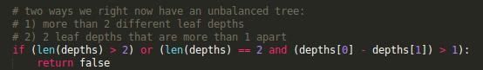

Is valid search tree? → One DFS pass with boundaries each time
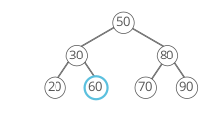

This seems valid, but 60 is actually greater than the root, so it should be in the right subtree. Because the tree's breadth can as much as double each time it gets one level deeper, depth-first traversal is likely to be more space-efficient than breadth-first traversal, though they are strictly both O(n) additional space in the worst case. The space savings are obvious if we know our binary tree is balanced—its depth will be O(lg(n)) and its breadth will be O(n)

Largest Element in stack → record each new arrival in push and compare with recorded max (dont' forget to pop it if need be!)
implement new class MaxStack with a function get_max() that returns max value in stack without removing it with O(1) runtime
def push(self, item):
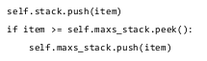

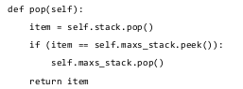

Bracket validator → LIFO because bracket have to be in order
Using a greedy approach (check each character of the string). We need to store the open brackets at each point in time and for that, we need to choose the best data structure to store the opened brackets

→ A closer is valid only if it corresponds to the most recent opener

→ what we need is a stack (get the most recent one quickly and remove most recently added one quickly) => LIFO!

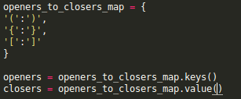

First we create a map to access closers and openers separately without having two arrays (openers are keys, closers are values) and we can compare easily if a closer corresponds to an opener

Linked List → the haze catches up with the turtle if cyclical
A linked list can have a node pointing to a previous node (it contains a cycle)

To detect such cycles, we need to store the nodes we already visited in a hash_map.

We also need to make sure we don't loop forever if the list is cyclical so we need to chose two pointers, one fast and one slow. If it goes on for long enough and we loop and loop, the faster looper will catch up with the slow looper and we know that the list is cyclical
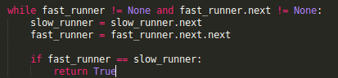

Kth-to-last el in singly-linked list → haze and turtle keep a k-distance between them, haze finds el when turtle reaches end of list
singly linked list: you can't go back!

Highest product of 3 from an array of ints → Greedy algo, using a value only one time
Since products is higher if numbers are higher, we can sort the array and take maxs. This is n*log n time, but we can do n time
=> greedy approach (do one walk and one walk only)
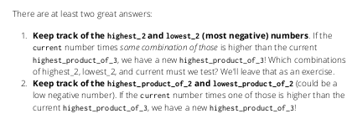

A greedy algorithm is an algorithmic paradigm that follows the problem solving heuristic of making the locally optimal choice at each stage[1] with the hope of finding a global optimum. In many problems, a greedy strategy does not in general produce an optimal solution, but nonetheless a greedy heuristic may yield locally optimal solutions that approximate a global optimal solution in a reasonable time.

In place shuffle → Conditional probabilities
An in-place algorithm operates directly on its input and changes it, instead of creating and returning a new object. This is sometimes called destructive, since the original input is "destroyed" when it's edited to create the new output.
Careful: "In-place" does not mean "without creating any additional variables"! Rather, it means "without creating a new copy of the input." In general, an in-place function will only create additional variables that are O(1) space.

If we were to swap two random indices chosen at random every iteration, this would not give us a proper random distribution

We need to work with conditional probabilities. A value has 1/n chances to be chosen first, (n-1)/n * 1/(n-1) to be chosen second etc.

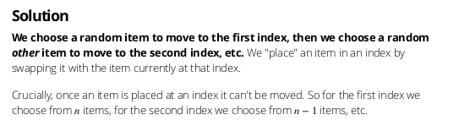
Reduce space taken by hash containing URLs. Tries → break url into letters, each letter becomes a shelf

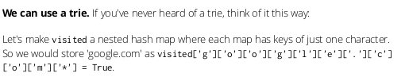
the * means it is the end of an entry

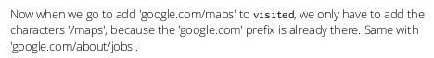

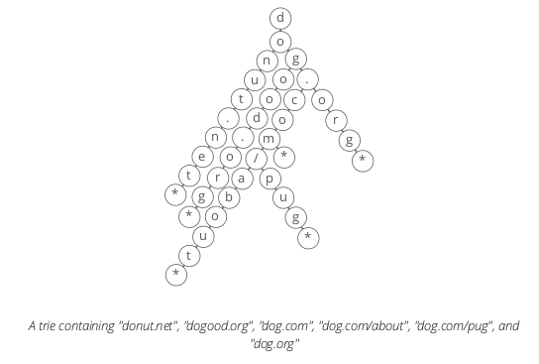

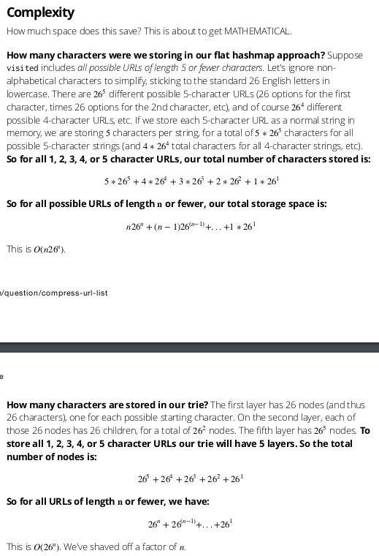

Display position of corresponding closing parenthesis to opening parenthesis – one counter, increment when stumble on opening, decrement when closing, return when 0
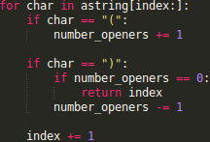

Product of all other integers → loop and reverse loop with an offset of one to populate new list while excluding current index
The product of all the integers except the integer at each index can be broken down into:
1. the product of all the integers before each index
2. the product of all the integers after each index.
Each result will be the product of integers before him plus the product of all integers after him
By using a greedy approach (instead of doing the total product of an index each iteration, we add previous product and then multiply the previous product by current value at current index to prep for the product in the next index
Same with a second reverse loop to complete the products

Queue with two stacks – two stacks make a queue like two negatives make a positive

Lets say we have a, b, c in our two stacks and want to have a FIFO situation where a is the first to come out. Because stacks are LIFO, if we pop the first stack, c is gonna come out, and go the second stack. If we pop first stack three times, the second stack is gonna look like c, b, a. If we pop the second stack once, we indeed have a like we wanted

Find all permutations
Let's make our subproblem be getting all permutations for all characters except
the last one

Reverse linked list → store Current, next_node.next becomes Current, reversed!
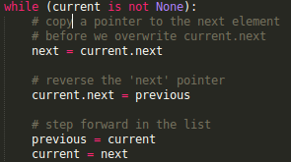

Get rand5() with a rand7() function (rand5 and rand7 only return integers)
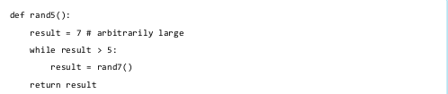
Worst case running time: infinity

Get rand7() with a rand5() function → create matrix and roll the row/column

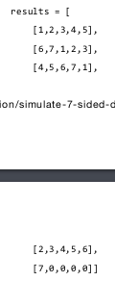

We create this matrix and make two rand5 rolls. First one determines the row we choose, the second one determines the column we choose. If we arrive on the last 4 places, we reroll both rand5
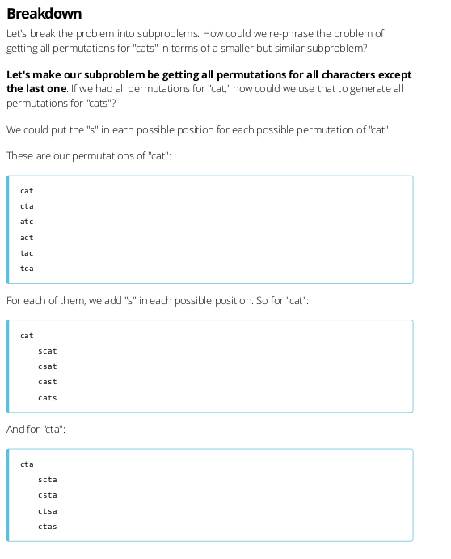
Find missing duplicate in an array – XOR the result by value in current index every iteration, watch it morph into what we are looking for

The ^= operator operates on bits. If you XOR two values like that, it will put 1s where there are 0 and vice versa. Since we iterate over the whole array, the final ID will be XOR-ed twice for all IDs except the one that is not duplicate and the second occurrence of an ID cancels out the first

