Wrocław, 02.01.2016

Advanced Informatics and Control

Optimization Methods: Theory and Applications

Newton algorithm for the unconstrained task

Supervisor: Dr inż. Edward Puchała

Author: Piotr Lechowicz, 195651
- Introduction

For the project Newton gradient algorithm for finding the minimum of function of two variables were implemented.

- Symbols used in algorithm

- Algorithm description

Step 0:
- set up required accuracy of calculations
- select starting point
- set
- set

Step 1:
- determine the matrix of second derivatives H at the starting point
- determine the gradient of the goal function at the point
- determine direction of next point
- determine step size based on the optimization in direction with Golden Section Search algorithm
- determine next point
- check ? If YES then STOP, otherwise and go to step 1

- Environment

Appropriate environment were created in python language with the usage of numpy, matplotlib, py_expression_eval, scipy and PyQt5 libraries.

- Investigation

To test algorithm effectiveness following function were chosen:

with the minimum at point

Function has other local minimum:
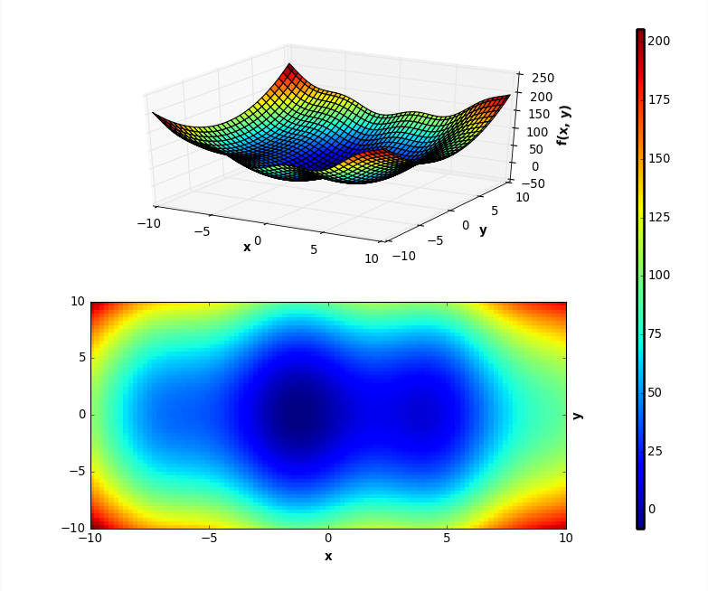

- Selection of starting point

There were made an investigation how the starting point location effects the relationship between the number iteration of the algorithm, and the tolerance of the solution.

starting point | nr of iterations | optimal point | value
(1, 1) | 3 | (-1.305, -0.003) | -7.945
(1, 2) | 4 | (3.835, -0.009) | 8.315
(1, 3) | 4 | (3.826, -0.028) | 8.316
(0, -2) | 3 | (-1.309, -0.018) | -7.945
(0, -5) | 3 | (-1.305, 0.003)  (  [ | -7.945
(0, 0) | 2 | (-1.304, -0.009) | -7.945
(-1, -1) | 3 | (-1.305, 0.004) | -7.945
(-2, -2) | 2 | (-1.305, -0.007) | -7.945
(-4, -4) | 3 | (-1.307, 0.008) | -7.945
(-5, -3) | 4 | (-1.309, 0.017) | -7.945
(-7, 8) | 4 | (-1.304, -0.012) | -7.945
(8, -6) | 4 | (-1.310, -0.026) | -7.944
(6, 7) | 3 | (-1.302, -0.025) | -7.945
(4, 7) | 2 | (3.835, -0.014) | 8.315
(5, -5) | 2 | (3.840, -0.017) | 8.315
(15, 14) | 7 | (-1.303, 0.013) | -7.945
(-16, 12) | 4 | (-1.305, 0.005) | -7.945
(-17, -15) | 6 | (-1.305, 0.002) | -7.945

As it can be observed wrong selection of starting point can totally change the result. When point is selected near to the local optimum algorithm finds it instead of the global optima. What's more appropriate selection of starting point influence number of iterations. Below are presented few of the graphical results.

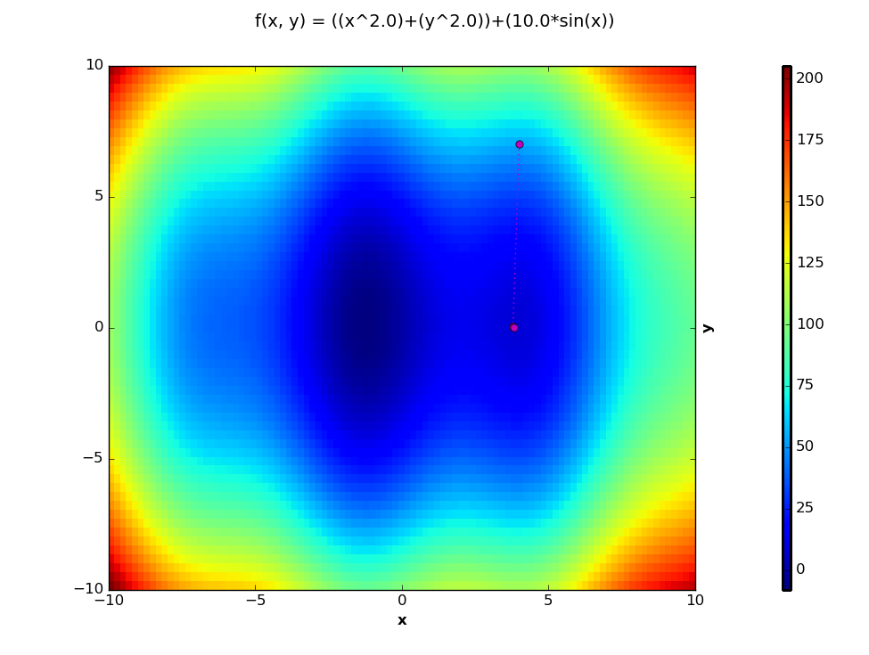Illustration 1: Solution for starting point (4, 7)
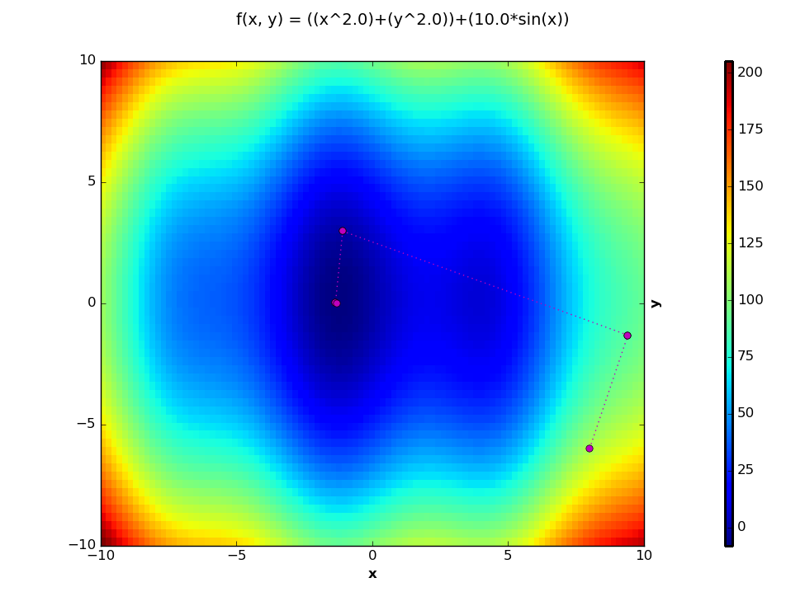Illustration 2: Solution for starting point (8, -6)
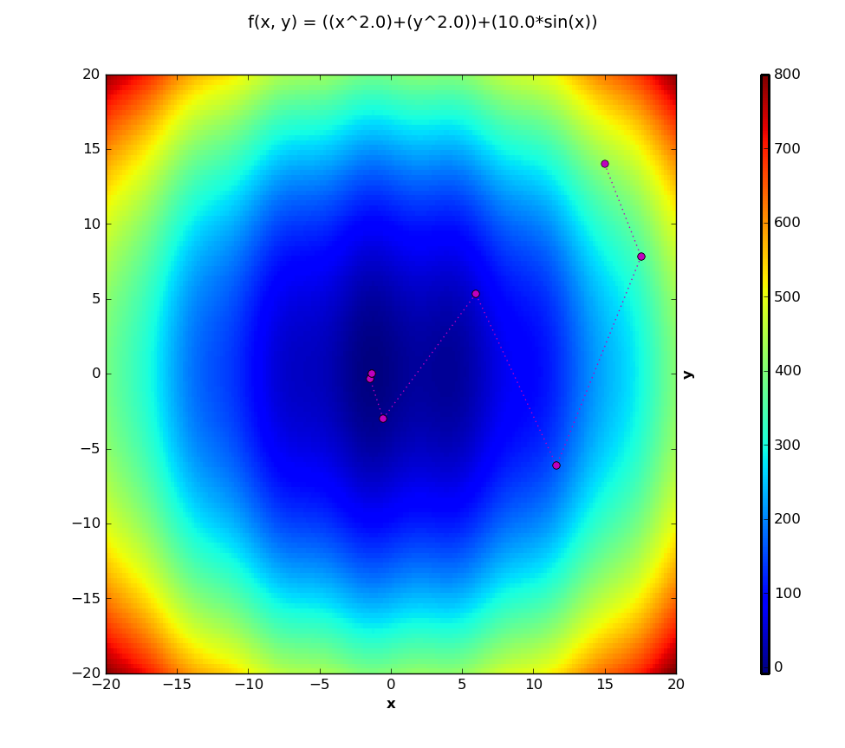Illustration 3: Solution for starting point (15, 15)
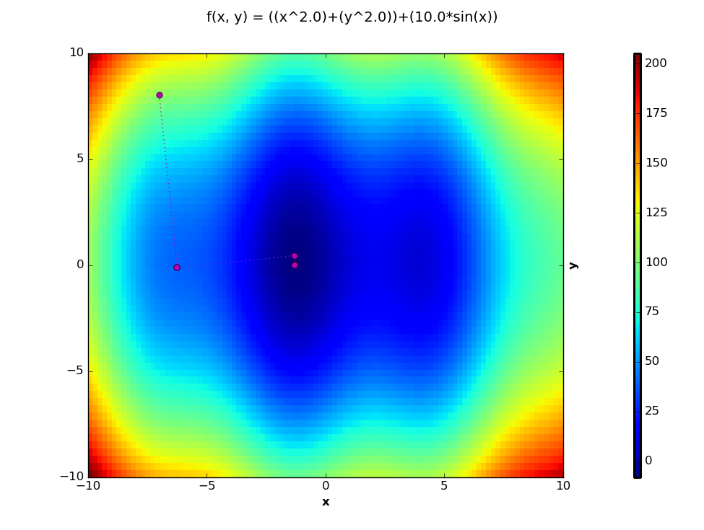Illustration 4: Solution for starting point (7, -8)

- Tolerance of calculations

There were made an investigation how the tolerance of calculations effects the accuracy of the solution and the number of iterations of the algorithm.

As a starting point were chosen a point (-12, -10)

tolerance | nr of iterations | value
0.1 | 5 | -7.94569304334
0.05 | 5 | -7.94569304334
0.01 | 6 | -7.94569323532
0.005 | 6 | -7.94569323532
0.001 | 6 | -7.94569323532
0.0005 | 6 | -7.94569323532
0.0001 | 7 | -7.94569323532
0.00005 | 7 | -7.94569323532

And the console output:

Function: ((x^2.0)+(y^2.0))+(10.0*sin(x))
(-12.0, -10.0)
with value: 249.36572918
(-13.910575869, -5.80654324461)
with value: 217.475686508
(-9.55900285584, 5.59166824451)
with value: 123.979511536
(-1.23050713784, 4.88844806804)
with value: 15.984490477
(-1.28315422389, -0.0100519320077)
with value: -7.94256876684
(-1.30473797949, 0.0106515815076)
with value: -7.94569304334
(-1.30457104211, 0.0104781514514)
with value: -7.94569323532
minimum found at point:
(-1.30457126715, 0.0104783852386)
with value: -7.94569323532
with nr of iterations: 7
As it can be observed at the last iterations are found points located close to each other.

- Conclusions

With higher tolerance more iterations are required to obtain solution. Selection of starting point can determine in how many steps and if at all optimal solution will be found. Inappropriate selection of starting point may cause stack in local optima.

