Inserting linear and surface horizontal road signs on the map in the program QGIS v. 3.6.0:


Inserting the P-2a line:

Select the layer horizontal_rad_signs_line
>> Layer >> Properties ... >> Symbology
set "unique value" and for type = "P-2a" (if it is not displayed, press the [Classify] button) set:
Map Units
Width: 0.12
Line style: Simple line


Inserting the P-3a line:

Select the layer horizontal_rad_signs_line
>> Layer >> Properties ... >> Symbology
and do this:
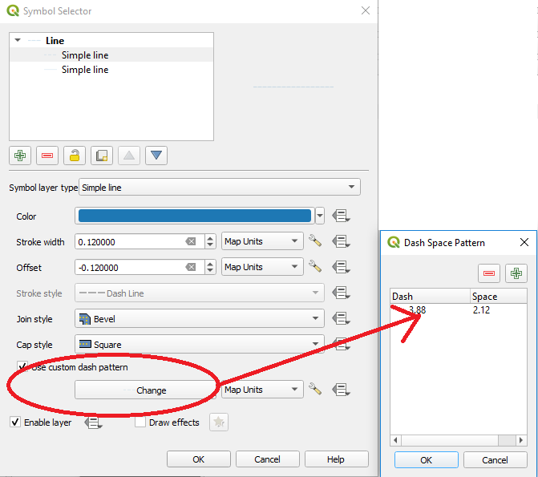

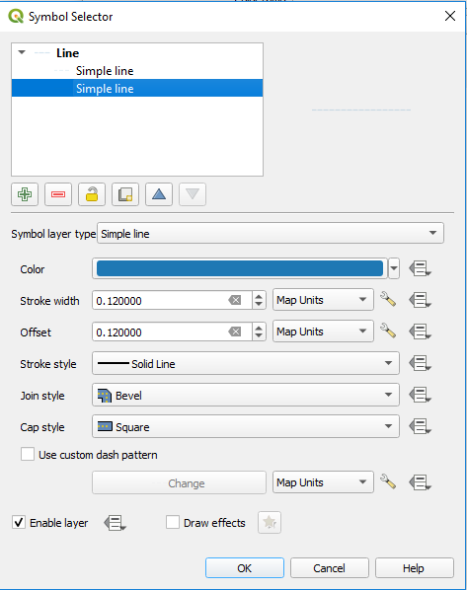

NOTE 1:
WHEN YOU SET LENGTH OF DASH AND LENGTH OF SPACE IN YOUR OWN DASH LINE YOU SHOULD BE AWARE THAT QGIS WILL ADD TO THE LENGTH OF DASH THE WIDTH OF THE LINE AND SUBTRACTS WIDTH OF THE LINE FROM LENGTH OF SPACE.

Inserting P-14 line (conditional stop line):

Select the layer horizontal_rad_signs_line
>> Layer >> Properties ... >> Symbology
set "unique value" and for type = "P-14" (if it is not displayed, press the [Classify] button) set:
line >> Simple line
Map Units
Stroke width: 0.5
Line style: dash line
Use custom dash pattern >> Change
in the drawing, the line dash should be 0.75 m and the length of the space 0.25 m, so after taking into account the NOTE 1, enter: dash length: 0.25 m and length of the space: 0.75 m.

Inserting the P-10 sign (pedestrian crossing):

Select the layer horizontal_rad_signs_polygon
>> Layer >> Properties ... >> Symbology
set "unique value" and for type = "P-10" (if it is not displayed, press the [Classify] button) set
Fill >> Line pattern fill >> Rotation: angle, Spacing: 1.0
Line >> Map Units, Width: 0.5

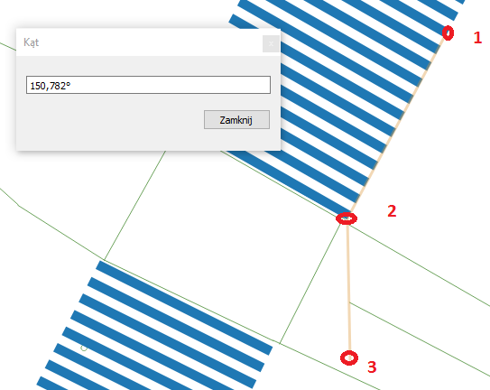
Angle measurement:

------------------------------------------------------------------------------------------------------------------------
manual version: 0.1.c

