

CAO Points Calculator

An app dedicated to helping students calculate their desired CAO points

Abstract

This project goes through the design process for an app. It features many aspects such as the initial vision, personas, scenarios and more.

Piotr Placzek (20097618)

20097618@mail.wit.ie

Contents

Overall Introduction to Project 2

Product Vision 2

Personas 3

What is a Persona? 3

Persona 1 3

Persona 2 3

Persona 3 4

Scenarios 5

What is a Scenario? 5

Scenario 1 5

Scenario 2 5

Scenario 3 5

User Stories 6

What is a User Story? 6

User Story 1 6

User Story 2 6

User Story 3 6

User Story 4 6

User Story 5 6

User Story 6 7

Features 8

What are features? 8

Prototype 10

What is a Prototype? 10

Sketches of Prototype 10

Tool used to create Prototype 11

URL or Screen Shots 11

Technology Research 12

Conclusion 12

# Overall Introduction to Project

The project is dedicated to a CAO point calculator android app. It is directed towards Leaving Certificate students and is meant to help them keep track of the points they need for their desired CAO course more easily.

There are many similar apps on the Google Play store:

*“Leaving Cert CAO Points Calculator”* by *“CareersPortal”*

is an app that performs exactly what I want my app to do. However, I am not a fan of its UI; I think the design isn’t very modern. I would also prefer if I could see all the subjects, grades and points presented at the same time in a nice-looking way. I do like the simple colour scheme which makes the app easy to look at.

*“Leaving Cert Points Calculator”* by *“Paul Connolly”*

also performs all the features I would like to have, it even displays all the data at the same time. However, again, I think the UI isn’t very nice; It is very plain-looking and the lack of contrast doesn’t add emphasis on the important elements. Again, I like the simple colour scheme, and I wouldn’t mind using this app.

## Product Vision

This app will be made for Irish Leaving Certificate students who are looking for an easier, and more modern way of keeping track of desired CAO points. The CAO point calculator is a productivity tool that will be able to save and record a student’s desired CAO points and grades on their phone unlike the currently existing apps and websites which don’t remember any of your details. Our product is a modern, efficient, and easy-to-use alternative to the other apps on the market.

# Personas

## What is a Persona?

A *persona* is a made-up user that can be utilised to imagine what type of person might interact with our product. A product should be designed with potential users in mind to optimize and enhance it, and personas allow us to do so without involving real people.

## Persona 1

Jack, age 18, is a 6th year Leaving Certificate student in a small secondary school in Wexford. Maths is his favourite subject, and he loves messing around with numbers and equations. He wants to become a Physicist. To achieve this, he must get a degree in Physics, and plans to acquire it at IT Carlow Wexford.

Jack loves maths and is planning to do Higher Level, but is considering switching to Ordinary Level in Geography. He also isn’t sure which Physics related course to settle on. Because of this, he constantly doesn’t know how many points he will need, and needs to consider the possibilities for different subject levels. He wishes there was a solution available that would allow him to easily keep track of different sets of subjects and levels, without having to re-enter them into a website every time to calculate his CAO points.

## Persona 2

Danielle, age 17, is a 5th year Leaving Certificate student in a large secondary school in Cork. She has dreams of becoming a doctor, like her dad. She loves medical dramas and knows lots of interesting facts about the human body. She knows that she must study hard so she can get into a good university and become a good doctor.

She wants to go to Trinity College Dublin, a prestigious university. However, the CAO points needed are very high. Because of this, she would like to know all the different variations of grades she could use to get those points. She would love if there was an app that could keep track of a list of grades, allow here to make small changes, and see if she will still be able to achieve the points she needs for the course.

## Persona 3

Noah, age 17, is a 6th year Leaving Certificate student in a medium-sized secondary school in Dublin. He spends all his free time on the computer, making simple video games and sharing them with his friends. He is very passionate about this and wants to make games for a living. He plans to achieve this by entering a game development course at the Waterford IT.

Noah has already settled on a course and knows roughly what grades he’s going to get based on his mocks. He just wants a simple way of keeping track of his grades and points on his phone to show others and not forget.

# Scenarios

## What is a Scenario?

A scenario is an account of how a user might use your product.

## Scenario 1

Jack is looking at a course and wants to know if he will get enough CAO points to enter if he stays in Higher Level Maths. Jack opens the app and enters the grades he thinks he will get based on his recent mocks. The app displays the CAO points he will achieve from those grades instantly, which are enough for the course.

He wants to know if he can still enter the course with Ordinary Level Maths, so he changes the level for Maths from ‘Higher’ to ‘Ordinary’ and the points update automatically. Jack sees that he will still have enough CAO points even with Ordinary Level, so he saves the subject list using the ‘Save’ button in case he wants to change something in the future and not have to retype all the subjects.

## Scenario 2

Danielle wants to keep track of her CAO points easily so she can always know exactly what grades to aim for so she can enter her course. She opens the app and types in the subjects she is studying, along with her average grades. She sees that the total point count is lower than what is required for the medicinal course she want to take.

She easily keeps increasing the grades for the subjects she thinks she can do better in until the point count is enough for the course. Thanks to this, she now knows what subjects she needs to study for harder so she can enter the course. She also saves the subjects in case she wants to quickly try out some other combinations of grades in the future.

## Scenario 3

Noah has decided on a course and thinks he will easily enter as the point count required is low. However, he often gets asked how many CAO points he thinks he will get, and he keeps forgetting. He opens the app, enters in the grades he got on his recent mocks, and immediately is shown the CAO points he will get if his grades don’t change.

Noah saves the subject list so he can show off his score to his friends if they ask. He also goes into the settings of the app and switches to the ‘Dark Mode’ theme because he thinks it makes the app look cooler.

# User Stories

## What is a User Story?

A user story is a short, simple description of a software feature from the perspective of the person who will use it. User stories are written from the user's perspective and describe the value that they will receive from the feature.

## User Story 1

As an Irish Leaving Certificate student, I want to be able to easily store my desired CAO points so that I can keep track of them e.g. I can enter my points into the app so I can keep track of them.

## User Story 2

As a 5th Year Leaving Certificate student, I want to be able to see my desired CAO points in a modern interface so that I can easily refer to them e.g. I can open the app and see my stored CAO point nicely displayed in a readable format.

## User Story 3

As a 6th Year Leaving Certificate student, I want to be able to update my desired CAO points as my plans change so that I can always have an accurate representation of my goals e.g. I go into the app and update my grades to have a higher CAO point count.

## User Story 4

As a 5th Year Leaving Certificate student, I want to be able to receive reminders about my desired CAO points so that I can stay on track e.g. The app sends me a notification every 2 weeks to motivate me and remind me of my goals.

## User Story 5

As a 6th Year Leaving Certificate student, I want to be able to see my progress towards my desired CAO points so that I can gauge how well I am doing e.g. I look at the grades I need in the app, and compare them to my mocks to see where I need to improve.

## User Story 6

As a 6th Year Leaving Certificate student, I want to be able to share my desired CAO points with my parents or guardians so that they can help me stay on track e.g. the app allows me to easily communicate what grades and points I’m trying to achieve.

# Features

## What are features?

App features are the functions and capabilities of an app. They are the reasons why users download and use an app.

I have decided on four main features:

1. Save & Load
   * There will be a Save/Load button at the bottom of the main screen that lets you save and load sets of subjects and grades.
   * It will let you set the name for a new set, and rename other sets.
   * It will store these in the phone’s storage in easy to access files so the user can copy them over to other devices.
2. Dark and Light themes
   * The app will have an option to switch between dark and light mode in the settings.
   * This option will change the colour scheme of the app.
   * It will let you customize the look of the app.
   * It will make the app look nicer and more modern.
3. Subject and Grade input
   * You will be presented with a list of default/typical subjects at the start.
   * You will be able to easily change the subject and the grade you are planning to get.
   * There will be options for all subject and all levels including ordinary and higher level.
   * The subject and grade will be shown beside each other, and sets of these will be displayed in an aesthetically pleasing, and easy to read list.
   * You will be able to add and remove subjects to suit your needs.
4. Point calculation
   * There will be a number beside the subject and grade that shows how many CAO points the aforementioned combination will achieve.
   * There will be a circular loading bar around the points that visually shows how good the amount of points is.
   * This loading bar will be animated and smoothly transition to different lengths when the points change.
   * The total points from all the grades combined will be shown at the bottom of the main screen to easily display what points you will get from the set.
   * There calculator will factor in and display bonus points e.g. for higher level maths.

I have decided on these features because I think they are the most essential elements that the app must have. The main reason for the existence of the app is to help calculate and keep track of CAO points, so calculation and storage of CAO points must be the two main features. I decided on the two themes as a main feature because there are already some competitors in the field, however they aren’t very modern; these themes will make the app stand out and appeal to the new generation of Leaving Certificate students.

# Prototype

## What is a Prototype?

A prototype is an early model of what the final product will be like. It usually has some of the main features and lets you experience what the usage experience of the app will mostly be.

## Sketches of Prototype

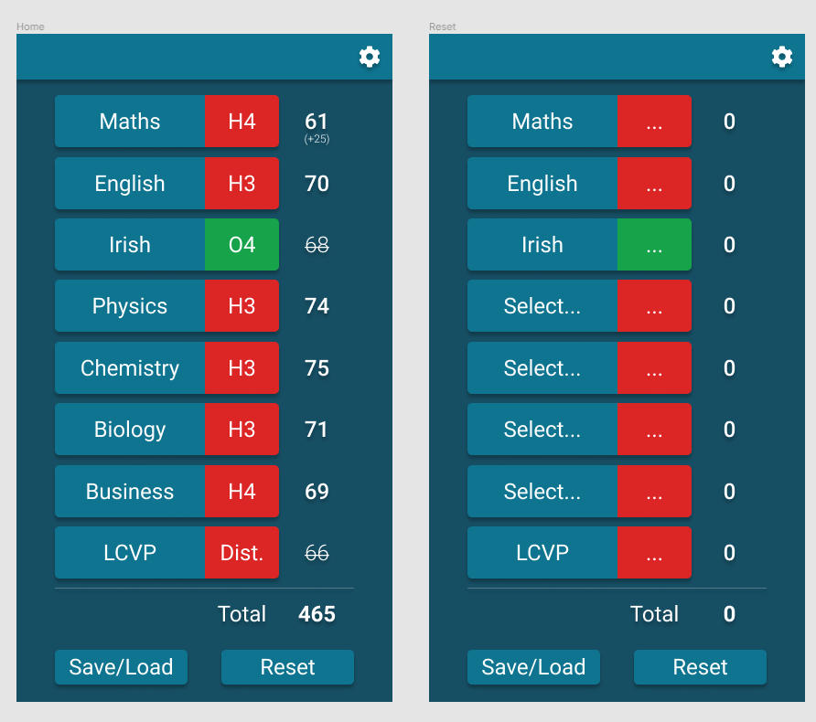

## Tool used to create Prototype

I decided to use Figma to create my prototype. I believe Figma is a good choice for designing an app because it is easy to use and has a variety of features that make designing an app easy. Figma also has a community of designers who can offer feedback and support. It is also fully free, and you have access to all the features on the website.

I mainly chose it because I have worked in it many times, and find it is a very efficient tool.

## URL or Screen Shots

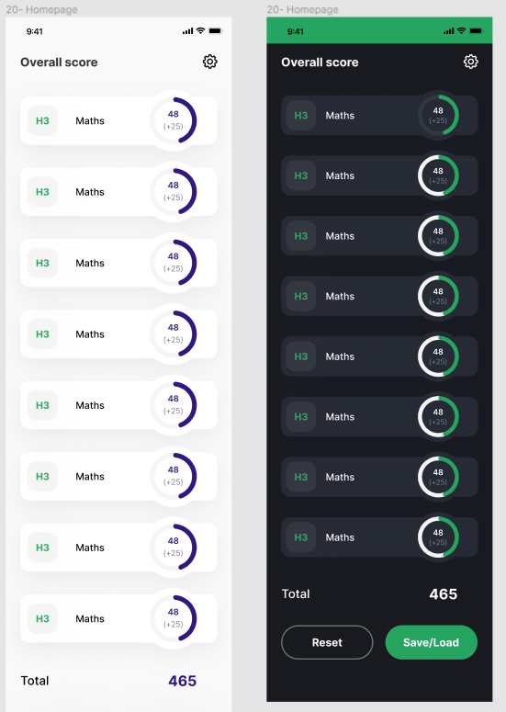

[Figma prototype](https://www.figma.com/proto/Vd90Qx4URSvcwz3UpCjjFs/Overall-score?node-id=20%3A0&scaling=scale-down&page-id=0%3A1&starting-point-node-id=20%3A0)

# Technology Research

If I was making this app, I would use [Expo](https://expo.dev/) and [React Native Paper](https://callstack.github.io/react-native-paper/). Expo is tool that allows you to easily create apps for both iOS and Android; It lets you write the app once, and then creates and publishes the actual app files to the respective app stores on both platforms. It uses the JavaScript programming language, which is easy to learn and I think is quite intuitive.

React Native Paper is a *component library*, put simply it provides pre-written pieces of code that can be used to add elements such as buttons to your app. I would use this specific component library because it is popular among apps, and I think it looks nice.

*Many* other tools and programming languages could also be used to make this app. The most popular choices include Android Studio (an IDE used to make Android apps), Flutter (UI SDK used to create cross-platform apps) and others.

# Conclusion

I believe this would be a very useful app for Leaving Certificate students. I think this is an app that takes a simple idea, and develops it into a useful, easy-to-use, and intuitive product.

When I was attending secondary school, I always wanted an app like this. I would usually keep my CAO points stored on a notepad app on my phone or on a piece of paper; This was annoying because I would have to remake it often when I changed my mind about subject or scores.

I think that with the features and prototypes provided in this document, realising the ideas and implementing them in a real product would be very manageable. Researching this app idea was fun, and I definitely learned a lot about planning and determining the feasibility of an idea.