Strip transmission line medium for TEM wave propagation
One of the early milestones in microwave engineering was the development of waveguide and other transmission lines for the low-loss transmission of power at high frequencies. Early RF and microwave systems relied on waveguides, two-wire lines, and coaxial lines for transmission. Waveguides have the advantage of high power-handling capability and low loss but are bulky and expensive, especially at low frequencies. Two-wire lines are inexpensive but lack shielding. Coaxial lines are shielded but are a difficult medium in which to fabricate complex microwave components. Planar transmission lines provide an alternative, in the form of stripline, microstrip lines, slotlines, coplanar waveguides, and several other types of related geometries. Such transmission lines are compact, low in cost, and capable of being easily integrated with active circuit devices, such as diodes and transistors, to form microwave integrated circuits [].
In this chapter a transmission line that consist of two or more conductors and support transverse electromagnetic (TEM) waves is considered. A transmission line can be characterized by a propagation constant, an attenuation constant, and a characteristic impedance which will be derived here to provide theoretical background for further analysis. In opposition to circuits theory where the physical dimensions of the network are assumed to be much smaller than the electrical wavelength, in transmission line theory such line may be a considerable fraction of a wavelength, or many wavelengths, in size. Thus, a transmission line is a distributed parameter network, where voltages and currents can vary in magnitude and phase over its lengths while the aforementioned properties are determined based on the analysis of its lumped-element circuit model described using per-unit-length elements.
Even though transmission lines have losses due to finite conductivity and/or lossy dielectric, these losses are usually small and for many practical problems loss may be neglected. However, when e.g. high power circuits where low line attenuation is necessary, resonant circuits in which very high quality factor is of need or low-noise feeding networks for active circuits are of need, the effect of loss is of importance. Therefore a lossy transmission line is considered here to allow for inclusion of effects of loss on transmission line behavior.

Lossy transmission line circuit model (p. 48 2.1)
A one dimensional section of transmission line shown schematically in Fig. Xa as a two-wire line representation can be considered in terms of propagating voltage and current waves along z-axis. At a distance z into the line, there is current I(z) travelling through each wire, and there is a voltage difference V(z) between the wires. To calculate their distance and time relations, a transmission line model shown in Fig. Xb can be used. The piece of line of infinitesimal length Δz is modeled as a lumped-element circuit, where L, C, R, G, and are per-unit-length quantities defined as follows:
L = series inductance per unit length, for both conductors, in H/m representing the total self-inductance of the two conductors
C = shunt capacitance per unit length, in F/m representing the total self-capacitance is due to the close proximity of the two conductors.
R = series resistance per unit length, for both conductors, in Ω/m representing the resistance due to the finite conductivity of the individual conductors
G = shunt conductance per unit length, in S/m representing the dielectric loss in the material between the conductors
A finite length of transmission line can be viewed as a cascade of sections of the form shown in Fig. Xb.

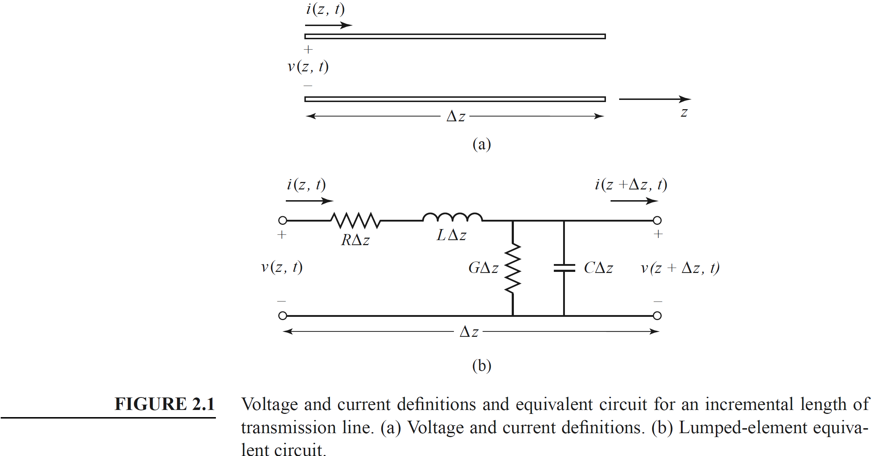

From the circuit of Fix Xb, Kirchhoff’s voltage law can be applied to give
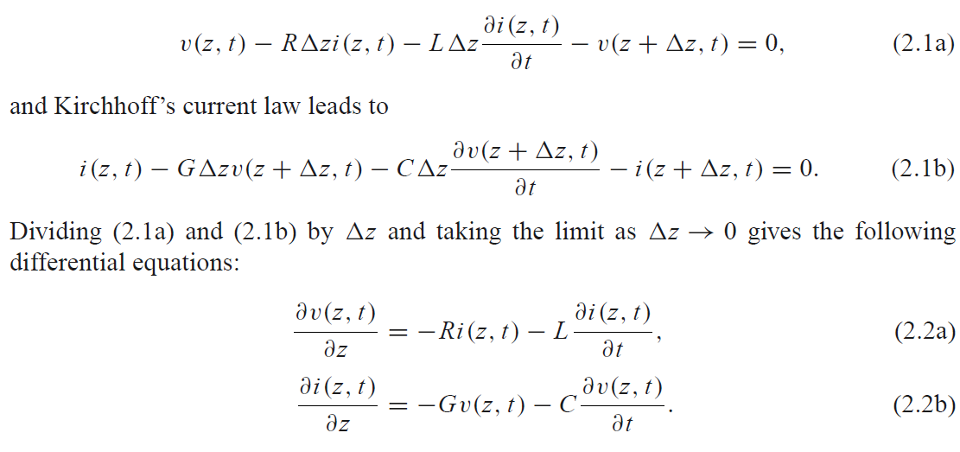and Kirchhoff’s current law leads to
Dividing (2.1a) and (2.1b) by Δz and taking the limit as Δz → 0 gives the following
differential equations:
These are the time domain form of the transmission line equations, also known as the telegrapher equations.
For the sinusoidal steady-state condition, with cosine-based phasors, (2.2a) and (2.2b) simplify to
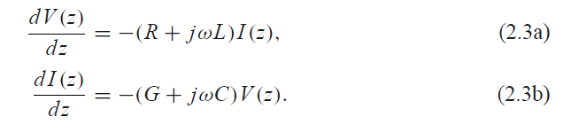
The two equations (2.3a) and (2.3b) can be solved simultaneously to give wave equations
for V(z) and I (z):
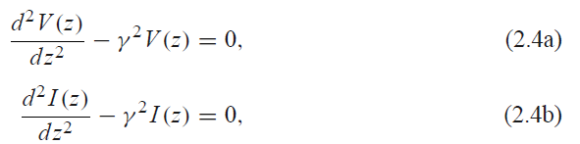
where
is the complex propagation constant, which is a function of frequency. Traveling wave solutions to (2.4) can be found as
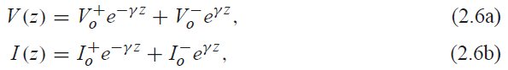
where the e−γ z term represents wave propagation in the +z direction, and the eγ z term represents wave propagation in the −z direction. Applying (2.3a) to the voltage of (2.6a) gives the current on the line:
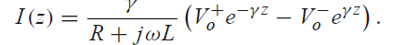
Comparison with (2.6b) shows that a characteristic impedance, Z0, can be defined as
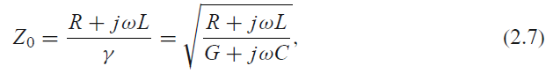
to relate the voltage and current on the line as follows:
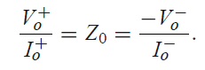
Then (2.6b) can be rewritten in the following form:
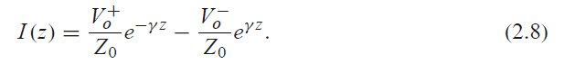
Converting back to the time domain, we can express the voltage waveform as
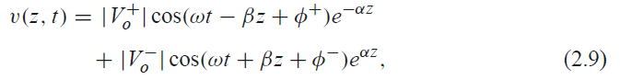
where φ± is the phase angle of the complex voltage V±o . Moreover, the wavelength on the line is
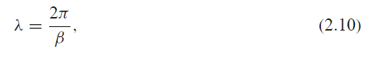
The Low-Loss Line
In most practical microwave and RF transmission lines the loss is small—if this were not the case, the line would be of little practical value. When the loss is small, some approximations can be made to simplify the expressions for the general transmission line parameters of γ = α + jβ and Z0.
The general expression for the complex propagation constant is, from (2.5),
which can be rearranged as
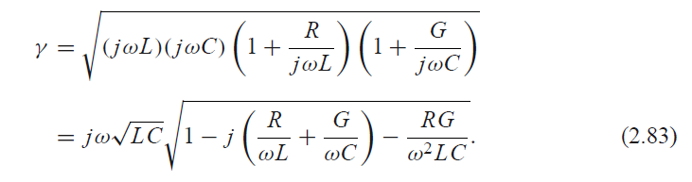
For a low-loss line both conductor and dielectric loss will be small, and we can assume that R ωL and G ωC. Then, RG ω2LC, and (2.83) reduces to
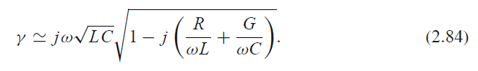
If we were to ignore the (R/ωL + G/ωC) term we would obtain the result that γ was purely imaginary (no loss), so we will instead use the first two terms of the Taylor series expansion for√1 + x _ 1 + x/2+· · · to give the first higher order real term for γ:
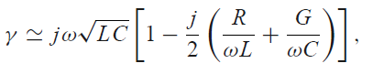
so that
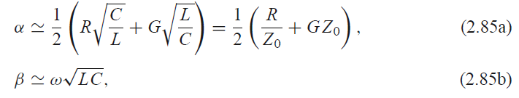
where Z0 = √L/C is the characteristic impedance of the line in the absence of loss. Note from (2.85b) that the propagation constant β is identical to that of the lossless case of (2.12). By the same order of approximation, the characteristic impedance Z0 can be approximated as a real quantity:
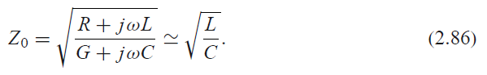
Equations (2.85)–(2.86) are known as the high-frequency, low-loss approximations for
transmission lines, and they are important because they show that the propagation constant
and characteristic impedance for a low-loss line can be closely approximated by considering
the line as lossless.

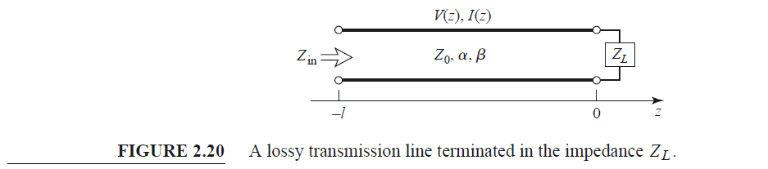

The Terminated Lossy Line

The voltage and current wave propagating along a lossy transmission line terminated with Zl is attenuated at constant rate of alpha. The actual power delivered to the load can be determined using the following analysis.
The voltage and current wave on a lossy line are V(z) = V+
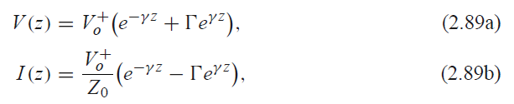
where Γ is the reflection coefficient of the load, and V+o is the incident voltage amplitude referenced at z = 0. The reflection coefficient at a distance l from the load is
The input impedance Zin at a distance l from the load is then
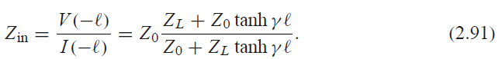
We can compute the power delivered to the input of the terminated line at z = −_ as
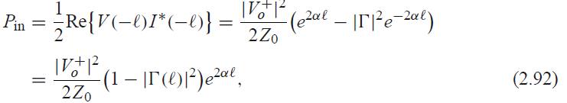
where (2.89) has been used for V(−_) and I (−_). The power actually delivered to the load is
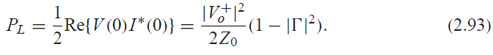
The difference in these powers corresponds to the power lost in the line:
The first term in (2.94) accounts for the power loss of the incident wave, while the second
term accounts for the power loss of the reflected wave; note that both terms increase as α
increases.

The Perturbation Method for Calculating Attenuation
The attenuation constant of a low-loss line can be found using the following method, called the perturbation method. The method relies on the fields of the lossless line, with the assumption that the fields of the lossy line are not greatly different from the fields of the lossless line allowing to avoids the use of the transmission line parameters L, C, R, G.
The power flow along a lossy transmission line, in the absence of reflections, is of the form
where Po is the power at the z = 0 plane and α is the attenuation constant we wish to determine. Now define the power loss per unit length along the line as
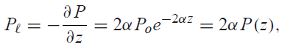
where the negative sign on the derivative was introduced so that P_ would be a positive quantity. From this, the attenuation constant can be determined as
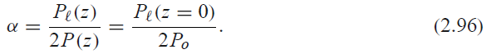
This equation states that α can be determined from Po, the power on the line, and P_, the power loss per unit length of line. It is important to realize that P_ can be computed from the fields of the lossless line and can account for both conductor loss [using (1.131)] and dielectric loss [using (1.92)].

power loss in a good conductor can be accurately and simply calculated as
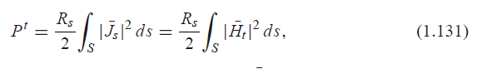
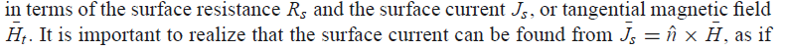
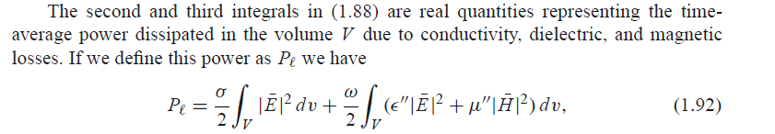
E(z kreską u gory). is the electric field, in volts per meter (V/m).
H(z kreską u gory) is the magnetic field, in amperes per meter (
A/m).

Planar realizations of transmission lines
Two most commonly used planar types of a transmission line supporting TEM wave propagation are stripline and microstrip lines. This is primarily because they can be fabricated by photolithographic processes and are easily miniaturized and integrated with both passive and active microwave devices.

STRIPLINE (Pozar p.141)
\indent The geometry of stripline is shown in \ref{th:fig3} together with a sketch of the field lines. A thin conducting strip of width $W$ is centered between two wide conducting ground planes of separation $b$, and the region between the ground planes is filled with a dielectric material. In practice stripline is usually constructed by etching the center conductor on a grounded dielectric substrate of thickness $b/2$ and then covering with another grounded substrate. Variations of the basic geometry of \ref{th:fig3} include stripline with differing dielectric substrate thicknesses (asymmetric stripline) or different dielectric constants (inhomogeneous stripline). Air dielectric is sometimes used when it is necessary to minimize loss.
\indent Because stripline has two conductors and a homogeneous dielectric, it supports a TEM wave, and this is the usual mode of operation. However, stripline can also support higher order waveguide modes. These can usually be avoided in practice by restricting both the ground plane spacing and the sidewall width to less than $\lambda _{d} /2$. Shorting vias between the ground planes are often used to enforce this condition relative to the sidewall width. Shorting vias should also be used to eliminate higher order modes that can be generated when an asymmetry is introduced between the ground planes (e.g., when a surface-mounted coaxial transition is used).
\\
\indent Intuitively, one can think of stripline as a sort of “flattened-out” coax—both have a center conductor completely enclosed by an outer conductor and are uniformly filled with a dielectric medium.
\\
\indent Because TEM mode of stripline is of primary concern, an electrostatic analysis is sufficient to give the propagation constant and characteristic impedance. Phase velocity can be expressed as

\begin{equation}\label{th:eq23}
v_{p}=\frac{1}{\sqrt{\mu _{0}\epsilon _{0}\epsilon _{r}}}=\frac{c}{\epsilon _{r}},
\end{equation}

\noindent where $c% = 3*10^8 m/s is the speed of light in free-space, and thus the propagation constant of stripline is

\begin{equation}\label{th:eq24}
\beta =\frac{\omega}{v_{p}}=\omega \sqrt{\mu _{0}\epsilon _{0}\epsilon _{r}}=\sqrt{\epsilon _{r}}k_{0}.
\end{equation}

\noindent Charactersitic impedance of a transmission line can be determined under assumption of very low loss as

\begin{equation}\label{th:eq24}
Z_{0} =\sqrt{\frac{L}{C}}=\frac{\sqrt{LC}}{C}=\frac{1}{v_{p}C},
\end{equation}

\noindent where $L$ and $C$ are the inductance and capacitance per unit length of the line. Thus, $Z_0$ can be found when knowing $C$.

Since stripline is a TEM line, the attenuation due to dielectric loss is of the same form
as that for other TEM lines. The attenuation due to conductor loss can be found by the perturbation method or Wheeler’s incremental inductance rule. An approximate result is
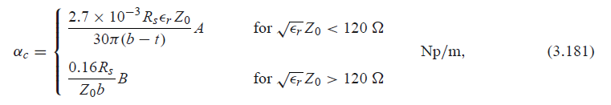
with
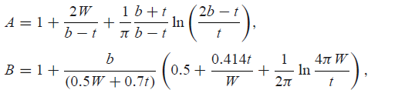
where t is the thickness of the strip.

MICROSTRIP LINE (Pozar p. 147)
\indent The geometry of a microstrip line is shown in Fig. \ref{th:fig4} together with a sketch of the field lines. A conductor of width $W$ is printed on a thin, grounded dielectric substrate of thickness $d$ and relative permittivity $\epsilon _{r}$ ;

\indent If the dielectric substrate were not present ($\epsilon _{r}$ = 1), we would have a two-wire line consisting of a flat strip conductor over a ground plane, embedded in a homogeneous medium (air). This would constitute a simple TEM transmission line with phase velocity $vp = c$ and propagation constant $\beta = k0$.
\\
\indent The presence of the dielectric, particularly the fact that the dielectric does not fill the region above the strip ($y$ > $d$), complicates the behavior and analysis of microstrip line. Unlike stripline, where all the fields are contained within a homogeneous dielectric region, microstrip has some (usually most) of its field lines in the dielectric region between the strip conductor and the ground plane and some fraction in the air region above the substrate. For this reason microstrip line cannot support a pure TEM wave since the phase velocity of TEM fields in the dielectric region would be $c/\sqrt{\epsilon _{r}}$, while the phase velocity of TEM fields in the air region would be $c$, so a phase-matching condition at the dielectric–air interface would be impossible to enforce.
\\
\indent In actuality, the exact fields of a microstrip line constitute a hybrid TM-TE wave and require more advanced analysis techniques than we are prepared to deal with here. In most practical applications, however, the dielectric substrate is electrically very thin ($d \|| \lambda $), and so the fields are quasi-TEM. In other words, the fields are essentially the same as those of the static (DC) case. Thus, good approximations for the phase velocity, propagation constant,and characteristic impedance can be obtained from static, or quasi-static, solutions.
Then the phase velocity and propagation constant can be expressed as

\begin{equation}\label{th:eq25}
v_{p}=\frac{c}{\sqrt{\epsilon _{e}}},
\end{equation}

\begin{equation}\label{th:eq26}
\beta = k_{0}\sqrt{\epsilon _{e}},
\end{equation}

\noindent where $\epsilon _{e}$ is the effective dielectric constant of the microstrip line. Because some of the
field lines are in the dielectric region and some are in air, the effective dielectric constant satisfies the relation

\begin{equation}\label{th:eq27}
1 < \epsilon _{e} < \epsilon _{r}
\end{equation}

\noindent and depends on the substrate dielectric constant, the substrate thickness, the conductor
width, and the frequency. The effective dielectric constant of a microstrip line is given approximately by

\begin{equation}\label{th:eq28}
\epsilon _{e}=\frac{\epsilon _{r}+1}{2}+\frac{\epsilon _{r}-1}{2}\frac{1}{\sqrt{1+12d/W}}.
\end{equation}

\noindent The effective dielectric constant can be interpreted as the dielectric constant of a homogeneous medium that equivalently replaces the air and dielectric regions of the microstrip line. The phase velocity and propagation constant are then given by \ref{th:eq25} and \ref{th:eq26}.
\\
\indent Considering a microstrip line as a quasi-TEM line,the attenuation due to dielectric loss can be determined as

\begin{equation}\label{th:eq29}
\alpha _{d}=\frac{k_{0}\epsilon _{r}(\epsilon _{e}-1)tan\delta}{2\sqrt{\epsilon _{e}}(\epsilon _{r} -1)} Np/m,
\end{equation}

\noindent where $tan\delta $ is the loss tangent of the dielectirc. The aboveprovided formula accounc for the fact taht the fields around the microstrip line are partly in air (lossless) and partly in the dielectric (lossy). The attenuation due to conductor loss is given approximately by

\begin{equation}\label{th:eq29}
\alpha _{c}=\frac{R_{S}}{Z_{0}W} Np/m.
\end{equation}

\noindent For most microstrip substrates, conductor loss is more significant than dielectric loss; exceptions may occur, however, with some semiconductor substrates.

