Strip transmission line medium for TEM wave propagation
The lumped-element circuit model for a lossy transmission line (p. 48 2.1)
Za Pozar:
The key difference between circuit theory and transmission line theory is electrical size. Circuit analysis assumes that the physical dimensions of the network are much smaller than the electrical wavelength, while transmission lines may be a considerable fraction of a wavelength, or many wavelengths, in size. Thus a transmission line is a distributed parameter network, where voltages and currents can vary in magnitude and phase over its length, while ordinary circuit analysis deals with lumped elements, where voltage and current do not vary appreciably over the physical dimension of the elements. As shown in Figure 2.1a, a transmission line is often schematically represented as a two-wire line since transmission lines (for transverse electromagnetic [TEM] wave propagation) always have at least two conductors. The piece of line of infinitesimal length Δz of Figure 2.1a can be modeled as a lumped-element circuit, as shown in Figure 2.1b, where R, L, G, and C are per-unit-length quantities defined as follows:
R = series resistance per unit length, for both conductors, in _/m.
L = series inductance per unit length, for both conductors, in H/m.
G = shunt conductance per unit length, in S/m.
C = shunt capacitance per unit length, in F/m.
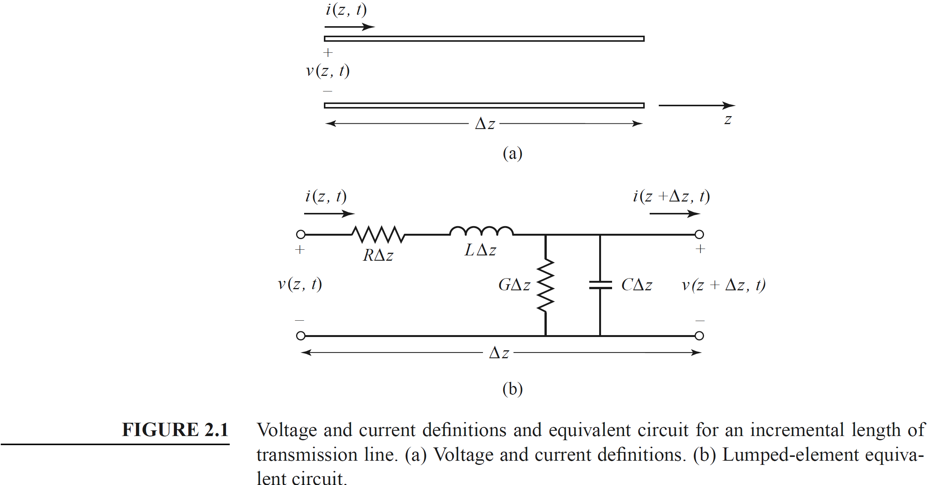
The series inductance L represents the total self-inductance of the two conductors, and the shunt capacitance C is due to the close proximity of the two conductors. The series resistance R represents the resistance due to the finite conductivity of the individual conductors, and the shunt conductance G is due to dielectric loss in the material between the conductors. R and G, therefore, represent loss. A finite length of transmission line can
be viewed as a cascade of sections of the form shown in Figure 2.1b.
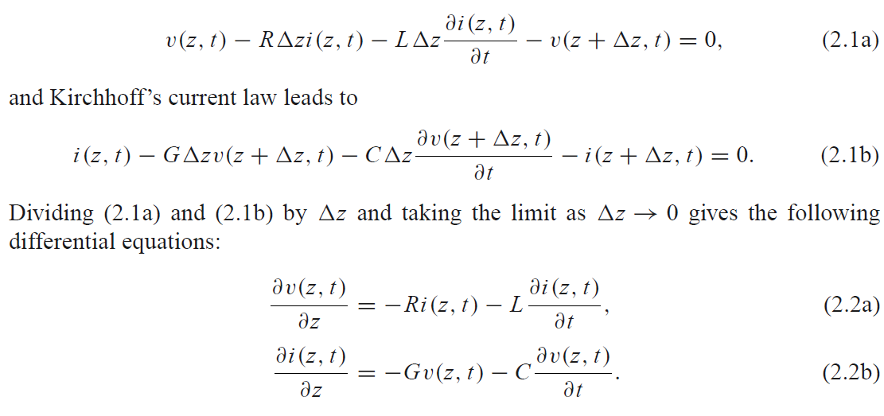and Kirchhoff’s current law leads to
Dividing (2.1a) and (2.1b) by _z and taking the limit as _z → 0 gives the following
differential equations:
These are the time domain form of the transmission line equations, also known as the telegrapher equations.
For the sinusoidal steady-state condition, with cosine-based phasors, (2.2a) and (2.2b) simplify to
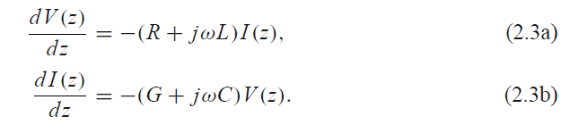
Note the similarity in the form of (2.3a) and (2.3b) and Maxwell’s curl equations of (1.41a) and (1.41b).

Wave Propagation on a Transmission Line
The two equations (2.3a) and (2.3b) can be solved simultaneously to give wave equations
for V(z) and I (z):
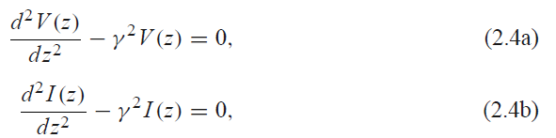
where
is the complex propagation constant, which is a function of frequency. Traveling wave solutions to (2.4) can be found as
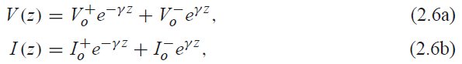
where the e−γ z term represents wave propagation in the +z direction, and the eγ z term represents wave propagation in the −z direction. Applying (2.3a) to the voltage of (2.6a) gives the current on the line:
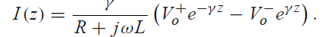
Comparison with (2.6b) shows that a characteristic impedance, Z0, can be defined as
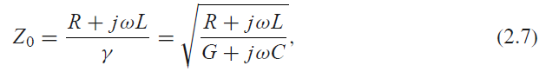
to relate the voltage and current on the line as follows:
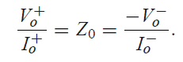
Then (2.6b) can be rewritten in the following form:
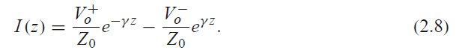
Converting back to the time domain, we can express the voltage waveform as
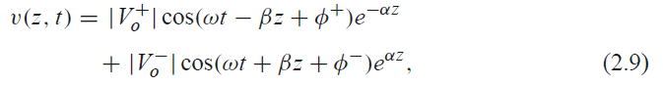
where φ± is the phase angle of the complex voltage V±o . Using arguments similar to those in Section 1.4, we find that the wavelength on the line is
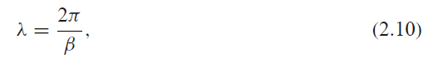
Lossy transmission lines (p. 79)
In practice, transmission lines have losses due to finite conductivity and/or lossy dielectric, but these losses are usually small. In many practical problems loss may be neglected, but at other times the effect of loss may be very important, as when dealing with the attenuation of a transmission line, noise introduced by a lossy line, or the Q of a resonator, for example. In this section we will study the effects of loss on transmission line behavior and show how
the attenuation constant can be calculated.
The Low-Loss Line
In most practical microwave and RF transmission lines the loss is small—if this were not the case, the line would be of little practical value. When the loss is small, some approximations can be made to simplify the expressions for the general transmission line parameters of γ = α + jβ and Z0.
The general expression for the complex propagation constant is, from (2.5),
which can be rearranged as
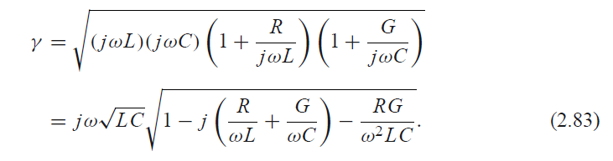
For a low-loss line both conductor and dielectric loss will be small, and we can assume that R ωL and G ωC. Then, RG ω2LC, and (2.83) reduces to
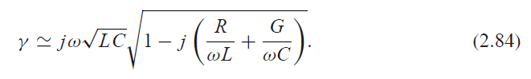
If we were to ignore the (R/ωL + G/ωC) term we would obtain the result that γ was purely imaginary (no loss), so we will instead use the first two terms of the Taylor series expansion for√1 + x _ 1 + x/2+· · · to give the first higher order real term for γ:
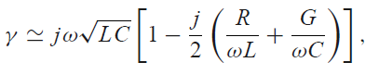
so that
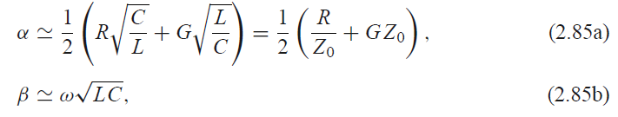
where Z0 = √L/C is the characteristic impedance of the line in the absence of loss. Note from (2.85b) that the propagation constant β is identical to that of the lossless case of (2.12). By the same order of approximation, the characteristic impedance Z0 can be approximated as a real quantity:
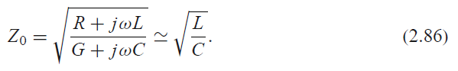
Equations (2.85)–(2.86) are known as the high-frequency, low-loss approximations for
transmission lines, and they are important because they show that the propagation constant
and characteristic impedance for a low-loss line can be closely approximated by considering
the line as lossless.

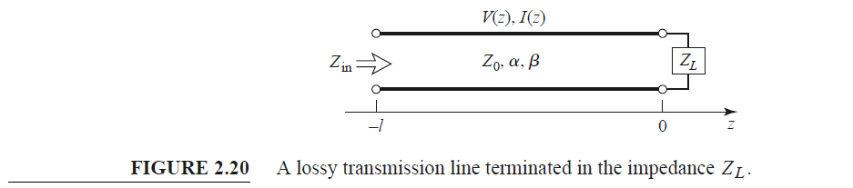

The Terminated Lossy Line
Figure 2.20 shows a length _ of a lossy transmission line terminated in a load impedance ZL . Thus, γ = α + jβ is complex, but we assume the loss is small, so that Z0 is approximately real, as in (2.86).
In (2.36), expressions for the voltage and current wave on a lossless line are given. The analogous expressions for the lossy case are V(z) = V+
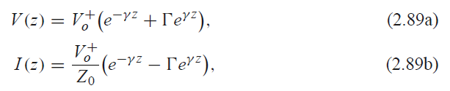
where Γ is the reflection coefficient of the load, as given in (2.35), and V+o is the incident voltage amplitude referenced at z = 0. From (2.42) the reflection coefficient at a distance l from the load is
The input impedance Zin at a distance l from the load is then
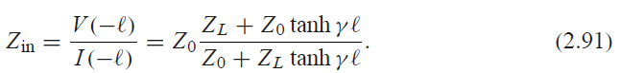
We can compute the power delivered to the input of the terminated line at z = −_ as
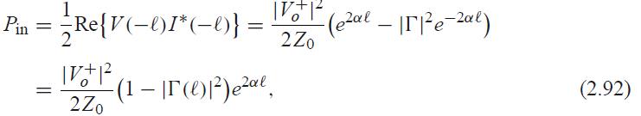
where (2.89) has been used for V(−_) and I (−_). The power actually delivered to the load is
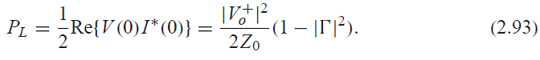)
The difference in these powers corresponds to the power lost in the line:
The first term in (2.94) accounts for the power loss of the incident wave, while the second
term accounts for the power loss of the reflected wave; note that both terms increase as α
increases.
The Perturbation Method for Calculating Attenuation
Here we derive a useful and standard technique for finding the attenuation constant of a
low-loss line. The method avoids the use of the transmission line parameters L, C, R, and
G and instead relies on the fields of the lossless line, with the assumption that the fields of
the lossy line are not greatly different from the fields of the lossless line—hence the term,
perturbation method.
We have seen that the power flow along a lossy transmission line, in the absence of reflections, is of the form
where Po is the power at the z = 0 plane and α is the attenuation constant we wish to determine. Now define the power loss per unit length along the line as
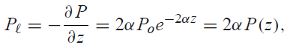
where the negative sign on the derivative was introduced so that P_ would be a positive quantity. From this, the attenuation constant can be determined as
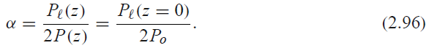
This equation states that α can be determined from Po, the power on the line, and P_, the power loss per unit length of line. It is important to realize that P_ can be computed from the fields of the lossless line and can account for both conductor loss [using (1.131)] and dielectric loss [using (1.92)].

Planar realizations of transmission lines
MICROSTRIP LINE (Pozar p. 147)
Microstrip line is one of the most popular types of planar transmission lines primarily because it can be fabricated by photolithographic processes and is easily miniaturized and integrated with both passive and active microwave devices. The geometry of a microstrip line is shown in Figure 3.25a. A conductor of width W is printed on a thin, grounded dielectric substrate of thickness d and relative permittivity _r ; a sketch of the field lines is shown in Figure 3.25b.
If the dielectric substrate were not present (_r = 1), we would have a two-wire line consisting of a flat strip conductor over a ground plane, embedded in a homogeneous medium (air). This would constitute a simple TEM transmission line with phase velocity vp = c and propagation constant β = k0.
The presence of the dielectric, particularly the fact that the dielectric does not fill the region above the strip (y > d), complicates the behavior and analysis of microstrip line. Unlike stripline, where all the fields are contained within a homogeneous dielectric region, microstrip has some (usually most) of its field lines in the dielectric region between the strip conductor and the ground plane and some fraction in the air region above the substrate. For
this reason microstrip line cannot support a pure TEM wave since the phase velocity of TEM fields in the dielectric region would be c/√εr, while the phase velocity of TEM fields in the air region would be c, so a phase-matching condition at the dielectric–air interface would be impossible to enforce.
In actuality, the exact fields of a microstrip line constitute a hybrid TM-TE wave and require more advanced analysis techniques than we are prepared to deal with here. In most practical applications, however, the dielectric substrate is electrically very thin (d _ λ), and so the fields are quasi-TEM. In other words, the fields are essentially the same as those of the static (DC) case. Thus, good approximations for the phase velocity, propagation constant, and characteristic impedance can be obtained from static, or quasi-static, solutions. Then the phase velocity and propagation constant can be expressed as
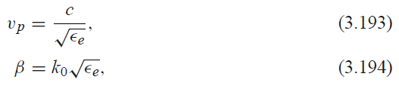
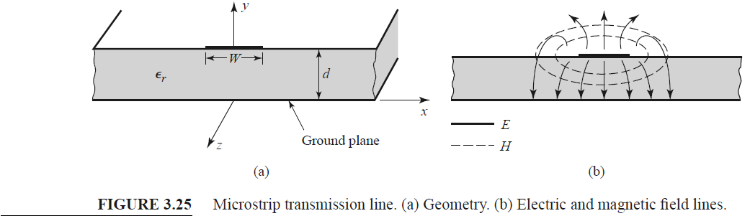

where εe is the effective dielectric constant of the microstrip line. Because some of the field lines are in the dielectric region and some are in air, the effective dielectric constant satisfies the relation
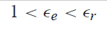
and depends on the substrate dielectric constant, the substrate thickness, the conductor width, and the frequency.
We will present approximate design formulas for the effective dielectric constant, characteristic impedance, and attenuation of microstrip line; these results are curve-fit approximations to rigorous quasi-static solutions [8, 9]. Then we will discuss additional aspects of microstrip lines, including frequency-dependent effects, higher order modes, and parasitic effects.
Formulas for Effective Dielectric Constant, Characteristic
Impedance, and Attenuation

The effective dielectric constant of a microstrip line is given approximately by
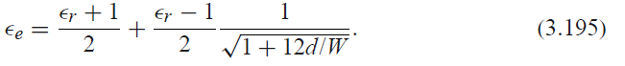
The effective dielectric constant can be interpreted as the dielectric constant of a homogeneous medium that equivalently replaces the air and dielectric regions of the microstrip line, as shown in Figure 3.26. The phase velocity and propagation constant are then given by (3.193) and (3.194). Given the dimensions of the microstrip line, the characteristic impedance can be calculated as
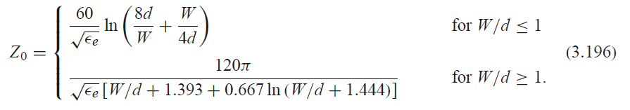
For a given characteristic impedance Z0 and dielectric constant _r, the W/d ratio can be
found as
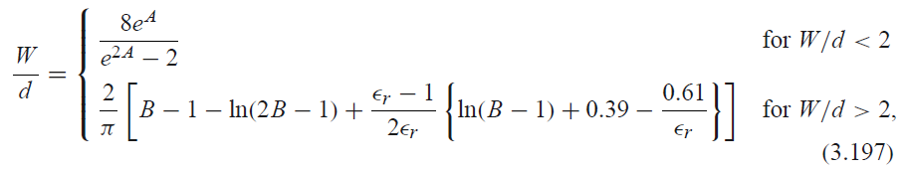
where
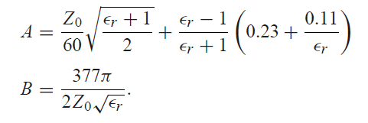
Considering a microstrip line as a quasi-TEM line, we can determine the attenuation
due to dielectric loss as
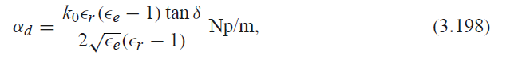
where tan δ is the loss tangent of the dielectric. This result is derived from (3.30) by multiplying
by a “filling factor,”
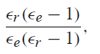,
which accounts for the fact that the fields around the microstrip line are partly in air (lossless)
and partly in the dielectric (lossy). The attenuation due to conductor loss is given
approximately by [8]
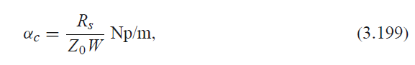
where Rs =√ωμ0/2σ is the surface resistivity of the conductor. For most microstrip substrates,
conductor loss is more significant than dielectric loss; exceptions may occur, however,
with some semiconductor substrates.

STRIPLINE (Pozar p.141)
Stripline is a planar type of transmission line that lends itself well to microwave integrated circuitry, miniaturization, and photolithographic fabrication. The geometry of stripline is shown in Figure 3.22a. A thin conducting strip of width W is centered between two wide conducting ground planes of separation b, and the region between the ground planes is filled with a dielectric material. In practice stripline is usually constructed by etching the center conductor on a grounded dielectric substrate of thickness b/2 and then covering with another grounded substrate. Variations of the basic geometry of Figure 3.22a include stripline with differing dielectric substrate thicknesses (asymmetric stripline) or different dielectric constants (inhomogeneous stripline). Air dielectric is sometimes used when it is
necessary to minimize loss. An example of a stripline circuit is shown in Figure 3.23. Because stripline has two conductors and a homogeneous dielectric, it supports a TEM wave, and this is the usual mode of operation. Like parallel plate guide and coaxial line, however, stripline can also support higher order waveguide modes. These can usually be avoided in practice by restricting both the ground plane spacing and the sidewall width to less than λd /2. Shorting vias between the ground planes are often used to enforce this condition relative to the sidewall width. Shorting vias should also be used to eliminate higher order modes that can be generated when an asymmetry is introduced between the ground planes (e.g., when a surface-mounted coaxial transition is used). Intuitively, one can think of stripline as a sort of “flattened-out” coax—both have a center conductor completely enclosed by an outer conductor and are uniformly filled with a dielectric medium. A sketch of the field lines for stripline is shown in Figure 3.22b. The geometry of stripline does not lend itself to the simple analyses that were used for previously treated transmission lines and waveguides. Because we will be concerned primarily with the TEM mode of stripline, an electrostatic analysis is sufficient to give the propagation constant and characteristic impedance. An exact solution of Laplace’s equation is possible by a conformal mapping approach [6], but the procedure and results are
cumbersome. Instead, we will present closed-form expressions that give good approximations to the exact results and then discuss an approximate numerical technique for solving Laplace’s equation for a geometry similar to stripline.

Formulas for Propagation Constant, Characteristic Impedance,
and Attenuation
From Section 3.1 we know that the phase velocity of a TEM mode is given by
and thus the propagation constant of stripline is
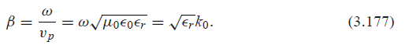
In (3.176), c = 3 × 108 m/sec is the speed of light in free-space. Using (2.13) and (2.16) allows us to write the characteristic impedance of a transmission line as
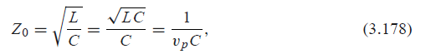
where L and C are the inductance and capacitance per unit length of the line. Thus, we can find Z0 if we know C. As mentioned previously, Laplace’s equation can be solved by conformal mapping to find the capacitance per unit length of stripline, but the resulting solution involves complicated special functions [6], so for practical computations simple formulas have been developed by curve fitting to the exact solution [6, 7]. The resulting
formula for characteristic impedance is
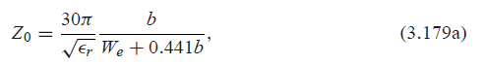
where We is the effective width of the center conductor given by
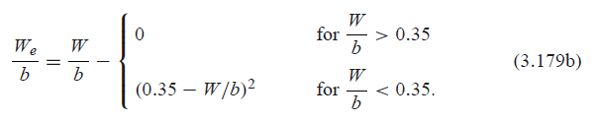
These formulas assume a strip with zero thickness and are quoted as being accurate to about 1% of the exact results. It is seen from (3.179) that the characteristic impedance decreases as the strip width W increases. When designing stripline circuits one usually needs to find the strip width, given the characteristic impedance (and height b and relative permittivity _r ), which requires the inverse of the formulas in (3.179). Such formulas have been derived as
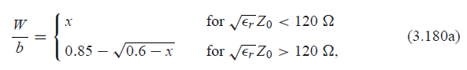
Where
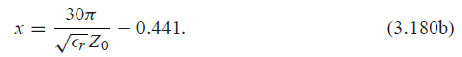
Since stripline is a TEM line, the attenuation due to dielectric loss is of the same form
as that for other TEM lines and is given in (3.30). The attenuation due to conductor loss
can be found by the perturbation method or Wheeler’s incremental inductance rule. An
approximate result is
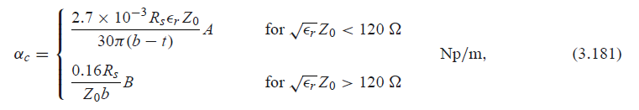
with
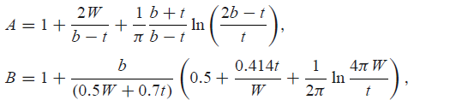
where t is the thickness of the strip.

Sources of power loss
Loses can be dividet into radiated losses and conducted lossess. Conducted are related to dielectric loss and conductor loss (skin effect, bulk conductivity, sourface roughness, thickness)2
Few words about conductor loss, what is the couse (skin efect, bulc conductivity, sourface roughness, volume resistivity, thickness) etc.
Few words about dielectric loss, what is the cous inticating options to reduce it (line loss of the dielectic medium, effective dielectric loss as an outcome of different used materials etc).
Say sometching that since wave propagates along the line so loses are higher for logner patsh, so it is good to recuce the overal propagation lengths etc.

