Metrics Test Plan

With a limited set of resources, testing of a system such as Metrics must rely on internal verification tests as much as possible. For this reason we will be taking a multi-level strategic approach to our testing efforts. These efforts are described in the graphic below:

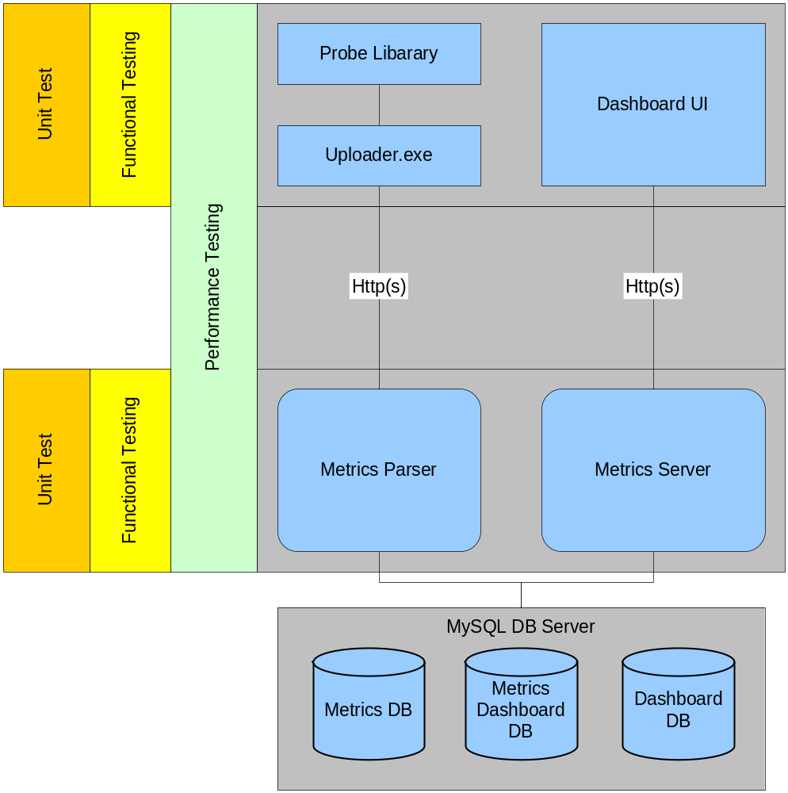

This multi-level strategy consists of the following:

- Unit Tests
- Functional Tests
- Performance/Scaling Tests
- Granular System Tests (more specific tests on a system unit level)
- Product Analysis through the use of tools

Desired Results

The system must be verified to work correctly from end to end.

Daily runs of all flavors of tests will be done.

The entire system must be usable and perform well under a number of conditions. Basic use should assume a small audience uploading reasonable sized log files and a small audience browsing that information.

The system must also perform adequately under load. In this case we must assume a large number of users uploading small to large sized log files and a reasonable number of users browsing that information.

Under conditions where every effort has been made to tune and optimize the software for performance under these tests, the next step will be to determine where hardware configuration changes can affect performance in a positive manner.

Metrics On Metrics (Using the Metrics Product to Record Test Results)

Where ever possible we will attempt to record the results of general tests using Metrics. It is unclear yet whether or not this will make sense for all Unit Tests.

In our attempts to do this previously we found that it was more work and created more problems that we benefited from. Mainly due to the fact that this product is currently in flux, as well as the tests so the data gathered has little meaning on a day to day basis, since the tests and the system are changing so much.

Most likely we will only really be able to do this once both the set of tests and the product itself stabilizes.

Unit Tests

At the lowest level we will have a large suite of unit tests. These tests will be implemented at every stage/level of the system. Specifically we will have unit testing in

- Metrics Probe Library (Cxx test)
- Metrics Uploader Library and Application (Cxx Test)
- Metrics Parser Web Application (JUnit)
- Dashboard Server (JUnit)
- Metrics Dashboard Web Application (JUnit)
- Dashboard Flex UI (Flex Unit)

All unit tests will be run during the build process, which is automated to run nightly. Any unit test failure equates to a build failure. No developer may check in any code that fails any of the unit tests.

We will also be using a code coverage tool to help assess the coverage of our unit tests (see tools section below).

As bugs are found, if at all possible developers will add unit tests to reproduce the problem prior to fixing the bug. If the bug was found with some other System Test, that version of the test will be Tagged in Perforce so that it can be re-run at a later date if needed.

Functional Testing

Functional testing in this context implies system level test that treat the product as somewhat of a black box. The intention of these tests is to validate basic expected behavior from the entire system.

The main part of this test system will be the “Smoke Test”. This test is meant to be a broad use test. It will not delve into detail, but can be used to verify a stable build on a daily basis.

The Smoke Test TDD is located here. It tests the product from Installation through general use. It will be an external application made of a suite of JUnit tests that exercise the following items to begin with:

- Installer: Does the installation occur successfully?
- Metrics Probe Library: Can valid log files be generated?
- Uploader: Can a log file be uploaded?
- Metrics Parser: Do known log files get parsed into the database correctly?
- Dashboard Metrics: Can known data be retrieved from the database through the Dashboard?

The Smoke Test will be run as part of the automated nightly build process, currently being built by the Automation Element. A failure to pass the smoke test will constitute a build failure.

The smoke test will be configured to run more than once making sure to test all release and debug builds of both the Probe library and the Uploader.

In later sections, below, more specific tests will be documented for each of the sub systems of the Metrics and Dashboard applications (see Granular System Tests).

We will be running a base set of performance tests on the minimum specification hardware in order to gauge lowest performance (see Hardware Requirements for min spec configuration).

Performance Tests

There are several areas where performance must be tested.

- Single Metrics Probe call
- Upload speeds
- Metrics Parser performance
- Dashboard Metrics query times
- Dashboard Metrics database aggregation performance

All tests will be performed on our minimum specification machines as well as a more reasonable general configuration.

All tests will also be executed on all required hardware (see Hardware Requirements for min spec configuration, as well as required OS’s). Where possible, performance tests will be run for the Metrics library on the required consoles.

Single Metrics Probe Call

This will be tested by a stand-alone C++ application that executes and times a series of Probe calls. The goal is to measure the average time it takes in microseconds for an individual Probe call.

Once we have a value that represents a good timing, this test will be added to the build process such that no subsequent code addition should decrease this value.

Upload Speed Tests

Generally this is just a basic HTTP post. But we will want to get a sense for how various hardware impacts performance. NOTE: Scaling tests for uploading are covered in the Scaling test section below.

Metrics Parser Performance

This system is a Java based web application. Its performance characteristics are simply how fast it can parse the log files sent to it. Again scaling will be handled separately.

TEST: Parse a large enough set of files such that the internal queue is full for a reasonable period. Once all parsing is complete calculate the average log lines per minute parsed. NOTE: We must parse enough log files such that the time to ramp up and down the queue is just noise as part of the test.

RESULT: xxx log lines / minute Note: Get a number from the team that seems reasonable for determining an acceptable Pass/Fail threshold.

This test will be run on min spec hardware as well as standard hardware.

Database Aggregation Performance

Aggregation is the process of migrating the most granular data in the MetricsSummary database table to the less granular tables. Migration occurs based on, hour, day, week, month, or year. This process is performed by a set of database stored procedures.

Currently aggregation is performed at 1 minute intervals by default. We have examined other possible ways of timing the aggregation to offset load, but have not made any changes to the system yet.

TEST: Aggregate a range of records counts to determine if aggregation performance is consistent or not. Range to include 100, 1000, 10000, 100,000, 500,000 records.

RESULT: xxx records / minute. We will collect a separate value for each of ranges. Note: Get a number from the team that seems reasonable for determining an acceptable Pass/Fail threshold.
If the time is not consistent across the record ranges we will need to examine this test further.

This test will be run on minimum specification hardware as well as standard hardware.

Dashboard Query Speed Tests

The Dashboard is capable of asking the database for a wide range of data. For performance reasons it is essential that general query requests are returned in a timely fashion.

TEST: Develop a set of queries against various sized databases, examining each query response time. The database sizes should consist of: 10,000, 100,000, and 1,000,000 records. We would also want to see how aggregated data impacts the query performance.

RESULT: xxx seconds to perform query (both an average across all queries, as well as the min and max) Note: get number from team that seams reasonable for Pass/Fail.

Scaling Tests

Generally these tests will be designed to stress the system to see what the scaling envelope looks like. Test should simulate various levels of system load and use across all portions of the product.

During testing the system performance will be monitored for CPU and Memory usage.

Metrics Library

TEST: Generate a large number of Probe calls with different Probe names. Time subsequent Probe calls with already existing names.

RESULT: verify that the time to execute the later Probe calls is reasonable.
Note: get number from team that seams reasonable for Pass/Fail.

TEST: Same as above, but instead subsequent calls use new Probe names.

RESULT: verify that the time to execute the later Probe calls is reasonable.
Note: get number from team that seams reasonable for Pass/Fail.

Metrics Uploader

TEST: Upload various sized files. This test will help determine a valid default timeout value for uploading log file.

RESULT: That each file can be uploaded in a reasonable amount of time. While we will have a very fast network on our test rack, we will also want to run this same scripted test in other environments to get a picture of the performance envelope, since this test relies heavily on network latency, and hardware, its results will vary a lot.

Metrics Parser

TEST: Push various sized files at the parsing system to determine if there are issues with log file size. Sizes to test: 1 KB, 10 KB, 100 KB, 512 KB, and 1 MB.

RESULT: Verify that the files get parsed correctly and that no data is lost. Also, verify that the performance is acceptable.

TEST: Simultaneously post of a variable number of log files. This really will end up testing the Tomcat connection limit, but we need to know how the server reacts to this type of environment. Log counts to test: 10, 100, 1000, 5000, 10000, and 100000. Note: File size will initially be the same, then with various sizes picked randomly from a range.

RESULT: Verify that the files get parsed correctly and that no data is lost. This test should also confirm that the parsing performance is acceptable.

TEST: Single log file with various numbers of Metrics Probes.

RESULT: Verify that the file gets parsed correctly and that no data is lost. This test should also confirm that the parsing performance is acceptable.

TEST: Single log file with Probes of various lengths.

RESULT: Verify that the files get parsed correctly and that no data is lost. Also, that the performance is acceptable.

TEST: Single log file with various sets of Name/Value pared session header information.

RESULT: Verify that the files get parsed correctly and that no data is lost. This test should also confirm that the parsing performance is acceptable.

Dashboard

TEST: Conduct multi-user simulation test. Generally, this test will follow a set of steps that simulate basic user interaction will be running in multiple instances to simulate basic Dashboard usage under load. The performance characteristics that will need to be measured are basic responsiveness during the test timeline. We will do a set of test to simulate 1, 5, 25, 100, and 250 users.

RESULT: Verify that the response time in the client (Dashboard) does not degrade to an unacceptable level under the load being tested.

TEST: Same as above but additionally the server will also be tasked with parsing files into the database to simulate both portions of Metrics being executed in parallel. The same performance characteristics will need to be examined.

RESULT: Verify that the response time in the client (Dashboard) does not degrade to an unacceptable level with load.

Note: It may be that the system does degrade too much under heavy user load. If this does occur we will also examine the impact of hardware and clustering of the server systems to alleviate this issue.

In General we will run this tests with various configurations, load balanced, etc, to get a picture of what kind of performance improvement our customers can expect when changing configurations.

Granular System Tests

While we will rely heavily on Unit Tests from within the systems themselves, we can execute pathological and edge condition testing from an external source. Tests to be conducted in this way are as follows.

Note: If any of these tests are already covered by Unit tests, then those tests will take precedence and these would not be needed.

Metrics Probe Library

TEST: Execute a Probe call with min-1, min, mid, max, and max+1 string lengths.

RESULT: Verify that within boundaries, the Probe is recorded correctly. Outside of that an error is recorded or the Probe fails to be written cleanly.

TEST: Execute a Probe call with min-1, min, mid, max, and max+1 values.

RESULT: Verify that within boundaries, the Probe is recorded correctly. Outside of that an error is recorded or the Probe fails to be written cleanly.

TEST: Execute Probe calls with enough max values such that the SUM field is overloaded.

RESULT: Verify that some kind of error is reported as this would cause a wrapping of the value for sum.

TEST: Execute Probe calls for some period of time without calling TICK, or closing the Probe system. The intent is to fill as many Summary Buckets as possible to use up all memory in the system.

RESULT: Verify that under low memory conditions the system should be smart enough to attempt to write the buckets stored in memory. Failing that, an error condition should be recorded.

Uploader

TEST: Execute Uploader with all command line options utilized. Test validity and edge conditions of all command line parameters.

RESULT: Verify that the system performs normally or handles the error conditions gracefully.

TEST: Execute Uploader with all .ini configuration properties. Test validity and edge conditions of all options.

RESULT: Verify that the system performs normally or handles the error conditions gracefully.

Note: Both the tests above include web service configuration information; these tests will test the handling of unavailable services as well.

Metrics Parser

Validity testing is handled by the Smoke Test, Performance, and Scaling tests are handled with those tests. Granular testing will be handled by Unit Tests within the system, developed by engineering.

Note: We will assure good coverage through the use of code coverage tools.
Note: If upon examination it is determined that the unit tests do not cover enough of the error handling and edge conditions, more will be added by QA.

Dashboard, General

Since there is no way currently to run the Dashboard system headless (though the debug mode of the flash player does provide some of this) we will be adding to the Flex Unit tests for greater test coverage.

Rather than call out all specific tests here, we will be building a suite of tests with the help of development to ensure that we have good coverage of all test types, which include, edge conditions, error conditions, and known positives.

Tools Used For Testing

JUnit http://junit.sourceforge.net/

Java Code Coverage http://emma.sourceforge.net/, this tool will be used to help determine if we have sufficient coverage in our unit tests.

Java Code Analysis (like lint) http://pmd.sourceforge.net/, this tool can be used to help find bugs statically. This will prevent these types of bugs preventing them from getting into production. In general we will develop a set of rules that will be applied when this tool is run. We will then add this tool to the nightly build process.

Flex Unit http://www.iterationtwo.com/open_source_flexunit.html

We will extend the current log file test generation system to be more robust in order to create the largest possible set of realistic log file for testing purposes.

Grinder http://grinder.sourceforge.net/, this tool will be used to drive the Dashboard load tests. We will record a basic unit test session or manual session that exercises the Dashboard. Then play that back simulating the required number of users.

Emergent Automation Element. We will be using this to run our nightly builds as well as our testing systems (Unit and Other) where possible the results of the tests will be recorded into the Results Manager, which is part of that system.

CxxTest http://cxxtest.sourceforge.net/

C++ Code Coverage http://www.bullseye.com/, this tool will be used to help determine if we have sufficient coverage in our unit tests.

C++ Code Analysis http://www.parasoft.com/jsp/solutions/home.jsp?solution=CCppT, this tool can be used to help find bugs statically. This will prevent these types of bugs from getting into production. In general we will develop a set of rules that will be applied when this tool is run. We will then add this tool to the nightly build process.

Hardware Requirements

Testing Hardware Configurations

We have defined a minimum spec single platform machine as follows:

Client Machine

2 GHz Celeron
512 MB RAM
Basic IDE HD

Server (run all server software, Tomcat + MySQL)

2 GHz Pentium 4
1 GB RAM
Basic IDE HD

The general testing hardware will be as follows:

3 machine configuration for server based software (Server, Dashboard, Database)

Each machine will be as follows:

Dual 3 GHz Xeon
2 GB RAM
7500 RPB IDE Drive

Client hardware will be similar to the above, with the expectation of running more than one simulated client per machine.

We will also be testing the Metrics Probe Library on the following consoles:

- PS3 DevKit
- Xbox 360 DevKit

Platform Requirements

The Metrics Probe Library will be tested on the following Platforms:

- PS3 DevKit
- Xbox 360 DevKit
- Windows XP
- Windows XP Pro
- Windows Vista

The server application will be tested to run under the following Platforms:

- Red Hat Fedora Core 4
- Gentoo

The Dashboard client will be tested to run under the following Platforms:

- Operating System(s): Windows XP, XP Pro, Vista
- Web Browser(s): Microsoft Internet Explorer version 6 and 7, Mozilla Firefox version 1.5

