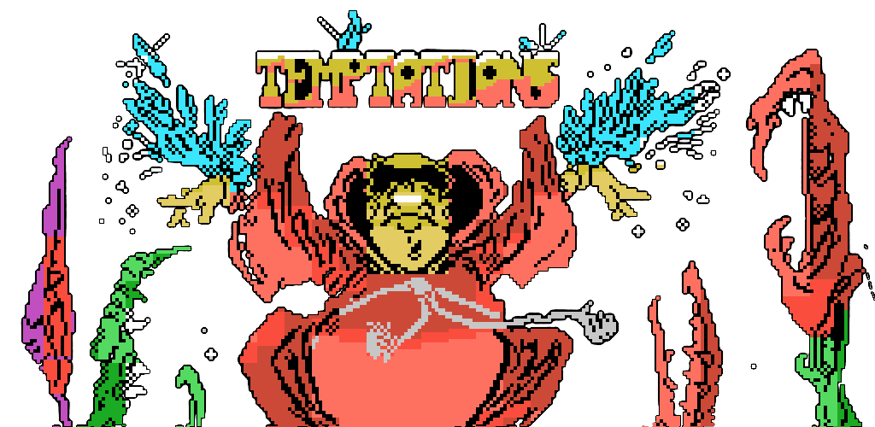

Nonato Brother, also known as Noni to his fellow novices, panic trembled under his wide robe. He recalled, almost wistfully, previous tests that he had been submitted from the Vitigudina order in order to see if he really deserved to be ordained as one of its members.

He almost wished to renounce the test and go back to the monastery where to vow himself to his usual tasks such as toilets cleaner and potato peeler.

But then he recalled those previous tests and kept adamant. After all (he thought), there was just this one test left and if not confronted, what would the 40 fasting days in the desert be good for but to subtract some roundness to his plump figure?

So he continued advancing, although he wished that the villagers had been less accurate describing the calamities from which he had to free them.

He was scared but faith gave him strength besides, he was well prepared. Therefore when he found himself facing the smoke column from which the lower class demon came out and jumped over him, he was abled to save himself due to the pentagram he cautionly had drawn hours earlier.

The infernal creature fell back upon see him, pretending to be safe in the thick smoke, but Nonato did not give it any chance. With uncharacteristic swiftness from its affable appearance, the novice threw some drops of Holy Water 'class 26' at the monster. It all ended with a chilling howl and a dreadful stench of sulfur.

Sighing, he continued walking towards the gates of Grimwood, outside the village. There, to the surprise of our hero he found laying asleep, in an obvious breach of its duty, a small horned creature with tail and a big belly on which its two tiny hands were laid. Then with great calm, Nonato got himself ready and spilled over the monster a single drop of Holy Water.

The effect was eerie:

"**Let me free**" (it sobbed) in return I'll tell you how to disenchant the village. "**OMNIA EST TEMPTATION**" Nonato said, but with the holy water jar suspended over its head, the little imp answered all questions from the novice...

**A SHOOTING MONK?**

Do not think that our hero could succesfully achieve his mission without a wide range of weapons where to use. Arrows will be our starting weapon which will help us to defend ourselves from starting enemies and also to find several power up as well as useful items.

Most objects and shooting power up are hidden inside chests and skulls. At sight, shoot at those objects and you will rewarded with shooting fireballs, magic cristals, arrows power up, extra lives, etc ...

Some chests contains wings that will enable you to fly and avoid, this way, inevitable obstacles.

**LOADING PROGRAM:**

Double click the left mouse button over the executable file and fully enjoy the gaming experience.

**CONTROLS:**

You can manage the game with the keyboard, joystick or touch screen. To activate the Joystick this must be connected before starting the game, to activate the touchscreen just have to play it to the detected.

LEFT / LEFT LEVER LEFT

RIGHT / RIGHT LEVER RIGHT

UP / **SHIFT** / BUTTON 2 / BUTTON 4 JUMP

**CTRL** / SPACE / BUTTON 1 / BUTTON 3 SHOOT

JOYSTICK / GAMEPAD BLUETOOTH / PS4 JOYSTICK

**G** GRAPHICS

**M** MUSIC

**F** / **F11** FULL SCREEN

**P** / **PAUSE** PAUSE / CONTINUE

**L** LANGUAGE

**ESC** / BUTTON BACK EXIT

CLOSE WINDOW OR REMOVE OUT SEVERAL TIMES QUIT

**TOUCH SCREEN:**

Touch the screen to activate the touch control, this consists of a control pad (**PAD**), two visible buttons (**A** and **B**) and three hidden buttons (**L**, **C** and **R**).

*During the game*:

**PAD** CONTROL RIGHT/LEFT/UP/DOWN

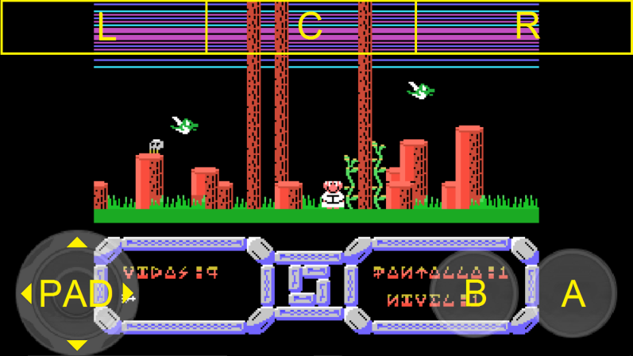 **A** SHOOT

**B** JUMP

**L** CHANGING GRAPHICS

**C** PAUSE / CONTINUE

**R** ENABLE / DISABLE THE MUSIC

*During pause*:

**PAD** UP/DOWN BUTTON AIZE

**PAD** RIGHT/LEFT CHANGE THE TRANSPARENCY

**A** CONTINUE

**B** CHANGE LANGUAGE

**L** CHANGING THE GRAPHICS

**C** PAUSE / CONTINUE

**R** REMOVING THE TOUCH CONTROL

**DESIGN TEAM**

Original Design: *LuigiLópez* Luis López Navarro

Original Graphics: *LuigiLópez* Luis López Navarro

Original Programming: *LuigiLópez* Luis López Navarro

Original Music: *Gominolas* César Astudillo

Cover page: *Azpiri*  Alfonso Azpiri Mejía

Load Screen: *Quick-fingers* Julio Martín Erro

Improved Graphics: *Nene Franz* Francisco Javier Wis Gil

Improved Music: *Snabisch* Victor Navarro

Translation: *Gravitonio* Antonio E.

Programming Remake: *PipaGerardo* Gerardo Herce Ripa

Snabisch: https://makeagame.bandcamp.com/

Temptations Remake: https://sites.google.com/site/temptationsremake/