CONFIDENTIAL

Apple Inc.
FP&A Variance Report
Q1 FY2026

Prepared by Karan Pipaliya
13 May 2026

Variance Analysis | Q1 FY2026
The table below sets out the actual results for Apple Inc. against budget for Q1 FY2026. Favourable variances are shaded green; adverse variances are shaded red. All amounts are in millions of $.
Line Item | Actual ($m) | Budget ($m) | Variance ($m) | Variance % | Direction
Revenue | 124.3 | 119.0 | +5.3 | +4.5% | Favourable
COGS | 54.9 | 53.5 | +1.4 | +2.6% | Adverse
Gross Profit | 69.4 | 65.5 | +3.9 | +6.0% | Favourable
OpEx | 14.5 | 15.0 | -0.5 | -3.3% | Favourable
EBITDA | 54.9 | 50.5 | +4.4 | +8.7% | Favourable
D&A | 3.2 | 3.0 | +0.2 | +6.7% | Adverse
EBIT | 51.7 | 47.5 | +4.2 | +8.8% | Favourable
Net Income | 36.3 | 33.5 | +2.8 | +8.4% | Favourable
Gross Margin % | 55.8% | 55.0% | +0.8 pp | — | Favourable
EBITDA Margin % | 44.2% | 42.4% | +1.7 pp | — | Favourable
Net Margin % | 29.2% | 28.2% | +1.1 pp | — | Favourable

Variance Visualisation
Top panel: actual versus budgeted values by line item. Bottom panel: variance percentage versus budget, shaded green where favourable and red where adverse.
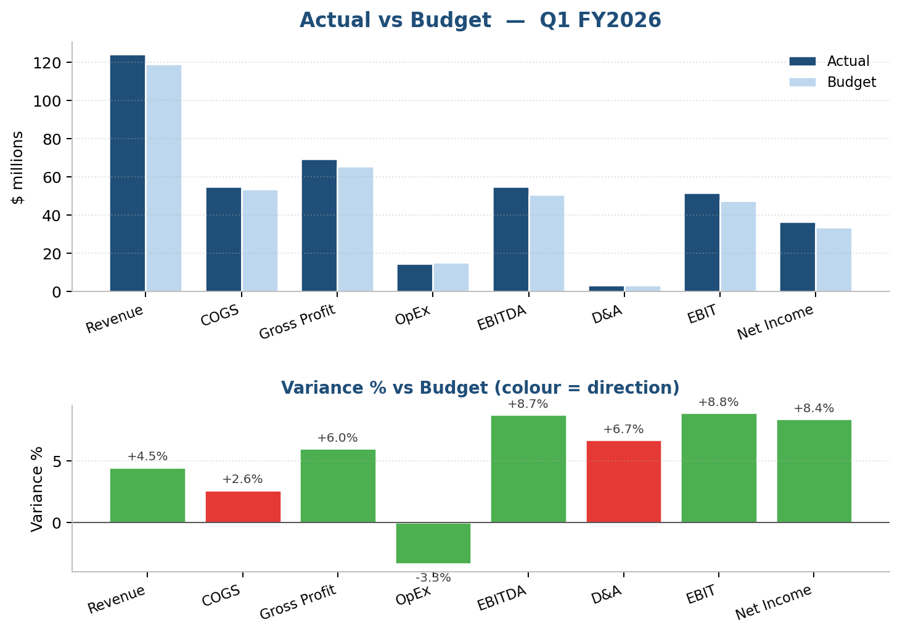

Management Commentary
Executive Summary
Apple Inc.delivered a strong operating performance ahead of plan on both the top and bottom lines during Q1 FY2026. Reported revenue of $124.3m compared with a budget of $119.0m, producing a variance of $5.3m or +4.5% (favourable). EBITDA closed at $54.9m versus a plan of $50.5m, a +8.7% swing that translated into an EBITDA margin of 44.2% against a planned 42.4% (+1.7pp). Net income finished at $36.3m (+8.4% versus plan). Of the eight tracked line items 6 were favourable to plan and 2 adverse, framing the detailed commentary that follows.
Revenue & Gross Profit
Revenue of $124.3m outperformed budget, reflecting stronger-than-anticipated demand and favourable pricing dynamics across the principal revenue streams, representing a variance of $5.3m or +4.5% against a budget of $119.0m.Cost of goods sold of $54.9m exceeded the budget, driven by input-cost inflation and an unfavourable mix shift that diluted unit economics, a +2.6% movement relative to the planned $53.5m. The combined effect produced gross profit of $69.4m (+6.0% versus a budgeted $65.5m), while the gross margin expanded by +0.8pp to 55.8% against the planned 55.0%. The gross-profit outcome is therefore classified as favourable for variance-reporting purposes.
OpEx & EBITDA
Operating expenses of $14.5m demonstrated firm cost discipline, with operating expenses held below the budgeted envelope despite the underlying activity level, a -3.3% variance against the planned $15.0m.Combined with the gross-profit outcome, this produced EBITDA of $54.9m versus a budget of $50.5m — a variance of $4.4m or +8.7%, classified as favourable. The EBITDA margin expanded by +1.7pp to 44.2% relative to the planned 42.4%, while the COGS-to-revenue cost ratio of 44.2% compared with a budgeted 45.0% (-0.8pp). Together these movements describe the quality of the underlying operating performance.
Net Income
Below the EBITDA line, depreciation and amortisation came in above plan, creating a modest headwind below EBITDA: $3.2m versus a planned $3.0m (+6.7%).EBIT therefore closed at $51.7m against a budgeted $47.5m, a variance of $4.2m or +8.8% (favourable). Net income of $36.3m exceeded the budgeted level, supported by the favourable operating drop-through and disciplined below-the-line items, representing a +8.4% variance against the planned $33.5m. Net margin of 29.2% compares with a planned 28.2% (+1.1pp), completing the walk from top-line revenue down to the bottom-line earnings outcome reported for the period.
Outlook
Management views the result as a constructive foundation for the remainder of the year.The combination of favourable revenue, EBITDA and net-income outcomes points to sustained operating momentum, and the priority is to convert this strength into raised full-year guidance once the second quarter has been closed and reviewed. On the current trajectory, run-rate revenue of roughly $497.2m and run-rate EBITDA of $219.6m provide a useful, if simplistic, reference for the annualised picture. Apple Inc. will reconfirm its full-year guidance at the next scheduled trading update, and the FP&A team will continue to monitor the cost ratio (44.2% this period) and EBITDA margin (44.2%) as the primary leading indicators of underlying profitability.

Appendix — Key Ratios
Summary of the profitability and cost ratios derived from the actual and budget figures for the period.
Ratio | Actual | Budget | Delta (pp) | Direction
Gross Margin | 55.8% | 55.0% | +0.8 | Favourable
EBITDA Margin | 44.2% | 42.4% | +1.7 | Favourable
Net Margin | 29.2% | 28.2% | +1.1 | Favourable
Cost Ratio (COGS / Revenue) | 44.2% | 45.0% | -0.8 | Favourable
Note: percentage-point (pp) deltas compare the period's actual ratio with the budgeted ratio. For the cost ratio, a lower outcome is treated as favourable.

